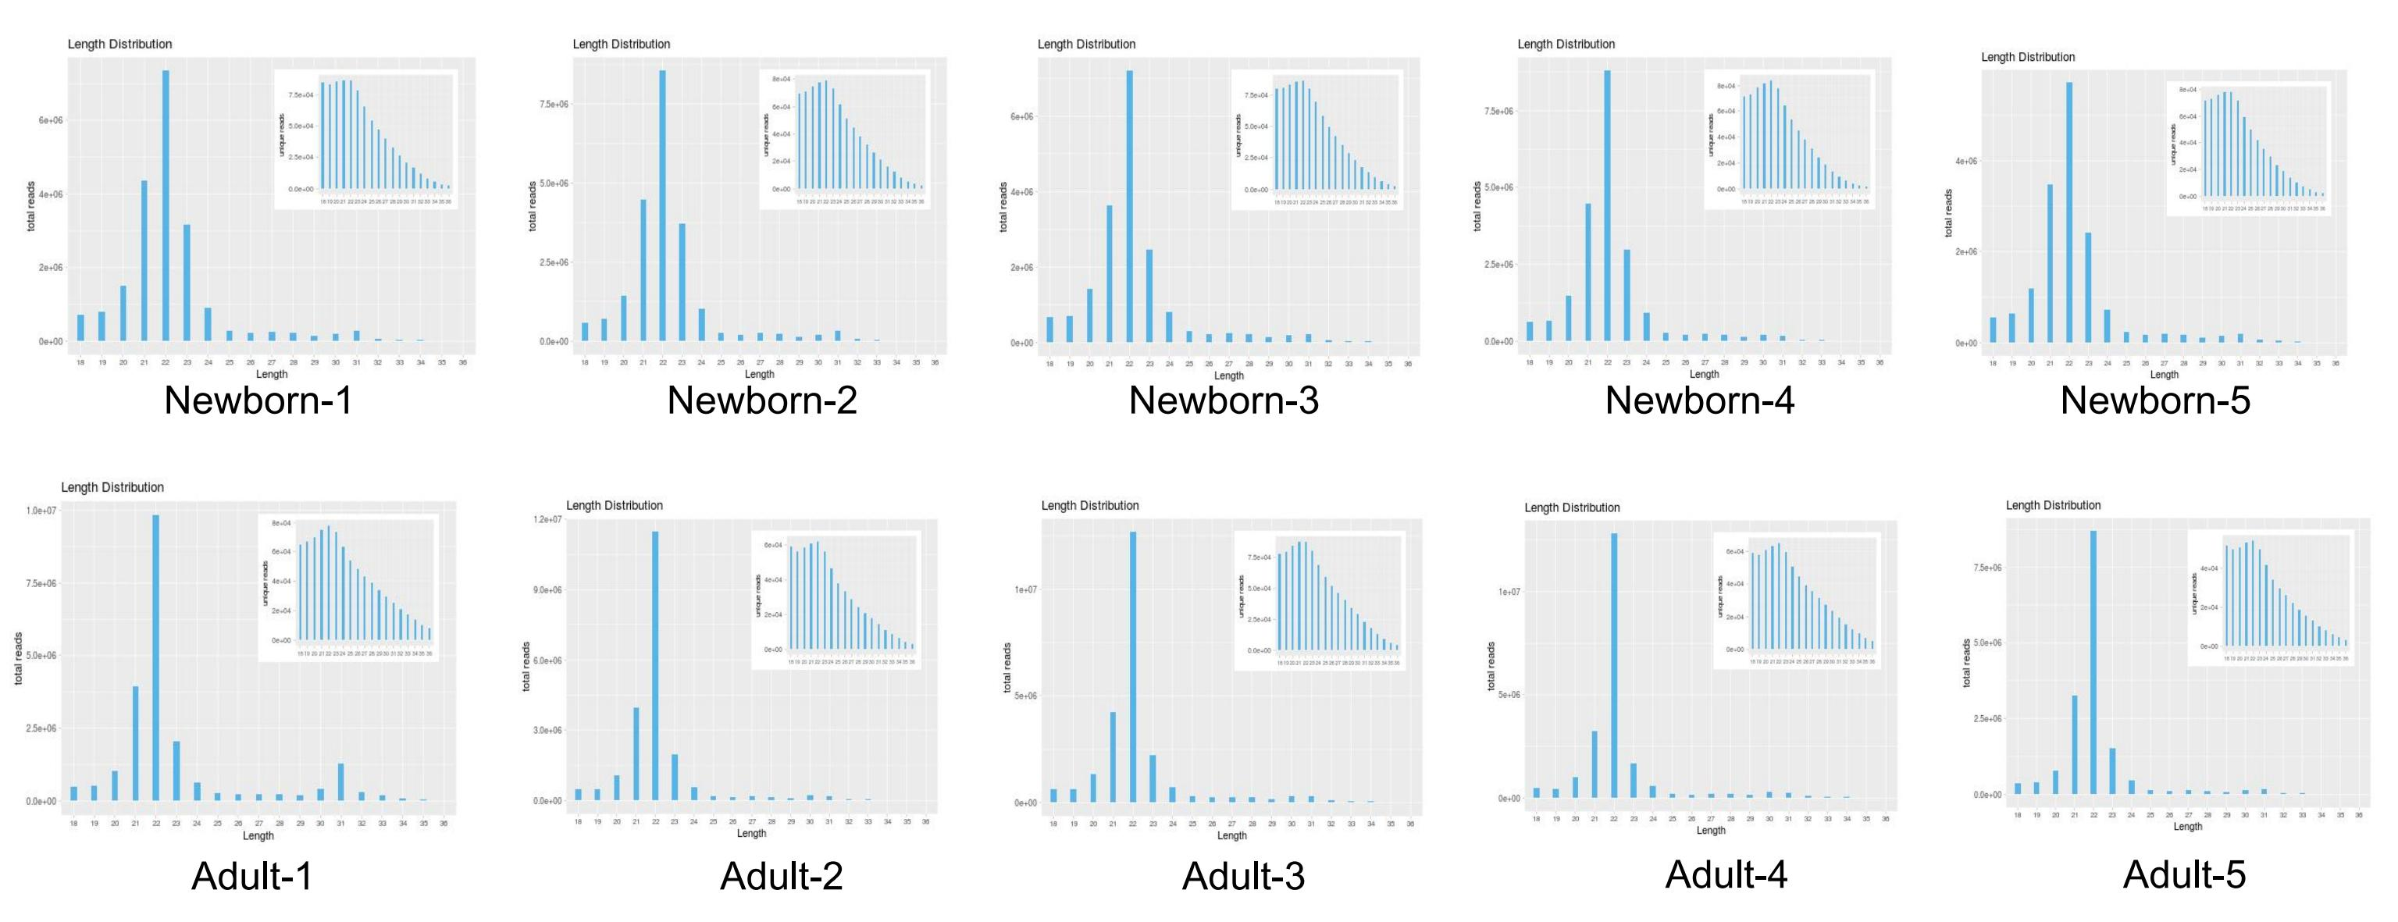

Additional file 2: Figure S1. Length distribution of total small RNA fragments.

