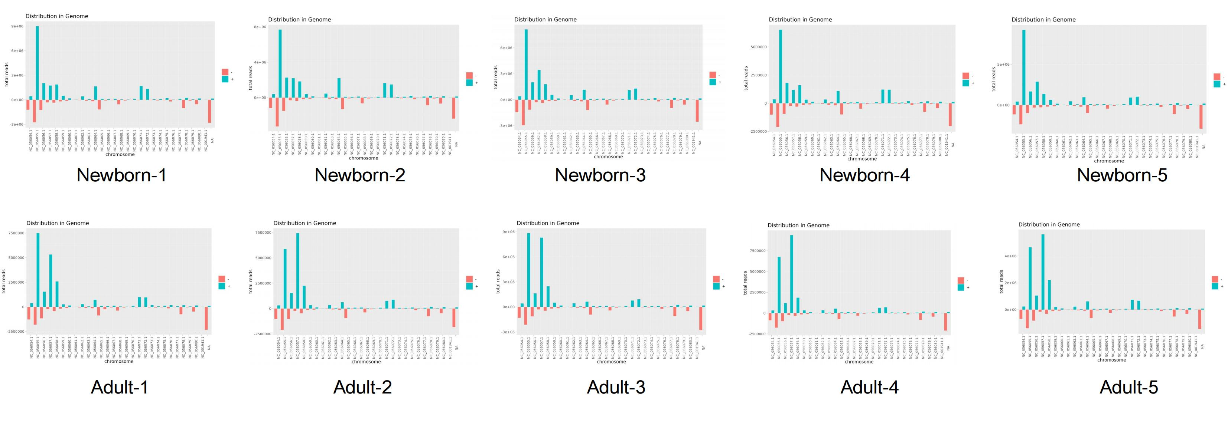

Additional file 3: Figure S2. Genome-wide distribution of small RNAs.

