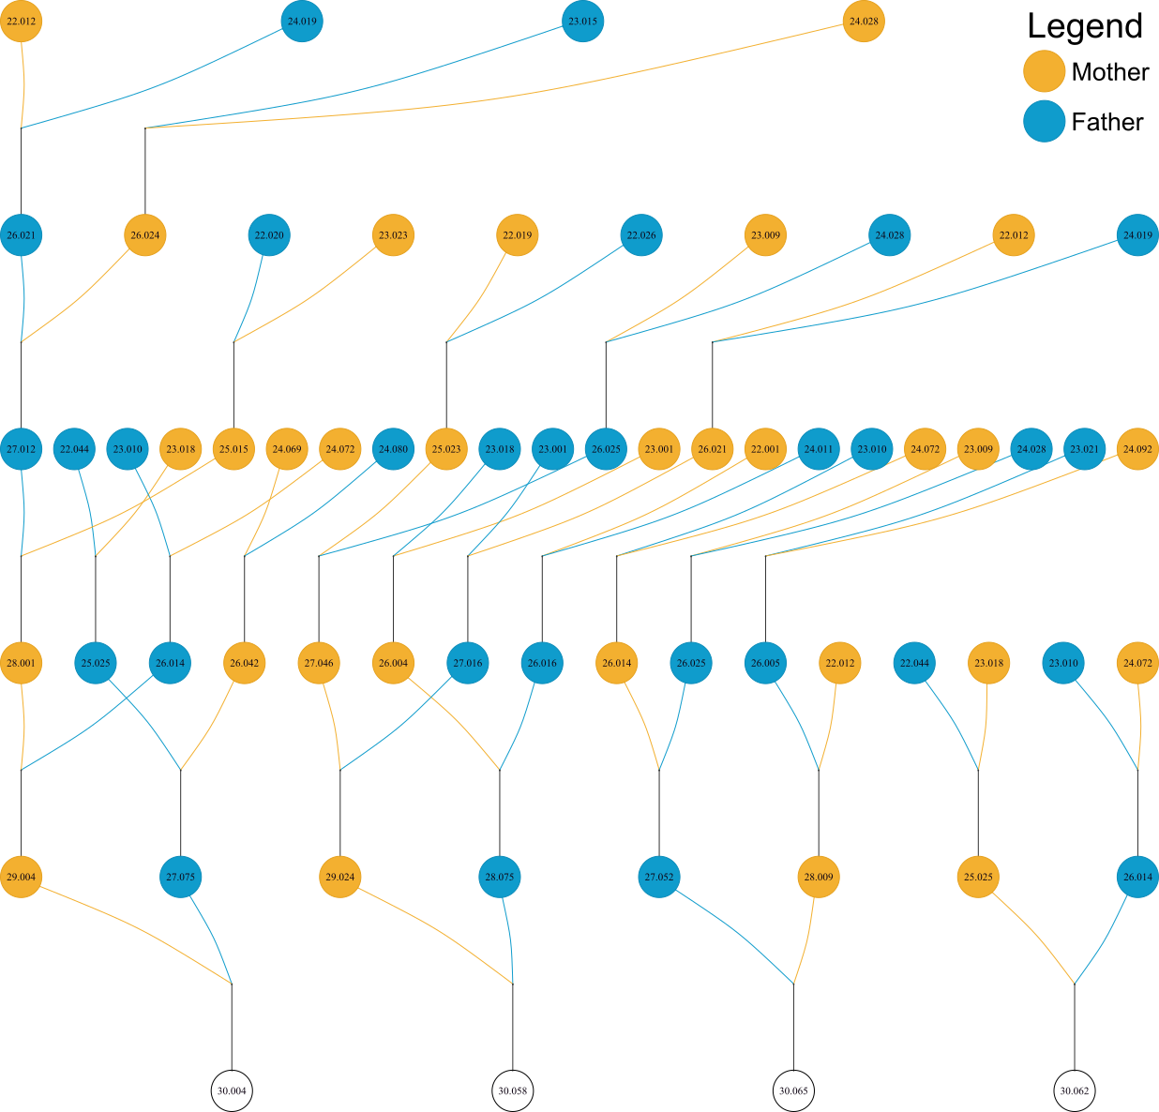
Fig. S1. Pedigree of families 30.004, 30.058, 30.062, and 30.065. Ancestry prior to cohort 22 is not shown as families in these cohorts were not spawned using single pair matings.

