Sample | Raw reads | Clean reads | Error rate | Q20 | Q30 | GC content
FT_LCG_1 | 46,321,014 | 44,024,988 | 0.02% | 98.11% | 94.56% | 51.46%
FT_LCG_2 | 46,730,722 | 43,668,406 | 0.02% | 98.19% | 94.78% | 50.85%
FT_LCG_3 | 48,040,536 | 44,506,336 | 0.02% | 98.42% | 95.33% | 52.12%
CT_LCG_4 | 46,503,644 | 43,080,972 | 0.02% | 98.38% | 95.21% | 51.51%
CT_LCG_5 | 45,609,522 | 43,605,410 | 0.02% | 98.45% | 95.30% | 51.33%
CT_LCG_6 | 45,602,548 | 43,037,778 | 0.02% | 98.30% | 95.08% | 51.89%
Table S1 Sample sequencing data quality in transcriptomics

Table S2 Sample sequencing data quality in translatomics
Sample | Raw reads | Error rate | Q20 | Q30 | GC content
FT_LCG_1 | 50,666,392 | 0.01% | 99.10% | 96.97% | 55.41%
FT_LCG_2 | 50,286,756 | 0.01% | 99.12% | 96.94% | 55.09%
FT_LCG_3 | 52,749,309 | 0.01% | 98.97% | 96.79% | 55.85%
CT_LCG_4 | 49,894,812 | 0.01% | 98.81% | 96.54% | 55.57%
CT_LCG_5 | 51,599,006 | 0.01% | 99.13% | 97.09% | 55.29%
CT_LCG_6 | 59,901,380 | 0.01% | 99.15% | 97.13% | 55.94%

Table S3 Proteomics identification overview
Total spectra | Matched spectrum | Peptide | Identified protein | ALL
314,881 | 70,066 | 29,446 | 4,022 | 3,999

Table S4 Top 20 differentially expressed TE genes
Gene id | Gene Name | log₂FoldChange | P value | P.adjust (Padj)
102190399 | LOC102190399 | -6.005187657 | 1.10E-05 | 0.061492
102178021 | ITIH4 | 3.837280025 | 1.71E-05 | 0.061492
102175337 | FRMD4B | 1.798622283 | 1.98E-05 | 0.061492
102184185 | CCNE1 | 2.086546502 | 2.94E-05 | 0.061492
102188389 | DENND1C | 2.521558221 | 5.62E-05 | 0.100772
102191129 | SHANK3 | 2.08914259 | 7.59E-05 | 0.119159
102172989 | CHAF1A | 1.280095525 | 9.52E-05 | 0.132785
102175721 | TOPAZ1 | -3.156989891 | 0.000117 | 0.140578
102190475 | FAM65B | 1.793876951 | 0.000123 | 0.140578
102172352 | JAKMIP2 | -3.469457163 | 0.000212 | 0.194457
102173569 | LOC102173569 | 4.669837843 | 0.000217 | 0.194457
102179737 | PRKAG1 | 1.668625301 | 0.000295 | 0.246842
102172524 | NAP1L5 | -3.348768078 | 0.000375 | 0.28844
102191254 | COL22A1 | -3.479799607 | 0.000391 | 0.28844
106501932 | NHLH2 | -7.303833401 | 0.000464 | 0.32389
102188917 | FAM185A | 4.554038023 | 0.000521 | 0.324215
102183081 | MED30 | -3.546948715 | 0.000534 | 0.324215
102177314 | NOL12 | -1.723668369 | 0.000555 | 0.324215
102181106 | LOC102181106 | 1.869466716 | 0.000576 | 0.324215
106502488 | SCAF8 | 0.771709994 | 0.000594 | 0.324215

Table S5 KEGG pathway common to transcriptomics, translatomics, proteomics, and metabolomics
KEGG pathway | Transcriptomics | Translatomics | Proteomics | Metabolomics
Arachidonic acid metabolism | LOC108634920/LOC102176340/ALOX5/LOC102187504/LOC102184867/GPX2/TBXAS1/LOC102169702 | LOC102190498/PTGES/PLA2G12A | PLA2G4A/ALOX12B | Prostaglandin B2

Table S6 Common GO terms enriched by transcriptomics, translatomics, and proteomics
GO_Term | Transcriptomics | Translatomics | Proteomics
multicellular organismal process | TNF/LOC102186727/CXCL9/PRG4/LOC106503915/IL1B/CD74/LOC102187998/CXCL10/LOC102189356/CD40LG/LOC106503481/CCL16/GCSAML/CCL27/LOC102180664/LOC108633459/LOC102188267 | LOC102181854/LOC102181202/LST1/TMEM173/LOC106503915/PRG4/LOC102182395 | CAMSAP3/GJA1/ERAP1
immune system process | TMEM119/MYF6/EDN3/C14H8orf22/WNT16 | DKK2/TMEM173 | C9/ERAP1
extracellular region | IGFBP2/CXCL9/IL1B/CXCL10/EDN3/MMP9/IGFBPL1/CCL16/WNT16/LOC100860781/CCL27/THBS4/CSN3/LOC102168428 | LOC102173761/LOC102181854/PLAT/CSN2/C3/THBS4/IGFBP4/DKK2/THBS2/LOC102182395/MMP19/FN1/WFDC1/PLA2G12A/COL15A1 | ALB/PON1/SERPINA12/KRT79/LOC102169231

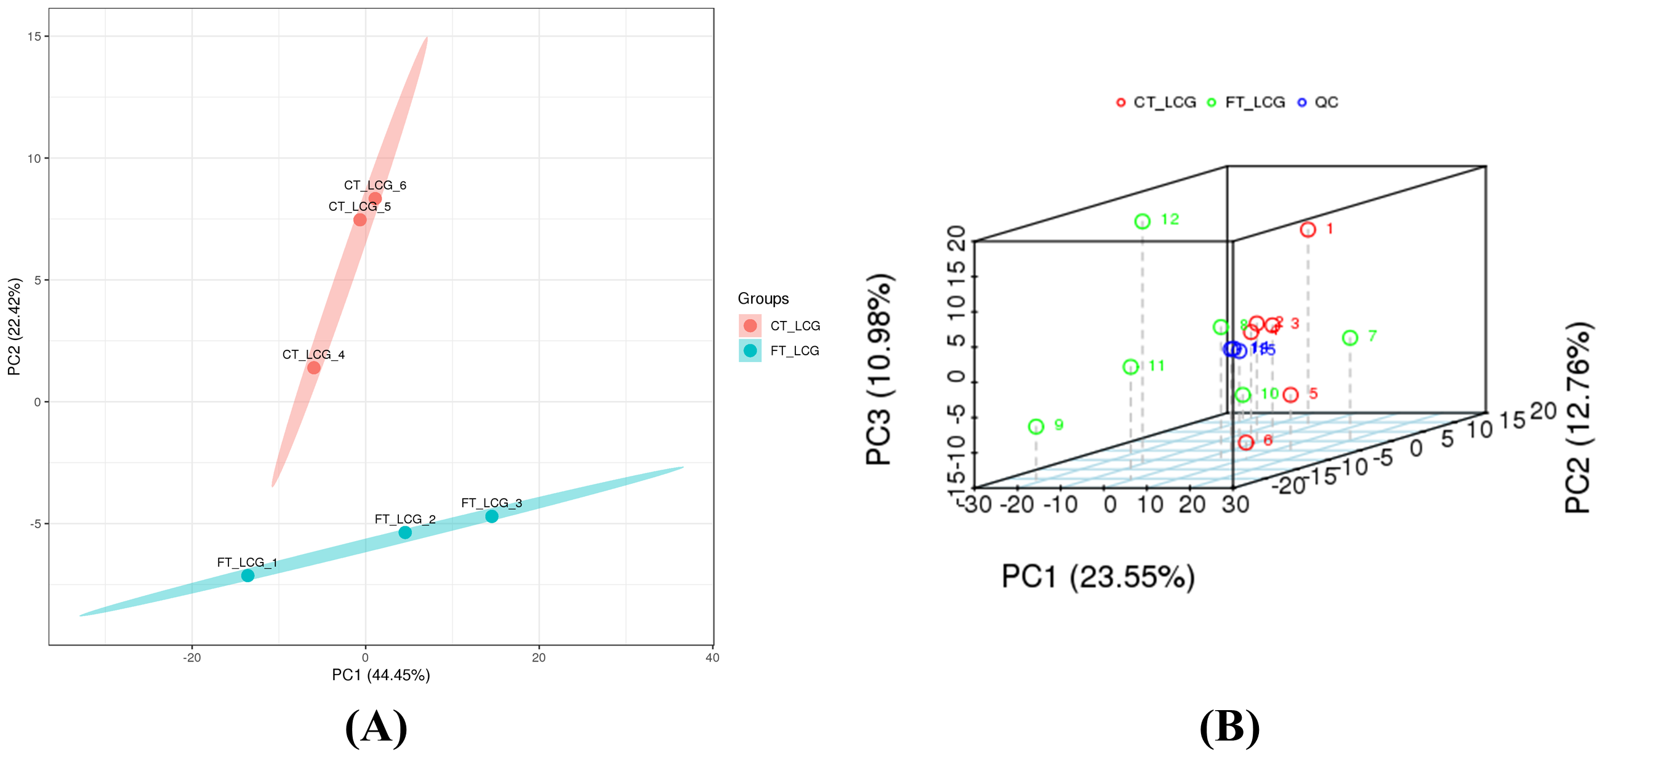

Fig. S1 PCA analysis. (A) PCA analysis of proteomics. Blue indicates FT_LCG and red indicates CT_LCG. (B) PCA analysis of metabolomics. Green indicates FT_LCG, red indicates CT_LCG, and blue indicates QC.

