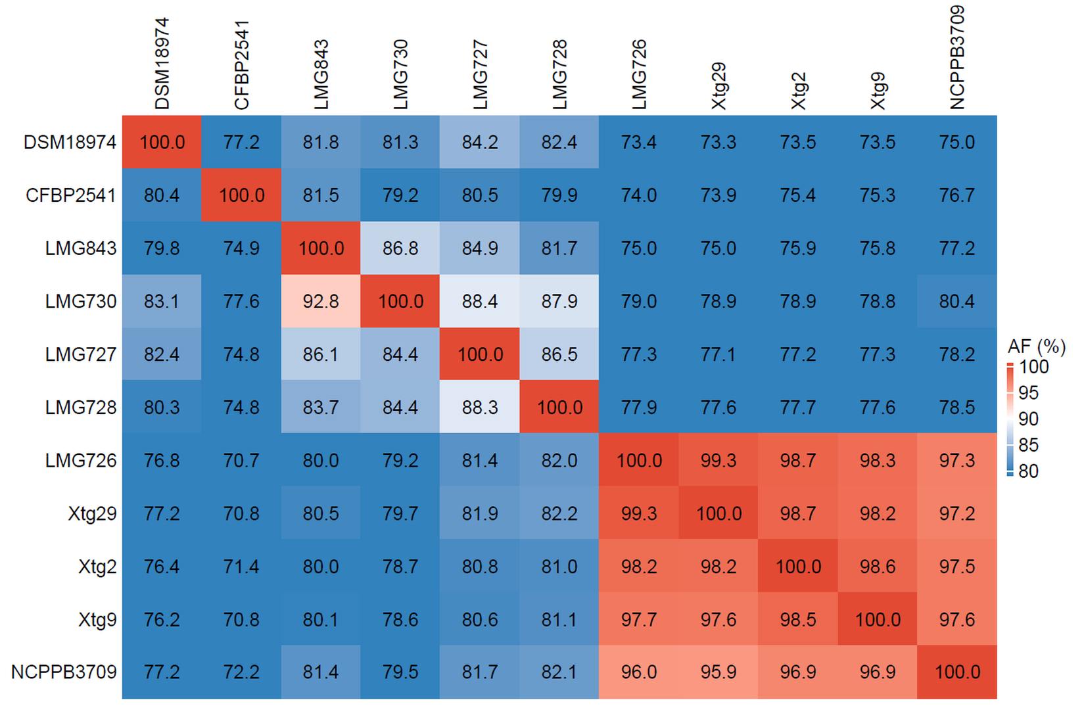
Figure S1 Alignment fraction (AF) used in each comparison for the ANI calculations

