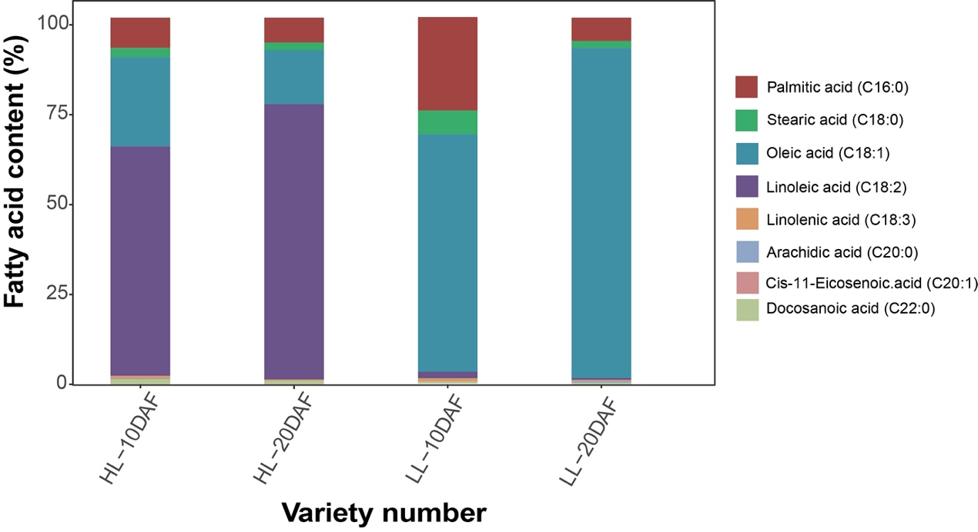
Fig.S1. Differences in the fatty acid content of safflower seeds at different developmental stages. DAF, days after flowering.

