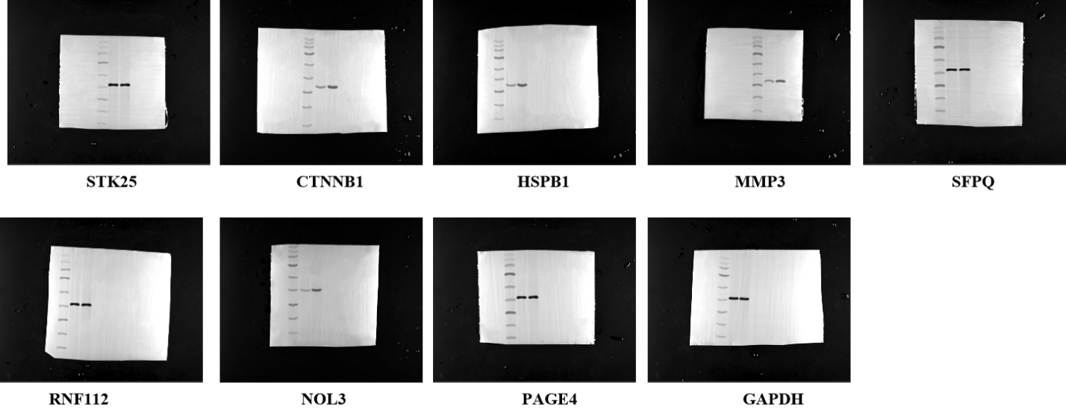
Figure 8. (A) Western blot was conducted to detect the protein expression of the 8 oxidative stress-related genes in indicated groups shown in the manuscript file.

