Sturgill et al., Supplementary Figure S1

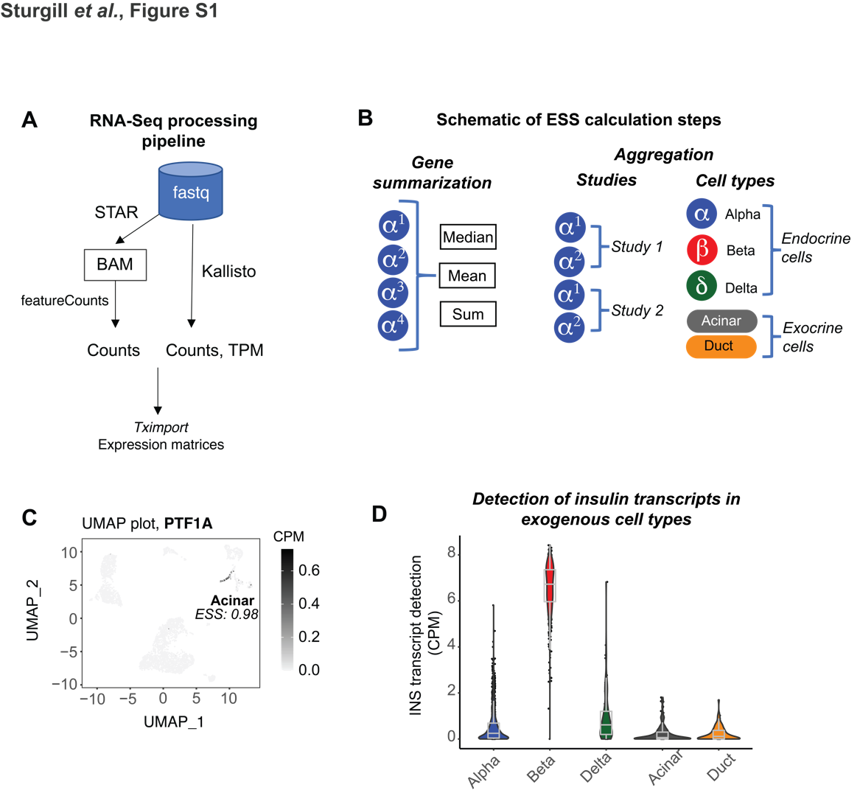

Figure S1: RNA-Seq processing and ESS details. (A) Schematic of scRNA-Seq primary quantitation pipeline. (B) Schematic of ESS calculation steps with variations. (C) UMAP plot showing acinar specific detection in a low-expressed gene. (D) Insulin transcript detection in each cell type. Outlier spots show detection of exogenous RNA

Sturgill et al., Supplementary Figure S2

Sturgill et al., Figure S2
Identification of studies via databases and repositories

Articles identified from Pubmed searching
(n = 128)
Data submissions identified on GEO
(n = 203)

Identification

Studies identified (>100 normal single cell samples)
(n = 9)

Screening

Studies excluded
(n = 3 )
Studies performed with full length protocols
(n = 6)

Studies included in review
(n = 6)

Included

Figure S2: PRISMA flow diagram for study selection

Sturgill et al., Supplementary Figure S3

Sturgill et al., Figure S3

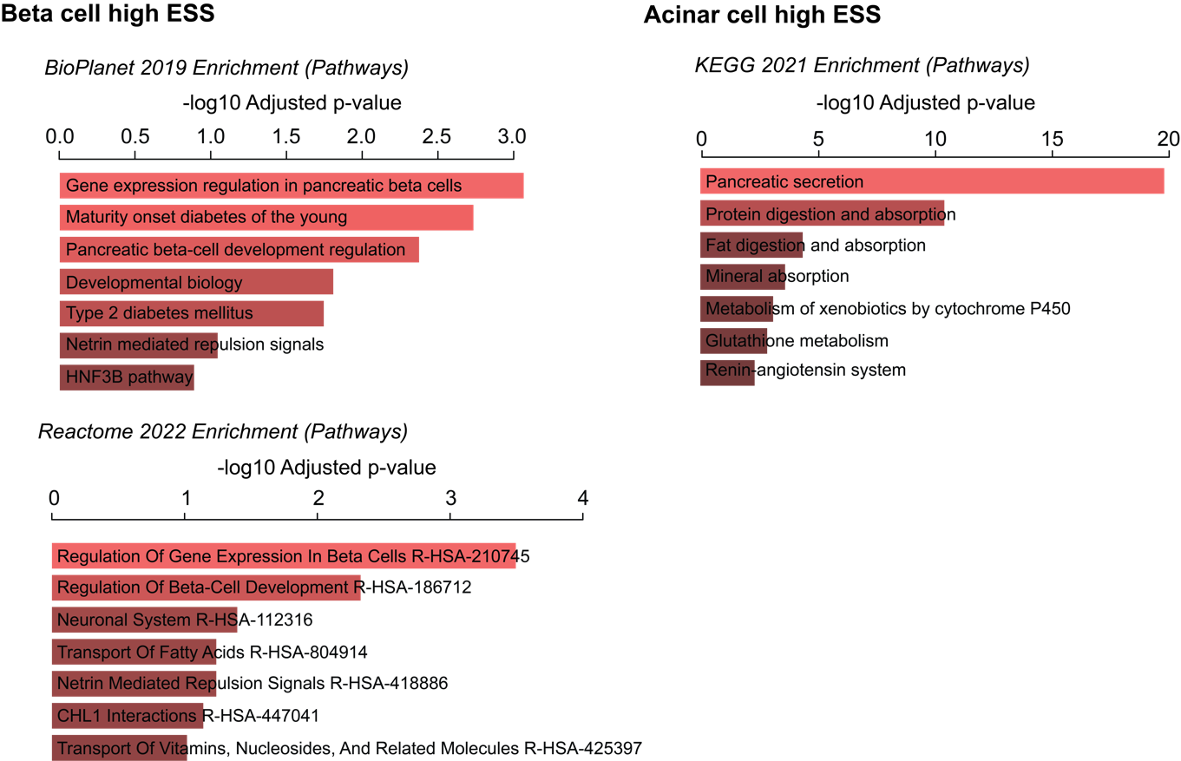

Figure S3: Functional annotation enrichment of high ESS genes. Functional enrichment results from the EnrichR tool (Chen et al., BMC Bioinformatics 2013), from the Ma’ayan Lab (https://maayanlab.cloud/Enrichr).

