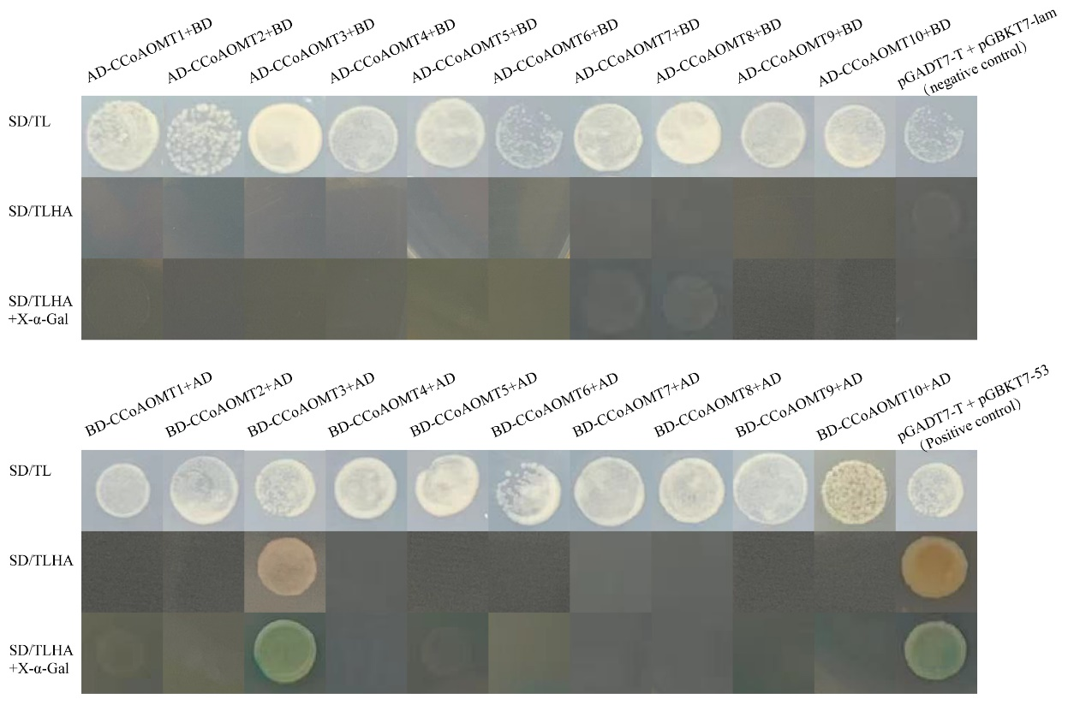
Fig.S1. Detection of CCoAOMT gene autoactivation
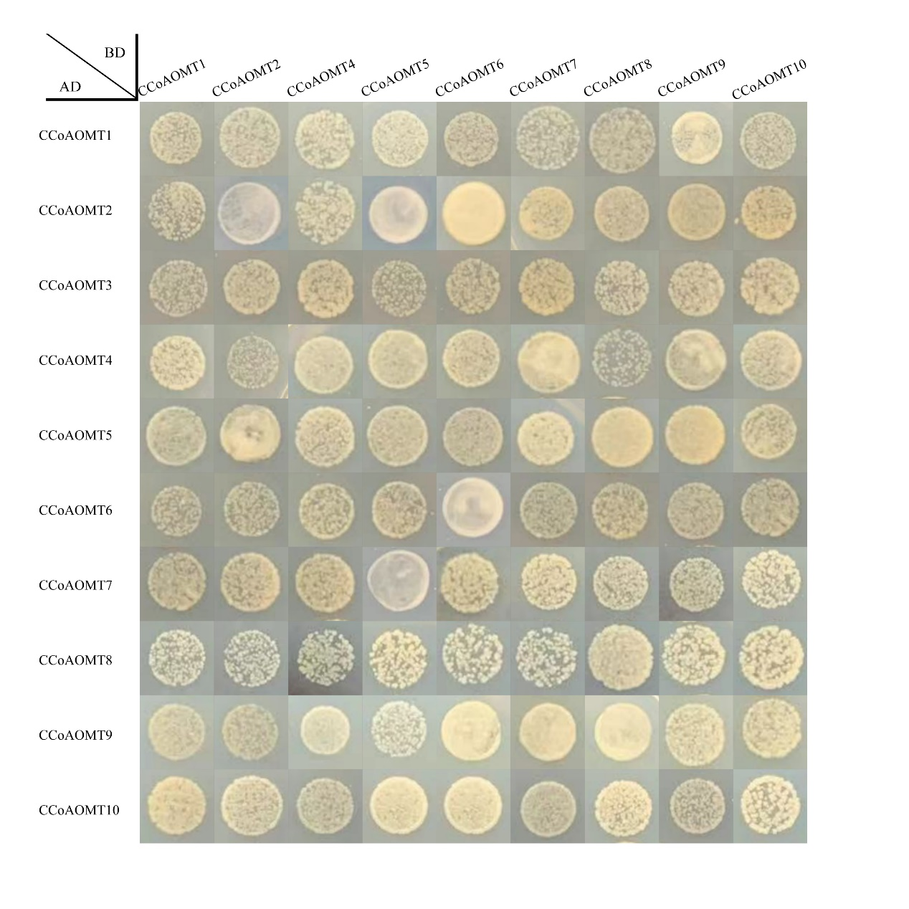
Fig.S2. The hybrid yeast cells were grown on DDO

