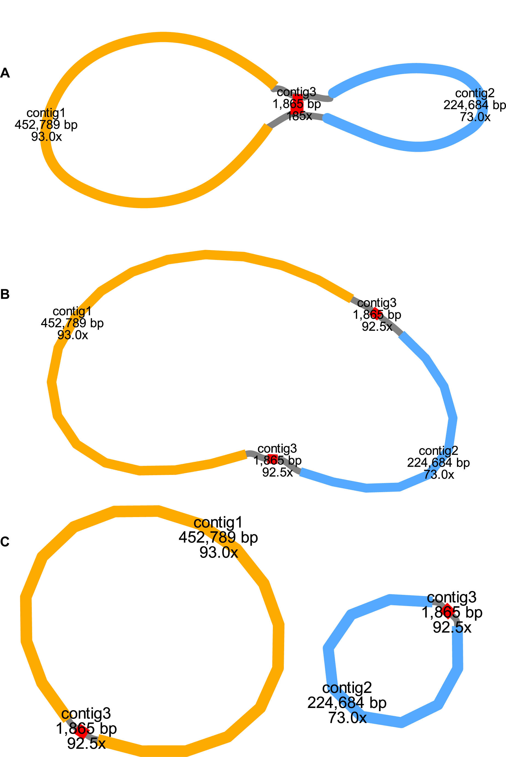

Supplementary figure 1: Construction of the mitochondrial genome assembly graph for Stewartia gemmata. (A) illustrates the preliminary draft of the mitochondrial genome. (B) describes the major circular conformation of the mitochondrial genome, while (C) explores potential alternative conformations of (B).
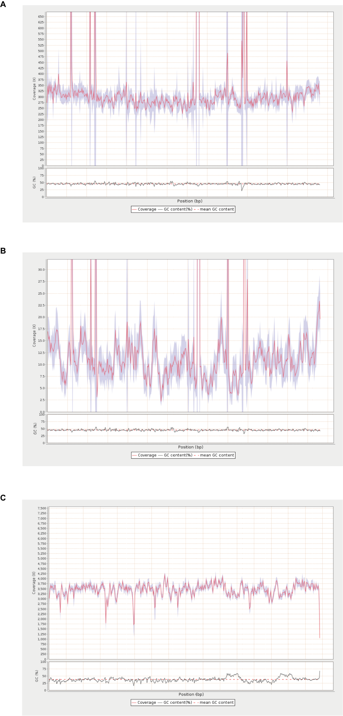
Supplementary figure 2: Depth of coverage of organelle genomes by sequenced sequences. (A), (B), and (C) show the depth of coverage of the genome by short-reads and long-reads mapped to the mitochondrial genome and short-reads mapped to the chloroplast genome, respectively.
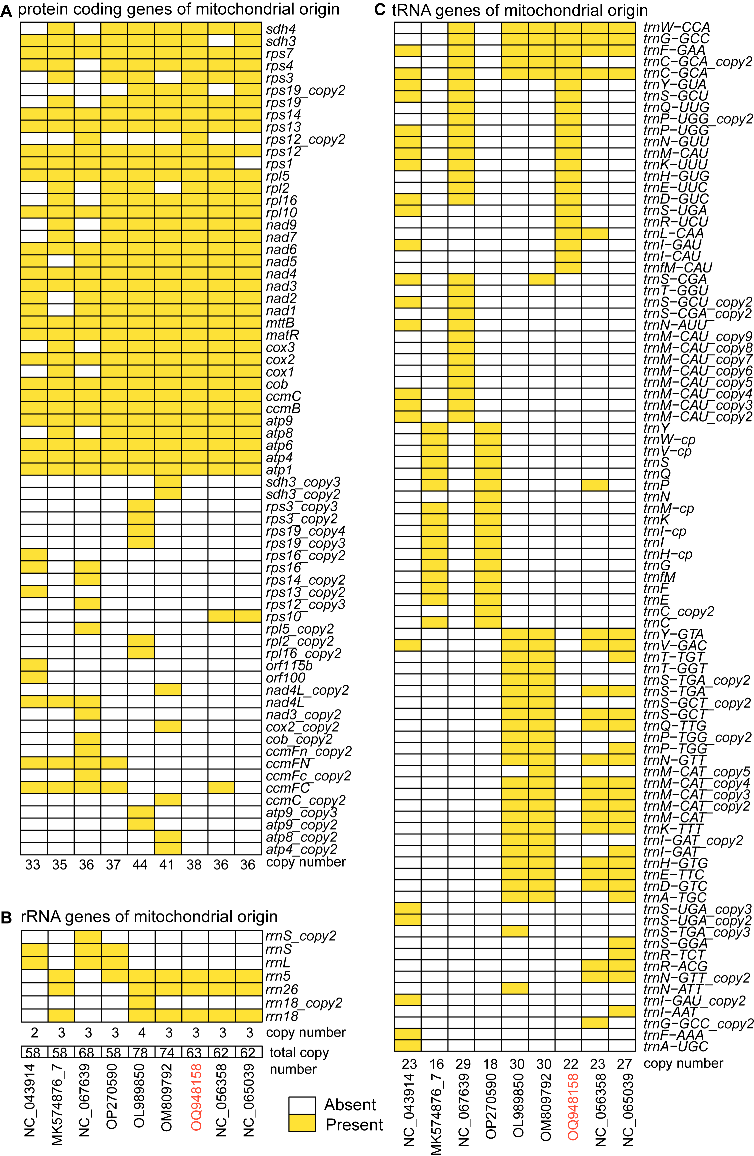
Supplementary figure 3: Comparative analysis of the gene content in mitochondrial genomes of representative species in Ericales. Displayed are protein-coding genes (A), rRNA genes (B), and tRNA genes (C). Yellow means one copy exists; white means no copy exists. The red font indicates the genome released in this study.
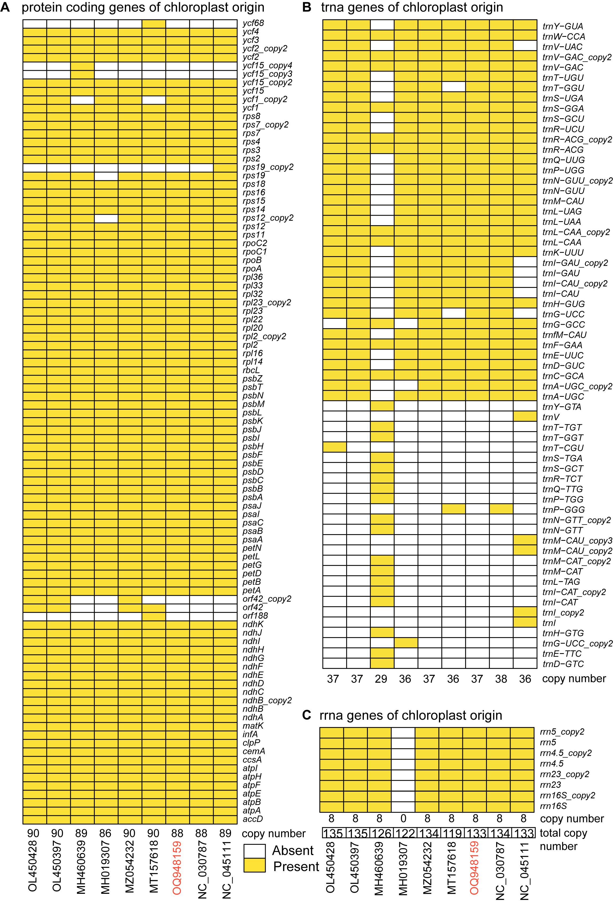
Supplementary figure 4: Comparative analysis of the gene content in chloroplast genomes of representative species in Ericales. Displayed are protein-coding genes (A), trRNA genes (B), and rRNA genes (C). Yellow means a copy exists, white means no copy exists. The red font indicates the genome released in this study.

MTPT1
mtDNA: 378,944-374,549
Length: 4,396 bp
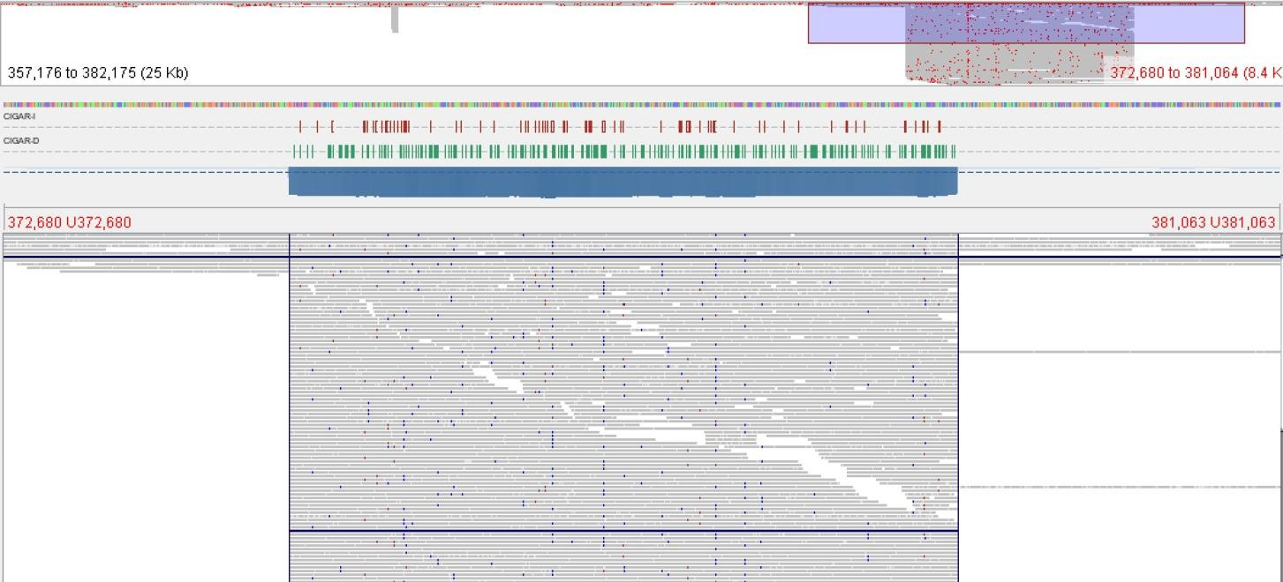
Plastid reads
Mitochondrial reads
MTPT1

MTPT7
mtDNA: 351,440-351,357
Length: 84 bp
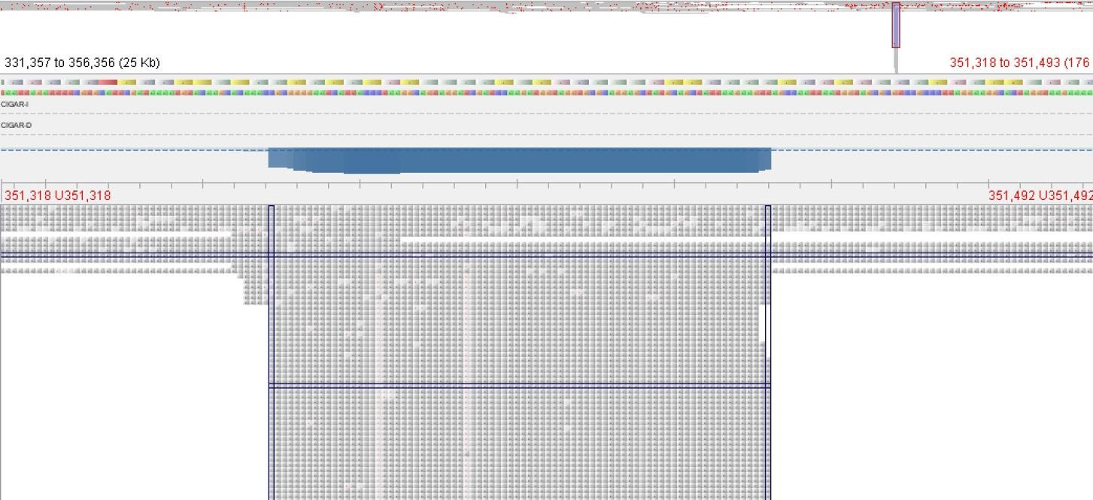
Mitochondrial reads
Plastid reads
MTPT7

MTPT8
mtDNA: 364,660-364,809
Length: 150 bp
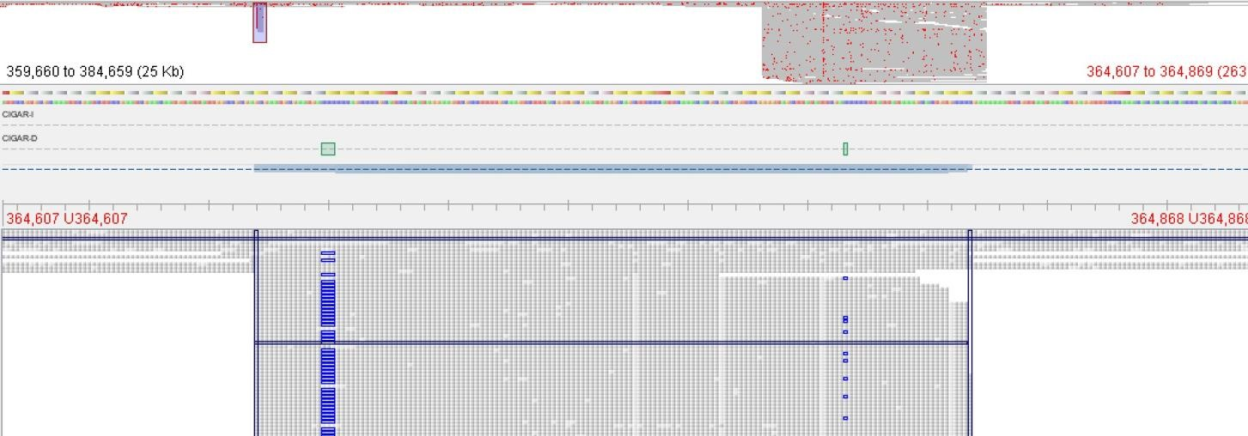
Mitochondrial reads
Plastid reads
MTPT8

MTPT11
mtDNA: 198,580-198,699
Length: 126 bp
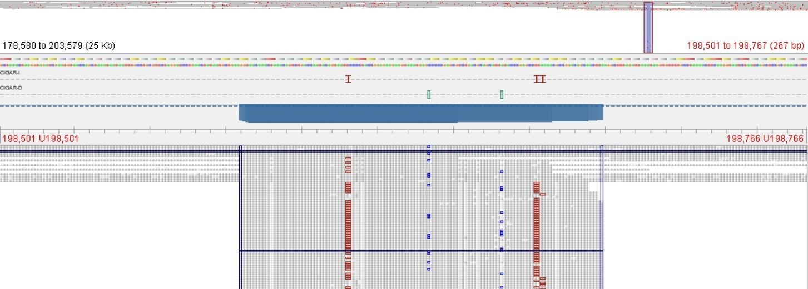
Mitochondrial reads
Plastid reads
MTPT11

MTPT13
mtDNA: 487,235-487,425
Length: 196 bp
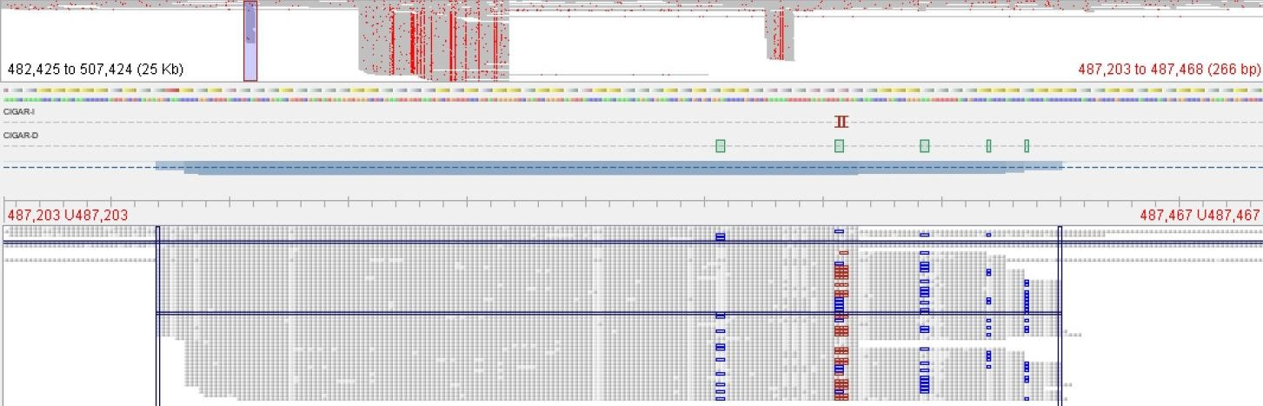
MTPT13
Mitochondrial reads
Plastid reads

MTPT14
mtDNA: 108, 235-108,725
Length: 504 bp
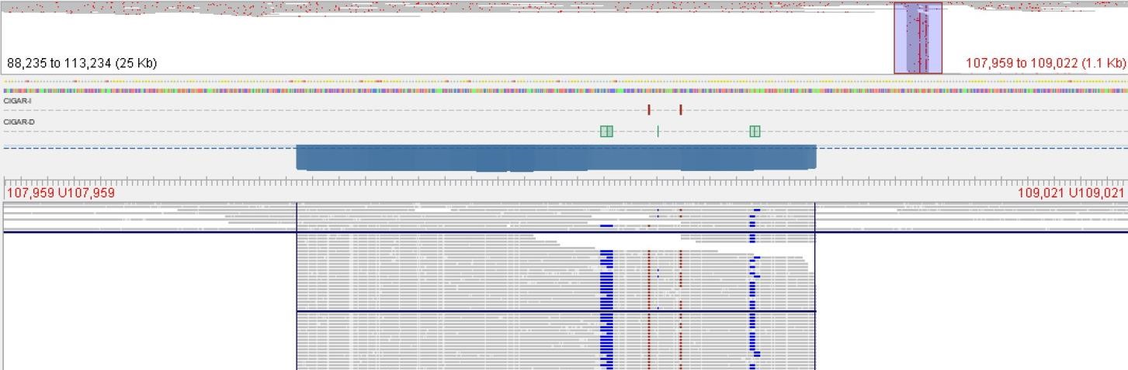
Mitochondrial reads
Plastid reads
MTPT14

MTPT15
mtDNA: 60,056-61,513
Length: 1,506 bp
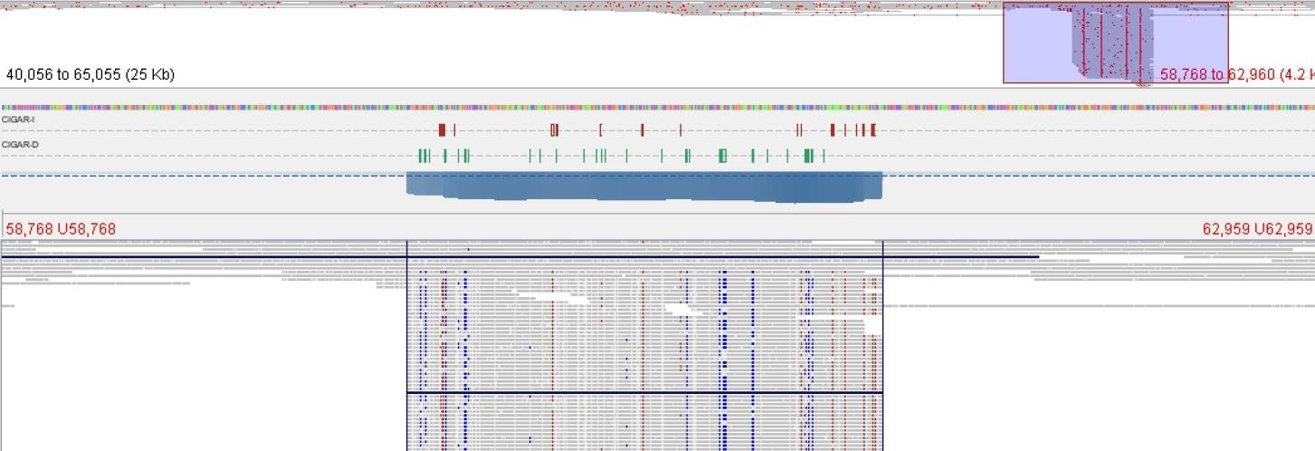
Mitochondrial reads
Plastid reads
MTPT15

MTPT16
mtDNA: 497,650-498,057
Length: 414 bp
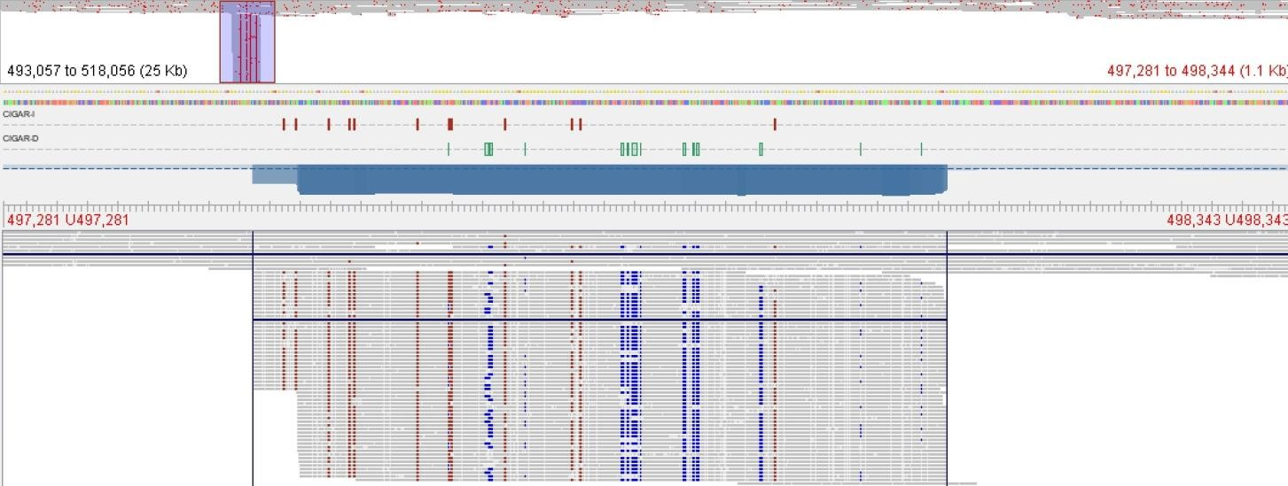
Mitochondrial reads
Plastid reads
MTPT16

MTPT17
mtDNA: 492,451-489,462
Length: 3,123 bp
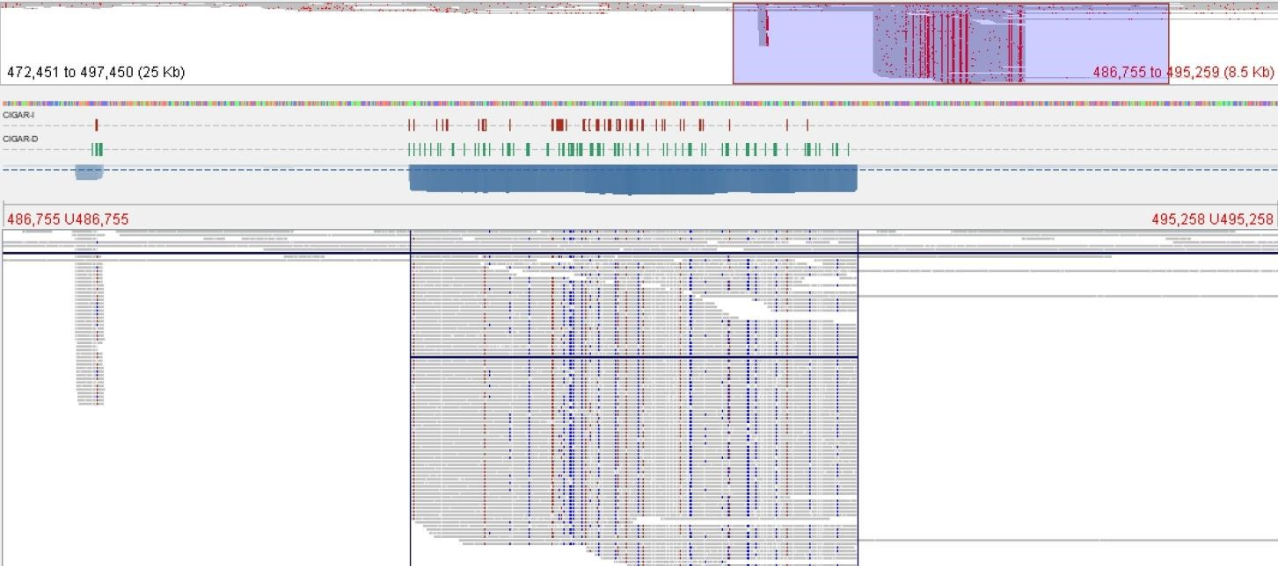
Mitochondrial reads
Plastid reads
MTPT17

Supplementary figure 5: Distribution of long-reads mapping of the MTPT (Mitochondrial plastid DNAs) region of the mitochondrial genome. The long-reads from chloroplasts and mitochondria are mapped onto the mitochondrial genome, and the corresponding regions mapped are observed. In the figure, mitochondrial reads can map to the MTPT and regions on both sides, while chloroplast reads can only map to the MTPT region and not to the regions on both sides. MTPTs below 80 bp in length are not shown here due to their short length. For each MTPT, the gray area indicates the region covered by the sequence and the dark blue line segments highlight the mitochondrial (top) and chloroplast (bottom) reads, respectively, as representative of the two reads.

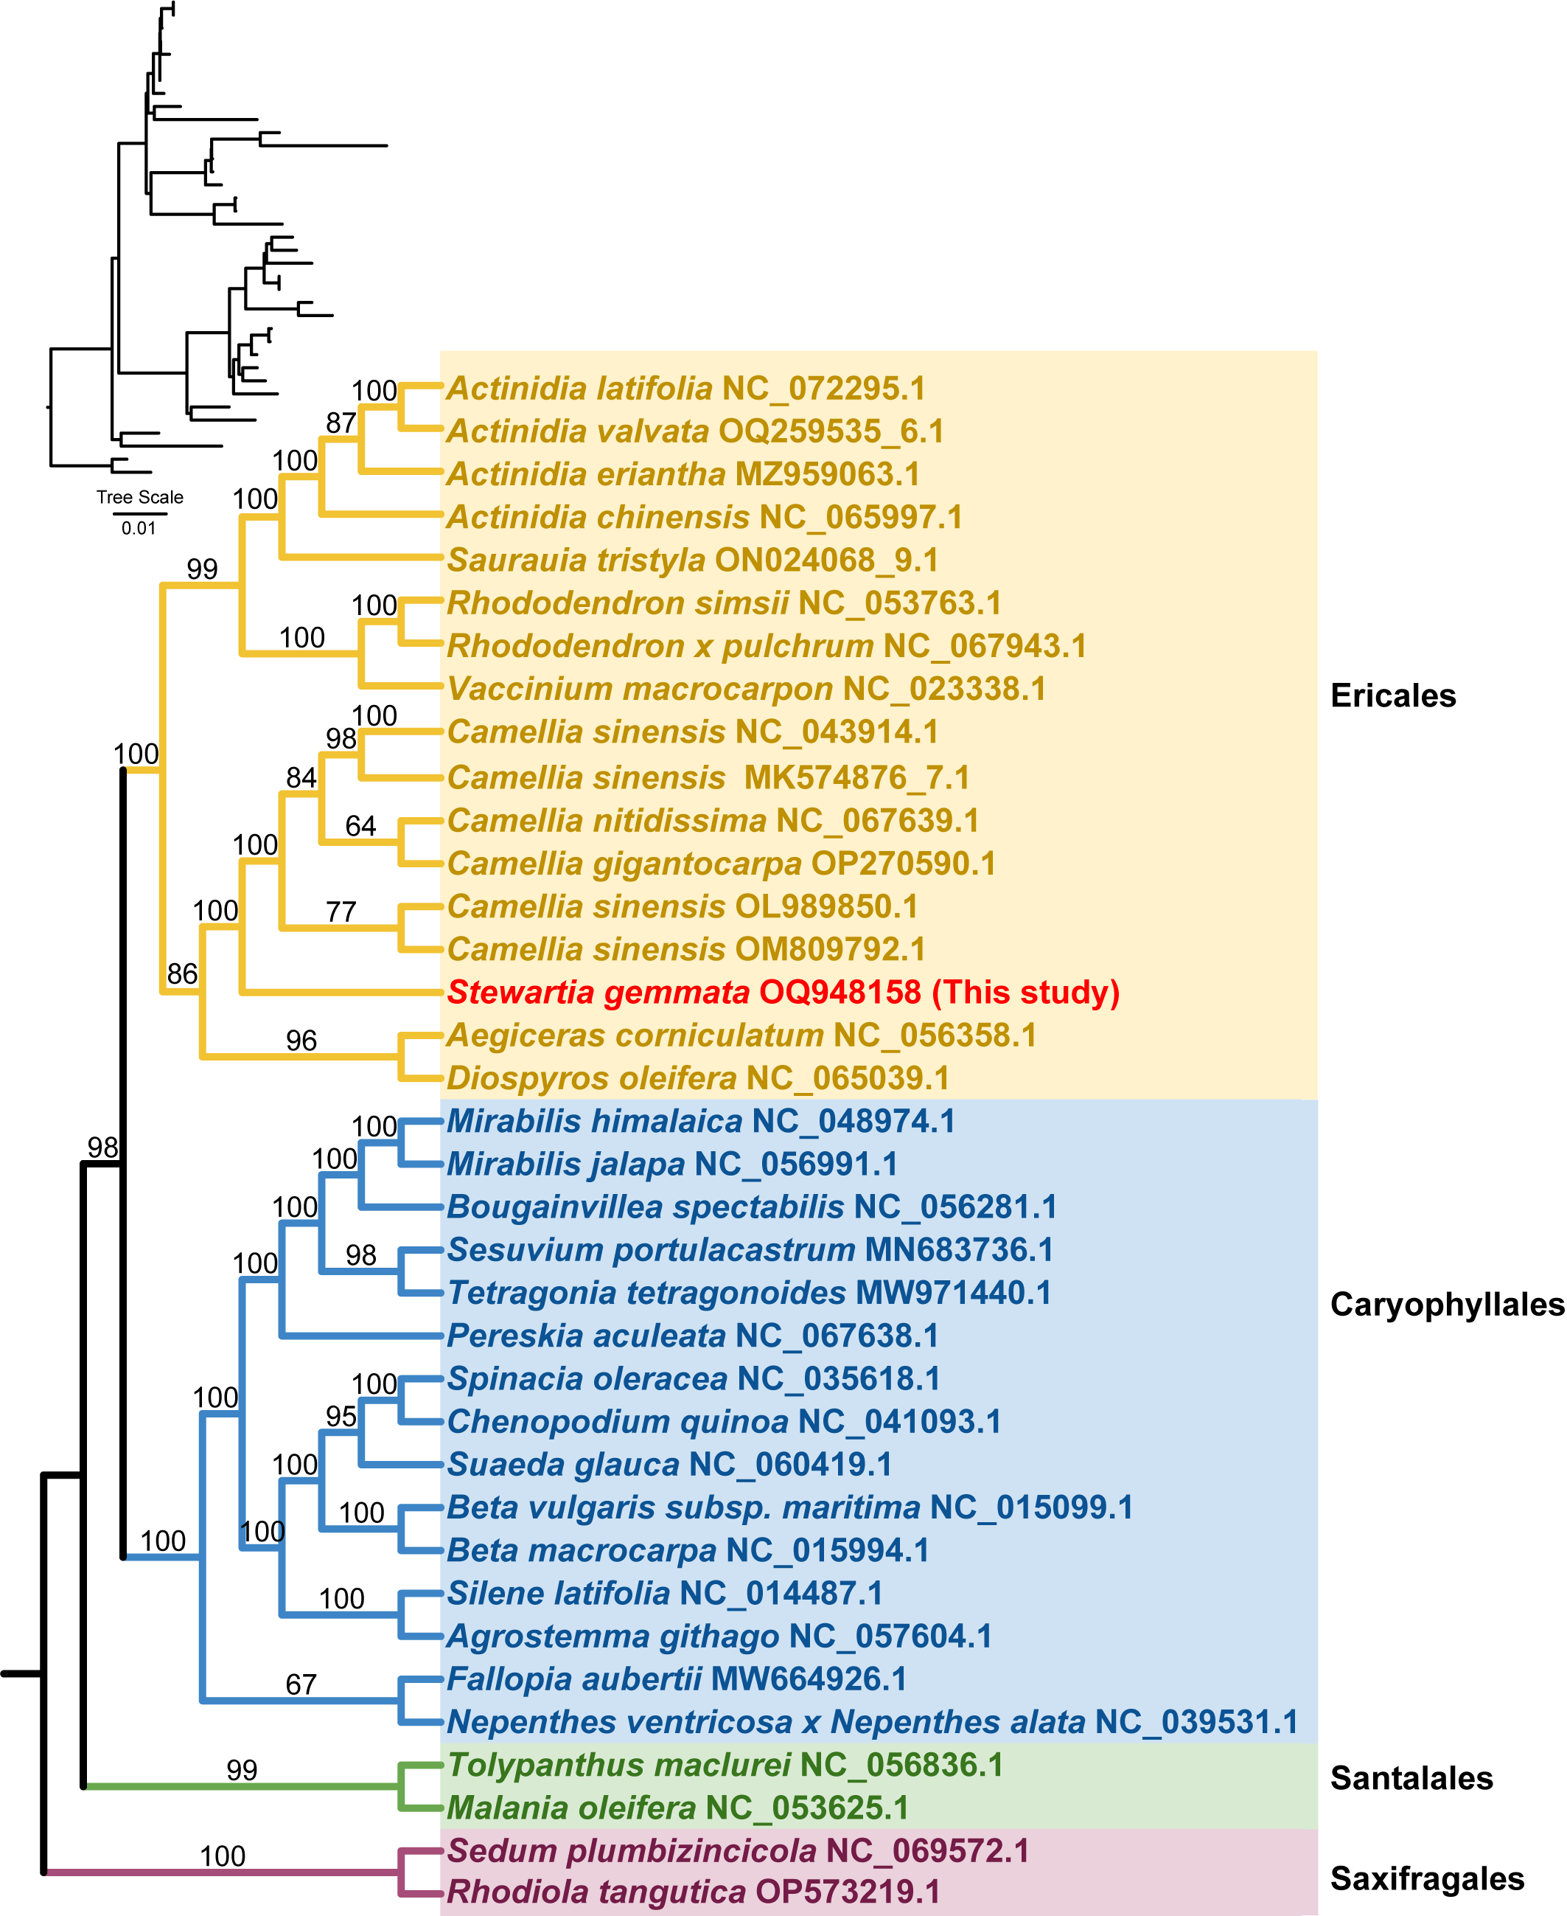

Supplementary figure 6: Best maximum likelihood phylogenetic tree based on mitochondrial genomes of 36 species (including seven species of Theaceae). Numbers above each branch are the maximum likelihood bootstrap of each clade >50%. The four different background colors indicate different orders, respectively. Red font indicates the species of this study. The top right corner is a tree with branch length information.

