Supplementary Figures

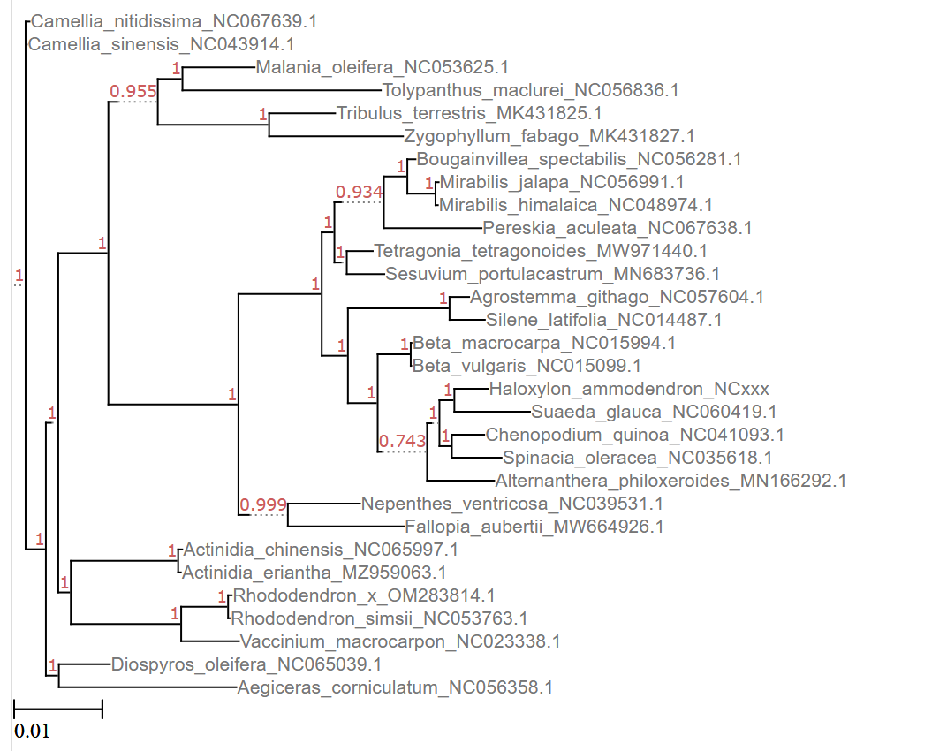

Figure S1. Bayesian-based phylogenetic tree. The Bayesian tree inference was conducted using the MrBayes tool based on a conserved gene set. Node support values are highlighted in red. The tree was inferred using the 4by4 model. The tree was visualized using etetoolkit online viewer http://etetoolkit.org/treeview/.

