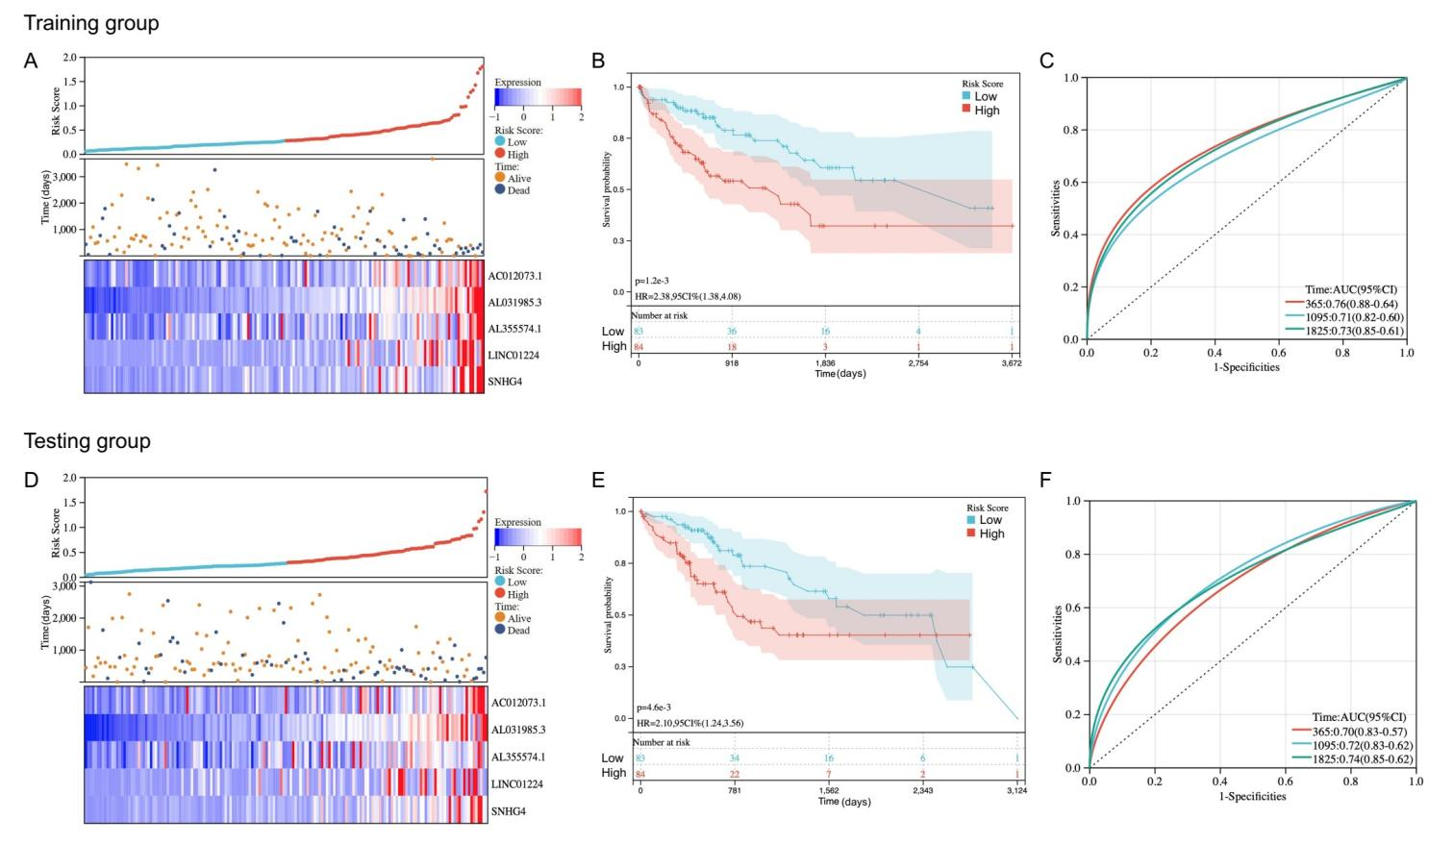
Figure S1. Evaluation and validation of the utility of the DDR-related lncRNAs signature. The distribution of the risk score and scatter plot of survival in the training (A) and testing group (D). K-M curve of the high- and low- risk group in the training (B) and testing group (E). Time-dependent ROC curve for the prognostic prediction of the risk model at 1-, 3-, and 5-year survival time in the training (C) and testing group (F).

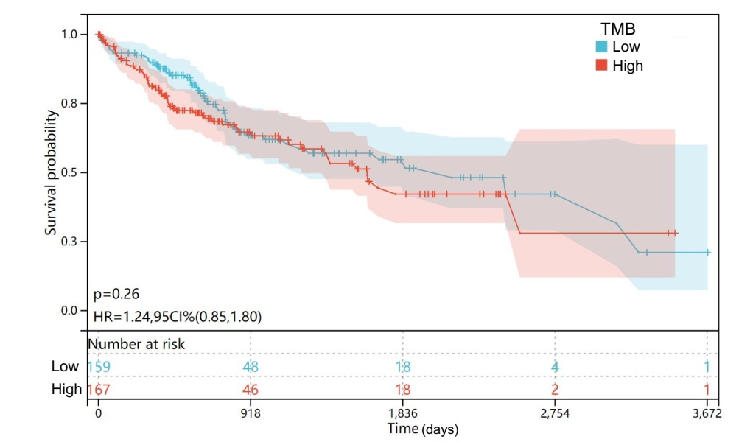
Figure S2. K-M curve of the high- and low- TMB groups.

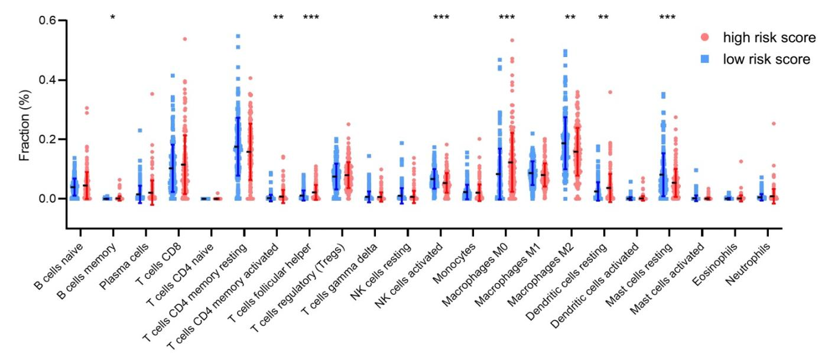
Figure S3. Comparison of the relative percentage of 22 immune cells estimated between the high- and low- risk groups.

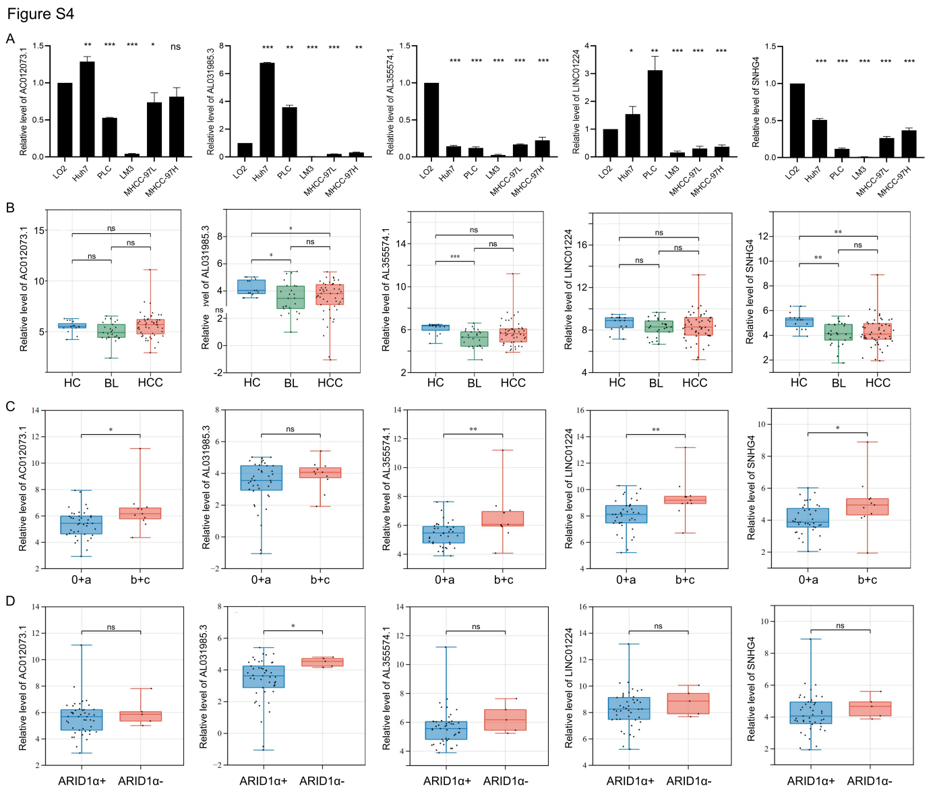
Figure S4. Evaluation of candidate lncRNAs using qRT-PCR. Expression analysis of lncRNAs in various cell lines (A) were normalized to GAPDH. Comparison of candidate lncRNAs in different groups (B), BCLC stage (C) and ARID1α status (D). *: P< 0.05, **: P< 0.01, ***: P< 0.001, ns: not significant.

