Supplemental Figure 1
Figure S1. Single-cell RNA-Seq of Lin28-YFP⁺ spermatogonia isolated from the testes of adult mice.
(A) Whole-mount immunostaining of LIN28A and YFP expression in seminiferous tubules of testes from Lin28-YFP knock-in mice at PD60. Scale bar=20 μm, n=3. (B) The proportion of A_{s}, A_{pr}, A_{al-4}, A_{al-8}, and A_{al-16} spermatogonial clones in seminiferous tubules of testes from 2-month-old mice and at least 1500 LIN28A⁺ spermatogonia were counted for each sample. n=4. (C) Immunostaining for LIN28A in FACS-sorted YFP cells from the Lin28-YFP mouse line. (D) Schematic diagram of single-cell RNA-seq of Lin28-YFP single cells from adult mice. (E) Count number, gene number, mitochondrial gene ratio, and red blood cell gene ratio of each cell in scRNA-seq. (F) The number and proportion of cells in each cluster in the t-SNE plot of Lin28-YFP⁺ cells after stringent quality control. (G) Volcano plot of DEGs in clusters 0-6 (adjusted p value <0.05; fold change >2). Red indicates upregulated genes, and blue indicates downregulated genes. (H) Expression patterns of representative marker gene of clusters 0-6 projected on the t-SNE plots.

Supplemental Figure 2
Figure S2. Lin28-YFP single cells contained a quiescent subpopulation.
(A) Quantifications of EdU⁺ spermatogonia in Lin28⁺ cells of testes collected 2 h and 5 days after EdU injection from 60-day-old mice. At least 1500 Lin28⁺ cells were counted for each time point. n = 5. ****p value < 0.0001. (B) Quantifications of EdU⁺ spermatogonia in A_{s} spermatogonia of Lin28⁺ cells of testes collected by EdU injection 2 h and 5 days from 60-day-old mice. At least 1500 LIN28⁺ cells were counted for each time point. n = 5. *p value < 0.05. (C) Whole-mount immunostaining of EdU and LIN28A in seminiferous tubules 2 h and 5 days after EdU injection. Scale bars = 100 μm, n=5. (D) Cell cycle analysis of Lin28-YFP single cells was performed using Seurat, reputation= t-SNE. G1, S and G2/M phases are indicated in the corresponding colors.

Supplemental Figure 3
Figure S3. Heatmap of cluster-specific genes in Lin28-YFP single cells.
Lin28-YFP single cells were mainly divided into different states according to the t-SNE gene expression profile. Cluster 8 was putative SSCs, cluster 9 was progenitors, and cluster 7 was differentiating spermatogonia. Top 10 enriched KEGG terms for each temporal cell type cluster (right).

Supplemental Figure 4
Figure S4. Undifferentiated spermatogonial-specific transcription regulators expressed in C8.
- Differential expression patterns of new genes from C8 of genes along developmental pseudotime trajectory. (B) Undirected regulon network generated from strongly correlated scores by transcription factor regulons prediction in C8. (C) Immunofluorescence of ZBTB16 and LIN28A (undifferentiated spermatogonia) costained with FOXF1, FOXC2, FOXP1 and EOMES in 6-day-old mouse testicular paraffin sections. Asterisks indicate colocalization. Scale bars=10 μm, n=3. (D) Statistical results of immunofluorescent colocation of FOXF1, FOXC2, FOXP1 and EOMES in A_{s}, A_{pr} and A_{al} spermatogonia of adult mice. At least 1000 LIN28A⁺ /ZBTB16⁺ cells were counted for each sample. n = 3.

Supplemental Figure 5
Figure S5. Regulon activity heatmap of C8. Heatmap of regulon activity scores. Hierarchically clustered regulons are listed on the left and top sides.
Supplemental Figure 6
Figure S6. Eomes⁺ spermatogonia act as SSCs after transplantation.
(A) Whole-mount immunostaining of EdU & LIN28A, KI67 & LIN28A, EdU & EOMES, and KI67 & EOMES in seminiferous tubules at 2 h after EdU injection at PD6. Scale bars=50 μm, n=3. (B) Whole-mount immunostaining of EdU & EOMES in seminiferous tubules 5 days after EdU injection at PD6 and PD60. Scale bars=50 μm/100 μm, n=3. (C) Statistical results of EdU & EOMES in seminiferous tubules after 5 days of EdU injection. At least 1000 LIN28A⁺ /EOMES⁺ cells were counted for each sample, ns means no significance. (D) Transplantation of Eomes-GFP-positive and Eomes-GFP-negative cells and after 2 months of recipient testes collection, (left) morphology of testicular tissue observed by H&E, (middle) germ cell staining to determine the origin of SSC and (right) red spermatozoa derived from Eomes-positive donor cells.

Supplemental Figure7

Figure S7. Eomes⁺ spermatogonia contained more quiescent cells than Lin28-YFP single cells. (A) Gene expression patterns of Eomes projected on the t-SNE plots in C8 of Lin28-YFP single cells. (B) t-SNE plot of integrated Lin28-YFP⁺ spermatogonia and Eomes-GFP⁺ spermatogonia. Each dot represents a single cell, and cell clusters are distinguished by colors. (C) Gene expression patterns of selected marker genes (Zbtb16 and Gfra1)projected on the t-SNE plots. (D) t-SNE plot of the integrated Lin28-YFP⁺ spermatogonia and Eomes-GFP⁺ spermatogonia single-cell data. Each point represents a cell. Points were colored according to cell type. (E) Cell cycle analysis of integrated Lin28-YFP⁺ spermatogonia and Eomes-GFP⁺ spermatogonia. G1, S and G2/M phases are indicated in the corresponding colors.The proportion of G1, S and G2/M phases cells in different cell types were shown in the table.

Supplemental Figure8
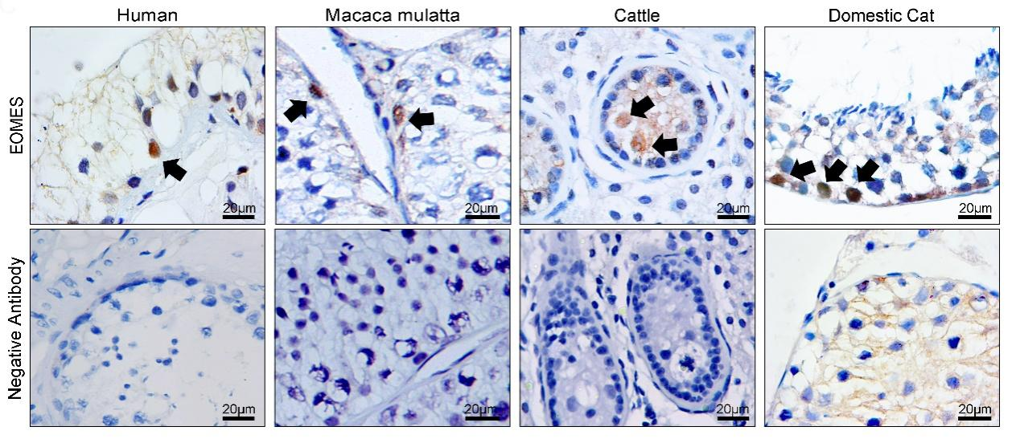
Figure S8. Distribution of Eomes⁺ spermatogonia in the testes of different species. Eomes+ cells were detected in the testes of humans, monkeys, cattle, and cats. Arrowheads show localization of signal to Eomes⁺ spermatogonia. Scale bars=20 μm.

Supplemental Figure 9
Figure S9. Eomes deletion in the germline did not affect steady-state spermatogenesis.
(A) Immunofluorescent costaining for ZBTB16 with EOMES in cross-sections of testes from adult Eomes-cKO mice. Scale bar=100 μm, n=3. (B) Immunofluorescent costaining for GCNA1 or LIN28A with SOX9 in cross-sections of testes from adult control and Eomes-cKO mice. Scale bars=100 μm, n=3. (C) The numbers of germ cells (GCNA1⁺) or undifferentiated spermatogonia (LIN28A⁺) per 500 Sertoli cells (SOX9⁺). At least 500 SOX9⁺ cells were counted for each sample, ns means no significance, n=3.

Supplemental Figure10
Figure S10. Effects of forced Eomes expression on spermatogenesis in mice.
(A) Schematic diagram of the transgene used for generating the conditional Eomes overexpression model. Cre-mediated recombination of the LoxP sites removes the stop cassette and activates Eomes expression under the direction of the CAG promoter. (B) Whole-mount immunofluorescent staining for EOMES in seminiferous tubules of Eomes-cOE mice. Scale bar=50 μm, n=3. (C) Relative concentration of Eomes transcripts in the testes of control and Eomes-cOE mice. Data are mean ± s.e.m. for 7 independent experiments. ***p value <0.001. (D) Immunofluorescence staining for the germ cell markers VASA and EOMES in testicular cross-sections from Eomes-cOE mice. Scale bars=50 µm, n=3. (E) Hematoxylin and eosin (H&E)-stained sperm from control and Eomes-cOE mice at PD90. Scale bars=50 μm, n=3. (F) Quantifications of EdU⁺ cells in LIN28A⁺ spermatogonia using whole mount staining of Eomes-cOE testes. At least 1500 LIN28A⁺ cells were counted for 3 independent experiments. *p value < 0.05, n=3.

Supplemental Figure 11
Figure S11. Forced Eomes overexpression in the germline impaired spermatogenesis beginning at PD8.
(A) Histological analysis and immunofluorescent costaining for GCNA1 or LIN28A with SOX9 in testicular cross-sections from testes of control and Eomes-cOE mice at PD0. Scale bars=10 µm, n=3. (B) Quantification of GCNA1⁺ cells and LIN28A⁺ cells per 500 SOX9⁺ cells supported at PD0. At least 500 SOX9⁺ cells were counted for each sample, ns means no significance, n=3. (C) Histological analysis and immunofluorescent costaining for GCNA1 or LIN28A with SOX9 in testicular cross-sections from testes of control and Eomes-cOE mice at PD8. Scale bars=10/20 µm, n=3. (D) Quantification of GCNA1⁺ cells and LIN28A⁺ cells per 500 SOX9⁺ cells at PD8. At least 500 SOX9⁺ cells were counted for each sample, n=3. **p value<0.01. (E) Immunofluorescent costaining for LIN28A and TUNEL (TdT-mediated dUTP nick-end labeling) in cross-sections of testes from control and Eomes-cOE mice at different developmental stages. Scale bars=10/50 µm, n=3. (F) Quantification of TUNEL⁺ cells per 100 LIN28A⁺ undifferentiated spermatogonia at different developmental stages. At least 500 SOX9⁺ cells were counted for 3 independent biological samples, *p value <0.05 and ****p value <0.0001.

Supplemental Figure 12

Figure S12. The proliferation of Eomes⁺ spermatogonia after busulfan-induced testicular injury.
(A) The ratios of EdU⁺ EOMES⁺ cells in testes from mice at different times were treated with busulfan (20 mg/kg body weight). Data are mean±s.e.m. for three independent experiments. At least 200 EOMES⁺ cells were counted for each sample. ****p value < 0.0001. n=3.(B) The ratios of KI67⁺EOMES⁺ cells in testes from mice at different times were treated with busulfan (20 mg/kg body weight). Data are mean±s.e.m. for three independent experiments. At least 200 EOMES⁺ cells were counted for each sample. ***p value<0.001 and ****p value < 0.0001. n=3.

Supplemental Figure13
Figure S13.Single-cell RNA-Seq of Eomes⁺ spermatogonia isolated from the testes of adult mice.
(A) Count number, gene number, mitochondrial gene ratio, and red blood cell gene ratio of each cell in scRNA-seq of Eomes+ spermatogonia from control (Eomes-Ctr) . (B) Count number, gene number, mitochondrial gene ratio, and red blood cell gene ratio of each cell in scRNA-seq of Eomes+ spermatogonia from busulfan treatment day8 mice(Eomes-TM) (C) t-SNE plot of Eomes+ spermatogonia clusters from Eomes-Ctr defined by scRNA-seq analysis. Each dot represents a single cell, and clusters are marked by different colors. (D) t-SNE plot of Eomes+ spermatogonia clusters from Eomes-TM defined by scRNA-seq analysis. Each dot represents a single cell, and clusters are marked by different colors. (E) Violin plots of SSC, progenitor and differentiated spermatogonial markers in different clusters of integrated Eomes+ spermatogonia from Eomes-Ctr and Eomes-TM.

