Additional File 3. Supplementary Figures and Tables
Figure S1
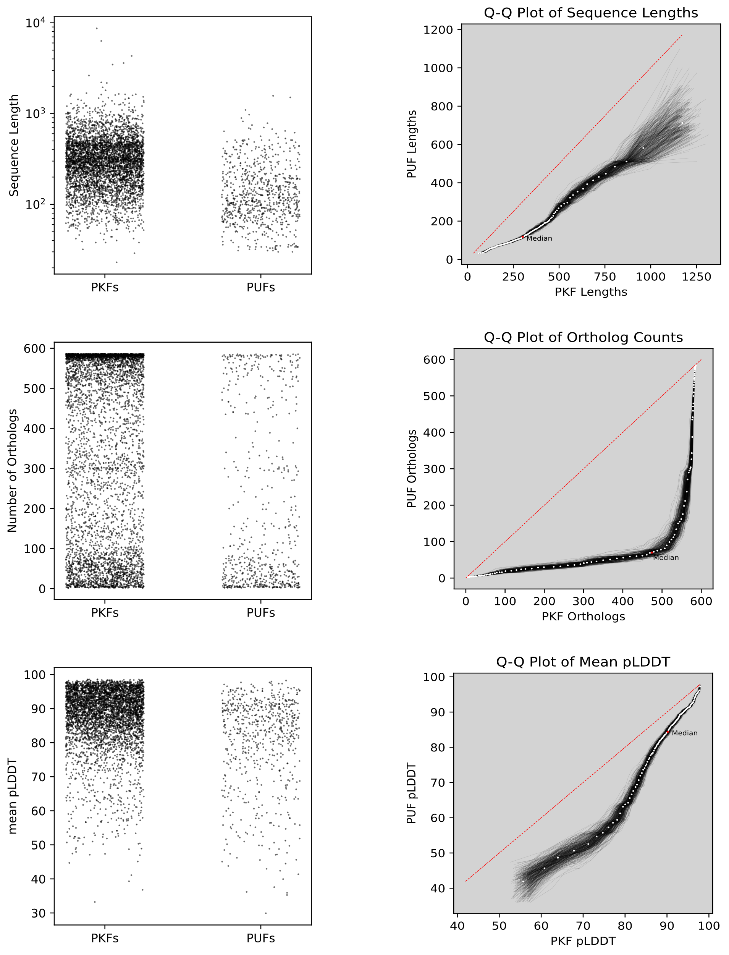
On the left are plotted individual PUF metrics. On the right are quantile-quantile plots of the same data. White dots represent measured values black lines represent bootstrap resamples.
Figure S2
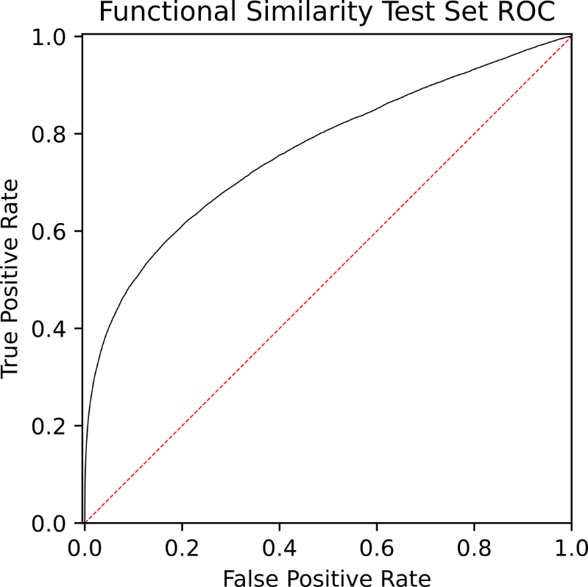
ROC curve for the functional similarity predictive model (see Fig 1B). Area under the curve is 0.77.
Figure S3
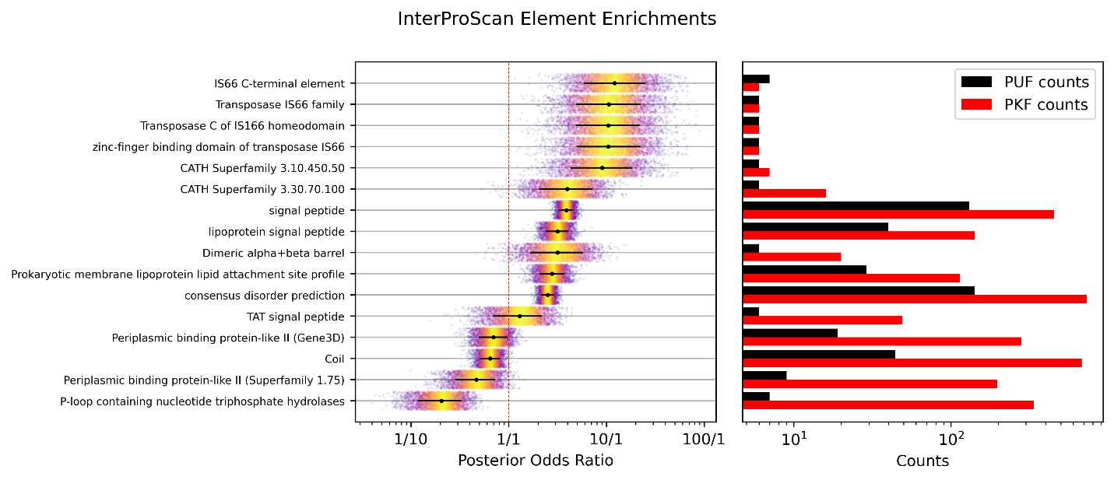
Results of the enrichment model for InterProScan features using the same model as the GO enrichement analysis. On the left are plotted samples from the posterior distribution of odds ratios for each element with at least 6 observations in each condition. Black dots represent the median of the posterior and black lines represent 0.1-0.9 quantiles. On the right are plotted the number of proteins annotated with each element.
Table S1
GOREF number | GOREF name | Count
GO_REF-0000108 | Automatic assignment of GO terms using logical inference, based on on inter-ontology links. | 1040
GO_REF-0000003 | Gene Ontology annotation based on Enzyme Commission mapping | 1111
GO_REF-0000002 | Gene Ontology annotation through association of InterPro records with GO terms. | 11453
GO_REF-0000038 | OBSOLETE Gene Ontology annotation based on automatic assignment of UniProtKB keywords in UniProtKB/TrEMBL entries. | 7386
GO_REF-0000104 | Electronic Gene Ontology annotations created by transferring manual GO annotations between related proteins based on shared sequence features. | 4719
GO_REF-0000041 | Gene Ontology annotation based on UniPathway vocabulary mapping. | 358
GO_REF-0000037 | OBSOLETE Gene Ontology annotation based on manual assignment of UniProtKB keywords in UniProtKB/Swiss-Prot entries. | 2873
GO_REF-0000039 | OBSOLETE Gene Ontology annotation based on the manual assignment of UniProtKB Subcellular Location terms in UniProtKB/Swiss-Prot entries. | 347
GO_REF-0000040 | OBSOLETE Gene Ontology annotation based on the automatic assignment of UniProtKB Subcellular Location terms in UniProtKB/TrEMBL entries. | 384
GO_REF-0000024 | Manual transfer of experimentally-verified manual GO annotation data to orthologs by curator judgment of sequence similarity. | 8
A summary of the evidence used in Biocyc GO annotations. Count refers to the number of GO terms supported with each evidence code.
Table S2
ECO number | ECO name | Count
ECO:0000259 | match to InterPro member signature evidence used in automatic assertion | 10362
ECO:0000136 | nucleic acid binding evidence | 1
ECO:0000096 | electrophoretic mobility shift assay evidence | 1
ECO:0000044 | sequence similarity evidence | 2
ECO:0000250 | sequence similarity evidence used in manual assertion | 4
ECO:0000016 | loss-of-function mutant phenotype evidence | 11
ECO:0000315 | mutant phenotype evidence used in manual assertion | 13
ECO:0000314 | direct assay evidence used in manual assertion | 2
ECO:0000012 | functional complementation evidence | 4
ECO:0000005 | enzymatic activity assay evidence | 3
ECO_0000024 | protein binding evidence | 2
A summary of the evidence used in the Pseudomonas Genome Database GO annotations. Count refers to the number of GO terms supported with each evidence code.
Table S3
ECO number | ECO name | Count
ECO:0000305 | curator inference used in manual assertion | 346
ECO:0000269 | experimental evidence used in manual assertion | 535
ECO:0000303 | author statement without traceable support used in manual assertion | 66
ECO:0000312 | imported information used in manual assertion | 51
ECO:0007744 | combinatorial computational and experimental evidence used in manual assertion | 140
ECO:0000255 | match to sequence model evidence used in manual assertion | 8378
ECO:0007829 | combinatorial computational and experimental evidence used in automatic assertion | 1045
ECO:0000353 | physical interaction evidence used in manual assertion | 41
ECO:0000314 | direct assay evidence used in manual assertion | 55
ECO:0000250 | sequence similarity evidence used in manual assertion | 483
ECO:0000315 | mutant phenotype evidence used in manual assertion | 27
ECO:0000256 | match to sequence model evidence used in automatic assertion | 31063
ECO:0000313 | imported information used in automatic assertion | 39931
ECO:0000259 | match to InterPro member signature evidence used in automatic assertion | 4218
ECO:0008006 | deep learning neural network method evidence used in automatic assertion | 800
ECO:0000270 | expression pattern evidence used in manual assertion | 1
A summary of the evidence used in Uniprot GO annotations. Count refers to the number of GO terms supported with each evidence code.
Table S4
Guilt by Association Similarity Model
STRING: coexpression transferred
STRING: combined score
STRING: cooccurence
STRING: database transferred
STRING: database
STRING: experiments transferred
STRING: fusion
STRING: homology
STRING: neighborhood transferred
STRING: neighborhood
STRING: textmining transferred
STRING: textmining
bitscore
proteomic coexpression
proteomic cooccurence
sequence feature similarity
TM-score
Robinson-Foulds tree similarity
number of shared taxa
shared operon
The vector of scores used in the protein-protein similarity model for the guilt by association arm of the analysis.
Table S5
Guilt by Association Term Transfer Model
Similarity Measure | Summary Statistics
STRING: coexpression transferred | sum, max
STRING: combined score | sum, max
STRING: cooccurence | sum, max
STRING: database transferred | sum, max
STRING: database | sum, max
STRING: experiments transferred | sum, max
STRING: fusion | sum, max
STRING: homology | sum, max
STRING: neighborhood transferred | sum, max
STRING: neighborhood | sum, max
STRING: textmining transferred | sum
STRING: textmining | sum, max
bitscore | sum, max
proteomic coexpression | sum, min
proteomic cooccurence | sum
sequence feature similarity | sum, min
TM-score | sum, max
Robinson-Foulds tree similarity | sum, max
number of shared taxa | sum
shared operon | count
number of hits | -
Summary statistics used as prediction features for the guilt by association annotation model.
Table S6
Structural Similarity Term Transfer Model
Similarity Measure | Summary Statistics
TM-score | sum, max
RMSD | min, mean
% sequence ID | sum, max
% non-gap | sum, max
is eukaryote | any, all
phylogenetic similarity | min, mean
number of hits | -
Summary statistics used as prediction features for the structural similarity annotation model.
Table S7
Protein | Hypothesized Function
PP_2483 | Nucleotidyl Transferase
PP_1372 | DNA Translocase
PP_4312 | Phosphotase
PP_4586 | M1 Peptidase
PP_27447 | Long Chain Fatty Acid CoA Ligase
PP_2666 | Phosphotase, Reductase, or Hydrolase
PP_2447 | Peptidase
PP_0512 | Pilotin
PP_0717 | Ferratin
PP_3777 | Methyltransferase
PP_2099 | Ribosomal Binding Protien
PP_2200 | DinB DNA Polymerase or Thiol S-Transferase
PP_3784 | Chorismatase
PP_3785 | WD-40 Fold Scaffold Protein
PP_3787 | Chalcone Synthase
PP_5628 | Acyl Carrier Protein
PP_3800 | Pilin
PP_4969 | Chitooligosaccharide Deacetylase
PP_0576 | Porin, possibly involved in biofilm formation
PP_2007 | P-47 like Lipid Binding Protein
PP_2363 | CsuE like Biofilm Forming Protein
PP_2853 | FapF like Biofilm Amyloid Exporter
PP_3350 | Porin
PP_3954 | Periplasmic Substrate Binding Protein
PP_5531 | DinB Superfamily Metalloenzyme
Hypothesized functions based on a manual analysis of the data collected for both predictive models and visualizations of RUPEE hit structural alignments using the PDB pairwise structural alignment tool.

