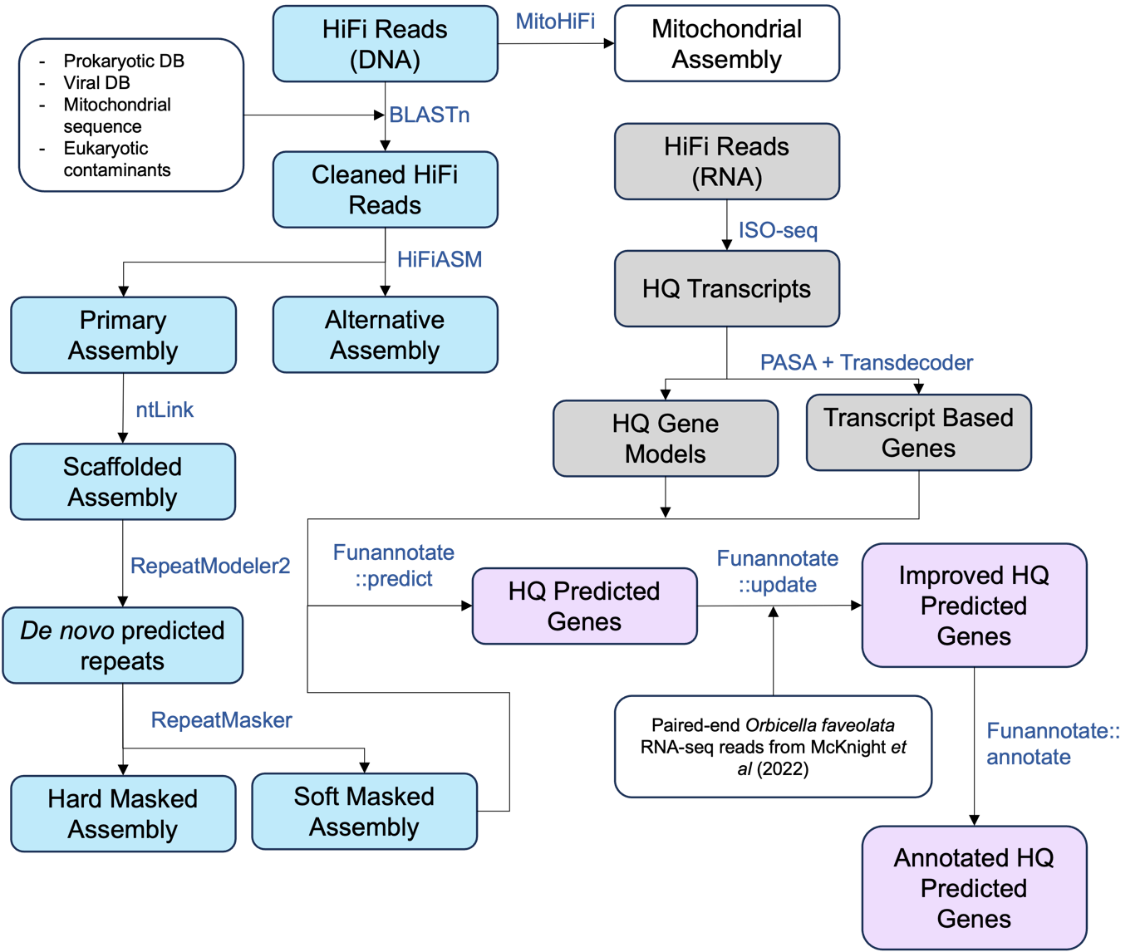

Supplementary Figure 3 - Bioinformatic pipeline for de-novo genome and transcriptome assembly
Full bioinformatic pipeline for genome (blue boxes), transcriptome (gray boxes), and their annotation (purple boxes). Blue filled boxes show raw DNA HiFi reads through to soft and hard masked de-novo genome assemblies. Grey filled boxes show RNA HiFi reads used to generate high quality gene models and transcript-based genes. Purple filled boxes show gene prediction, updating, and annotation using outputs from the blue (DNA) and gray (RNA) processing pipelines. White fill boxes show additional input/output datasets used/generated during the bioinformatic pipeline.

