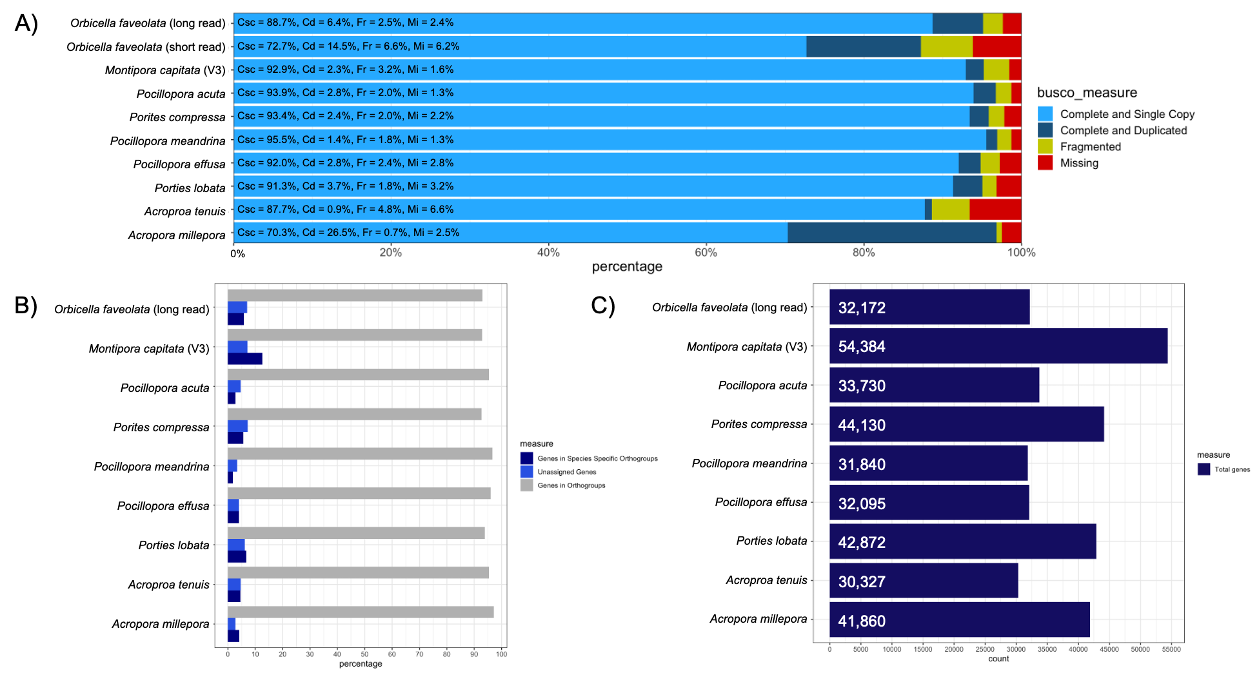

Supplementary Figure 1 - Results from the analysis of BUSCO and Orthofinder on the protein coding genes from our de-novo assembly, previous O. faveolata reference genome, and other long-read coral genomes.
- Results of BUSCO (database = metazoa_odb10) analysis on the protein coding genes on our de-novo assembly, the previous O. faveolata reference genome, and other long read coral genomes. Completeness is split into single copy (light blue) and duplicated (dark blue). Fragmented = yellow, Missing = red. Percentages for each metric are present in each bar: Csc = complete and single copy, Cd = complete and duplicated, Fr = fragmented, M = missing. “Orbicella faveolata (short read)” is the previously assembled short-read genome, and “Orbicella faveolata (long read)” is our de-novo assembly using PacBio HiFi reads.
- Results from Orthofinder analysis between our de-novo assembly and other publicly available coral long-read genomes
- Total number of protein coding genes present in coral long-read genomes used in Orthofinder analysis. Number within the bar shows the total number of protein coding genes present in each long-read genome assembly.

