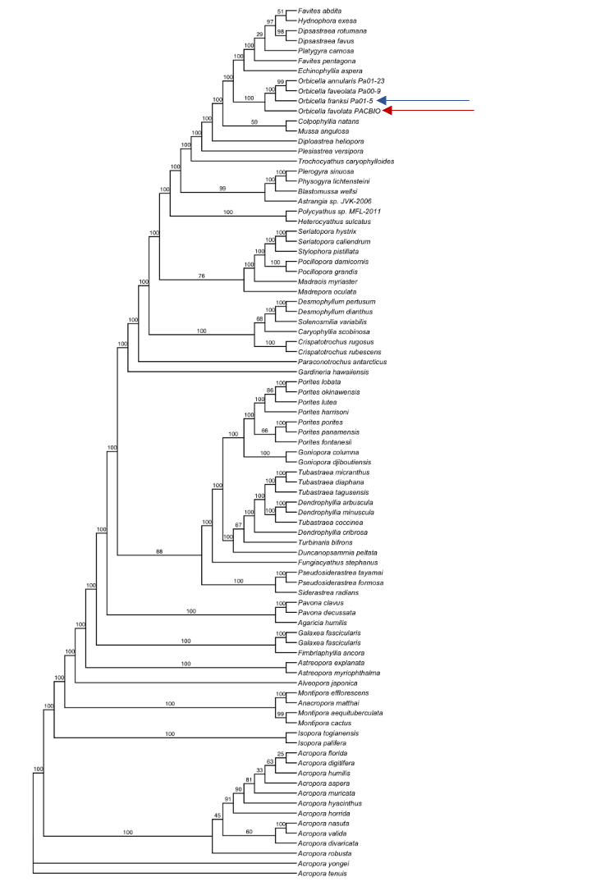
Supplementary Figure 2 - Phylogenetic placement and gene content of the new Orbicella faveolata mitochondrial genome.
Phylogenetic tree of all available stony coral mitochondrial genomes available on the NCBI. Blue arrow = previous short-read reference mitochondrial genome of O. faveolata. Red arrow = our de-novo assembled mitochondrial genome from O. faveolata.

