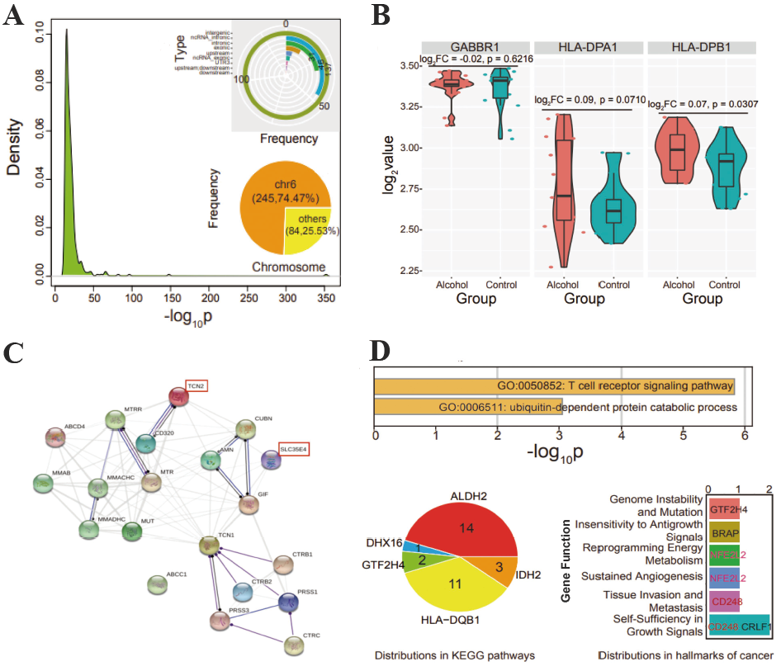
Figure S1. Distribution and function analysis for screened genes
- Distribution of p-values for all screened significantly varied sites (p <= 9.96e-07). The pie chart shows the dominant distribution on chromosome 6 (245 varied sites are located on chromosome 6), and the detailed distribution types are also shown.
- Expression distributions of several genes in alcohol and control samples, and p-values are estimated using t-test (alcohol group = 18, control group = 17).
- STRING interaction network for cobalamin (vitamin B12) transport and metabolism SuperPath. TCN2 and SLC35E4 are both involved in the pathway, indicated by red rectangles.
- The significantly enriched GO terms for genes detected by PLINK, and the potential contributions in KEGG pathways.

Table S1. Haplotype association tests on condition of single SNP
Condition on SNP |  |  | BF₂ of rs9606757 | BF₂ of rs147307448 | BF₂ of rs140377384
\ |  |  | 6.077 | 7.339 | 6.768
rs9608955 | chr22 | 30900829 | 6.224 | 7.411 | 6.797
rs9608956 | chr22 | 30901592 | 6.084 | 7.300 | 6.687
rs933339 | chr22 | 30905491 | 5.434 | 6.644 | 5.947
rs2023967 | chr22 | 30907168 | 6.244 | 7.438 | 6.807
rs118116676 | chr22 | 30934885 | 5.864 | 7.096 | 6.507
rs5753194 | chr22 | 30935682 | 5.744 | 6.996 | 6.607
rs182798258 | chr22 | 30948498 | 6.084 | 7.349 | 6.777
rs6518702 | chr22 | 30948752 | 5.724 | 7.226 | 6.377
rs2267159 | chr22 | 30952396 | 4.644 | 5.574 | 5.127
rs2267161 | chr22 | 30953295 | 5.374 | 7.012 | 6.527
rs118120731 | chr22 | 30955669 | 6.034 | 7.308 | 6.607
rs5749126 | chr22 | 30955722 | 5.254 | 6.489 | 5.797
rs12628608 | chr22 | 30955907 | 6.814 | 8.034 | 7.097
rs42938 | chr22 | 30965757 | 6.404 | 7.509 | 6.777
rs142214789 | chr22 | 30977576 | 5.974 | 7.282 | 6.667
rs191006503 | chr22 | 30979921 | 6.024 | 7.222 | 6.607
rs111338112 | chr22 | 30981984 | 6.224 | 7.397 | 6.707
rs377738551 | chr22 | 30983044 | 5.734 | 7.045 | 6.607
rs4820018 | chr22 | 30986172 | 6.434 | 7.544 | 6.837
rs11912615 | chr22 | 30989492 | 5.924 | 7.157 | 6.497
rs4820876 | chr22 | 30992672 | 5.274 | 6.463 | 5.717
rs5753231 | chr22 | 31003069 | 5.624 | 6.759 | 6.247
rs16988828 | chr22 | 31003561 | 5.604 | 6.419 | 5.617
rs9606756 | chr22 | 31006860 | 6.024 | 7.166 | 6.447
rs5749135 | chr22 | 31011906 | 5.014 | 5.707 | 4.727
rs2283873 | chr22 | 31013296 | 6.424 | 7.476 | 6.717
rs117458738 | chr22 | 31013374 | 5.754 | 6.662 | 6.167
rs9606757 | chr22 | 31016645 | 6.114 | 7.298 | 6.657
rs9306264 | chr22 | 31024934 | 6.644 | 7.685 | 6.707
rs731991 | chr22 | 31025189 | 5.124 | 5.893 | 4.527
rs184886704 | chr22 | 31029674 | 5.774 | 6.970 | 6.587
rs147307448 | chr22 | 31043537 | 2.174 | 2.805 | 2.677
rs181701741 | chr22 | 31057697 | 6.024 | 7.208 | 6.577
rs8630 | chr22 | 31058115 | 4.364 | 5.138 | 3.917
rs67153574 | chr22 | 31061283 | 5.684 | 7.071 | 6.317
rs117728004 | chr22 | 31063007 | 6.104 | 7.403 | 7.067
rs3827379 | chr22 | 31063939 | 6.114 | 7.415 | 7.027
rs9606764 | chr22 | 31067427 | 6.284 | 7.682 | 7.757
rs117344502 | chr22 | 31091747 | 5.904 | 7.189 | 6.837
rs11089471 | chr22 | 31113828 | 6.214 | 7.515 | 7.307
rs58884052 | chr22 | 31114622 | 5.494 | 7.160 | 6.437
rs140377384 | chr22 | 31116387 | 5.644 | 6.349 | 6.267
rs136369 | chr22 | 31123292 | 6.304 | 7.628 | 7.357
rs139174051 | chr22 | 31131227 | 6.104 | 7.401 | 7.317
rs141280512 | chr22 | 31138802 | 6.124 | 7.511 | 7.287
rs926340 | chr22 | 31139318 | 5.484 | 6.955 | 6.397
rs5753303 | chr22 | 31139653 | 5.824 | 7.215 | 6.807
rs9609077 | chr22 | 31153162 | 1.044 | 1.779 | 1.527
rs9609078 | chr22 | 31153276 | 5.974 | 7.238 | 6.737
rs117498931 | chr22 | 31179867 | 5.674 | 7.018 | 6.697
rs136262 | chr22 | 31198037 | 5.604 | 6.938 | 7.307
rs142059627 | chr22 | 31212513 | 2.184 | 2.719 | 2.297
rs738374 | chr22 | 31212641 | 5.874 | 7.255 | 6.887
rs361844 | chr22 | 31215815 | 6.334 | 7.469 | 6.937
rs136223 | chr22 | 31219869 | 4.534 | 5.496 | 5.357
rs140951642 | chr22 | 31225189 | 5.364 | 6.571 | 5.817
rs4577391 | chr22 | 31256584 | 5.614 | 6.899 | 6.437
rs5753355 | chr22 | 31259658 | 4.554 | 5.600 | 5.067
rs142720771 | chr22 | 31261083 | 6.084 | 7.231 | 6.407
rs2301816 | chr22 | 31266546 | 6.044 | 7.297 | 6.527
rs2285917 | chr22 | 31268091 | 4.884 | 5.964 | 5.537
rs112446420 | chr22 | 31268556 | 6.164 | 7.404 | 6.777
rs11089481 | chr22 | 31288769 | 5.574 | 6.524 | 5.817
rs5749191 | chr22 | 31295082 | 5.524 | 6.446 | 5.687
rs143900220 | chr22 | 31326576 | 5.284 | 6.414 | 5.827
rs118054267 | chr22 | 31330594 | 6.024 | 7.314 | 6.847
rs117178020 | chr22 | 31344684 | 6.284 | 7.568 | 7.147
rs1003480 | chr22 | 31346752 | 3.344 | 4.087 | 3.377
rs2285919 | chr22 | 31355635 | 5.714 | 6.973 | 6.437
rs56686418 | chr22 | 31388971 | 5.814 | 7.072 | 6.667
rs9621153 | chr22 | 31392606 | 6.204 | 7.434 | 6.887
BF₂ is log₁₀(Bayes factor) of haplotype association. “\” stands for not on condition of any SNP. Top 3 SNPs are red. Top 5 SNPs are yellow.

Table S2. Haplotype association tests on condition of multiple SNPs
Condition | BF₂ of rs9606757 | BF₂ of rs147307448 | BF₂ of rs140377384
\ | 6.077* | 7.339* | 6.768*
3 SNPs | 0.051 | 0.384 | 0.516
5 SNPs | -0.606 | -0.389 | -0.855
11 SNPs | -0.389 | 0.255 | 0.047
71 SNPs | -0.410 | 0.067 | 0.197
For the region with allelic heterogeneity on chromosome 22 we performed haplotype association tests on condition of multiple SNPs. The line with "\" is haplotype association not conditioned on any SNP, while the other lines are haplotype association conditioned on multiple SNPs. BF₂ is log₁₀BF for haplotype test, the threshold of BF₂ to declare genome-wide significant associations is 6. BF₂ on condition of 5 SNPs were the lowest. Intuitively, the 5 SNPs can tag this local haplotype well.

Table S3. Frequencies of haplotypes on 5 tag SNPs in case and control samples
 | Chromosome | Position | Gene
rs147307448 | chr22 | 31043537 | SLC35E4
rs8630 | chr22 | 31058115 | SLC35E4/DUSP18
rs9609077 | chr22 | 31153162 | OSBP2
rs142059627 | chr22 | 31212513 | OSBP2
rs1003480 | chr22 | 31346752 | MORC2

Table S4. Frequencies of haplotypes on all SNPs in case and control samples
Haplotype | Case (N=9622) |  | Control (N=81832) |  | p-value | Type
Haplotype | n | Freq | n | Freq | p-value | Type
AGACG | 29 | 0.0151 | 515 | 0.0315 | 1.9e-05 | Protective
GAGTA | 372 | 0.1933 | 2566 | 0.1568 | 5.3e-05 | Risky
GGATG | 151 | 0.0785 | 1636 | 0.1000 | 0.002 | Protective
AGACA | 1 | 0.0005 | 57 | 0.0035 | 0.028
GGGTA | 1002 | 0.5208 | 8323 | 0.5086 | 0.311
GGACG | 0 | 0.0000 | 13 | 0.0008 | 0.385
AGGTG | 0 | 0.0000 | 9 | 0.0005 | 0.611
AGATG | 0 | 0.0000 | 11 | 0.0007 | 0.619
GGGTG | 240 | 0.1247 | 2085 | 0.1274 | 0.772
GAGTG | 46 | 0.0239 | 407 | 0.0249 | 0.877
AGGTA | 7 | 0.0036 | 68 | 0.0042 | 1.000
GGATA | 65 | 0.0338 | 558 | 0.0341 | 1.000
GAATA | 7 | 0.0036 | 62 | 0.0038 | 1.000
GAATG | 4 | 0.0021 | 40 | 0.0024 | 1.000
GAACG | 0 | 0.0000 | 7 | 0.0004 | 1.000
GGACA | 0 | 0.0000 | 2 | 0.0001 | 1.000
AGATA | 0 | 0.0000 | 4 | 0.0002 | 1.000
GGGCG | 0 | 0.0000 | 3 | 0.0002 | 1.000
The 5 tag SNPs are rs147307448 (chr22:31043537, SLC35E4); rs8630 (chr22:31058115, SLC35E4/DUSP18); rs9609077 (chr22:31153162, OSBP2); rs142059627 (chr22:31212513, OSBP2); rs1003480 (chr22:31346752, MORC2). The frequencies of each haplotype on 5 tag SNPs in case and control samples are calculated and compared. Three causal haplotypes are finally identified, namely AGACG，GAGTA and GGATG, respectively.

Table S5. Verification of signals on Chr12, Chr22, and Chr6 using Plink set-based tests and VEGAS2 gene-based tests
Signal | SNP set | Plink set-based test |  | VEGAS2
Signal | SNP set | nSNPs | Set p-value |  | nSNPs | Gene p-value
Chr12 | BRAP | 3 | 2.6e-07 |  | 3 | <1.0e-06
Chr12 | ALDH2 | 10 | 2.3e-05 |  | 10 | 2.0e-05
Chr22 | 5 tag SNPs of the LD block | 5 | 3.0e-09 |  | \ | \
Chr22 | SNPs within the LD block | 71 | 7.7e-08 |  | \ | \
Chr22 | OSBP2 | 26 | 1.4e-05 |  | 26 | 4.0e-05
Chr22 | SLC35E4 | 6 | 1.9e-05 |  | \ | \
Chr22 | MORC2 | 5 | 5.5e-05 |  | 5 | 1.5e-05
Chr22 | TCN2 | 7 | 0.001 |  | 4 | 1.7e-04
Chr22 | DUSP18 | 4 | 0.004 |  | 3 | 0.004
Chr6 | HLA-H | 339 | 2e-08 |  | \ | \
Chr6 | GABBR1 | 78 | 4e-08 |  | \ | \
Chr6 | HLA-DPA1 | 60 | 0.009 |  | 18 | 0.239
Chr6 | HLA-DPB1 | 100 | 0.012 |  | 2 | 0.146
A SNP set is a group of SNPs within a gene or a certain region, nSNP is the number of SNPs in the set. The numbers of permutations are 1.0e+9 and 1.0e+6 for set-based and gene-based tests respectively. The recommended significant threshold of p-value for set-based and gene-based tests is 10e-06. Therefore, BRAP, 5 tag SNPs of the LD block, HLA-H, and HLA-DPB1 are genome-wide significant.

Table S6. Genetic correlations between our GWAS findings and other GWAS results
 | MDD | BIP | Cannabis | Alcohol
Genetic correlation | 0.29 | 0.04 | 0.11 | 0.28
p value | 0.002* | 0.194 | 0.604 | 0.129
The genetic correlation of drug dependence and major depressive disorder (MDD) is significantly positive.

