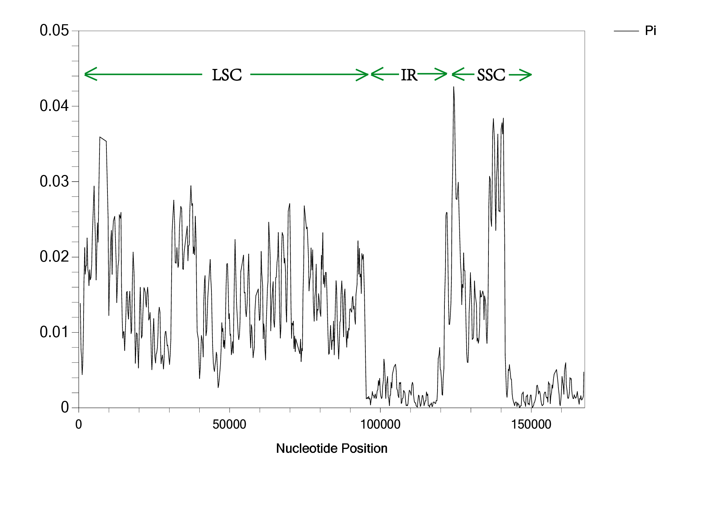
Figure S2. Nucleotide diversity (pi) of Ampelopsideae.

