Fig S1. Essential oil content of ‘Malayer-21’ and ‘Zagheh-11’ clones of T. daenensis measured at different phenological stages.

Table S1. Relative percentage of essential oil components measured at different phenological stages in Malayer-21 and Zagheh-11 clones of T. daenensis.
Zagheh-11 |  |  |  |  |  |  |  | Malayer-21
N | RI_{calculated} | RI_{Adams} | Compound | Vegetative | Flower bud burst | Early flowering | Full flowering | Vegetative | Flower bud burst | Early flowering | Full flowering
1 | 923 | 924 | α-Thujene | 2.53±0.24 | 2.49±0.55 | 1.41±0.19 | 3.51±0.01 | 1.64±0.51 | 1.19±0.24 | 3.6±0.73 | 4.62±1.04
2 | 930 | 932 | α-Pinene | 1.38±0.53 | 1.57±0.51 | 1.22±0.37 | 1.15±0.08 | 0.62±0.13 | 0.58±0.09 | 1.46±0.35 | 1.44±0.36
3 | 944 | 946 | Camphene | 0.4±0.1 | 0.47±0.29 | 0.24±0.05 | 0.23±0.02 | 0.49±0.06 | 0.57±0.09 | 0.32±0.12 | 0.31±0.15
4 | 971 | 969 | Sabinene | 0.63±0.2 | 0.39±0.39 | 0.04±0.04 | 0.17±0.06 | 0.35±0.11 | 0.6±0.11 | 0.24±0.03 | 0.28±0.05
5 | 975 | 974 | β-Pinene | 0.49±0.06 | 0.45±1 | 0.31±0.1 | 0.57±0.08 | 0.29±0.07 | 0.36±0.09 | 0.37±0.26 | 0.43±0.1
6 | 990 | 995 | Myrcene | 0.43±0.31 | 0.2±0.05 | 0.21±0.1 | 0.33±0.11 | 0.72±0.03 | 0.59±0.2 | 0.61± 0.05 | 2.48±1.09
7 | 1002 | 1003 | α -Phellandrene | 0.69±0.22 | 1.13±0.64 | 0.57±0.11 | 0.16±0.04 | 0.4±0.44 | 0.28±0.19 | 0.22±0.03 | 0.16±0.06
8 | 1009 | 1008 | Δ-Carene | 1.16±0.5 | 0.65±0.02 | 0.41±0.14 | 0.49±0.08 | 0.66±0.16 | 0.35±0.02 | 0.71±0.19 | 0.45±0.23
9 | 1014 | 1015 | α-Terpinene | 3.77±0.82 | 3.05±0.06 | 1.62±0.74 | 2.6±0.14 | 1.47±0.36 | 1.12±0.31 | 3.51±0.22 | 3.71±0.52
10 | 1020 | 1021 | p-Cymene | 8.78±1.17 | 6.1±0.93 | 2.74±0.75 | 7.03±0.47 | 6±1.19 | 3.78±0.62 | 2.76±0.35 | 2.65±0.33
11 | 1027 | 1026 | 1,8-Cineole | 0.77±0.16 | 0.49±0.32 | 0.23±0.14 | 1.03±0.07 | 0.72±0.14 | 0.53±0.04 | 1.08±0.16 | 0.58±0.16
12 | 1045 | 1044 | β-Ocimene | 0.52±0.15 | 0.39±0.06 | 0.1±0.07 | 0.18±0.07 | 0.32±0.07 | 0.07±0.03 | 0.2±0.06 | 0.23±0.04
13 | 1054 | 1054 | γ-Terpinene | 21.07±1.8 | 17.42±0.57 | 6.19±0.58 | 9.86±1.4 | 15.7±0.55 | 11.19±0.48 | 9.19±0.41 | 8.83±0.44
14 | 1063 | 1065 | Cis-Sabinene hydrate | 0.52±0.19 | 0.62±0.07 | 0.33±0.16 | 0.83±0.03 | 0.38±0.09 | 0.32±0.16 | 1.34±0.45 | 1.38±0.25
15 | 1087 | 1086 | α-Terpinolene | 0.38±0.23 | 0.39±0.25 | 0.25±0.09 | 0.15±0.02 | 0.3±0.12 | 0.33±0.1 | 0.2± 0.01 | 0.26±0.06
16 | 1096 | 1096 | Linalool | 0.93±0.47 | 0.34±0.28 | 0.2±0.07 | 0.43±0.09 | 0.36±0.12 | 0.26±0.09 | 0.49±0.09 | 0.41±0.03
17 | 1097 | 1098 | trans-Sabinene hydrate | 0.46±0.16 | 0.23±0.11 | 0.29±0.06 | 0.57±0.06 | 0.43±0.19 | 0.27±0.04 | 0.49±0.19 | 0.52±0.17
18 | 1240 | 1241 | Carvacrol methyl ether | 3.25±0.82 | 2.76±0.76 | 1.81±0.26 | 1.00±0.65 | 3.72±0.41 | 3.04±0.4 | 4.77±0.39 | 5.36±0.94
19 | 1288 | 1289 | Thymol | 38.98±1.37 | 46.29±3.56 | 52.39±1.83 | 50.79±1.24 | 58.35±1.53 | 67.98±1.56 | 62.16±1.67 | 62.01±2.97
20 | 1297 | 1298 | Carvacrol | 6.6±0.39 | 10.07±1.41 | 26.14±1.98 | 14.37±1.39 | 1.43±0.11 | 1.41±1.15 | 1.12±0.36 | 0.55±0.61
21 | 1415 | 1417 | (E)-β-Caryophyllene | 1.03±0.03 | 1.16±0.01 | 1.43±0.09 | 1.11±0.09 | 1.07±0.02 | 1.07±0.05 | 1.15±0.04 | 1.15±0.06
22 | 1448 | 1452 | α-Humulene | 0.18±0.02 | 0.21±0.04 | 0.3±0.01 | 0.27±0.03 | 0.1±001 | 0.12±0.02 | 0.16±0.02 | 0.18±0.02
23 | 1504 | 1506 | α-Bisabolene | 0.55±0.08 | 0.66±0.14 | 0.85±0.01 | 0.71±0.07 | 0.3±0.04 | 0.37±0.08 | 0.5±0.07 | 0.56±0.06
24 | 1579 | 1582 | Caryophyllene oxide | 0.2±0.04 | 0.25±0.07 | 0.35±0.04 | 0.26±0.02 | 0.07±0.02 | 0.1±0.04 | 0.17±0.03 | 0.2±0.03
 |  |  | Total | 95.64 | 97.77 | 99.59 | 97.82 | 95.89 | 96.46 | 96.71 | 98.75

Fig S2. Gene ontolgy functional classification of assembled unigenes. Each bar represent the number of assigned unigenes to each GO terms.

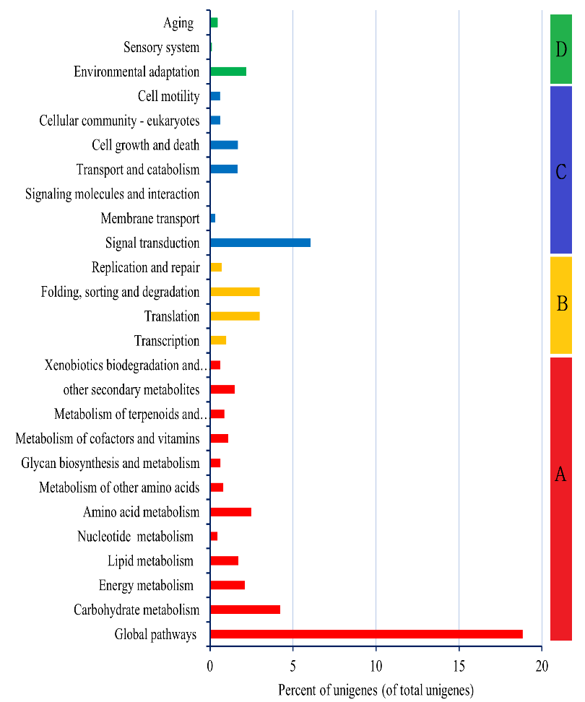
Fig. S3. Functional classification of KEGG terms assigned for assembled unigenes. Subcategories are summarized in four main domains: A, Metabolism; B, Genetic Information Processing; C, Cellular Processes; E, Organismal Systems. The y-axis contains the name of the KEGG pathways. The x-axis indicates the percentage of genes annotated under that pathway to the total number of annotated unigenes.

Table S2. Information on global and main KEGG pathway maps assigned for assembled unigenes.
Pathways | References KEGG map ID (KO) | No. of genes in each pathway | No. of identified genes in each pathway | Percent of identified genes in each pathway | No. of identified unigenes (orthologs) in each KEGG pathway
Metabolic pathways | 110 | 2260 | 1007 | 45 | 25853
Biosynthesis of secondary metabolites | 1110 | 995 | 506 | 51 | 15234
Carbon metabolism | 1200 | 342 | 98 | 29 | 3895
2-Oxocarboxylic acid metabolism | 1210 | 75 | 30 | 40 | 812
Fatty acid metabolism | 1212 | 70 | 27 | 39 | 875
Biosynthesis of amino acids | 1230 | 227 | 99 | 44 | 3090
 | Category | Pathways | Referencemap ID (KO) | N. of genes in each KEGG pathway | N. of identified genes in each KEGG pathways | Percent of identified genes in each pathway | N. of unigenes (orthologs) assigned for each pathway
Metabolism of  terpenoids and  polyketides |  | Terpenoid backbone biosynthesis | 900 | 53 | 31 | 58 | 776
 |  | Monoterpenoid biosynthesis | 902 | 23 | 6 | 26 | 289
 |  | Sesquiterpenoid and triterpenoid biosynthesis | 909 | 66 | 11 | 17 | 306
 |  | Diterpenoid biosynthesis | 904 | 42 | 10 | 24 | 239
 |  | Carotenoid biosynthesis | 906 | 46 | 20 | 43 | 347
 |  | Brassinosteroid biosynthesis | 905 | 10 | 9 | 9 | 139
Biosynthesis of  some other important secondary  metabolites |  | Phenylpropanoid biosynthesis | 940 | 33 | 16 | 45 | 1512
 |  | Stilbenoid, and gingerol biosynthesis | 945 | 13 | 5 | 38 | 532
 |  | Flavonoid biosynthesis | 941 | 19 | 14 | 74 | 714
 |  | Flavone and flavonol biosynthesis | 944 | 12 | 5 | 42 | 95
 |  | Anthocyanin biosynthesis | 942 | 14 | 3 | 21 | 43
 |  | Isoflavonoid biosynthesis | 943 | 13 | 5 | 38 | 100
 |  | Indole alkaloid biosynthesis | 901 | 10 | 2 | 20 | 39
 |  | Isoquinoline alkaloid biosynthesis | 950 | 42 | 11 | 26 | 438
 |  | Tropane, piperidine and pyridine alkaloids | 960 | 26 | 11 | 42 | 370

Table S3. KEGG annotation for assembled unigenes related to the secondary metabolite pathways.

Terpenoid backbone biosynthesis | Identified genes in metabolic map
ko:K00021 | HMGR; hydroxymethylglutaryl-CoA reductase (NADPH) [EC:1.1.1.34]
ko:K00099 | DXR; 1-deoxy-D-xylulose-5-phosphate reductoisomerase [EC:1.1.1.267]
ko:K00587 | ICMT; protein-S-isoprenylcysteine O-methyltransferase [EC:2.1.1.100]
ko:K00626 | ACAT; acetyl-CoA C-acetyltransferase [EC:2.3.1.9]
ko:K00787 | FDPS; farnesyl diphosphate synthase [EC:2.5.1.1 2.5.1.10]
ko:K00869 | MVK; mevalonate kinase [EC:2.7.1.36]
ko:K00919 | ispE; 4-diphosphocytidyl-2-C-methyl-D-erythritol kinase [EC:2.7.1.148]
ko:K00938 | E2.7.4.2; phosphomevalonate kinase [EC:2.7.4.2]
ko:K00991 | ispD; 2-C-methyl-D-erythritol 4-phosphate cytidylyltransferase [EC:2.7.7.60]
ko:K01597 | MVD; diphosphomevalonate decarboxylase [EC:4.1.1.33]
ko:K01641 | HMGCS; hydroxymethylglutaryl-CoA synthase [EC:2.3.3.10]
ko:K01662 | DXS; 1-deoxy-D-xylulose-5-phosphate synthase [EC:2.2.1.7]
ko:K01770 | ispF; 2-C-methyl-D-erythritol 2,4-cyclodiphosphate synthase [EC:4.6.1.12]
ko:K01823 | idi; isopentenyl-diphosphate Delta-isomerase [EC:5.3.3.2]
ko:K03526 | gcpE; (E)-4-hydroxy-3-methylbut-2-enyl-diphosphate synthase [EC:1.17.7.1 1.17.7.3]
ko:K03527 | ispH; 4-hydroxy-3-methylbut-2-en-1-yl diphosphate reductase [EC:1.17.7.4]
ko:K05356 | SPS; all-trans-nonaprenyl-diphosphate synthase [EC:2.5.1.84 2.5.1.85]
ko:K05906 | PCYOX1; prenylcysteine oxidase / farnesylcysteine lyase [EC:1.8.3.5 1.8.3.6]
ko:K05954 | FNTB; protein farnesyltransferase subunit beta [EC:2.5.1.58]
ko:K05955 | FNTA; protein farnesyltransferase/geranylgeranyltransferase type-1 subunit alpha [EC:2.5.1.58 2.5.1.59]
ko:K06013 | STE24; STE24 endopeptidase [EC:3.4.24.84]
ko:K06981 | ipk; isopentenyl phosphate kinase [EC:2.7.4.26]
ko:K08658 | RCE1; prenyl protein peptidase [EC:3.4.22.-]
ko:K10960 | chlP; geranylgeranyl diphosphate reductase [EC:1.3.1.83 1.3.1.111]
ko:K11778 | DHDDS; ditrans,polycis-polyprenyl diphosphate synthase [EC:2.5.1.87]
ko:K12742 | ispS; isoprene synthase [EC:4.2.3.27]
ko:K13789 | GGPS; geranylgeranyl diphosphate synthase, type II [EC:2.5.1.1 2.5.1.10 2.5.1.29]
ko:K14066 | GPS; geranyl diphosphate synthase [EC:2.5.1.1]
ko:K15889 | PCME; prenylcysteine alpha-carboxyl methylesterase [EC:3.1.1.-]
ko:K15891 | FLDH; NAD+-dependent farnesol dehydrogenase [EC:1.1.1.354]
ko:K15892 | FOLK; farnesol kinase [EC:2.7.1.216]
Monoterpens and diterpenoids (except gibberellin) | Identified genes in metabolic map
ko:K07385 | TPS-Cin; 1,8-cineole synthase [EC:4.2.3.108]
ko:K15095 | E1.1.1.208; (+)-neomenthol dehydrogenase [EC:1.1.1.208]
ko:K18108 | E4.2.3.111; (-)-alpha-terpineol synthase [EC:4.2.3.111]
ko:K21925 | TPS3; camphene/tricyclene/(4S)-limonene/myrcene synthase [EC:4.2.3.117 4.2.3.105 4.2.3.16 4.2.3.15]
ko:K23232 | 10HGO; 8-hydroxygeraniol dehydrogenase [EC:1.1.1.324]
ko:K23810 | CYP76F14; (E)-8-carboxylinalool synthase [EC:1.14.14.-]
ko:K17982 | TPS04; geranyl-linalool synthase [EC:4.2.3.144]
Sesquiterpenoid and triterpenoid | Identified genes in metabolic map
ko:K00511 | SQLE; squalene monooxygenase [EC:1.14.14.17]
ko:K00801 | FDFT1; farnesyl-diphosphate farnesyltransferase [EC:2.5.1.21]
ko:K14173 | AFS1; alpha-farnesene synthase [EC:4.2.3.46]
ko:K14175 | NES1; (3S,6E)-nerolidol synthase [EC:4.2.3.48]
ko:K14182 | HVS; vetispiradiene synthase [EC:4.2.3.21]
ko:K15472 | CYP71D55; premnaspirodiene oxygenase [EC:1.14.14.151]
ko:K15803 | GERD; (-)-germacrene D synthase [EC:4.2.3.75]
ko:K15805 | EAH; 5-epiaristolochene 1,3-dihydroxylase [EC:1.14.14.149]
ko:K15813 | LUP4; beta-amyrin synthase [EC:5.4.99.39]
ko:K15891 | FLDH; NAD+-dependent farnesol dehydrogenase [EC:1.1.1.354]
ko:K20659 | LUS; lupeol synthase [EC:5.4.99.41]
Table S4. List of identified genes in biosynthesis pathways of terpenoids (KEGG maps), their KO and enzyme EC number.

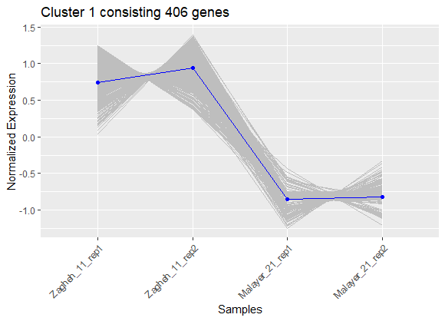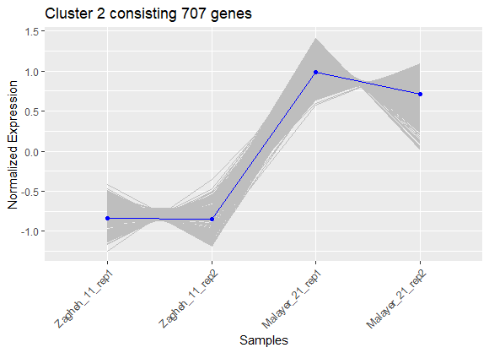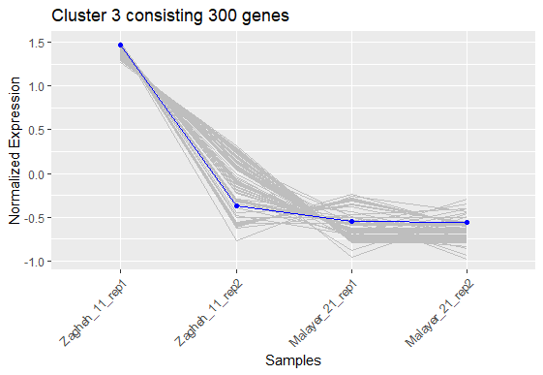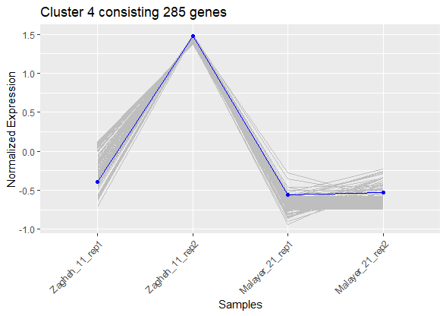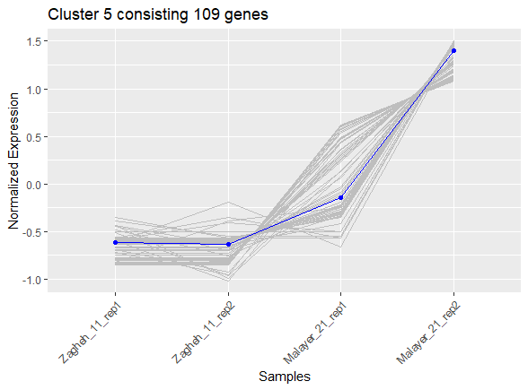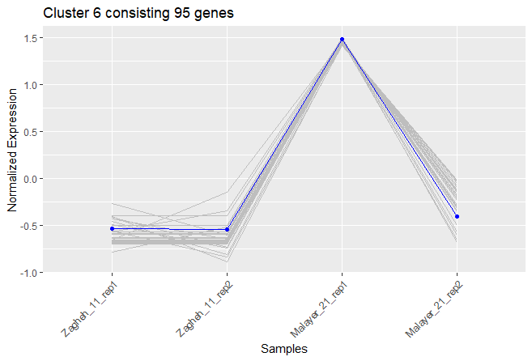
Fig S4. Normalized expression patterns of six clusters related to the unigenes showing similar expression patterns in analyzed samples. Normalization of gene expression values were based on variance stabilization.

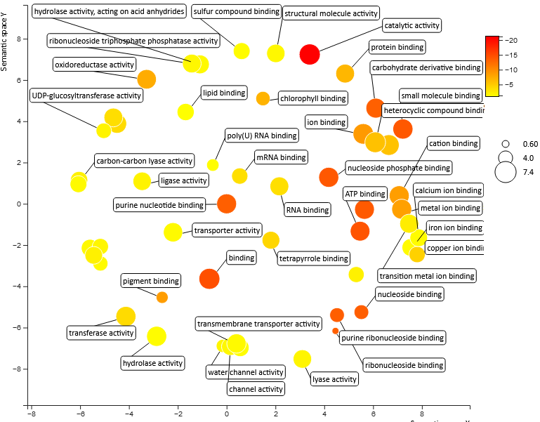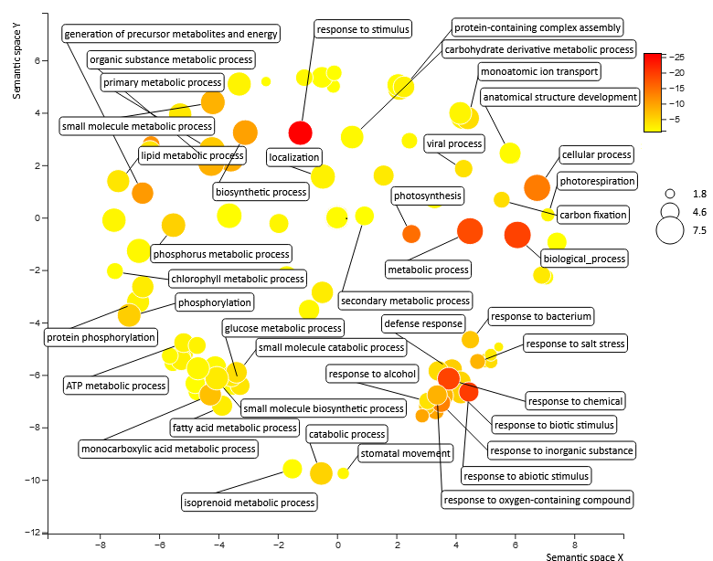
Fig S5. GO category enrichment analysis of differentially expressed unigenes related to molecular functions (left) and biological processes (right) in Zagheh-11 vs Malayer-21 comparison. Circles depicted by filled color show significantly enriched GO terms with log₁₀ p-value <0.05. The colour bubbles represent log₁₀ p-value for the GO terms in the underlying databases run through REVIGO webserver (larger size bubbles present having more related unigenes ).

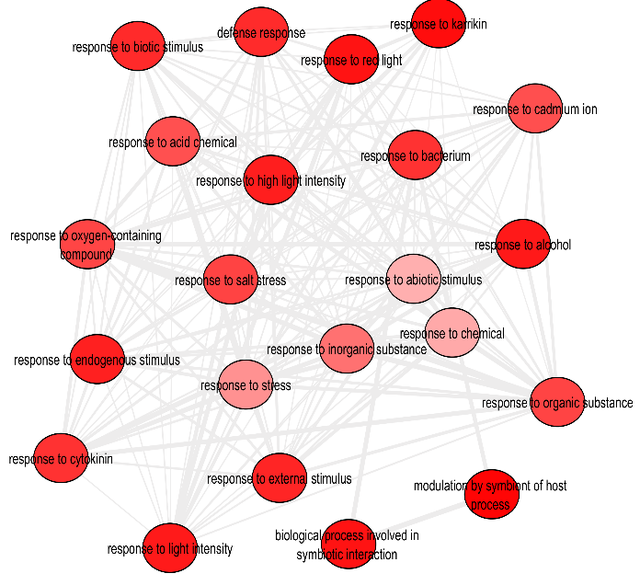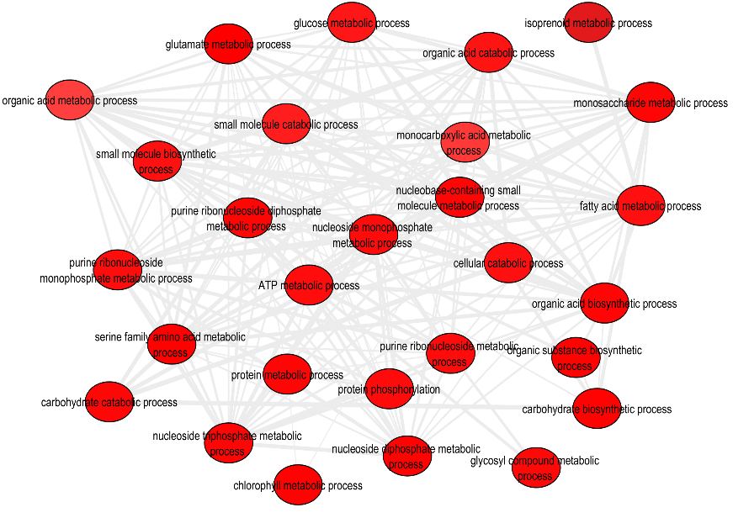

Figure S6. The interaction of GO terms in enrichment analysis of differentially expressed genes related to the biological process (BP). This figure was produced by REVIGO and adjusted by Cytoscape. The colour of bubbles shows the p-value of the GO term in related database. Highly similar GO terms are linked together.

Figure S7. The number of identified members for transcription factor families in the assembled transcriptome of T. daenensis.

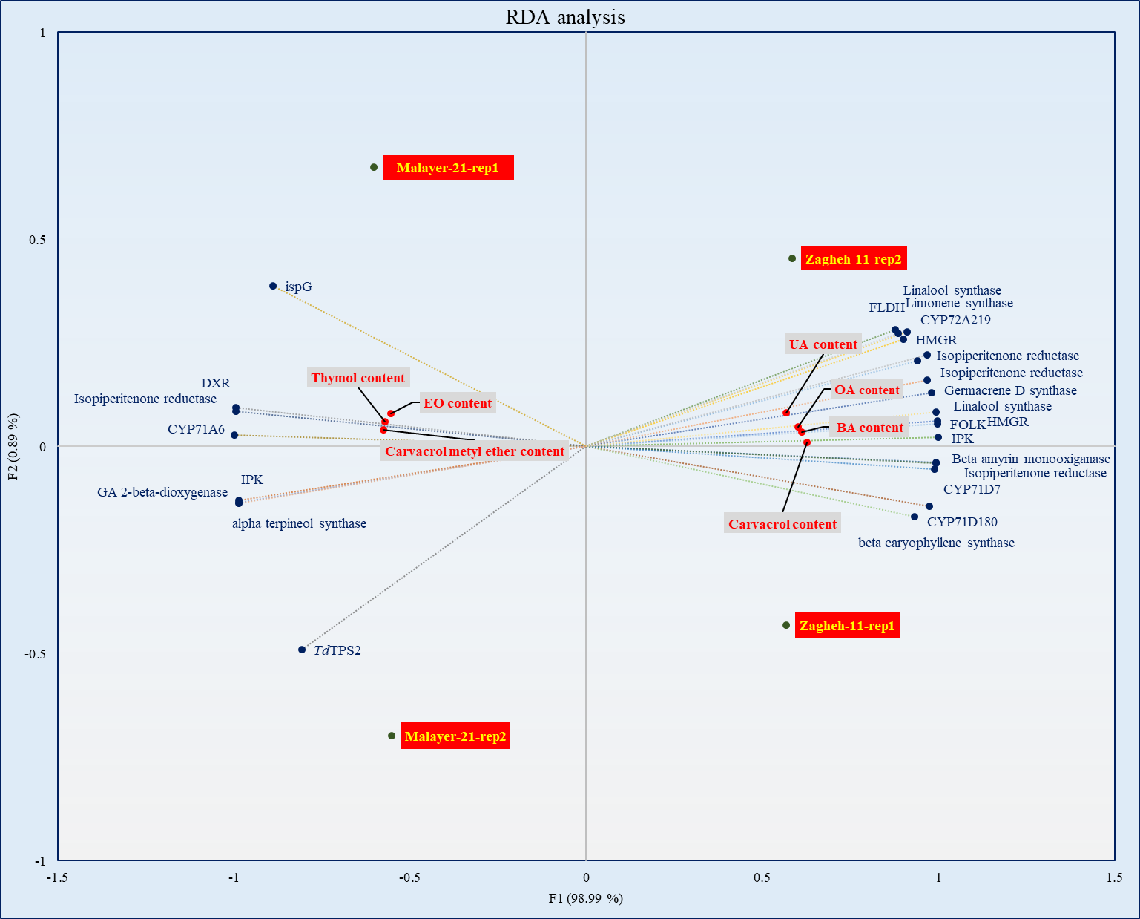
Fig S8. Redundancy analysis (RDA) of secondary metabolite content and their related genes.

Table S5. The characteristics of isoform-specific primers designed for utilizing in qRT-PCR analysis.
Real time PCR primers | Direction | Sequence | Tm (°C) | Primer length | Amplicon size (bp)
CYP71D180 (Evigene261541) | Forward  Reverse | GCAAAGAAGAATGCGAGGTC  GATTGAACGTGTCGGGATCT | 58.4  58.4 | 20  19 | 116
TdTPS2 (Evigene94215) | Forward  Reverse | AACCTCGCCGAGAAACTCCC  AGCTGCAGTTCGTCGAGTGT | 62.5  60.5 | 20  20 | 182
HMGR (Evigene1924, Evigene74151) | Forward  Reverse | TTGGTTTGGGTAGTGAGCATC  GCATCTGCTTCTTTCCTTCCT | 59.4  59.4 | 21  21 | 154
DXR (Evigene12571) | Forward  Reverse | AGAGGCTCACTATTTGTTTGGG  CACTGATGAATCCTGTGTTTCG | 60.3  60.3 | 22  22 | 104
ELF-1 (gene-specific, reference gene) | Forward  Reverse | CTCCAGTTCTTGATTGCCACAC  GGTGGGTACTCGGAGAATGTC | 62.1  63.3 | 22  21 | 187

