Supplementary files
Online Table 1 Characteristics of the SNPs associated with serum potassium and AF
Online Table 2 Characteristics of the SNPs associated with serum magnesium and AF
Online Table 3 Characteristics of the SNPs associated with serum calcium and AF
Online Table 4 Characteristics of the SNPs associated with serum phosphate and AF
Online Table 5 Details of studies and datasets used for MR analyses
Online Figure 1 Forest plot of causal effects between potassium-associated SNPs and risk of AF.
Online Figure 2 Forest plot of causal effects between magnesium-associated SNPs and risk of AF.
Online Figure 3 Forest plot of causal effects between phosphate-associated SNPs and risk of AF.
Online Figure 4 Forest plot of causal effects between calcium-associated SNPs and risk of AF.
Online Figure 5 Scatter plot of causal effects between potassium-associated SNPs and risk of AF.
Online Figure 6 Scatter plot of causal effects between magnesium-associated SNPs and risk of AF.
Online Figure 7 Scatter plot of causal effects between phosphate-associated SNPs and risk of AF.
Online Figure 8 Scatter plot of causal effects between calcium-associated SNPs and risk of AF.
Online Figure 9 MR leave-one-out sensitivity analysis for serum potassium on AF.
Online Figure 10 MR leave-one-out sensitivity analysis for serum magnesium on AF.
Online Figure 11 MR leave-one-out sensitivity analysis for serum phosphate on AF.
Online Figure 12 MR leave-one-out sensitivity analysis for serum calcium on AF.
Online Figure 13 Funnel plot of causal association between serum potassium on AF.
Online Figure 14 Funnel plot of causal association between serum magnesium on AF.
Online Figure 15 Funnel plot of causal association between serum phosphate on AF.
Online Figure 16 Funnel plot of causal association between serum calcium on AF.

Table 1 Characteristics of the SNPs associated with serum potassium and AF
Chromosome | SNP | EA | OA | EAF | R² | F-statistic | Associations with serum potassium |  |  |  |  | Associations with AF
 |  |  |  |  |  |  | Beta | se | P value |  |  | Beta | se | P value
1 | rs2745938 | T | G | 0.647 | 3.09E-04 | 18.778 | 0.026 | 0.006 | 4.10E-06 |  |  | 0.005 | 0.007 | 0.512
3 | rs3772928 | C | T | 0.575 | 3.56E-04 | 20.25 | -0.027 | 0.006 | 1.50E-06 |  |  | -0.004 | 0.007 | 0.59
5 | rs114300683 | A | G | 0.012 | 3.14E-04 | 21.16 | -0.115 | 0.025 | 4.00E-06 |  |  | 0.016 | 0.037 | 0.673
5 | rs145857065 | C | T | 0.03 | 4.01E-04 | 23.837 | -0.083 | 0.017 | 1.60E-06 |  |  | 0.021 | 0.026 | 0.417
5 | rs148244439 | T | C | 0.052 | 3.20E-04 | 22.563 | 0.057 | 0.012 | 3.90E-06 |  |  | 0.011 | 0.016 | 0.498
8 | rs35579431 | T | C | 0.266 | 3.28E-04 | 23.361 | 0.029 | 0.006 | 2.00E-06 |  |  | -0.013 | 0.008 | 0.102
8 | rs77126457 | A | G | 0.014 | 3.04E-04 | 20.841 | 0.105 | 0.023 | 4.80E-06 |  |  | 0.004 | 0.036 | 0.911
9 | rs7040926 | C | T | 0.065 | 3.16E-04 | 21.496 | -0.051 | 0.011 | 4.40E-06 |  |  | -0.018 | 0.014 | 0.198
10 | rs10764330 | G | A | 0.699 | 3.30E-04 | 21.778 | 0.028 | 0.006 | 2.60E-06 |  |  | -0.001 | 0.007 | 0.854
10 | rs12412051 | C | G | 0.034 | 3.50E-04 | 23.684 | 0.073 | 0.015 | 1.20E-06 |  |  | 0.015 | 0.019 | 0.435
10 | rs1360913 | T | A | 0.577 | 3.83E-04 | 21.778 | 0.028 | 0.006 | 4.40E-07 |  |  | -0.003 | 0.007 | 0.657
11 | rs361294 | C | A | 0.691 | 3.35E-04 | 21.778 | -0.028 | 0.006 | 2.00E-06 |  |  | 0.007 | 0.007 | 0.321
11 | rs7479680 | C | A | 0.144 | 3.56E-04 | 22.563 | -0.038 | 0.008 | 9.00E-07 |  |  | -0.0001 | 0.01 | 0.989
12 | rs12296227 | T | G | 0.267 | 3.07E-04 | 21.778 | 0.028 | 0.006 | 3.80E-06 |  |  | -0.008 | 0.008 | 0.292
14 | rs77824658 | G | A | 0.09 | 3.17E-04 | 19.36 | 0.044 | 0.01 | 4.40E-06 |  |  | 0.0003 | 0.012 | 0.981
16 | rs146963873 | A | T | 0.008 | 3.72E-04 | 21.496 | -0.153 | 0.033 | 4.00E-06 |  |  | -0.053 | 0.052 | 0.311
AF, atrial fibrillation; SNP, single-nucleotide polymorphism; EA, effect allele; OA, other allele; EAF, effect allele frequency; se, standard error.

Table 2 Characteristics of the SNPs associated with serum magnesium and AF
Chromosome | SNP | EA | OA | EAF | R² | F-statistic | Associations with serum magnesium |  |  |  |  |  | Associations with AF
 |  |  |  |  |  |  | Beta | se | P value |  | Beta |  |  | se | P value
1 | rs2745938 | T | G | 0.647 | 3.33E-04 | 20.25 | 0.027 | 0.006 | 1.60E-06 |  | 0.005 |  |  | 0.007 | 0.512
2 | rs116740989 | A | C | 0.012 | 3.30E-04 | 22.278 | 0.118 | 0.025 | 2.80E-06 |  | -0.011 |  |  | 0.031 | 0.712
4 | rs114575778 | A | G | 0.01 | 4.16E-04 | 28.841 | -0.145 | 0.027 | 1.20E-07 |  | 0.027 |  |  | 0.04 | 0.493
4 | rs140205161 | G | A | 0.007 | 3.65E-04 | 21.424 | 0.162 | 0.035 | 4.10E-06 |  | 0.037 |  |  | 0.039 | 0.342
5 | rs116028267 | G | C | 0.038 | 3.28E-04 | 22.903 | -0.067 | 0.014 | 3.90E-06 |  | 0.002 |  |  | 0.02 | 0.926
5 | rs4535437 | G | A | 0.245 | 3.33E-04 | 25 | 0.03 | 0.006 | 1.20E-06 |  | 0.004 |  |  | 0.008 | 0.583
6 | rs114989460 | C | T | 0.018 | 3.26E-04 | 20.898 | 0.096 | 0.021 | 4.60E-06 |  | -0.012 |  |  | 0.031 | 0.69
7 | rs144862520 | T | C | 0.041 | 3.85E-04 | 21.778 | -0.07 | 0.015 | 4.70E-06 |  | -0.022 |  |  | 0.023 | 0.344
8 | rs77126457 | A | G | 0.014 | 3.65E-04 | 25 | 0.115 | 0.023 | 4.50E-07 |  | 0.004 |  |  | 0.036 | 0.911
9 | rs7022555 | T | C | 0.012 | 3.47E-04 | 23.426 | -0.121 | 0.025 | 1.80E-06 |  | -0.05 |  |  | 0.035 | 0.152
9 | rs76330086 | T | C | 0.015 | 3.07E-04 | 21.496 | -0.102 | 0.022 | 4.40E-06 |  | -0.045 |  |  | 0.034 | 0.179
10 | rs1247081 | T | G | 0.508 | 3.38E-04 | 27.04 | 0.026 | 0.005 | 1.70E-06 |  | 0.009 |  |  | 0.007 | 0.187
11 | rs116979507 | T | C | 0.039 | 3.07E-04 | 20.898 | 0.064 | 0.014 | 4.60E-06 |  | -0.02 |  |  | 0.02 | 0.315
11 | rs573905 | G | A | 0.547 | 3.89E-04 | 31.36 | 0.028 | 0.005 | 3.20E-07 |  | 0.001 |  |  | 0.007 | 0.926
12 | rs147150587 | A | G | 0.01 | 3.24E-04 | 20.898 | 0.128 | 0.028 | 3.40E-06 |  | -0.012 |  |  | 0.038 | 0.752
13 | rs7339029 | T | G | 0.134 | 3.01E-04 | 20.25 | 0.036 | 0.008 | 4.70E-06 |  | 0.01 |  |  | 0.01 | 0.319
16 | rs146963873 | A | T | 0.008 | 4.48E-04 | 25.917 | -0.168 | 0.033 | 3.60E-07 |  | -0.053 |  |  | 0.052 | 0.311
18 | rs1559583 | C | T | 0.785 | 3.04E-04 | 18.367 | -0.03 | 0.007 | 3.50E-06 |  | 0.022 |  |  | 0.008 | 0.006
20 | rs111419911 | G | A | 0.31 | 3.60E-04 | 23.361 | -0.029 | 0.006 | 6.30E-07 |  | 0.005 |  |  | 0.008 | 0.507
AF, atrial fibrillation; SNP, single-nucleotide polymorphism; EA, effect allele; OA, other allele; EAF, effect allele frequency; se, standard error.
Table 3 Characteristics of the SNPs associated with serum calcium and AF
Chromosome | SNP | EA | OA | EAF | R² | F-statistic | Associations with serum calcium |  |  |  |  | Associations with AF
 |  |  |  |  |  |  | Beta | se | P value |  |  | Beta | se | P value
2 | rs12618785 | G | C | 0.399 | 3.50E-04 | 20.25 | 0.027 | 0.006 | 1.20E-06 |  |  | -0.004 | 0.007 | 0.591
2 | rs4988235 | A | G | 0.723 | 4.10E-04 | 28.444 | 0.032 | 0.006 | 7.40E-08 |  |  | 0.018 | 0.008 | 0.024
4 | rs73238581 | A | C | 0.347 | 3.30E-04 | 20.25 | -0.027 | 0.006 | 2.00E-06 |  |  | 0.0004 | 0.007 | 0.96
5 | rs4535437 | G | A | 0.245 | 3.79E-04 | 28.444 | 0.032 | 0.006 | 4.50E-07 |  |  | 0.004 | 0.008 | 0.583
5 | rs62347998 | T | C | 0.042 | 3.30E-04 | 20.898 | 0.064 | 0.014 | 3.40E-06 |  |  | -0.001 | 0.019 | 0.975
7 | rs39308 | A | G | 0.265 | 3.51E-04 | 25 | 0.03 | 0.006 | 1.50E-06 |  |  | 0.003 | 0.008 | 0.711
8 | rs1714800 | C | G | 0.662 | 3.51E-04 | 21.778 | 0.028 | 0.006 | 1.00E-06 |  |  | -0.004 | 0.007 | 0.561
8 | rs2443773 | G | T | 0.506 | 3.64E-04 | 29.16 | 0.027 | 0.005 | 5.10E-07 |  |  | 0.007 | 0.007 | 0.306
8 | rs7464794 | C | T | 0.499 | 3.38E-04 | 27.04 | -0.026 | 0.005 | 9.20E-07 |  |  | 0.007 | 0.007 | 0.327
9 | rs117456360 | A | G | 0.043 | 3.27E-04 | 20.25 | 0.063 | 0.014 | 4.40E-06 |  |  | -0.028 | 0.021 | 0.173
10 | rs1219820 | T | C | 0.029 | 3.25E-04 | 22.563 | -0.076 | 0.016 | 1.70E-06 |  |  | -0.03 | 0.022 | 0.166
11 | rs11030416 | A | G | 0.042 | 3.40E-04 | 21.556 | -0.065 | 0.014 | 1.50E-06 |  |  | -0.003 | 0.017 | 0.863
12 | rs7972943 | A | T | 0.066 | 5.70E-04 | 23.592 | -0.068 | 0.014 | 1.30E-06 |  |  | 0.038 | 0.024 | 0.107
12 | rs7972943 | A | T | 0.066 | 5.70E-04 | 23.592 | -0.068 | 0.014 | 1.30E-06 |  |  | -0.005 | 0.014 | 0.715
15 | rs753899 | C | T | 0.092 | 3.54E-04 | 26.123 | 0.046 | 0.009 | 7.40E-07 |  |  | -0.021 | 0.012 | 0.069
16 | rs35683760 | G | A | 0.229 | 3.39E-04 | 26.694 | -0.031 | 0.006 | 1.50E-06 |  |  | 0.013 | 0.008 | 0.105
17 | rs8067154 | A | G | 0.219 | 3.08E-04 | 18.367 | -0.03 | 0.007 | 4.60E-06 |  |  | -0.006 | 0.008 | 0.479
18 | rs17712285 | G | A | 0.034 | 3.31E-04 | 22.404 | -0.071 | 0.015 | 1.70E-06 |  |  | -0.016 | 0.024 | 0.508
19 | rs1974821 | A | G | 0.152 | 3.34E-04 | 20.25 | 0.036 | 0.008 | 2.30E-06 |  |  | 0.002 | 0.01 | 0.852
19 | rs8109178 | T | A | 0.121 | 3.24E-04 | 23.766 | 0.039 | 0.008 | 3.00E-06 |  |  | 0.007 | 0.012 | 0.537
21 | rs11088797 | A | G | 0.114 | 3.23E-04 | 25 | 0.04 | 0.008 | 3.10E-06 |  |  | -0.013 | 0.011 | 0.212
AF, atrial fibrillation; SNP, single-nucleotide polymorphism; EA, effect allele; OA, other allele; EAF, effect allele frequency; se, standard error.

Table 4 Characteristics of the SNPs associated with serum phosphate and AF
Chromosome | SNP | EA | OA | EAF | R² | F-statistic | Associations with serum phosphate |  |  |  |  | Associations with AF
 |  |  |  |  |  |  | Beta | se | P value |  |  | Beta | se | P value
1 | rs113487566 | T | C | 0.025 | 4.88E-06 | 59.172 | -0.01 | 0.0013 | 5.87E-16 |  |  | -0.015 | 0.025 | 0.5444
1 | rs11801716 | T | C | 0.046 | 2.19E-06 | 30.864 | -0.005 | 0.0009 | 9.47E-09 |  |  | -0.0051 | 0.015 | 0.7307
1 | rs12044944 | T | C | 0.193 | 2.80E-06 | 36 | 0.003 | 0.0005 | 4.29E-09 |  |  | 0.0015 | 0.009 | 0.8559
1 | rs12059422 | C | T | 0.023 | 1.01E-05 | 133.136 | 0.015 | 0.0013 | 3.32E-29 |  |  | 0.0429 | 0.022 | 0.0466101
1 | rs12132412 | G | A | 0.388 | 1.37E-04 | 1806.25 | 0.017 | 0.0004 | 1.00E-200 |  |  | -0.0109 | 0.007 | 0.1248
1 | rs12409158 | C | G | 0.032 | 2.23E-06 | 29.752 | -0.006 | 0.0011 | 1.70E-08 |  |  | -0.0364 | 0.024 | 0.1261
1 | rs12727188 | G | T | 0.089 | 4.05E-06 | 51.02 | -0.005 | 0.0007 | 6.82E-15 |  |  | 0.0076 | 0.011 | 0.4965
1 | rs4072537 | C | T | 0.681 | 1.74E-06 | 25 | -0.002 | 0.0004 | 3.95E-08 |  |  | 9.00E-04 | 0.008 | 0.9143
1 | rs71641333 | A | T | 0.075 | 3.47E-06 | 39.063 | -0.005 | 0.0008 | 2.73E-09 |  |  | 0.0381 | 0.014 | 0.00690399
1 | rs72660359 | T | G | 0.037 | 1.60E-05 | 225 | 0.015 | 0.001 | 1.30E-45 |  |  | 0.0217 | 0.018 | 0.2326
1 | rs7529925 | T | C | 0.738 | 3.48E-06 | 56.25 | 0.003 | 0.0004 | 7.01E-12 |  |  | -0.0047 | 0.008 | 0.5318
1 | rs7555660 | T | C | 0.085 | 1.26E-05 | 165.306 | 0.009 | 0.0007 | 4.91E-38 |  |  | 0.0149 | 0.012 | 0.226
1 | rs79472736 | A | G | 0.035 | 3.31E-06 | 40.496 | -0.007 | 0.0011 | 3.45E-11 |  |  | 0.0194 | 0.021 | 0.3537
2 | rs11684211 | A | G | 0.353 | 4.11E-06 | 56.25 | 0.003 | 0.0004 | 3.81E-10 |  |  | -0.0069 | 0.007 | 0.3216
2 | rs2303917 | A | G | 0.108 | 3.08E-06 | 44.444 | -0.004 | 0.0006 | 6.18E-09 |  |  | -0.0254 | 0.011 | 0.0162099
2 | rs55923451 | A | G | 0.179 | 2.65E-06 | 36 | -0.003 | 0.0005 | 5.39E-11 |  |  | 0.0044 | 0.009 | 0.615399
2 | rs6751217 | T | C | 0.632 | 4.19E-06 | 56.25 | 0.003 | 0.0004 | 6.03E-13 |  |  | -0.0112 | 0.007 | 0.1023
2 | rs72974112 | T | C | 0.237 | 3.25E-06 | 36 | -0.003 | 0.0005 | 4.78E-10 |  |  | 0.0035 | 0.008 | 0.6531
2 | rs77149268 | T | C | 0.105 | 9.21E-06 | 136.111 | 0.007 | 0.0006 | 5.82E-25 |  |  | -0.0206 | 0.011 | 0.0648007
2 | rs838717 | A | G | 0.566 | 1.23E-05 | 156.25 | 0.005 | 0.0004 | 3.04E-35 |  |  | -0.0042 | 0.007 | 0.5332
2 | rs878919 | C | T | 0.397 | 4.31E-06 | 56.25 | 0.003 | 0.0004 | 3.10E-15 |  |  | -0.012 | 0.007 | 0.0774194
2 | rs896788 | T | C | 0.155 | 4.19E-06 | 64 | 0.004 | 0.0005 | 6.52E-15 |  |  | 0.0107 | 0.009 | 0.2332
3 | rs11705850 | C | T | 0.079 | 2.33E-06 | 32.653 | -0.004 | 0.0007 | 9.86E-10 |  |  | 0.0093 | 0.012 | 0.4401
3 | rs1483842 | C | T | 0.481 | 4.49E-06 | 56.25 | -0.003 | 0.0004 | 1.42E-12 |  |  | -7.00E-04 | 0.007 | 0.9187
3 | rs17036160 | T | C | 0.118 | 3.33E-06 | 44.444 | -0.004 | 0.0006 | 5.67E-11 |  |  | 0.0344 | 0.01 | 0.0008104
3 | rs4855880 | A | G | 0.516 | 2.00E-06 | 25 | -0.002 | 0.0004 | 4.18E-08 |  |  | -0.0054 | 0.011 | 0.6148
3 | rs56328339 | T | C | 0.163 | 6.82E-06 | 100 | 0.005 | 0.0005 | 1.05E-22 |  |  | 0.0034 | 0.009 | 0.7134
3 | rs6780593 | A | G | 0.153 | 6.48E-06 | 100 | -0.005 | 0.0005 | 8.55E-17 |  |  | -0.001 | 0.009 | 0.9137
3 | rs73186030 | T | C | 0.128 | 3.21E-05 | 400 | -0.012 | 0.0006 | 5.39E-87 |  |  | 0.0167 | 0.01 | 0.0965295
3 | rs7625643 | G | A | 0.448 | 4.45E-06 | 56.25 | 0.003 | 0.0004 | 7.39E-11 |  |  | 0.0338 | 0.01 | 0.00085049
4 | rs10013062 | G | A | 0.352 | 1.82E-06 | 25 | 0.002 | 0.0004 | 3.46E-08 |  |  | 0.0313 | 0.007 | 7.25E-06
4 | rs4690098 | T | C | 0.235 | 3.24E-06 | 36 | -0.003 | 0.0005 | 2.08E-08 |  |  | 0.0067 | 0.008 | 0.3924
4 | rs62289280 | C | T | 0.305 | 3.82E-06 | 56.25 | -0.003 | 0.0004 | 1.09E-11 |  |  | -0.0163 | 0.007 | 0.0253998
4 | rs6841258 | T | C | 0.166 | 2.49E-06 | 36 | 0.003 | 0.0005 | 5.29E-09 |  |  | -9.00E-04 | 0.009 | 0.9214
4 | rs7672820 | C | G | 0.186 | 4.84E-06 | 64 | 0.004 | 0.0005 | 6.26E-18 |  |  | -0.0029 | 0.009 | 0.737199
5 | rs10051765 | C | T | 0.332 | 2.84E-05 | 400 | -0.008 | 0.0004 | 3.03E-87 |  |  | 0.0041 | 0.007 | 0.564999
5 | rs10900829 | G | A | 0.582 | 4.38E-06 | 56.25 | 0.003 | 0.0004 | 1.92E-13 |  |  | -0.0104 | 0.007 | 0.1261
5 | rs12518871 | T | C | 0.41 | 4.35E-06 | 56.25 | -0.003 | 0.0004 | 2.57E-10 |  |  | 0.0025 | 0.007 | 0.7142
5 | rs1432679 | T | C | 0.553 | 1.98E-06 | 25 | 0.002 | 0.0004 | 1.62E-09 |  |  | -0.0123 | 0.007 | 0.0654305
5 | rs62383568 | C | T | 0.35 | 1.82E-06 | 25 | -0.002 | 0.0004 | 3.35E-09 |  |  | 0.0142 | 0.007 | 0.0463404
5 | rs706300 | G | A | 0.858 | 6.09E-06 | 69.444 | -0.005 | 0.0006 | 2.96E-22 |  |  | 0.0108 | 0.01 | 0.2636
5 | rs7705189 | G | A | 0.467 | 1.99E-06 | 25 | -0.002 | 0.0004 | 4.64E-10 |  |  | -0.0085 | 0.007 | 0.2053
5 | rs7726961 | T | C | 0.426 | 1.96E-06 | 25 | -0.002 | 0.0004 | 6.85E-09 |  |  | -0.0164 | 0.007 | 0.0149001
6 | rs13208790 | C | T | 0.651 | 1.82E-06 | 25 | 0.002 | 0.0004 | 9.66E-09 |  |  | 0.0175 | 0.007 | 0.0134199
6 | rs145330264 | C | A | 0.005 | 1.02E-05 | 130.612 | -0.032 | 0.0028 | 5.75E-30 |  |  | 0.0073 | 0.02 | 0.715201
6 | rs145330264 | C | A | 0.005 | 1.02E-05 | 130.612 | -0.032 | 0.0028 | 5.75E-30 |  |  | 0.0307 | 0.077 | 0.690799
6 | rs17288460 | A | G | 0.18 | 2.66E-06 | 36 | -0.003 | 0.0005 | 7.84E-11 |  |  | 0.0201 | 0.01 | 0.0360296
6 | rs1889208 | A | G | 0.336 | 4.02E-06 | 56.25 | 0.003 | 0.0004 | 3.76E-15 |  |  | -0.0115 | 0.007 | 0.1043
6 | rs2982572 | T | C | 0.421 | 7.80E-06 | 100 | -0.004 | 0.0004 | 1.83E-25 |  |  | -0.0239 | 0.007 | 0.0003747
6 | rs3813498 | T | C | 0.813 | 7.60E-06 | 100 | 0.005 | 0.0005 | 3.42E-24 |  |  | 0.0013 | 0.009 | 0.8785
6 | rs453639 | A | C | 0.641 | 5.57E-05 | 756.25 | -0.011 | 0.0004 | 2.10E-150 |  |  | 0.0116 | 0.007 | 0.1065
6 | rs4706554 | A | G | 0.476 | 4.49E-06 | 56.25 | 0.003 | 0.0004 | 2.22E-13 |  |  | -0.0132 | 0.007 | 0.0474395
6 | rs4709746 | T | C | 0.134 | 2.09E-06 | 25 | 0.003 | 0.0006 | 1.97E-09 |  |  | 0.0179 | 0.01 | 0.0698602
6 | rs4869745 | T | C | 0.287 | 3.68E-06 | 56.25 | 0.003 | 0.0004 | 6.73E-13 |  |  | 0.0125 | 0.007 | 0.0900803
6 | rs56078331 | T | C | 0.054 | 6.54E-06 | 79.012 | 0.008 | 0.0009 | 2.07E-22 |  |  | -0.0226 | 0.015 | 0.1359
6 | rs60447213 | T | G | 0.07 | 1.17E-04 | 1406.25 | -0.03 | 0.0008 | 1.00E-200 |  |  | -0.0118 | 0.013 | 0.3467
6 | rs6911602 | A | G | 0.132 | 1.47E-05 | 177.778 | 0.008 | 0.0006 | 5.07E-46 |  |  | 0.0145 | 0.01 | 0.1307
6 | rs74551305 | C | T | 0.056 | 5.18E-06 | 60.494 | 0.007 | 0.0009 | 1.23E-16 |  |  | -0.0266 | 0.031 | 0.3847
6 | rs805288 | T | C | 0.249 | 1.50E-06 | 16 | 0.002 | 0.0005 | 4.98E-08 |  |  | -0.0203 | 0.008 | 0.0117101
6 | rs912981 | C | A | 0.581 | 4.38E-06 | 56.25 | -0.003 | 0.0004 | 3.22E-11 |  |  | 0.0067 | 0.007 | 0.3181
6 | rs9388490 | T | C | 0.437 | 4.43E-06 | 56.25 | 0.003 | 0.0004 | 4.59E-12 |  |  | -4.00E-04 | 0.007 | 0.9498
6 | rs9689096 | C | A | 0.064 | 5.87E-06 | 76.563 | -0.007 | 0.0008 | 4.31E-18 |  |  | 0.061 | 0.015 | 3.60E-05
7 | rs10279171 | T | A | 0.794 | 2.94E-06 | 36 | 0.003 | 0.0005 | 2.04E-09 |  |  | 0.0085 | 0.008 | 0.3006
7 | rs10282449 | A | T | 0.166 | 4.43E-06 | 64 | 0.004 | 0.0005 | 2.15E-12 |  |  | 0.0055 | 0.009 | 0.5348
7 | rs13232861 | G | A | 0.812 | 2.75E-06 | 36 | 0.003 | 0.0005 | 3.76E-10 |  |  | -0.0059 | 0.009 | 0.4867
7 | rs144214505 | T | C | 0.042 | 2.90E-06 | 36 | -0.006 | 0.001 | 7.05E-09 |  |  | -0.0068 | 0.019 | 0.726001
7 | rs2177470 | A | T | 0.682 | 3.90E-06 | 56.25 | -0.003 | 0.0004 | 2.60E-10 |  |  | 0.0116 | 0.007 | 0.1132
7 | rs2460421 | T | A | 0.502 | 2.00E-06 | 25 | -0.002 | 0.0004 | 2.85E-08 |  |  | -0.0211 | 0.007 | 0.00156599
7 | rs3757677 | G | A | 0.372 | 4.21E-06 | 56.25 | 0.003 | 0.0004 | 6.84E-14 |  |  | -0.0088 | 0.007 | 0.2083
7 | rs4410790 | C | T | 0.634 | 4.18E-06 | 56.25 | 0.003 | 0.0004 | 2.41E-11 |  |  | 0.0095 | 0.007 | 0.1699
8 | rs13273161 | T | A | 0.318 | 3.90E-06 | 56.25 | 0.003 | 0.0004 | 9.94E-13 |  |  | -0.0181 | 0.007 | 0.01243
8 | rs2941483 | G | A | 0.571 | 4.41E-06 | 56.25 | 0.003 | 0.0004 | 1.27E-13 |  |  | -0.0011 | 0.007 | 0.8707
8 | rs6983239 | T | G | 0.219 | 5.47E-06 | 64 | 0.004 | 0.0005 | 3.52E-16 |  |  | -0.0094 | 0.008 | 0.2437
8 | rs7017252 | T | C | 0.383 | 1.89E-06 | 25 | 0.002 | 0.0004 | 3.53E-08 |  |  | 0.0111 | 0.007 | 0.1058
9 | rs11144134 | C | T | 0.085 | 2.49E-06 | 32.653 | 0.004 | 0.0007 | 7.16E-10 |  |  | 0.0035 | 0.013 | 0.782499
9 | rs28542318 | T | A | 0.834 | 2.49E-06 | 36 | 0.003 | 0.0005 | 1.75E-09 |  |  | -0.0061 | 0.01 | 0.546
9 | rs296847 | T | G | 0.664 | 1.78E-06 | 25 | 0.002 | 0.0004 | 8.87E-09 |  |  | 3.00E-04 | 0.007 | 0.9632
9 | rs7033278 | T | C | 0.293 | 3.73E-06 | 56.25 | 0.003 | 0.0004 | 5.96E-16 |  |  | 7.00E-04 | 0.007 | 0.9235
9 | rs72716022 | T | C | 0.202 | 2.90E-06 | 36 | -0.003 | 0.0005 | 1.09E-10 |  |  | -0.0098 | 0.009 | 0.2587
9 | rs7860558 | C | T | 0.701 | 3.77E-06 | 56.25 | -0.003 | 0.0004 | 3.13E-11 |  |  | -7.00E-04 | 0.007 | 0.9204
10 | rs11191643 | G | C | 0.438 | 4.43E-06 | 56.25 | 0.003 | 0.0004 | 1.76E-12 |  |  | 0.0129 | 0.007 | 0.05433
10 | rs12770024 | G | C | 0.194 | 5.00E-06 | 64 | 0.004 | 0.0005 | 4.92E-14 |  |  | 0.002 | 0.009 | 0.8129
10 | rs2420055 | C | T | 0.843 | 4.24E-06 | 64 | -0.004 | 0.0005 | 4.21E-11 |  |  | 0.0047 | 0.009 | 0.6095
10 | rs4509682 | A | G | 0.392 | 4.29E-06 | 56.25 | -0.003 | 0.0004 | 5.48E-15 |  |  | -0.0307 | 0.007 | 6.29E-06
10 | rs485411 | C | T | 0.748 | 3.39E-06 | 36 | 0.003 | 0.0005 | 6.17E-13 |  |  | -0.0035 | 0.008 | 0.649101
10 | rs6650130 | T | A | 0.713 | 3.68E-06 | 56.25 | 0.003 | 0.0004 | 2.78E-13 |  |  | -0.0115 | 0.007 | 0.1144
10 | rs77282753 | C | T | 0.048 | 4.48E-06 | 60.494 | -0.007 | 0.0009 | 4.06E-14 |  |  | -0.0067 | 0.015 | 0.6586
11 | rs10896012 | C | T | 0.218 | 5.46E-06 | 64 | -0.004 | 0.0005 | 6.47E-18 |  |  | -0.0152 | 0.008 | 0.0688002
11 | rs11021221 | A | T | 0.171 | 2.55E-06 | 36 | -0.003 | 0.0005 | 2.18E-08 |  |  | -0.0044 | 0.009 | 0.6255
11 | rs273587 | T | A | 0.678 | 3.93E-06 | 56.25 | -0.003 | 0.0004 | 7.53E-13 |  |  | -0.0156 | 0.007 | 0.0293799
11 | rs2959652 | T | G | 0.908 | 2.67E-06 | 32.653 | -0.004 | 0.0007 | 3.13E-08 |  |  | 0.0033 | 0.011 | 0.7596
11 | rs4938642 | C | G | 0.074 | 2.19E-06 | 32.653 | 0.004 | 0.0007 | 4.74E-08 |  |  | 0.0086 | 0.014 | 0.5286
11 | rs61870274 | A | C | 0.078 | 5.18E-06 | 73.469 | 0.006 | 0.0007 | 7.92E-16 |  |  | 0.0114 | 0.012 | 0.3467
11 | rs73632745 | T | C | 0.074 | 2.19E-06 | 32.653 | 0.004 | 0.0007 | 3.37E-08 |  |  | 0.0025 | 0.013 | 0.8398
12 | rs10743976 | C | A | 0.851 | 1.24E-05 | 196 | 0.007 | 0.0005 | 7.00E-34 |  |  | -0.0011 | 0.01 | 0.9092
12 | rs138278885 | CA | C | 0.101 | 6.54E-06 | 73.469 | -0.006 | 0.0007 | 3.68E-18 |  |  | -0.0041 | 0.022 | 0.8494
12 | rs145978363 | G | A | 0.03 | 2.85E-06 | 34.028 | -0.007 | 0.0012 | 1.89E-09 |  |  | 0.0186 | 0.022 | 0.3986
12 | rs1468908 | G | A | 0.492 | 1.25E-05 | 156.25 | 0.005 | 0.0004 | 6.28E-37 |  |  | -0.0202 | 0.007 | 0.00236597
12 | rs17884869 | A | G | 0.025 | 3.12E-06 | 37.87 | 0.008 | 0.0013 | 2.58E-10 |  |  | -0.0328 | 0.021 | 0.1134
12 | rs2970818 | A | T | 0.104 | 8.22E-05 | 1225 | 0.021 | 0.0006 | 1.00E-200 |  |  | -0.0053 | 0.011 | 0.625101
12 | rs35026779 | T | C | 0.1 | 2.88E-06 | 32.653 | -0.004 | 0.0007 | 9.54E-11 |  |  | 0.0266 | 0.011 | 0.02016
12 | rs4759844 | G | A | 0.351 | 7.29E-06 | 100 | 0.004 | 0.0004 | 1.22E-20 |  |  | -0.0128 | 0.007 | 0.0679501
12 | rs596940 | C | T | 0.072 | 3.34E-06 | 39.063 | 0.005 | 0.0008 | 1.16E-11 |  |  | 0.0071 | 0.013 | 0.581599
12 | rs61909254 | C | T | 0.86 | 2.41E-05 | 277.778 | 0.01 | 0.0006 | 8.49E-72 |  |  | 0.0018 | 0.01 | 0.8519
12 | rs653178 | T | C | 0.517 | 7.99E-06 | 100 | -0.004 | 0.0004 | 3.60E-24 |  |  | -0.0033 | 0.007 | 0.6256
13 | rs1570603 | A | G | 0.572 | 1.96E-06 | 25 | -0.002 | 0.0004 | 3.69E-08 |  |  | 0.0091 | 0.007 | 0.176
13 | rs7324259 | T | G | 0.126 | 3.52E-06 | 44.444 | 0.004 | 0.0006 | 4.73E-10 |  |  | 0.0043 | 0.011 | 0.684499
13 | rs9574586 | C | T | 0.331 | 1.77E-06 | 25 | -0.002 | 0.0004 | 2.35E-08 |  |  | 7.00E-04 | 0.007 | 0.9158
14 | rs1286070 | C | T | 0.172 | 4.56E-06 | 64 | -0.004 | 0.0005 | 2.43E-15 |  |  | 0.0036 | 0.009 | 0.6815
14 | rs4982711 | G | T | 0.571 | 1.96E-06 | 25 | 0.002 | 0.0004 | 1.05E-08 |  |  | -0.0025 | 0.009 | 0.781601
14 | rs71413981 | A | G | 0.164 | 2.47E-06 | 36 | -0.003 | 0.0005 | 6.93E-09 |  |  | 0.0134 | 0.01 | 0.1618
15 | rs12902894 | C | A | 0.458 | 7.94E-06 | 100 | 0.004 | 0.0004 | 8.14E-29 |  |  | 0.002 | 0.007 | 0.764599
15 | rs339969 | A | C | 0.615 | 4.26E-06 | 56.25 | 0.003 | 0.0004 | 2.35E-11 |  |  | 0.0099 | 0.007 | 0.1508
15 | rs34933034 | A | G | 0.153 | 9.33E-06 | 144 | -0.006 | 0.0005 | 7.19E-26 |  |  | 3.00E-04 | 0.01 | 0.9726
16 | rs11646780 | A | T | 0.584 | 4.37E-06 | 56.25 | -0.003 | 0.0004 | 1.09E-10 |  |  | 0.0104 | 0.007 | 0.1262
16 | rs2230742 | G | A | 0.846 | 4.17E-06 | 64 | -0.004 | 0.0005 | 6.74E-14 |  |  | 0.0051 | 0.009 | 0.583399
16 | rs3213473 | A | T | 0.034 | 1.11E-05 | 139.669 | 0.013 | 0.0011 | 6.75E-31 |  |  | -0.0204 | 0.026 | 0.4376
16 | rs3213473 | A | T | 0.034 | 1.11E-05 | 139.669 | 0.013 | 0.0011 | 6.75E-31 |  |  | 0.0118 | 0.01 | 0.2553
16 | rs4077450 | T | G | 0.828 | 4.56E-06 | 64 | -0.004 | 0.0005 | 1.15E-15 |  |  | -0.0133 | 0.009 | 0.1287
16 | rs41278174 | A | G | 0.027 | 1.52E-05 | 200.694 | 0.017 | 0.0012 | 1.31E-45 |  |  | -0.0116 | 0.024 | 0.6231
16 | rs76819459 | G | A | 0.327 | 1.10E-05 | 156.25 | -0.005 | 0.0004 | 1.15E-34 |  |  | -0.0045 | 0.007 | 0.5261
16 | rs9745989 | C | T | 0.628 | 4.21E-06 | 56.25 | 0.003 | 0.0004 | 9.31E-10 |  |  | 0.0114 | 0.007 | 0.1237
17 | rs11078597 | C | T | 0.186 | 1.09E-05 | 144 | 0.006 | 0.0005 | 4.83E-28 |  |  | -0.0135 | 0.009 | 0.1183
17 | rs111723017 | C | G | 0.088 | 4.01E-06 | 51.02 | 0.005 | 0.0007 | 1.89E-14 |  |  | -0.0109 | 0.011 | 0.3179
17 | rs12941512 | T | C | 0.442 | 4.44E-06 | 56.25 | -0.003 | 0.0004 | 2.07E-16 |  |  | 0.0047 | 0.007 | 0.4865
17 | rs2120222 | C | A | 0.148 | 2.04E-05 | 324 | -0.009 | 0.0005 | 9.73E-63 |  |  | 0.0189 | 0.009 | 0.0385798
17 | rs2909212 | G | A | 0.297 | 1.67E-06 | 25 | 0.002 | 0.0004 | 2.31E-08 |  |  | 0.0011 | 0.007 | 0.8768
17 | rs2955382 | T | C | 0.612 | 4.27E-06 | 56.25 | -0.003 | 0.0004 | 4.82E-15 |  |  | -0.0138 | 0.007 | 0.0422503
17 | rs4795607 | T | C | 0.614 | 1.90E-06 | 25 | 0.002 | 0.0004 | 1.58E-09 |  |  | 0.0023 | 0.007 | 0.7362
17 | rs5435 | C | T | 0.612 | 1.90E-06 | 25 | -0.002 | 0.0004 | 4.08E-08 |  |  | -0.0101 | 0.007 | 0.1461
17 | rs55938136 | G | A | 0.226 | 5.60E-06 | 64 | -0.004 | 0.0005 | 6.77E-21 |  |  | 0.0469 | 0.009 | 7.79E-08
17 | rs71368113 | G | C | 0.071 | 2.11E-06 | 25 | -0.004 | 0.0008 | 4.44E-08 |  |  | -0.0178 | 0.015 | 0.2468
17 | rs76527351 | G | A | 0.226 | 5.60E-06 | 64 | -0.004 | 0.0005 | 7.59E-21 |  |  | 0.0647 | 0.022 | 0.00317497
17 | rs8072297 | T | A | 0.231 | 1.28E-05 | 144 | -0.006 | 0.0005 | 3.29E-33 |  |  | 0.0214 | 0.013 | 0.0870703
17 | rs8075449 | T | C | 0.259 | 3.45E-06 | 56.25 | -0.003 | 0.0004 | 5.03E-10 |  |  | -0.0025 | 0.008 | 0.7406
17 | rs872386 | A | G | 0.531 | 7.97E-06 | 100 | -0.004 | 0.0004 | 2.60E-23 |  |  | 0.025 | 0.007 | 0.0001875
18 | rs3897629 | A | T | 0.496 | 2.00E-06 | 25 | -0.002 | 0.0004 | 4.76E-10 |  |  | -0.0041 | 0.007 | 0.5413
19 | rs10401230 | G | A | 0.494 | 2.00E-06 | 25 | -0.002 | 0.0004 | 9.47E-09 |  |  | 0.0021 | 0.007 | 0.7643
19 | rs10415758 | T | A | 0.422 | 4.39E-06 | 56.25 | -0.003 | 0.0004 | 5.15E-11 |  |  | -0.0044 | 0.007 | 0.5432
19 | rs12710029 | C | T | 0.776 | 3.13E-06 | 36 | -0.003 | 0.0005 | 7.06E-10 |  |  | -0.0018 | 0.008 | 0.8239
19 | rs12985272 | A | G | 0.049 | 3.36E-06 | 44.444 | 0.006 | 0.0009 | 4.69E-12 |  |  | 0.014 | 0.017 | 0.4026
19 | rs139796809 | T | C | 0.557 | 4.44E-06 | 56.25 | -0.003 | 0.0004 | 1.53E-11 |  |  | -0.0056 | 0.013 | 0.6629
19 | rs308032 | T | G | 0.237 | 3.25E-06 | 36 | -0.003 | 0.0005 | 1.03E-09 |  |  | 0.0027 | 0.009 | 0.7493
19 | rs78030362 | G | A | 0.074 | 4.93E-06 | 56.25 | 0.006 | 0.0008 | 6.50E-17 |  |  | 0.0055 | 0.014 | 0.6924
19 | rs8105161 | C | T | 0.155 | 4.19E-06 | 44.444 | -0.004 | 0.0006 | 1.14E-10 |  |  | -0.0032 | 0.01 | 0.742299
20 | rs17265513 | C | T | 0.199 | 5.10E-06 | 64 | 0.004 | 0.0005 | 6.74E-19 |  |  | -0.0083 | 0.009 | 0.3276
20 | rs209961 | C | T | 0.722 | 6.42E-06 | 100 | 0.004 | 0.0004 | 1.38E-17 |  |  | 0.0071 | 0.008 | 0.347
20 | rs3091842 | A | G | 0.044 | 6.81E-06 | 81 | -0.009 | 0.001 | 1.49E-18 |  |  | -0.022 | 0.016 | 0.1648
20 | rs35666081 | A | G | 0.4 | 1.92E-06 | 25 | 0.002 | 0.0004 | 4.52E-08 |  |  | 0.0023 | 0.007 | 0.732799
20 | rs6136492 | T | C | 0.226 | 3.15E-06 | 36 | -0.003 | 0.0005 | 5.88E-09 |  |  | -0.0129 | 0.008 | 0.1029
22 | rs4820324 | C | G | 0.581 | 4.38E-06 | 56.25 | 0.003 | 0.0004 | 3.78E-14 |  |  | -0.0133 | 0.007 | 0.0507598
AF, atrial fibrillation; SNP, single-nucleotide polymorphism; EA, effect allele; OA, other allele; EAF, effect allele frequency; se, standard error.

Table 5 Details of studies and datasets used for MR analyses
Exposure/Outcomes | Sample size | Cases/non-cases | Number of SNP | Ethnicity | Author | Consortium | Year | Units | ID
AF | 1,030,836 | 60,620/970,216 | 33,519,037 | European | Nielsen JB | HUNT, deCODE, MGI, DiscovEHR, UK Biobank, and the AFGen Consortium | 2018 | NA | ebi-a-GCST006414
Serum potassium | 64,979 | - | 9,851,867 | European | Ben Elsworth | UK Biobank | 2018 | SD | ukb-b-17881
Serum magnesium | 64,979 | - | 9,851,867 | European | Ben Elsworth | UK Biobank | 2018 | SD | ukb-b-7372
Serum calcium | 64,979 | - | 9,851,867 | European | Ben Elsworth | UK Biobank | 2018 | SD | ukb-b-8951
Serum phosphate | 431,448 | - | 13,585,254 | European | Neale lab | UK Biobank | 2018 | mmol/L | ukb-d-30810_raw
SNP, Single Nucleotide Polymorphism; AF, Atrial fibrillation; HUNT, The Nord-Trøndelag Health Study; MGI, the Michigan Genomics Initiative; NA, not available.

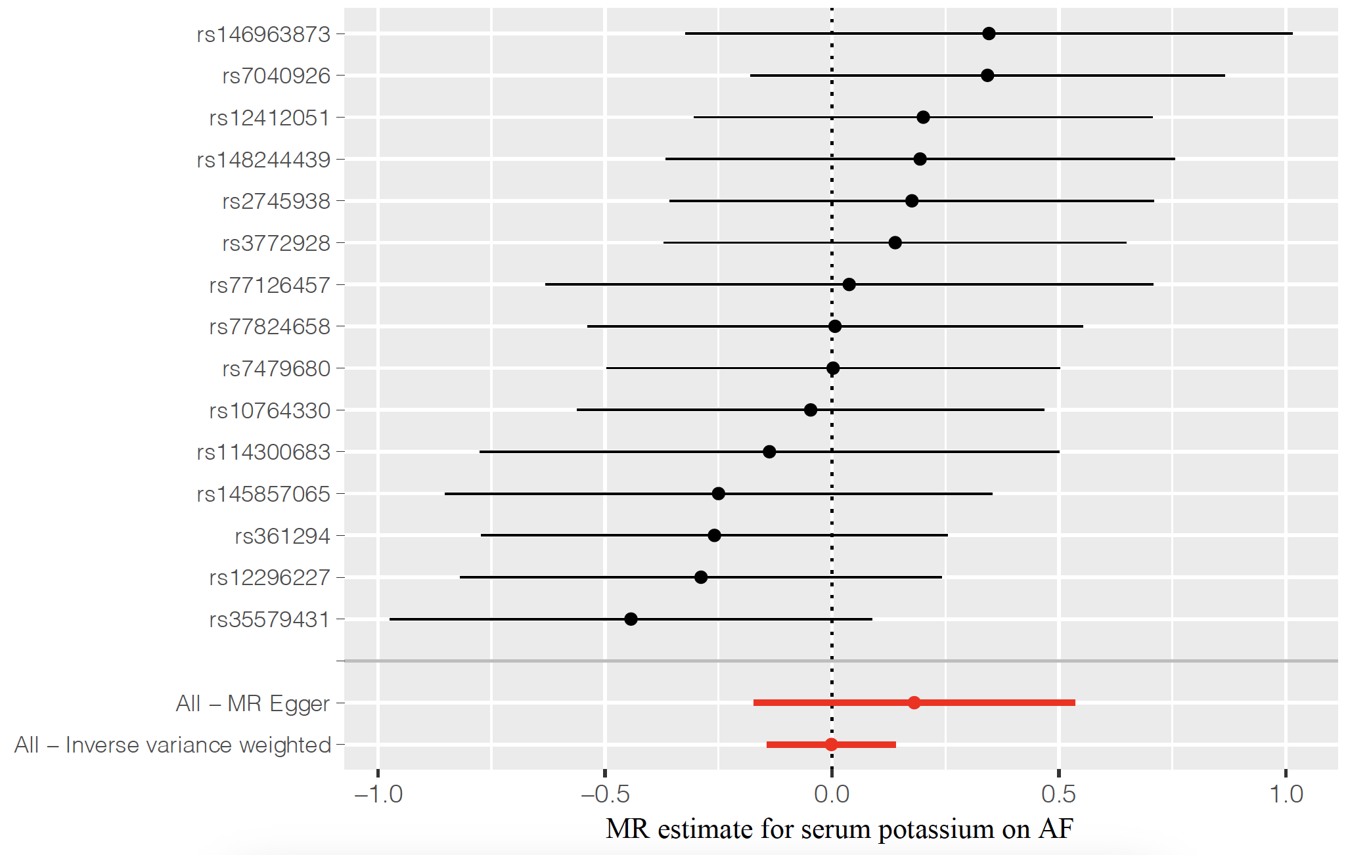
Figure 1 Forest plot of causal effects between potassium-associated SNPs and risk of AF.
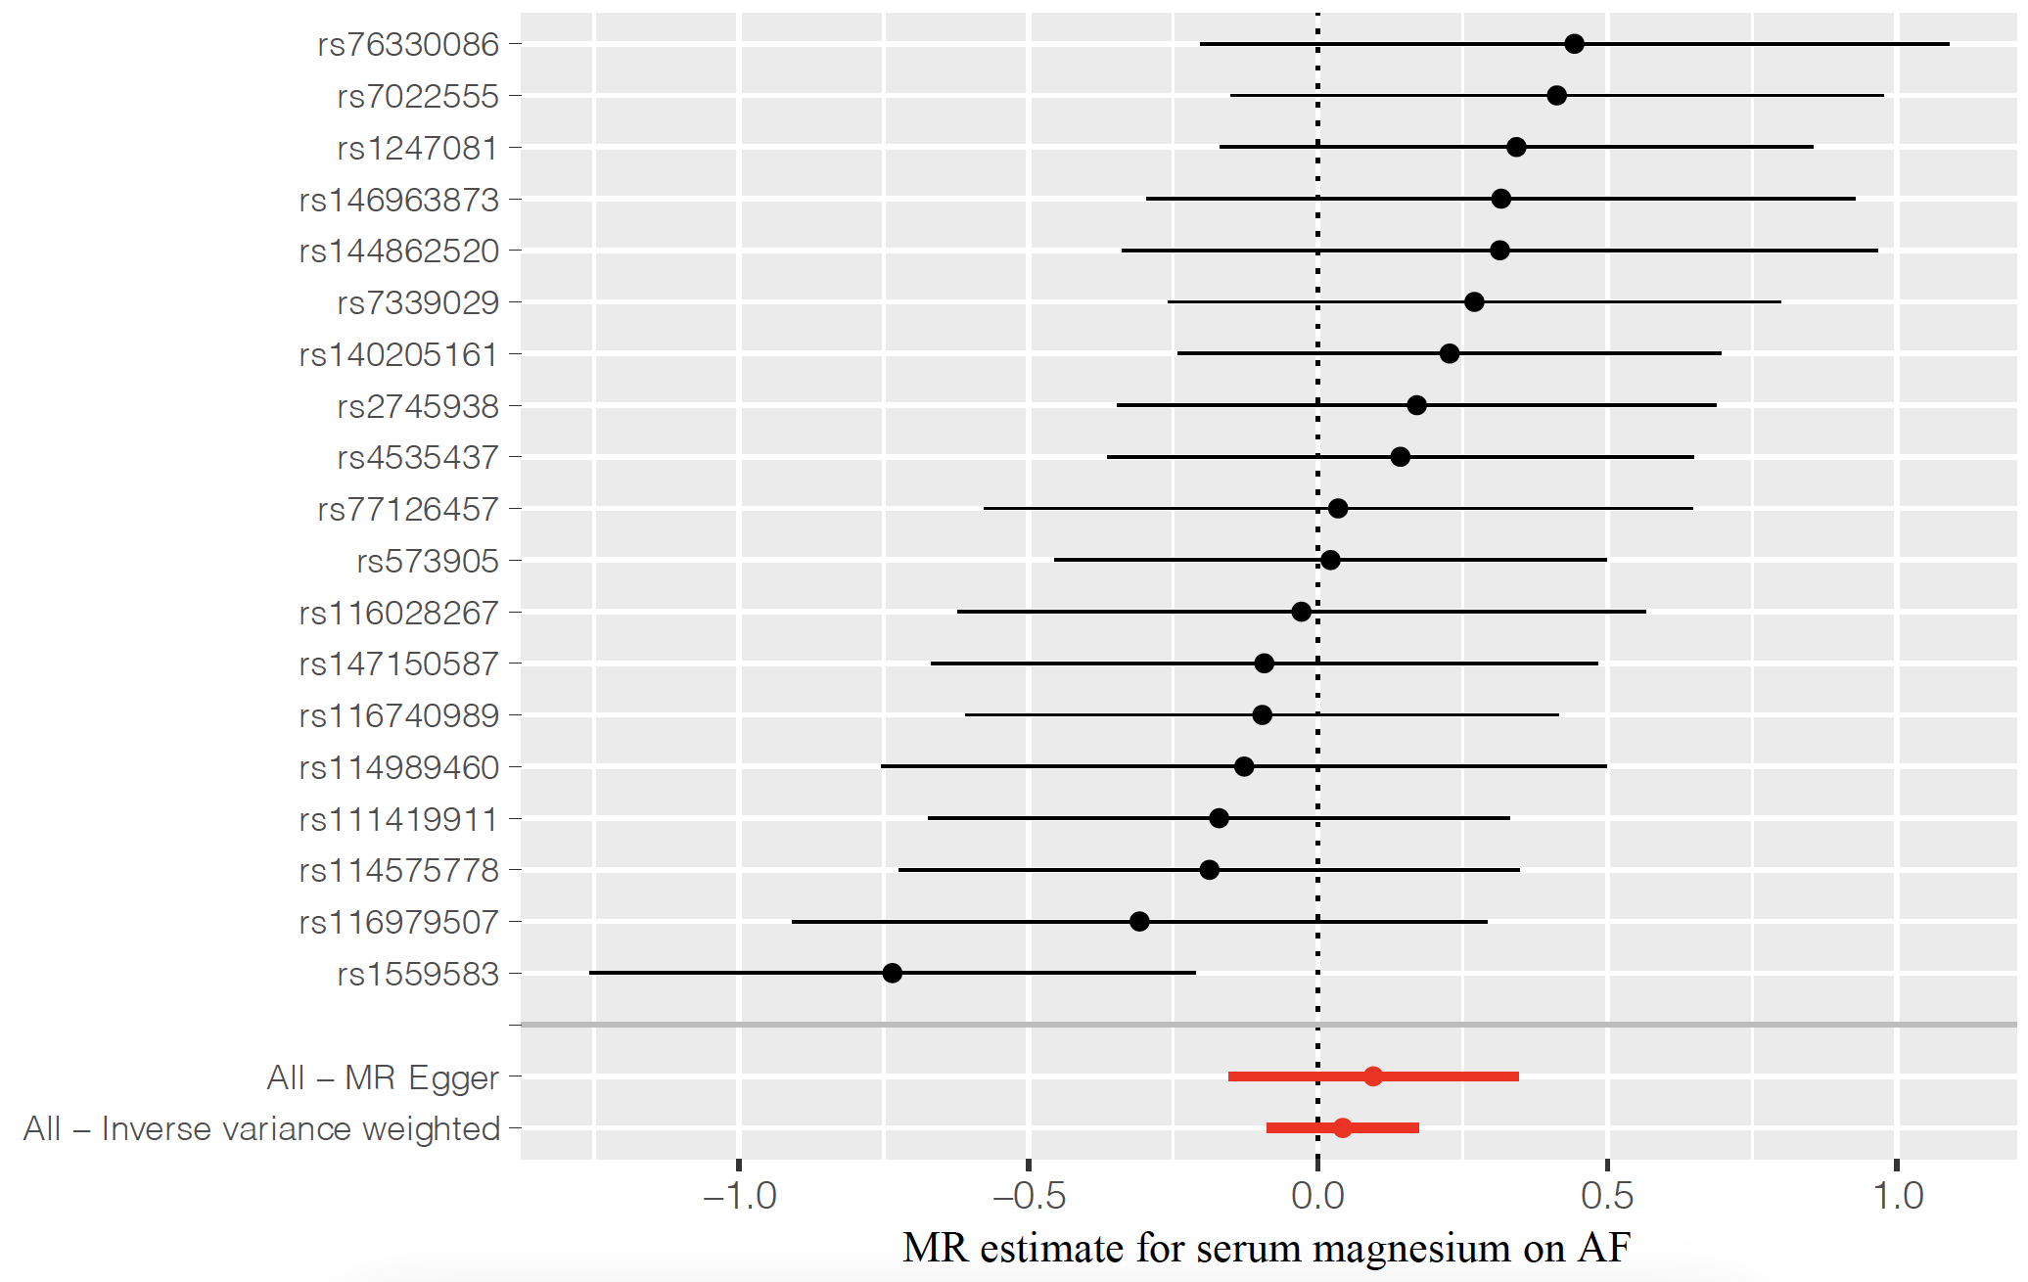
Figure 2 Forest plot of causal effects between magnesium-associated SNPs and risk of AF.
Figure 3 Forest plot of causal effects between phosphate-associated SNPs and risk of AF.
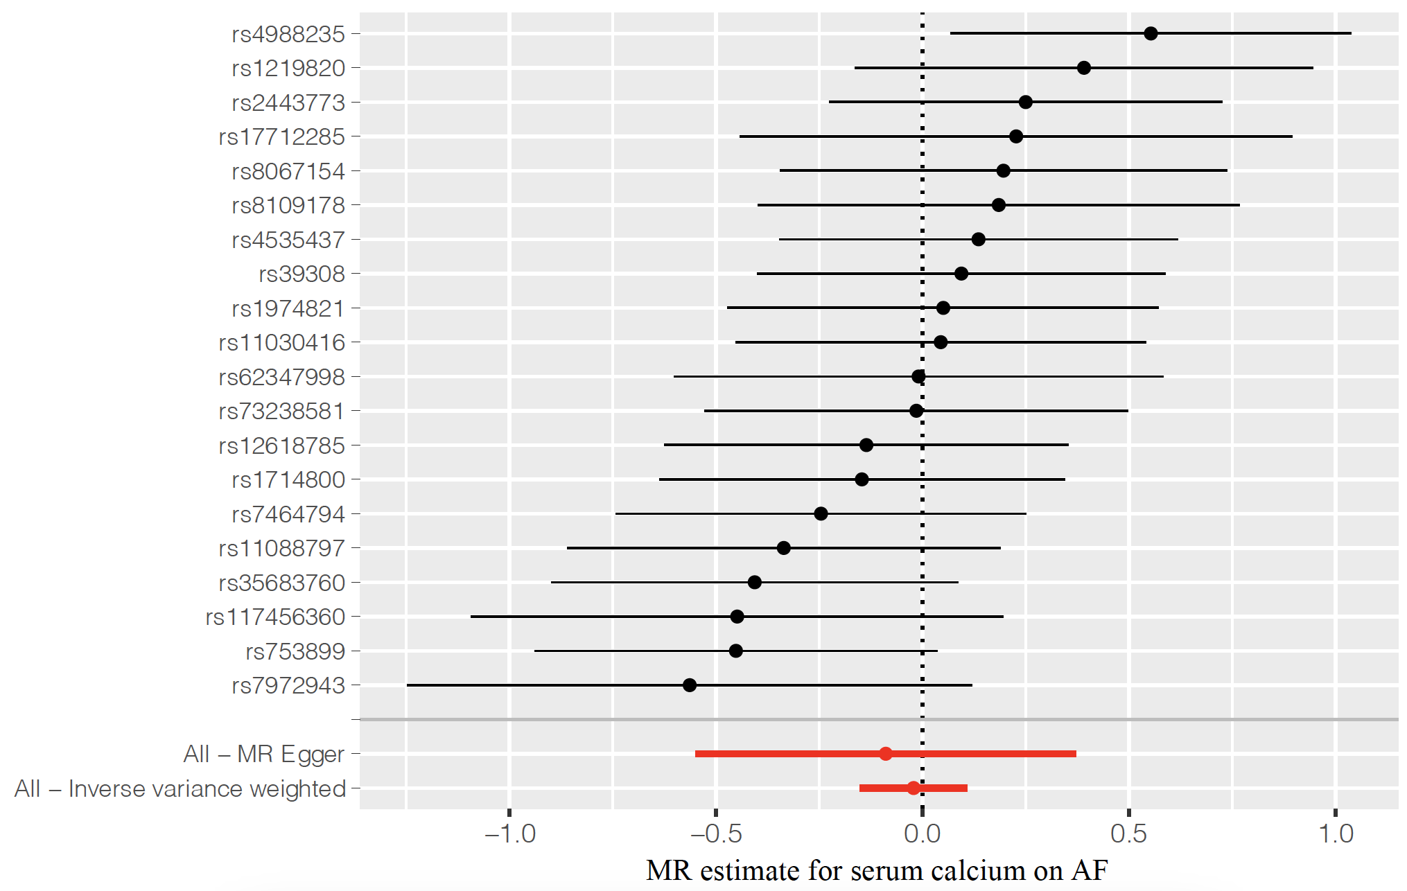
Figure 4 Forest plot of causal effects between calcium-associated SNPs and risk of AF.
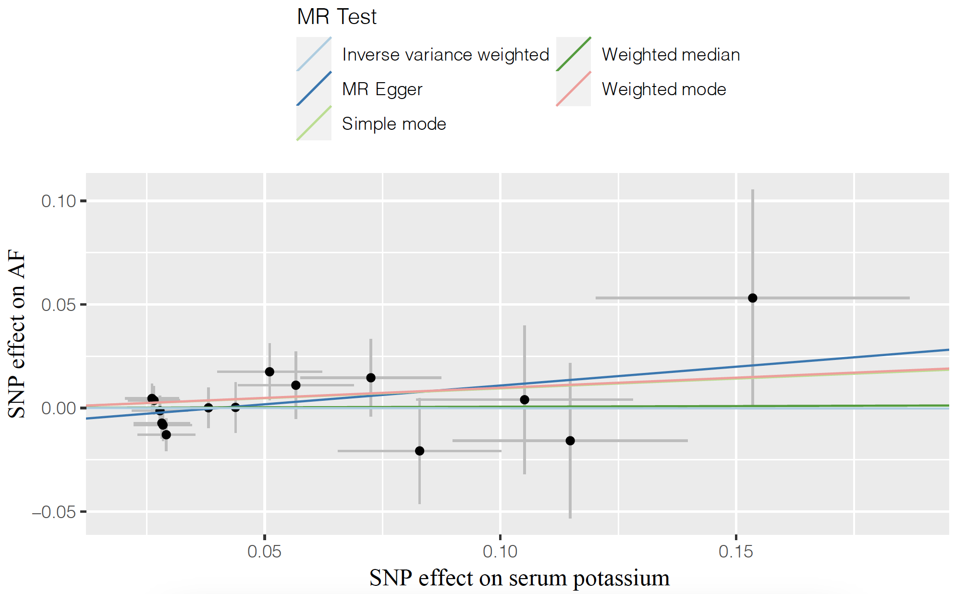
Figure 5 Scatter plot of causal effects between potassium-associated SNPs and risk of AF.
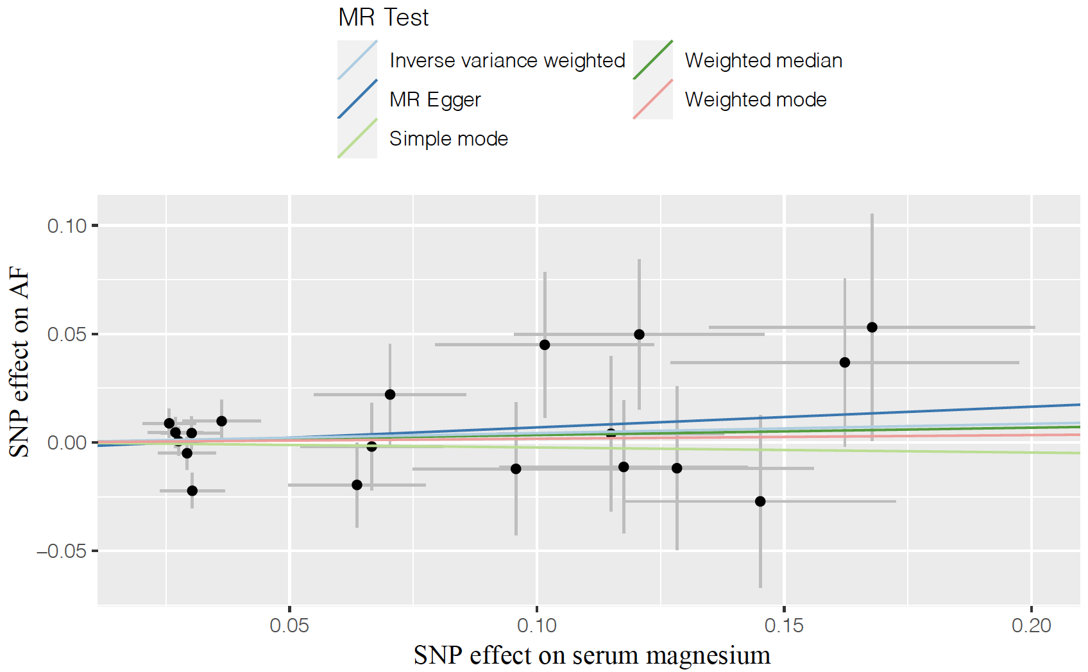
Figure 6 Scatter plot of causal effects between magnesium-associated SNPs and risk of AF.
Figure 7 Scatter plot of causal effects between phosphate-associated SNPs and risk of AF.
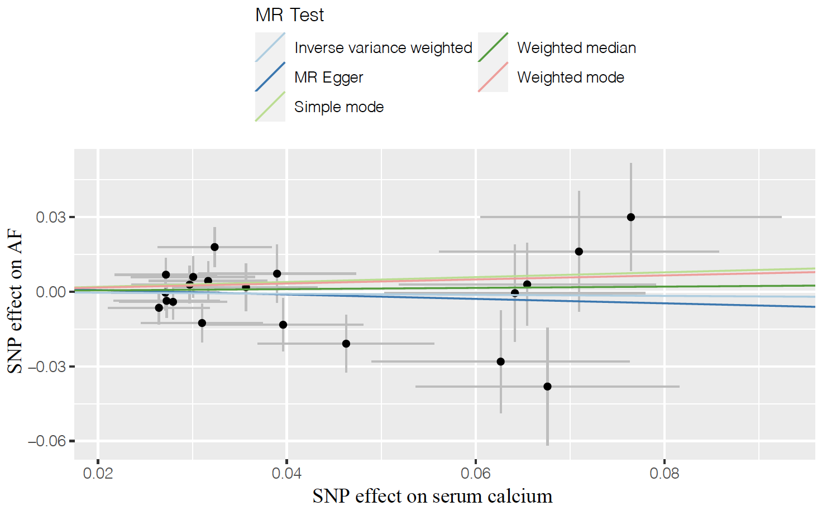
Figure 8 Scatter plot of causal effects between calcium-associated SNPs and risk of AF.
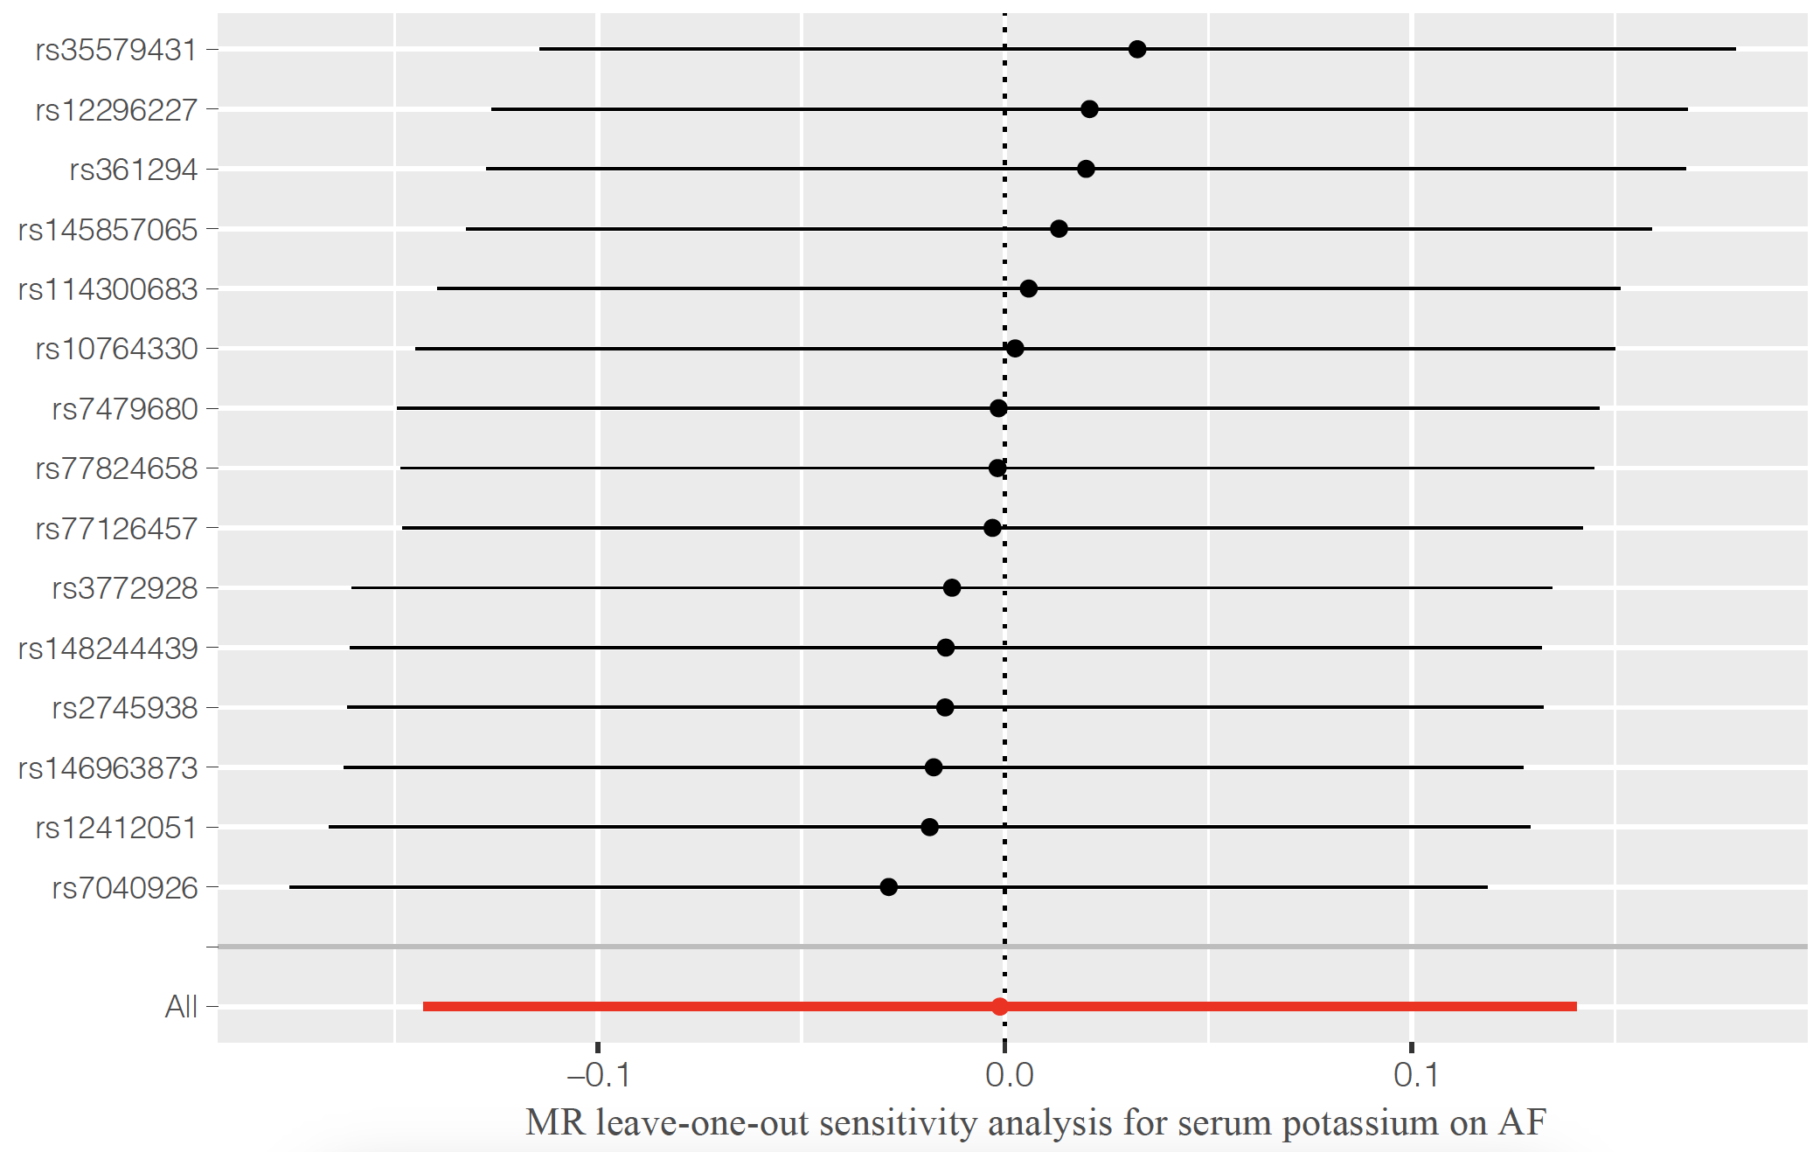
Figure 9 MR leave-one-out sensitivity analysis for serum potassium on AF.
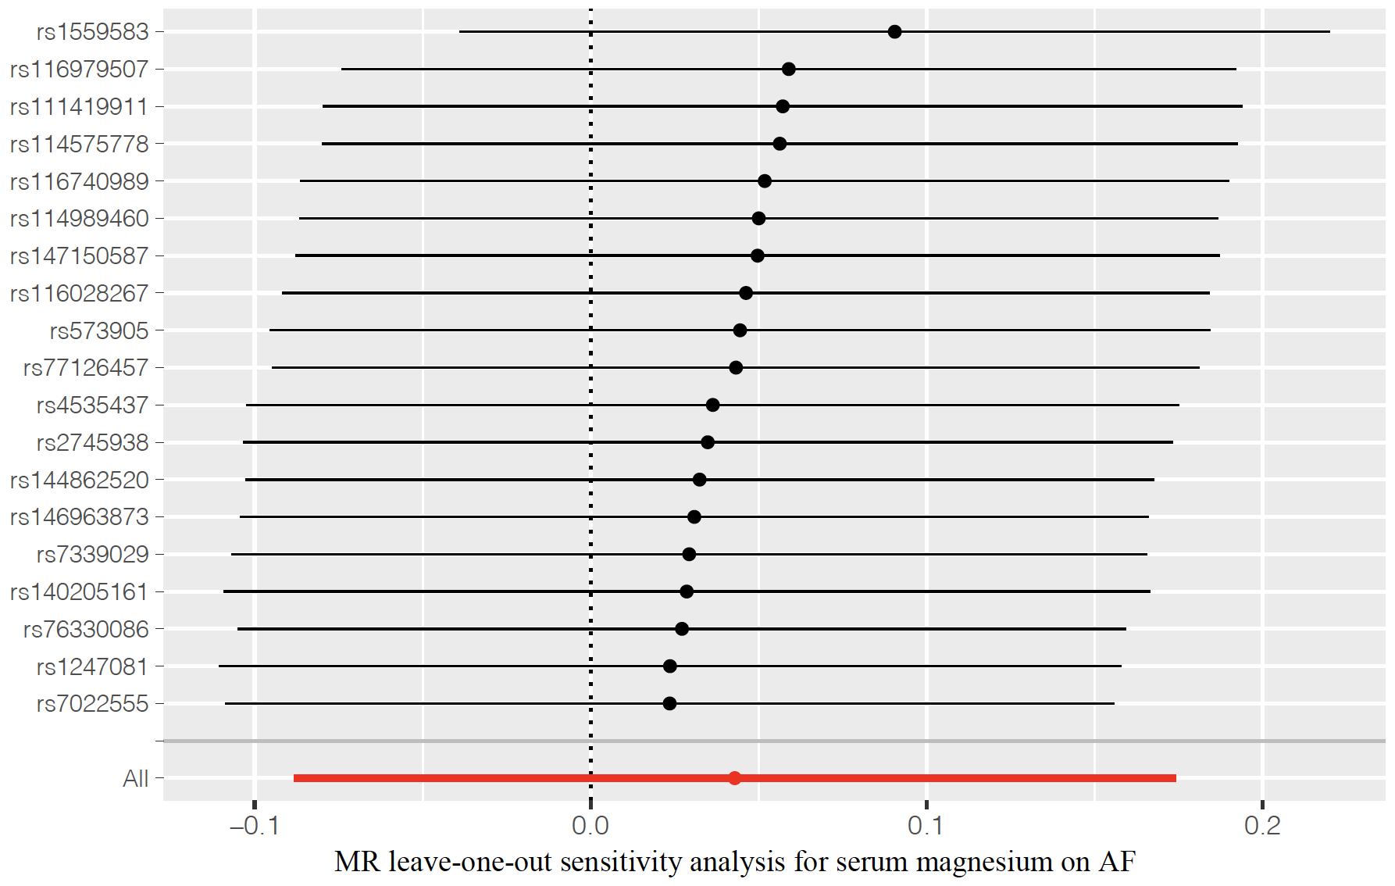
Figure 10 MR leave-one-out sensitivity analysis for serum magnesium on AF.
Figure 11 MR leave-one-out sensitivity analysis for serum phosphate on AF.
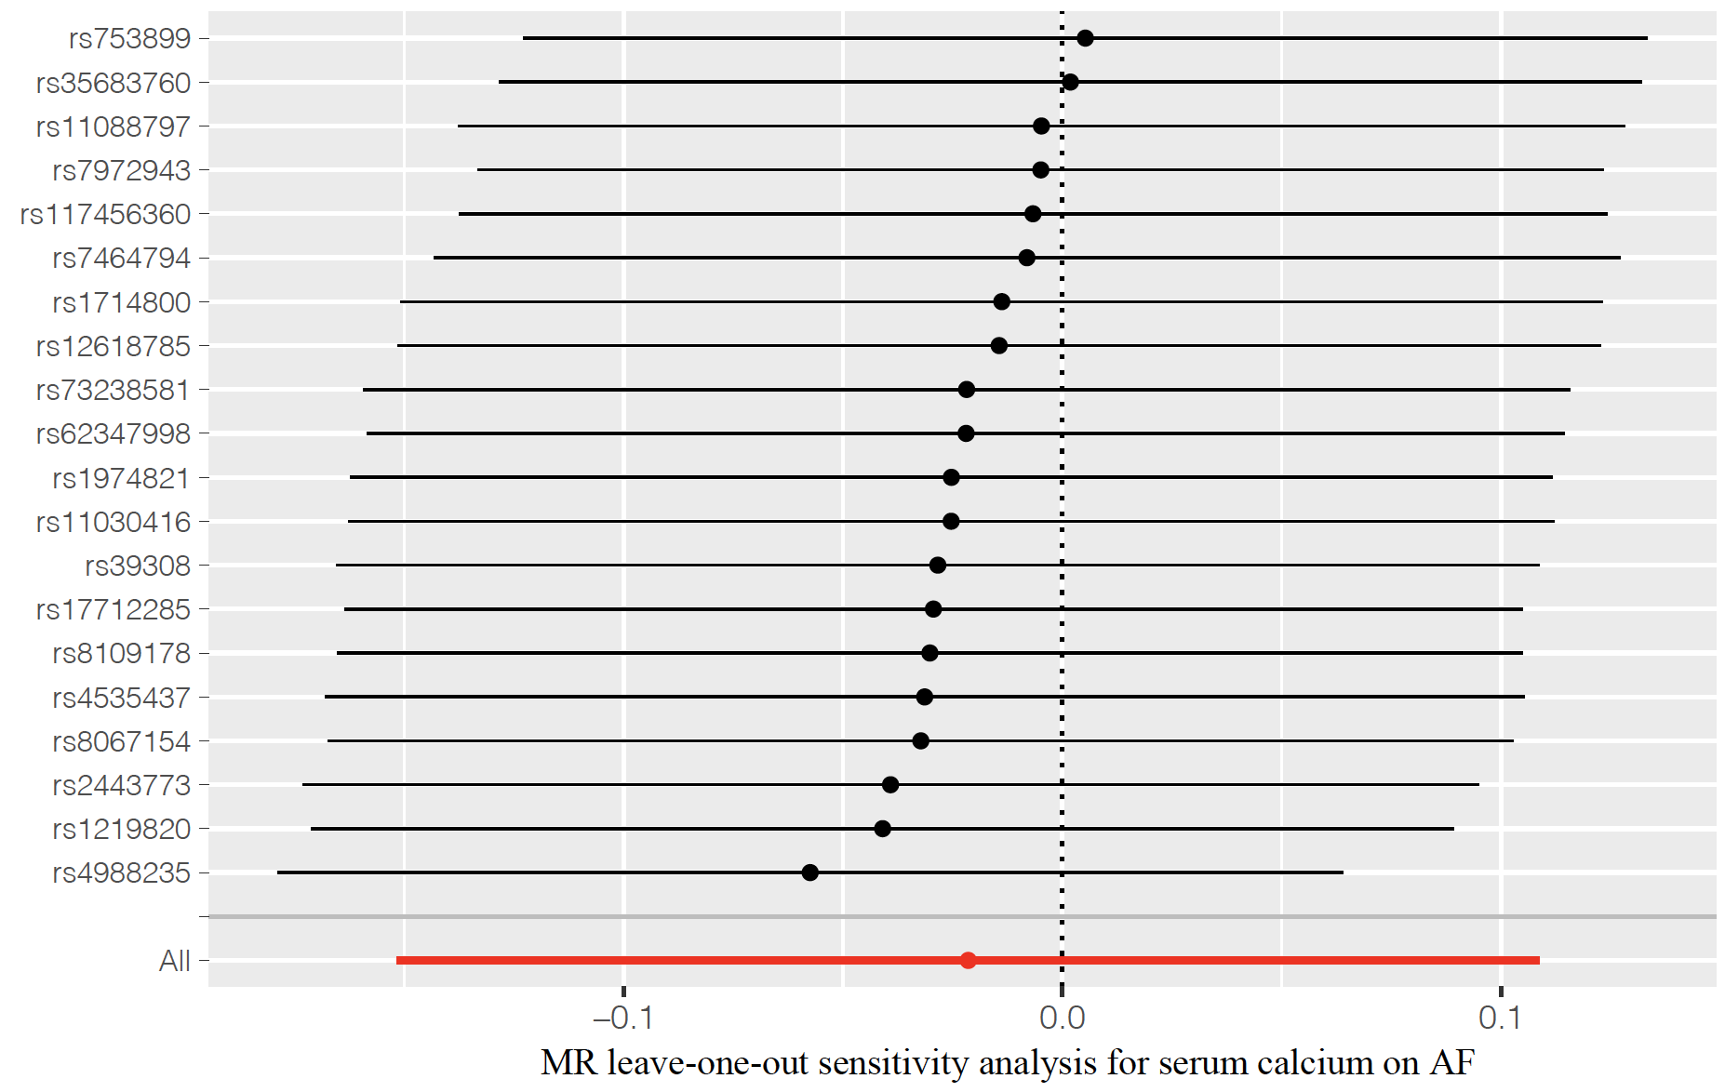
Figure 12 MR leave-one-out sensitivity analysis for serum calcium on AF.
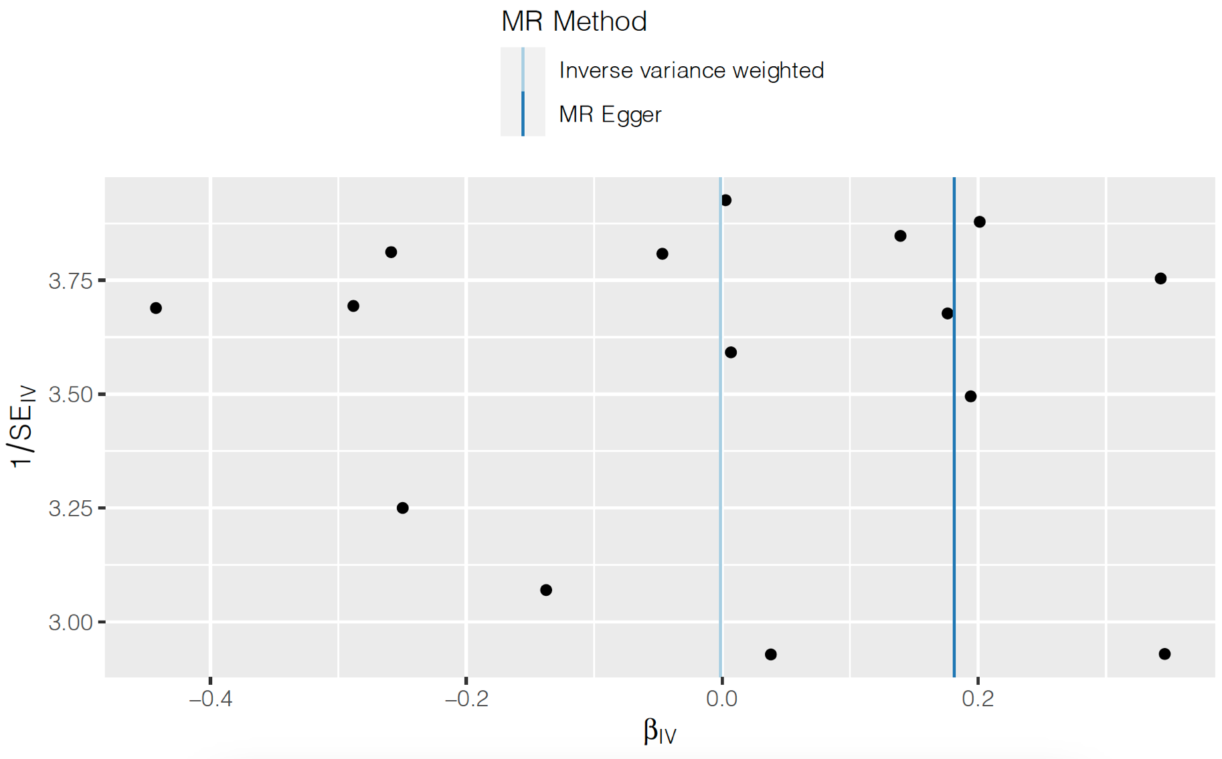
Figure 13 Funnel plot of causal association between serum potassium on AF.
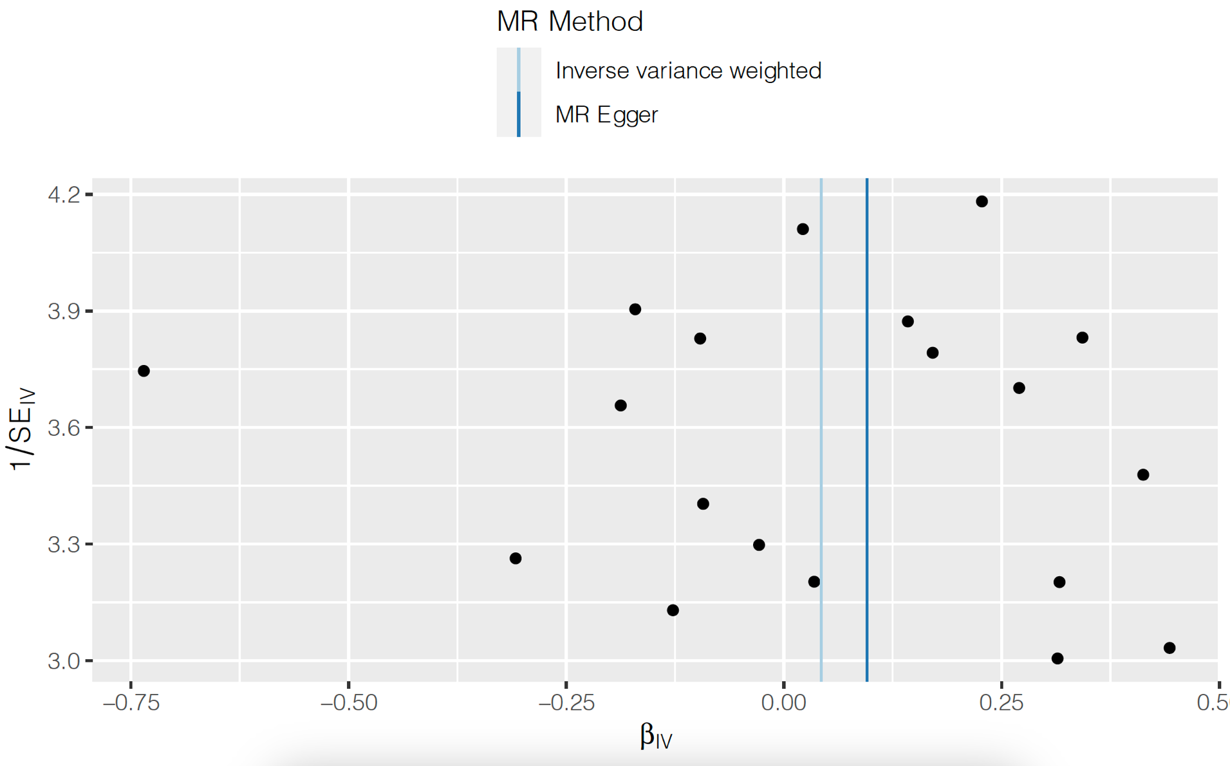
Figure 14 Funnel plot of causal association between serum magnesium on AF.
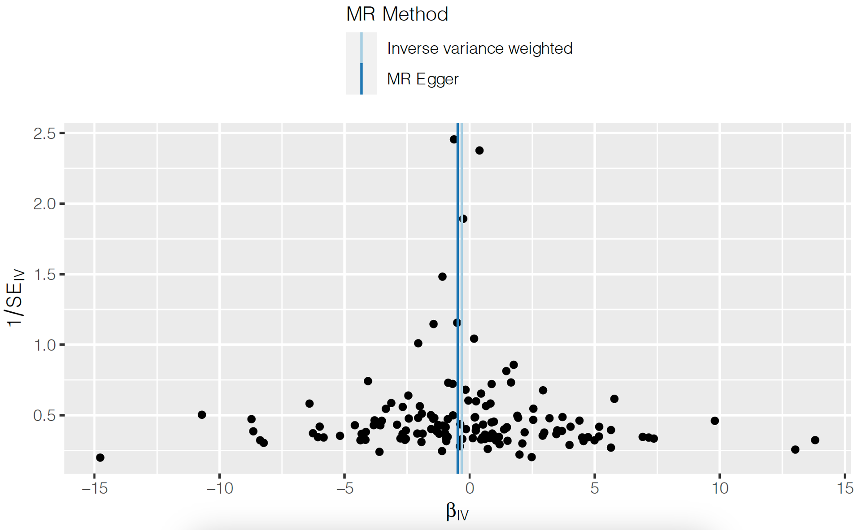
Figure 15 Funnel plot of causal association between serum phosphate on AF.
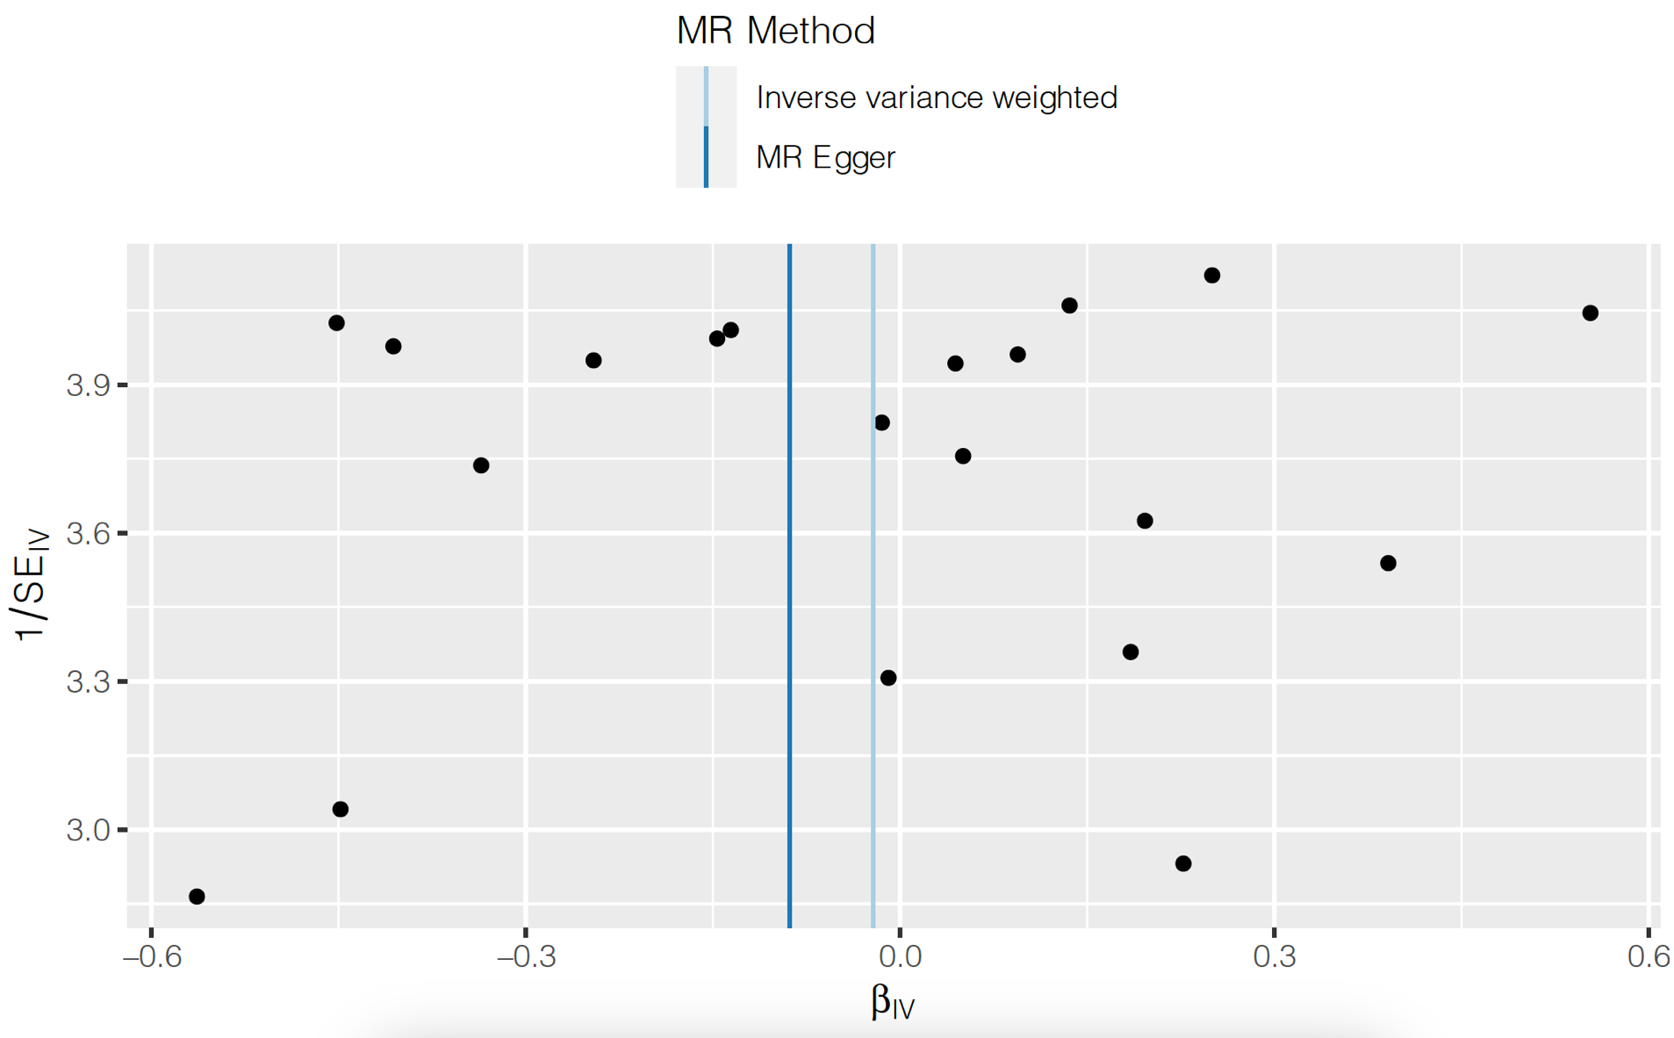
Figure 16 Funnel plot of causal association between serum calcium on AF.

