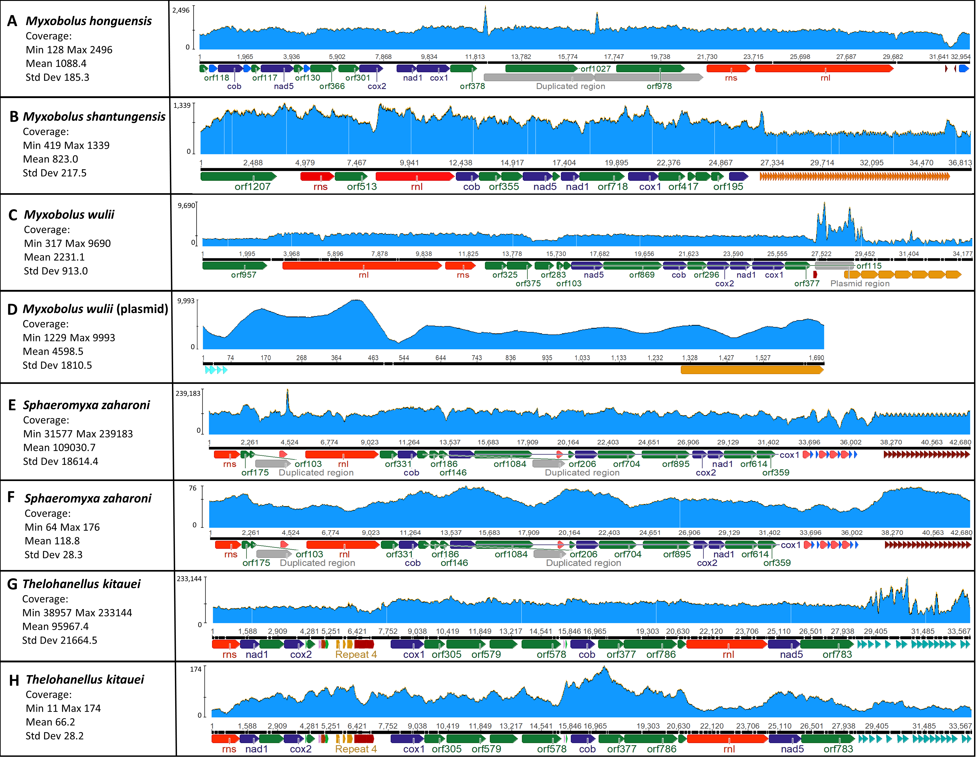

Additional file 2 – DNA coverage depth of the mt chromosomes.
Illumina reads (or ONT reads) were mapped to each chromosome individually using Geneious Prime version 2023.2.1 (see Methods). A) M. honghuensis Illumina reads; B) M. shantungensis Illumina reads; C) M. wulii Illumina reads; D) M. wulii plasmid Illumina reads; E) S. zaharoni Illumina reads; F) S. zaharoni ONT reads; G) T. kitauei Illumina reads; H) T. kitauei ONT reads. Each species sequence is shown schematically below the per-base coverage, indicated in light blue. The sequence annotations follow Figure 1. In dark blue are depicted the five canonical mt protein coding genes (cox1, cox2, cob, nad1 and nad5), in red the two rRNA subunits (rns and rnl), in green unknown ORF. All other colored arrows indicate repeated elements. Repeated elements the same sequence have the same color. Repeats shorter than 100 base pairs were not annotated. Regions with lower or higher mapping coverage were challenging for assembly (see Methods).

