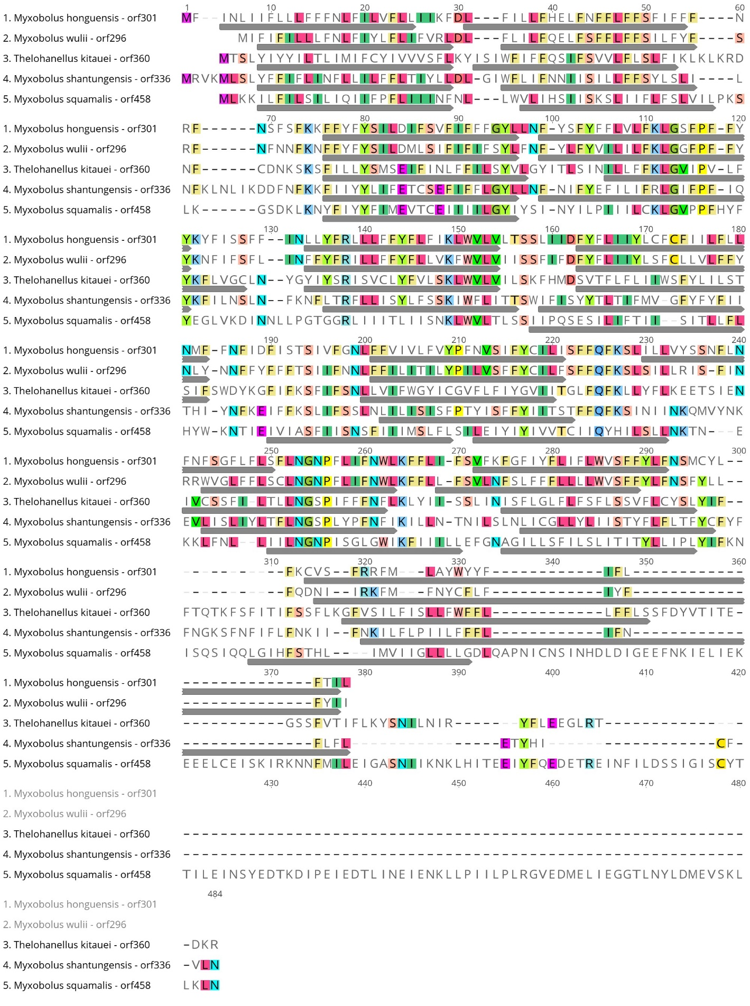
Additional file 5A.
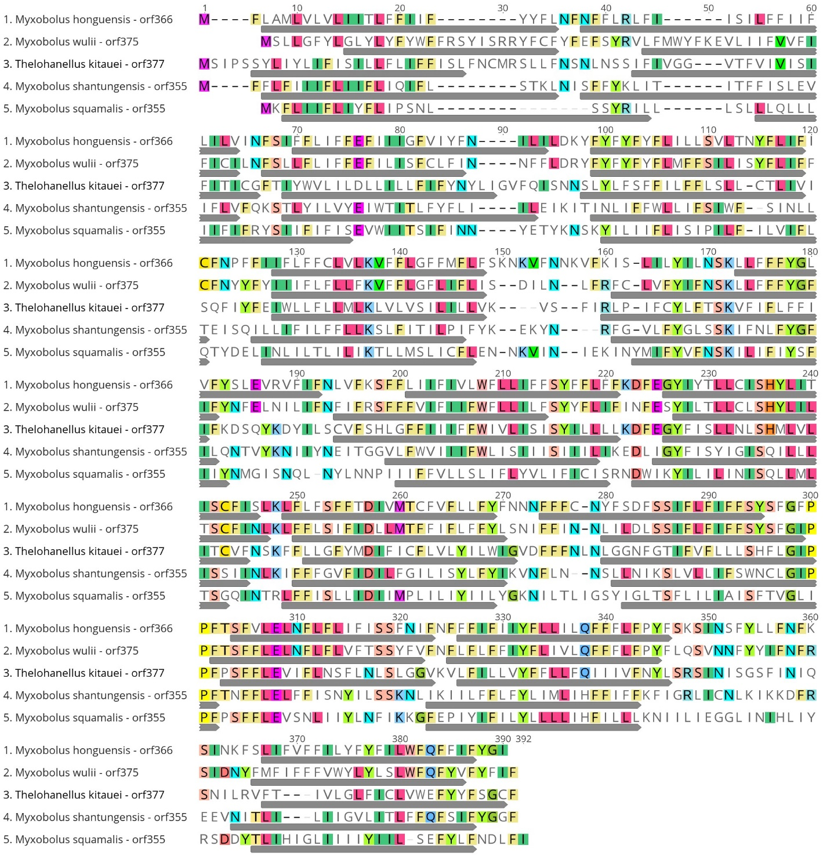
Additional file 5B.

Additional file 5 – Alignments showing sequence similarity between unknown ORFs from myxobolid species.
Amino acids positions shared by two sequences or more are colored. The gray arrows indicated putative transmembrane domains. A) Alignment of M. honghuensis orf301, M. wulii orf296, T. kitauei orf336, M. shantungensis orf 336 and M. squamalis orf458. B) Alignment of M. honghuensis orf366, M. wulii orf375, T. kitauei orf377, M. shantungensis orf 355 and M. squamalis orf355.

