Evolutionary genetics of pulmonary anatomical adaptations in deep-diving cetaceans
Boxiong Guo, Yixuan Sun, Yuehua Wang, Ya Zhang, Yu Zheng, Shixia Xu, Guang Yang & Wenhua Ren*
Jiangsu Key Laboratory for Biodiversity and Biotechnology, College of Life Sciences, Nanjing Normal University, Nanjing, China.
*Corresponding author: E-mail: 08162@njnu.edu.cn.

Supplementary Figures

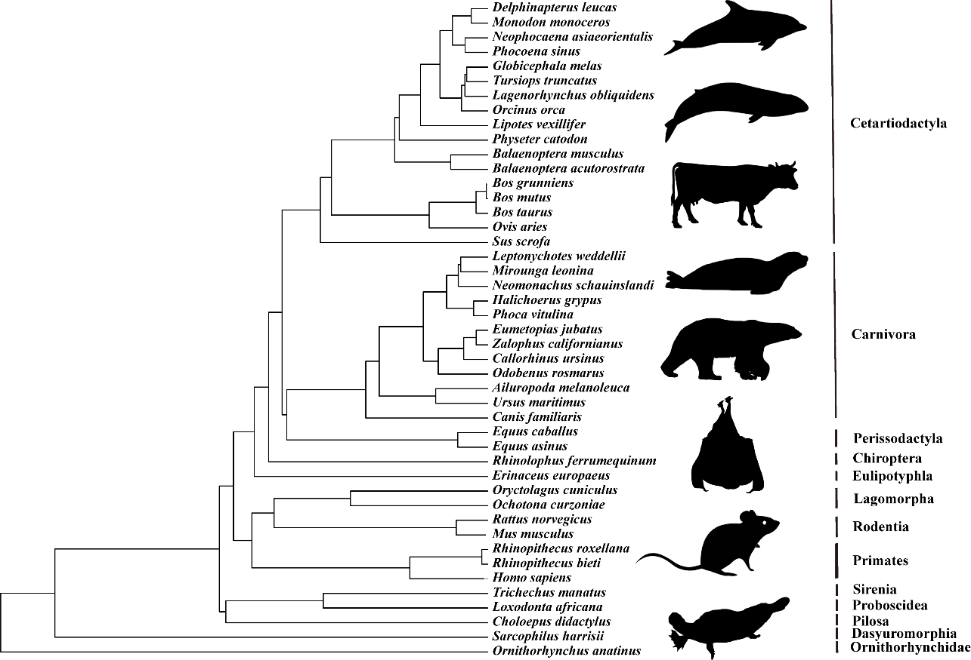

Fig. S1. The phylogeny of 45 mammals used in PAML (and in other subsequent evolutionary analyses such as PGLS) using TimeTree (http://www.timetree.org/), silhouette images come from the PhyloPic (https://www.phylopic.org/).

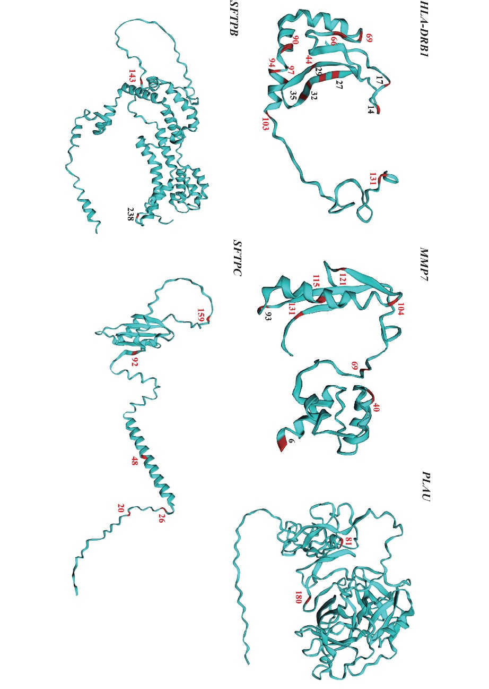

Fig. S2. The positively selected sites obtained using the branch-site model are mapped onto the three-dimensional structure of the gene. The sites with red numbers are located in the important functional domains of the gene. The figures were created using EzMOL.

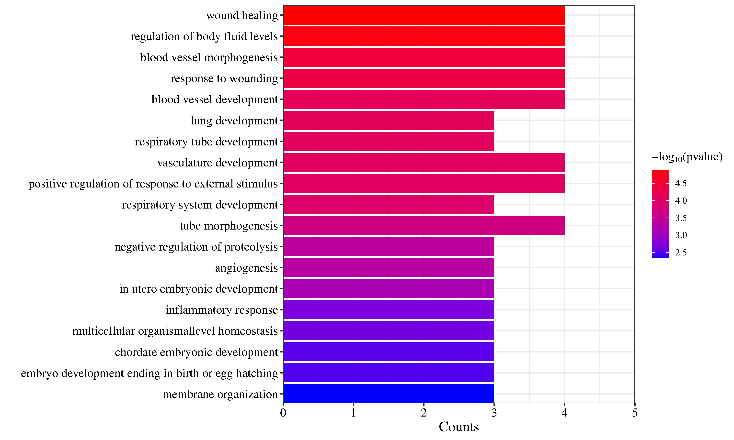

Fig. S3. GO enrichment terms for fourteen specific amino acid substitutions protein in cetaceans. The 20 related terms in biological process are shown.
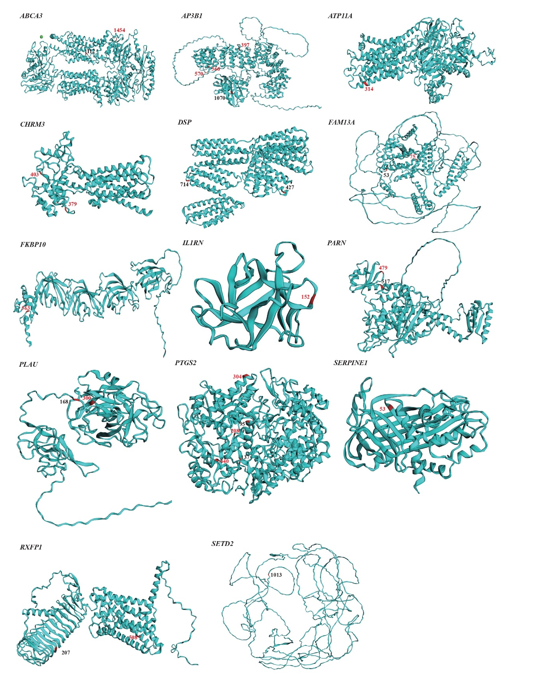

Fig. S4. cetacean-special amino acid substitutions mapped on the three-dimensional structure of genes. The sites with red numbers are located in the important functional domains of the gene. The figures were created using EzMOL.

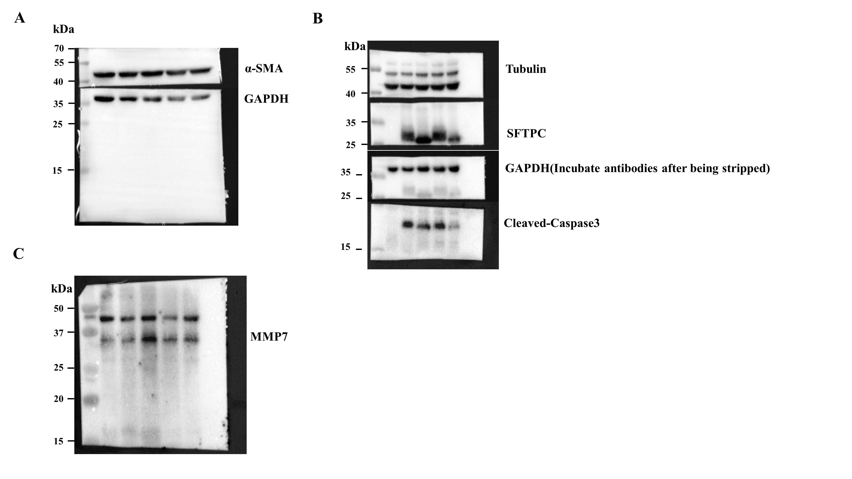

Fig. S5. Full-length blots/gels of α-SMA, GAPDH (A); Tubulin, SFTPC, GAPDH (Incubate antibodies after being stripped), Cleaved-Caspase 3 (B) and MMP7 (C).

