Supplementary Tables and Figures
Table S1. Characteristics of all MECC cases and selected cases that underwent pathologic review and ImmunoSeq assays.
Characteristic | All Cases |  | GWAS and Pathology TILs/hpf Data |  | GWAS and ImmunoSeq Data
Characteristic | Frequency | Percent | Frequency | Percent | Frequency | Percent
N | 6,006 | 100.00 | 2,876 | 47.90 | 2,395 | 39.90
Age | mean=68.8 | std=12.4 | mean=69.5 | std=12.2 | mean=69.4 | std=12.1
Sex
Female | 2,869 | 47.77 | 1,385 | 48.12 | 1,153 | 48.10
Male | 3,137 | 52.23 | 1,493 | 51.88 | 1,244 | 51.90
Ethnicity
Arab | 898 | 14.95 | 365 | 12.68 | 287 | 11.97
Ashkenazi | 3,572 | 59.47 | 1,805 | 62.72 | 1,507 | 62.87
Sephardi | 1,190 | 19.81 | 549 | 19.08 | 465 | 19.40
Other | 346 | 5.76 | 159 | 5.52 | 138 | 5.76
Jewish Ancestry
Yes | 4,762 | 79.29 | 2,354 | 81.79 | 1,972 | 82.27
No | 1,244 | 20.71 | 524 | 18.21 | 425 | 17.73
Stage
I | 1,213 | 20.20 | 467 | 16.23 | 388 | 16.19
II | 2,457 | 40.91 | 1,319 | 45.83 | 1,101 | 45.93
III | 976 | 16.25 | 540 | 18.76 | 459 | 19.15
IV | 631 | 10.51 | 302 | 10.49 | 252 | 10.51
Missing | 729 | 12.14 | 250 | 8.69 | 197 | 8.22
MSI Status
Stable | 3,256 | 82.16 | 2,249 | 84.36 | 1,939 | 86.02
Instable | 707 | 17.84 | 417 | 18.54 | 315 | 13.98

Table S2. Subset analysis on top SNPs for clonality in microsatellite stable (MSS) subjects. Three additional loci (denoted with †) were identified to be associated with clonality with p < 5x10⁻⁸ in patients with MSS tumors.
RS ID: CHR:BP | Nearest Gene | Locus | EFF/REF Allele* | Discovery Data (MECC)  (N=1,938) |  |  | Replication Data (CLX)  (N=92) |  |  | Replication Data (CRCGEN)  (N=162) |  |  | Meta Analysis  (N=2,192)
 |  |  |  | EAF** | OR  (95% CI)*** | p | EAF | OR (95% CI) | p | EAF | OR (95% CI) | p | EAF | OR (95% CI) | p | P_{Heterogeneity}
rs4918567:10:112459918 | RBM20 | 10q25.2 | T/C | 0.10 | 0.77 (0.69-0.84) | 3.54E-06 | 0.19 | 0.90 (0.64-1.27) | 0.5609 | 0.13 | 0.88 (0.63-1.24) | 0.4594 | 0.22 | 0.79 (0.72-0.87) | 3.70E-06 | 0.5769
rs34245610:18:56234676 | ALPK2 | 18q21.32 | T/C | 0.81 | 1.19 (1.1-1.29) | 1.38E-05 | 0.84 | 1.23 (0.83-1.83) | 0.3049 | 0.82 | 1.15 (0.86-1.53) | 0.3403 | 0.81 | 1.19 (1.11-1.29) | 4.89E-06 | 0.9569
rs4443313:4:79040704 | FRAS1 | 4q21.21 | A/G | 0.77 | 0.82 (0.77-0.89) | 5.01E-07 | 0.71 | 0.83 (0.60-1.15) | 0.2639 | 0.70 | 1.10 (0.88-1.38) | 0.3820 | 0.76 | 0.85 (0.79-0.91) | 3.54E-06 | 0.0506
rs184508436:6:106628943 | ATG5 | 6q21 | A/G | 0.01 | 2.40 (1.72-3.34) | 2.32E-07 | 0.01 | 1.44 (0.20-10.26) | 0.7196 | 1.00 | 9.47 (0.99-90.78) | 0.0531 | 0.01 | 2.43 (1.76-3.36) | 6.55E-08 | 0.4336
rs76250771:2:155371283 | AC009227.3 | 2q24.1 | T/C | 0.15 | 0.81 (0.74-0.88) | 2.19E-06 | 0.08 | 0.81 (0.49-1.33) | 0.4007 | 0.07 | 0.72 (0.47-1.11) | 0.1367 | 0.15 | 0.80 (0.74-0.88) | 5.04E-07 | 0.8766
rs7874748:9:35978632 | YBX1P10 | 9p13.3 | T/C | 0.29 | 1.15 (1.08-1.24) | 3.85E-05 | 0.34 | 1.12 (0.82-1.52) | 0.4788 | 0.31 | 1.05 (0.84-1.32) | 0.6530 | 0.34 | 1.14 (1.07-1.22) | 3.51E-05 | 0.7357
rs773042428:4:116966954† | RP11-659O3.1 | 4q26 | C/G | 1.00 | 0.18 (0.1-0.33) | 4.35E-08 | - | - | - | - | - | - | 1.00 | 0.18 (0.1-0.33) | 3.83E-08 | 1
rs149343558:6:106709461† | ATG5 | 6q21 | T/C | 0.99 | 0.41 (0.3-0.58) | 1.76E-07 | 0.01 | 0.69 (0.1-5) | 0.718355 | 0.004 | 0.11 (0.01-0.94) | 0.0455478 | 0.99 | 0.41 (0.29-0.56) | 4.51E-08 | 0.4153
rs75988446:1:191656812† | RP11-309H21,2 | 1q31.2 | T/C | 1.00 | 0.03 (0.01-0.11) | 8.66E-07 | 0.01 | 0.08 (0.01-0.56) | 0.0122138 | - | - | - | 0.997 | 0.04 (0.01-0.13) | 4.24E-08 | 0.351
* Effect/Reference Allele
** Effect allele frequency
*** Odds ratio and 95% Confidence Intervals
† Denote SNPs that are associated with clonality among patients with MSS tumors with p < 5x10⁻⁸.

Table S3. Subset analysis on top SNPs for abundance in microsatellite stable (MSS) subjects. Two additional loci (denoted with †) were identified to be associated with abundance with p < 5x10⁻⁸ in patients with MSS tumors.
RSID: CHR:BP | Nearest Gene | Loci | EFF/REF Alleles* | Discovery (MECC)  (N=1,938) |  |  | Replication (CLX)  (N=94) |  |  | Replication (CRCGEN)  (N=162) |  |  | Meta Analysis  (N=2,194)
 |  |  |  | EAF** | OR (95% CI)*** | p | EAF | OR (95% CI)*** | p | EAF | OR (95% CI)*** | p | EAF | OR (95% CI)*** | p | P_{Heterogeneity}
rs1518405:2:181016277 | CWC22 | 2q31.3 | A/T | 0.970 | 1.59 (1.31-1.94) | 4.22E-06 | 0.032 | 1.74 (0.74-4.07) | 0.2054 | 0.012 | 0.97 (0.14-6.56) | 0.9737 | 0.970 | 1.60 (1.32-1.94) | 1.73E-06 | 0.8417
rs144595725:14:31526087 | AP4S1 | 14q12 | A/G | 0.991 | 2.55 (1.69-3.84) | 7.94E-06 | - | - | - | 0.007 | 3.96 (0.18-88.64) | 0.3871 | 0.991 | 2.55 (1.69-3.84) | 7.50E-06 | 1.0000
rs56148061:11:61014040 | PGA4:PGA5 | 11q12 | A/C | 0.038 | 0.58 (0.46-0.72) | 1.39E-06 | 0.954 | 0.45 (0.18-1.08) | 0.0766 | 0.950 | 2.45 (0.42-14.31) | 0.3218 | 0.039 | 0.57 (0.46-0.71) | 2.88E-07 | 0.5704
rs147844733:17:36994755 | C17orf98 | 17q12 | A/T | 0.991 | 2.00 (1.36-2.93) | 4.35E-04 | - | - | - | 0.003 | 0.36 (0.01-19.56) | 0.6191 | 0.991 | 2 (1.36-2.93) | 4.25E-04 | 1.0000
rs142105062:11:122506047 | RP11-266E8.2 | 11q13.1 | T/C | 0.005 | 0.21 (0.1-0.44) | 2.66E-05 | - | - | - | 0.986 | 1.04 (0.09-12.46) | 0.9727 | 0.005 | 0.21 (0.1-0.44) | 2.54E-05 | 1.0000
rs577783:6:137918440 | BTF3L4P3 | 6q23.3 | A/G | 0.370 | 0.82 (0.77-0.89) | 1.56E-07 | 0.549 | 1.08 (0.8-1.46) | 0.6240 | 0.594 | 0.68 (0.45-1.03) | 0.0722 | 0.380 | 0.84 (0.78-0.9) | 5.53E-07 | 0.0890
rs9770081:7:622706 | PRKAR1B | 7p22.3 | T/G | 0.252 | 0.80 (0.73-0.88) | 2.85E-06 | - | - | - | 0.650 | 1.82 (0.92-3.62) | 0.0887 | 0.252 | 0.80 (0.73-0.88) | 2.66E-06 | 1.0000
rs12313375:12:94976499 | TMCC3 | 12q22 | A/C | 0.981 | 0.50 (0.39-0.65) | 1.90E-07 | 0.020 | 0.70 (0.23-2.1) | 0.5270 | 0.012 | 0.29 (0.04-1.97) | 0.2053 | 0.981 | 0.51 (0.4-0.66) | 1.65E-07 | 0.5671
rs135429:22:44657217 | KIAA1644 | 22q13.31 | T/C | 0.685 | 0.86 (0.8-0.92) | 4.44E-05 | 0.361 | 0.86 (0.58-1.26) | 0.4301 | 0.356 | 1.02 (0.66-1.58) | 0.9114 | 0.673 | 0.86 (0.8-0.92) | 3.06E-05 | 0.9996
rs4495475:8:66165989 | RPL31P41 | 8q13.1 | A/C | 0.208 | 1.20 (1.1-1.3) | 2.05E-05 | 0.821 | 1.03 (0.69-1.53) | 0.8851 | 0.810 | 0.86 (0.49-1.51) | 0.6014 | 0.234 | 1.19 (1.1-1.29) | 2.57E-05 | 0.4609
rs190417185:2:74892755 | SEMA4F | 2p13.1 | T/C | 0.013 | 2.19 (1.52-3.14) | 2.55E-05 | - | - | - | 0.994 | 0 (0-3.94) | 0.1030 | 0.013 | 2.19 (1.52-3.14) | 2.44E-05 | 1.0000
rs533820043:4:140253161† | NAA15 | 4q31 | T/C | 0.006 | 0.22 (0.13-0.37) | 2.08E-08 | - | - | - | - | - | - | 0.006 | 0.22 (0.13-0.37) | 1.82E-08 | 1.0000
rs571849233:4:140353143† | RP11-83A24.2 | 4q31 | T/C | 0.006 | 0.23 (0.14-0.39) | 4.47E-08 | - | - | - | - | - | - | 0.006 | 0.23 (0.14-0.39) | 3.95E-08 | 1
* Effect/Reference Allele
** Effect allele frequency
*** Odds ratio and 95% Confidence Intervals.
† Denote SNPs that are associated with abundance among patients with MSS tumors with p < 5x10⁻⁸.
Table S4. Subset analysis on top SNPs for TILs in microsatellite stable (MSS) subjects.
RS ID: CHR:BP | Nearest Gene | Loci | EFF/REF alleles* | Discovery (MECC)  (N=2,248) |  |  | Replication (CLX)  (N=97) |  |  | Meta Analysis Results  (N=2,345)
 |  |  |  | EAF** | OR (95% CI)*** | p | EAF | OR (95% CI) | p | EAF | OR (95% CI) | p | P_{Heterogeneity}
rs10982853:9:118405173 | RP11-284G10.1 | 9q33.1 | C/T | 0.133 | 1.51 (1.26-1.81) | 8.40E-06 | 0.88 | 1.07 (0.40-2.83) | 0.8928 | 0.132 | 1.49 (1.25-1.78) | 1.06E-05 | 0.4969
rs215529:20:2767620 | RPL19P1 | 20p13 | C/T | 0.431 | 0.77 (0.69-0.87) | 2.66E-05 | 0.54 | 1.33 (0.66-2.69) | 0.4244 | 0.432 | 0.78 (0.7-0.88) | 6.17E-05 | 0.1348
* Effect/Reference Allele
** Effect allele frequency
*** Odds ratio and 95% Confidence Intervals.

Table S5. SNPs associated with tumor immune infiltration from previous literature.
rsID | Chr:Pos (EFF/REF allele) | MAF/Odds Ratio/P value | Reported Previously | Genotyped or Imputed in Discovery GWAS | TCR Clonality |  | TCR Abundance |  | TILs/hpf
 |  |  |  |  | Discovery | Meta-Analysis | Discovery | Meta-Analysis | Discovery | Meta-Analysis
rs11676348 | 2:219010146 | MAF | 0.5 | Genotyped | 0.57 | 0.56 | 0.57 |  | 0.56
(Carcinogenesis, 2015) | T/C | OR |  |  | 0.95 | 0.98 | 0.98 | 1.04 | 1.02 | 1.00
 |  | P | 7.00E-05 |  | 0.0692 | 0.3626 | 0.6195 | 0.2600 | 0.7002 | 0.9460
rs102275 | 11:61557803 | MAF |  | Genotyped | 0.29 | 0.29 | 0.29 |  | 0.29
(Carcinogenesis, 2015) | T/C | OR |  |  | 0.95 | 0.96 | 0.92 | 0.91 | 0.94 | 0.95
 |  | P | 2.00E-05 |  | 0.1266 | 0.1432 | 0.0205 | 0.0061 | 0.2547 | 0.3221
rs3366 | 21:44834825 | MAF |  | Genotyped in Omni only | 0.24 | 0.28 | 0.24 |  | 0.24
(Cell Report, 2020) | G/A | OR |  |  | 0.94 | 0.95 | 1.02 | 0.99 | 1.01 | 0.99
 |  | P | 2.99E-09 |  | 0.0917 | 0.1686 | 0.6095 | 0.7430 | 0.9166 | 0.8944
rs4819959 | 22:17586631 | MAF |  | Imputed | 0.50 | 0.50 | 0.50 |  | 0.50
(Cell Report, 2020) | G/A | OR |  |  | 1.02 | 1.03 | 1.04 | 0.98 | 0.99 | 1.01
 |  | P | 2.52E-16 |  | 0.6149 | 0.3216 | 0.2545 | 0.4369 | 0.7896 | 0.8465

Figure S1. Detailed information on genotyping and SNP quality control for the Discovery GWAS.
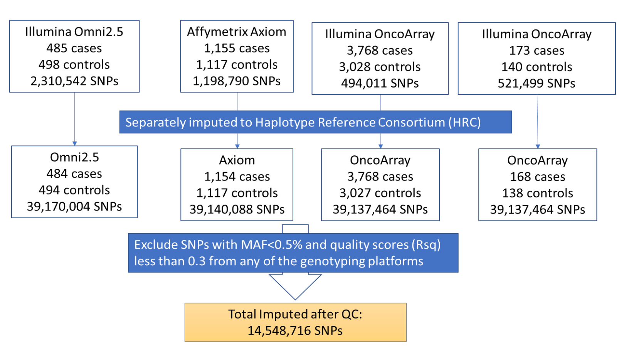

Figure S2. Q-Q plot for clonality from Discovery GWAS (N_{snp}=8,775,871).
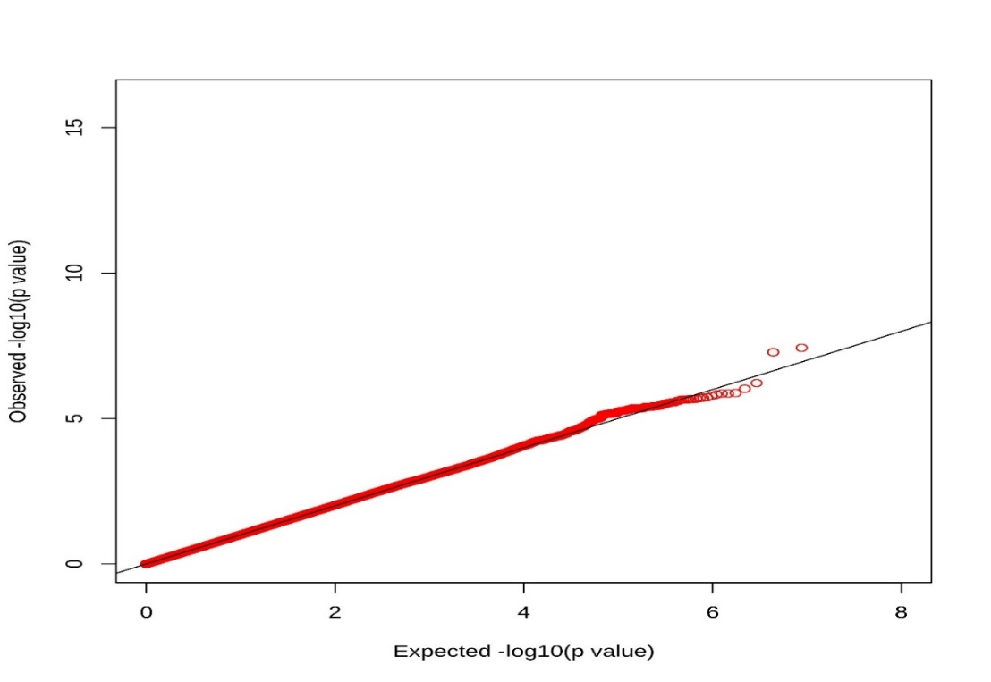

Figure S3. Manhattan plot for clonality from Discovery GWAS (N_{snp}=8,775,871).
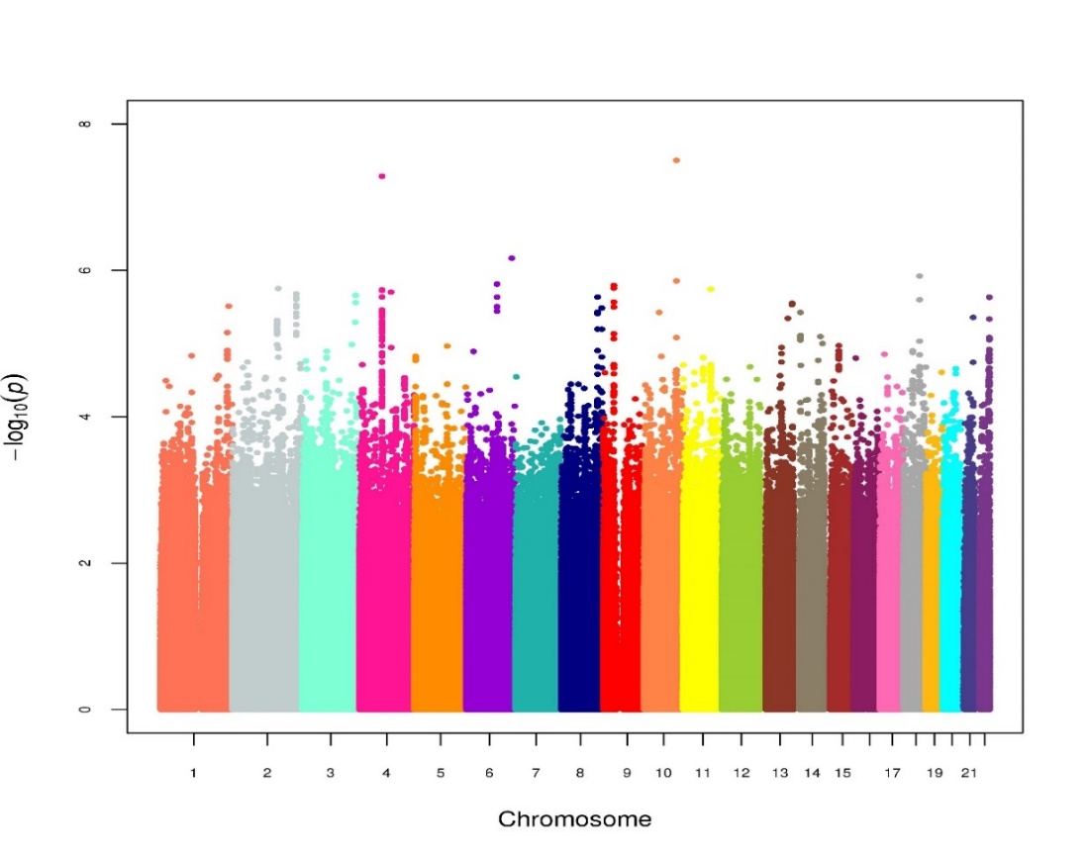

Figure S4. eQTL results for rs4918567 with ADRA2A using BarcUV-Seq healthy colonic mucosa transcriptomic data.
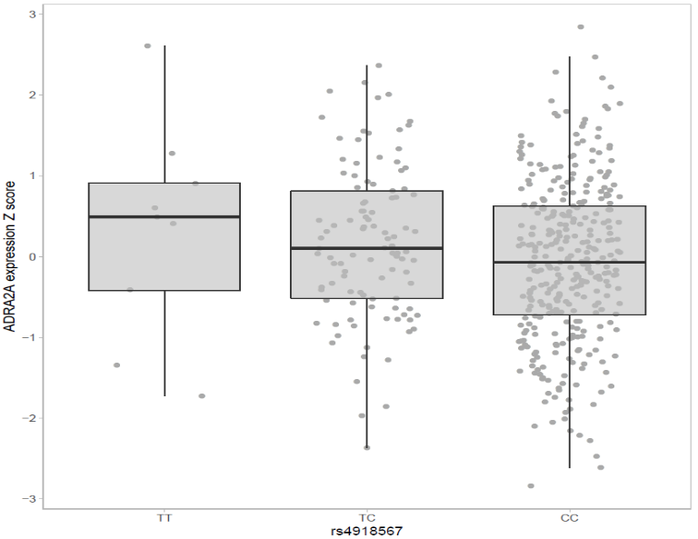
P=0.0119

Figure S5. eQTL results for rs4443313 with LINC01094 using BarcUVa-Seq healthy colonic mucosa transcriptomic data.
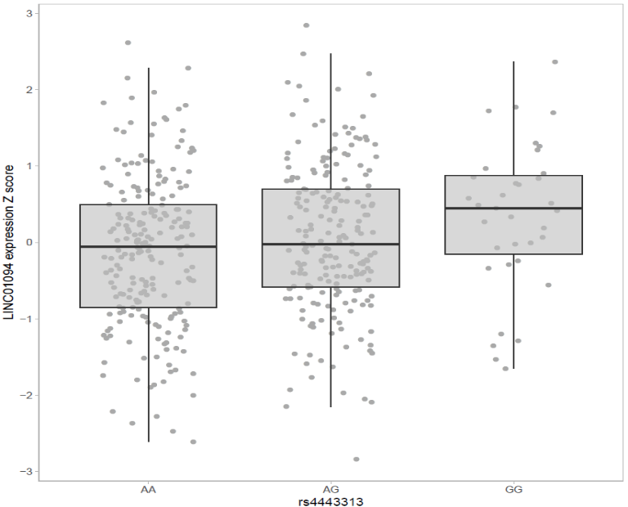
P=0.0025

Figure S6. eQTL result for rs4443313 with CCNG2 using Colonomics colon tumor tissue transcriptomic data.
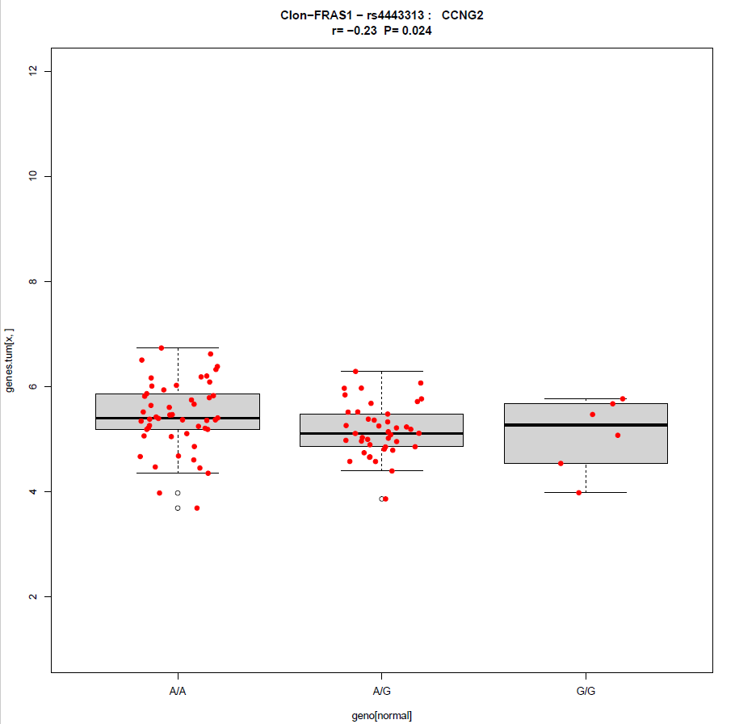

Figure S7. eQTL results for rs7874748 with NPR2 and RECK using BarcUVa-Seq healthy colonic mucosa transcriptomic data.
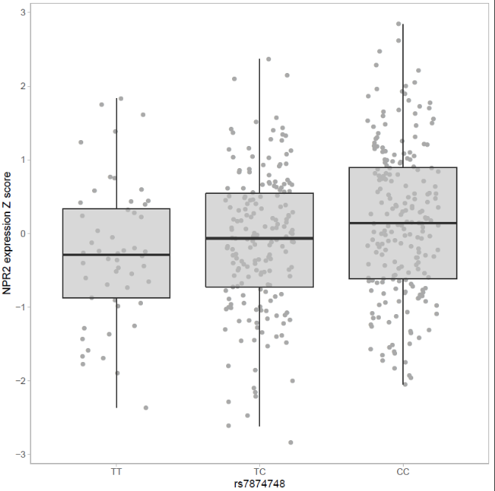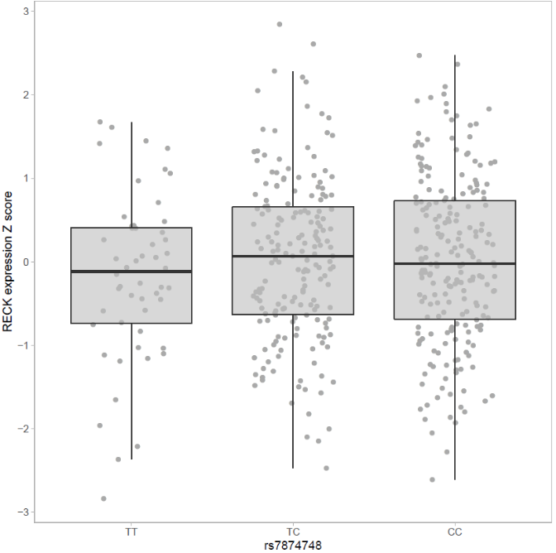
P=0.0497
P=0.0269

Figure S8. eQTL result for rs7874748 with ALPK2 and NEDD4L using Colonomics colon tumor tissue transcriptomic data. 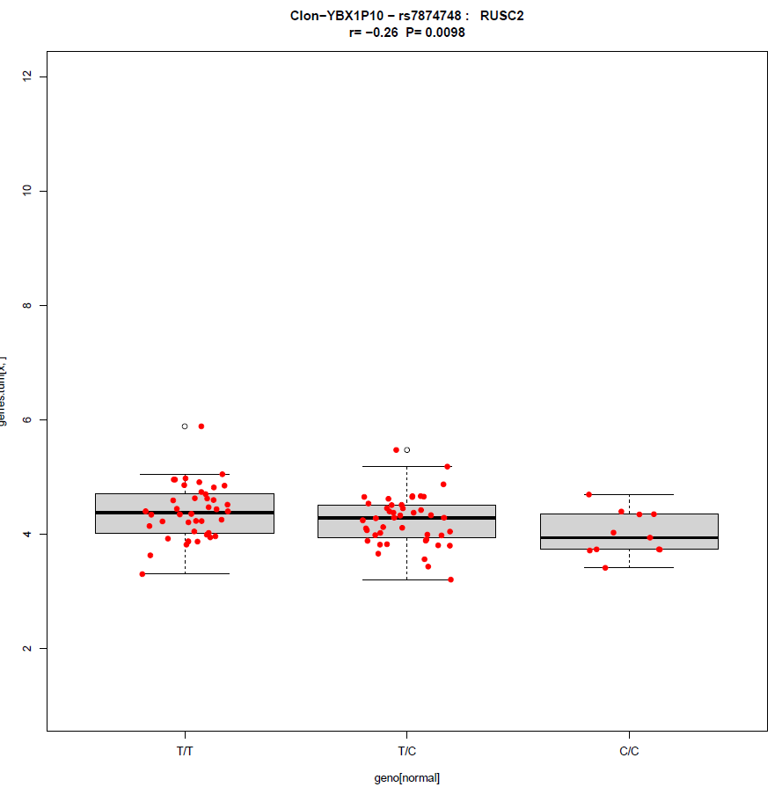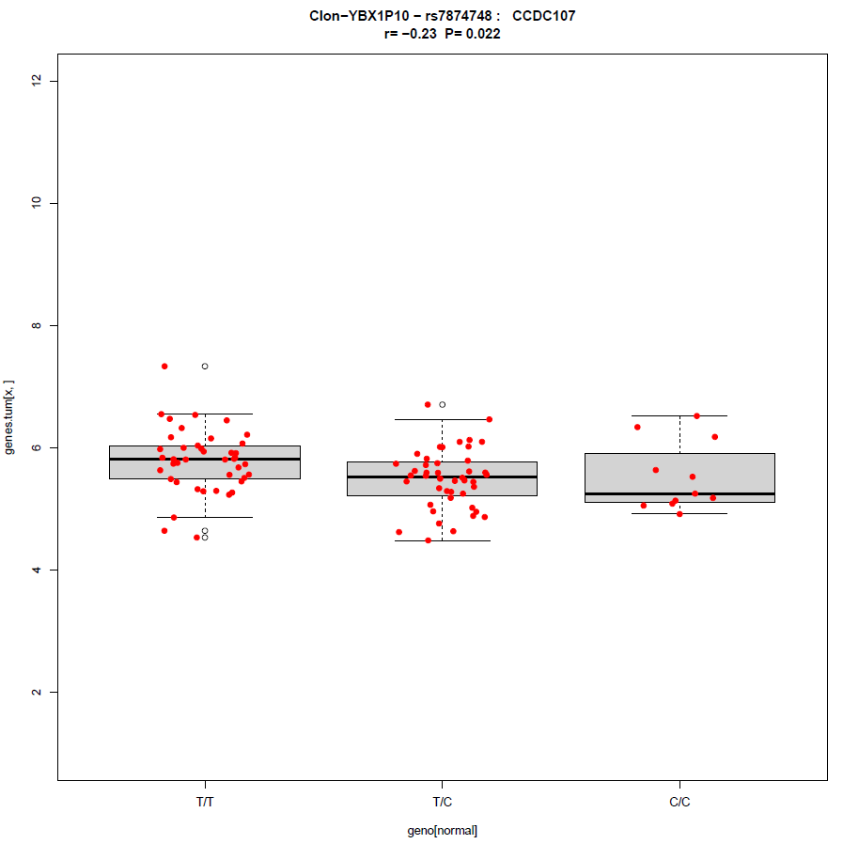 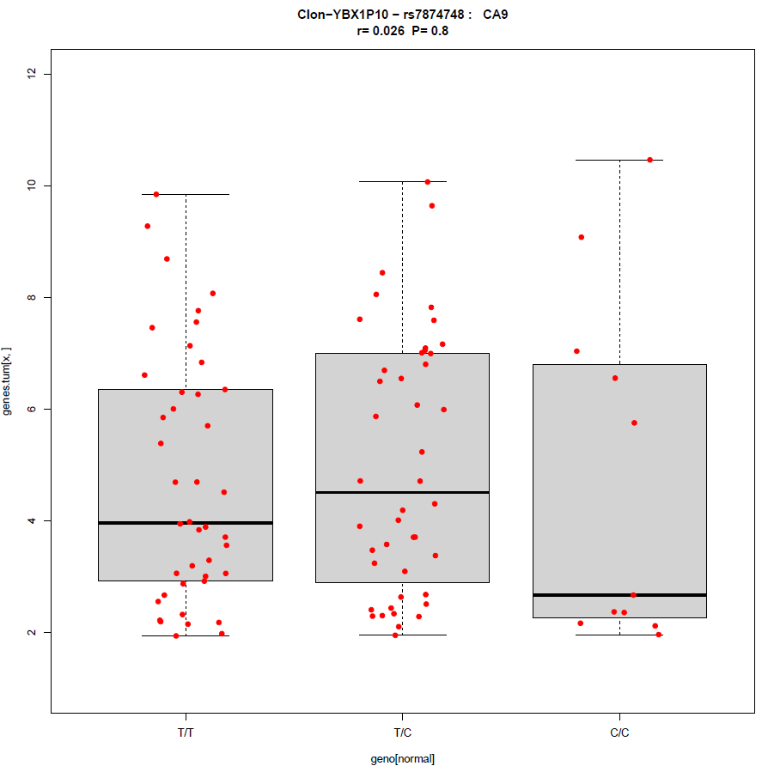 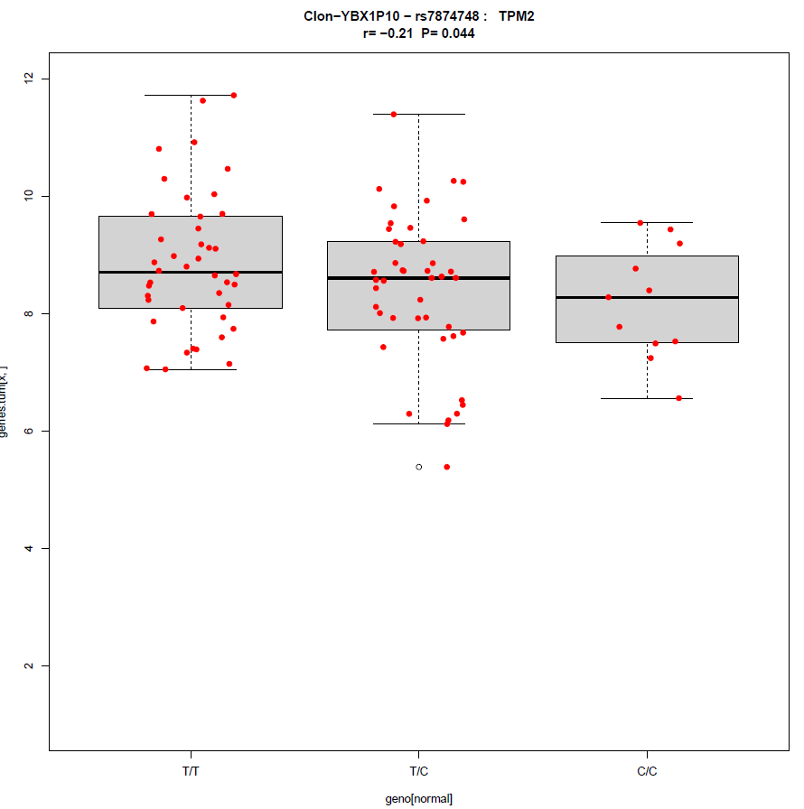
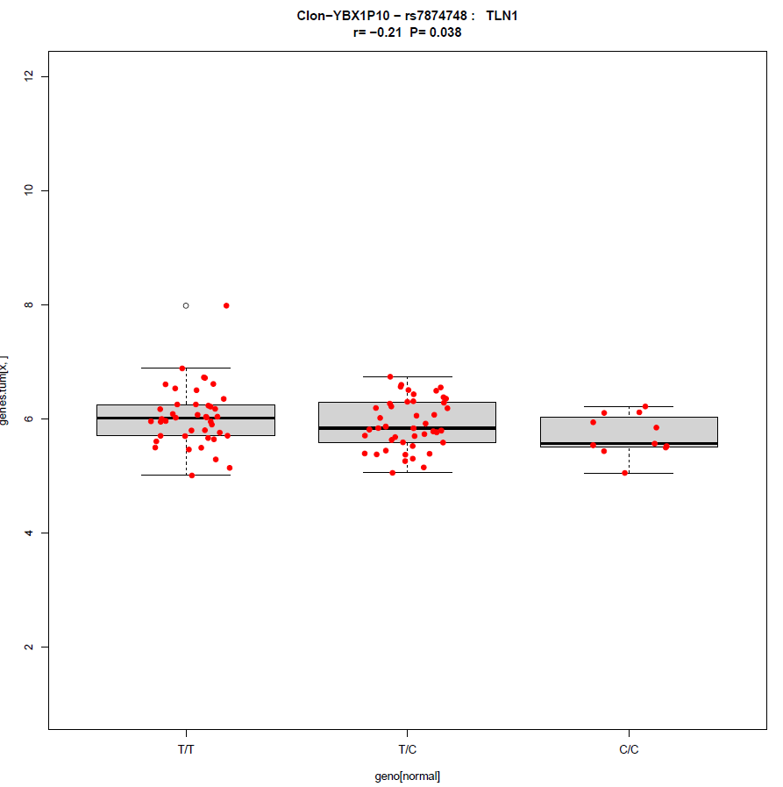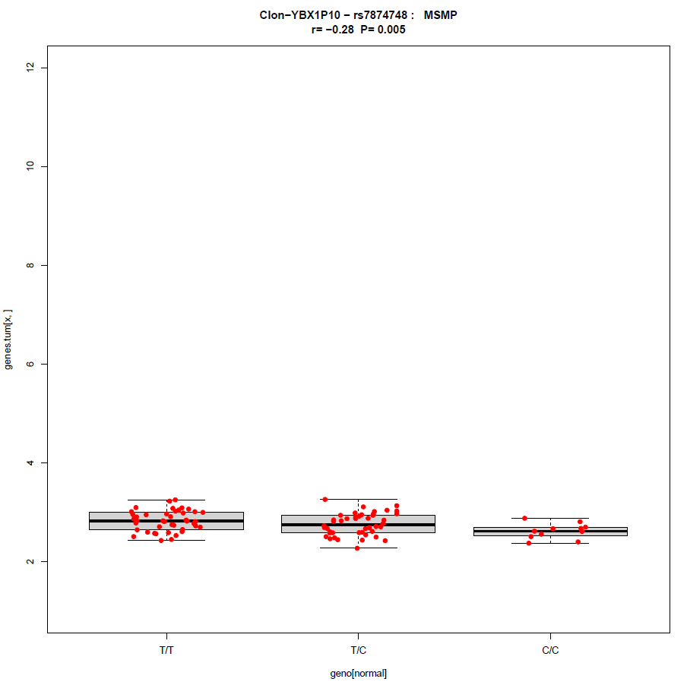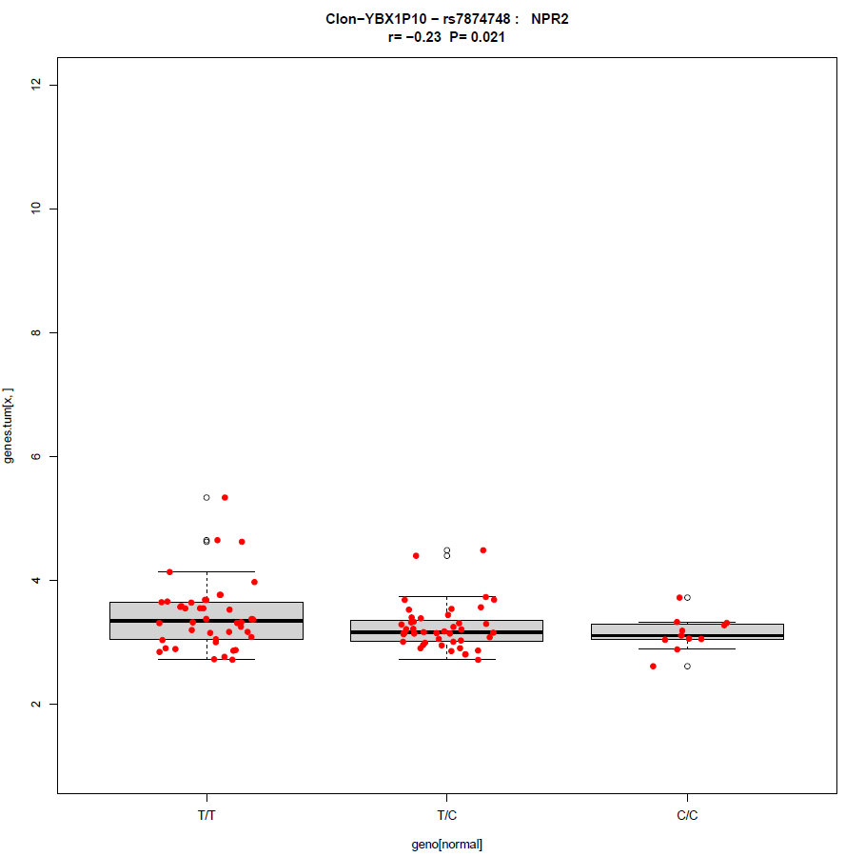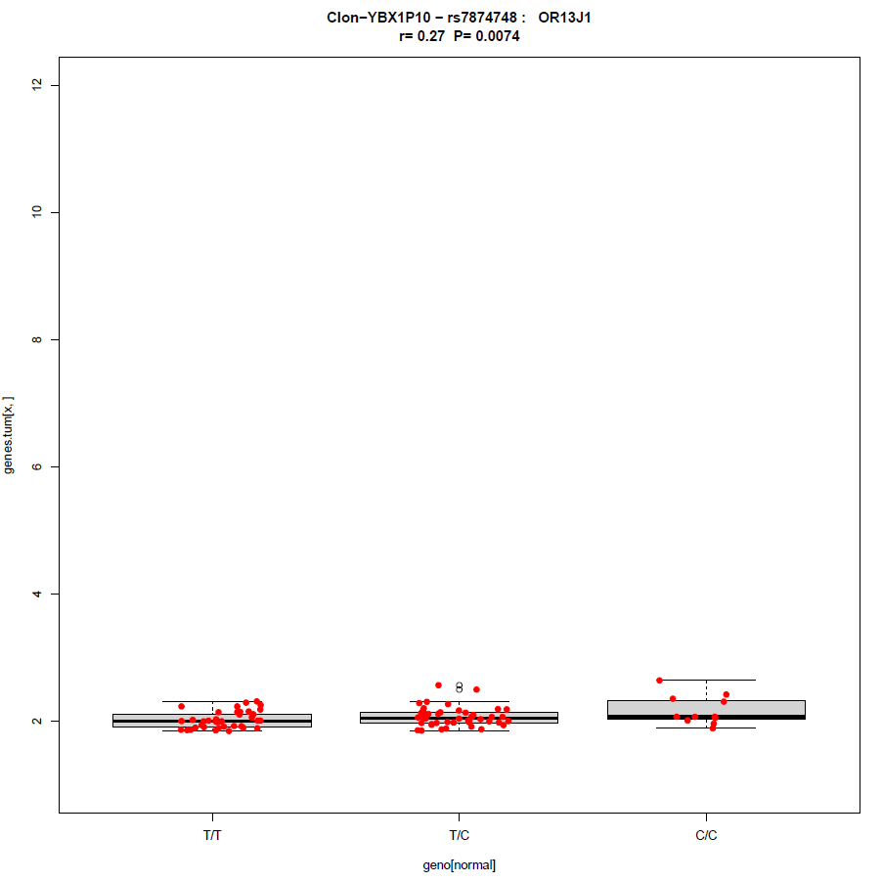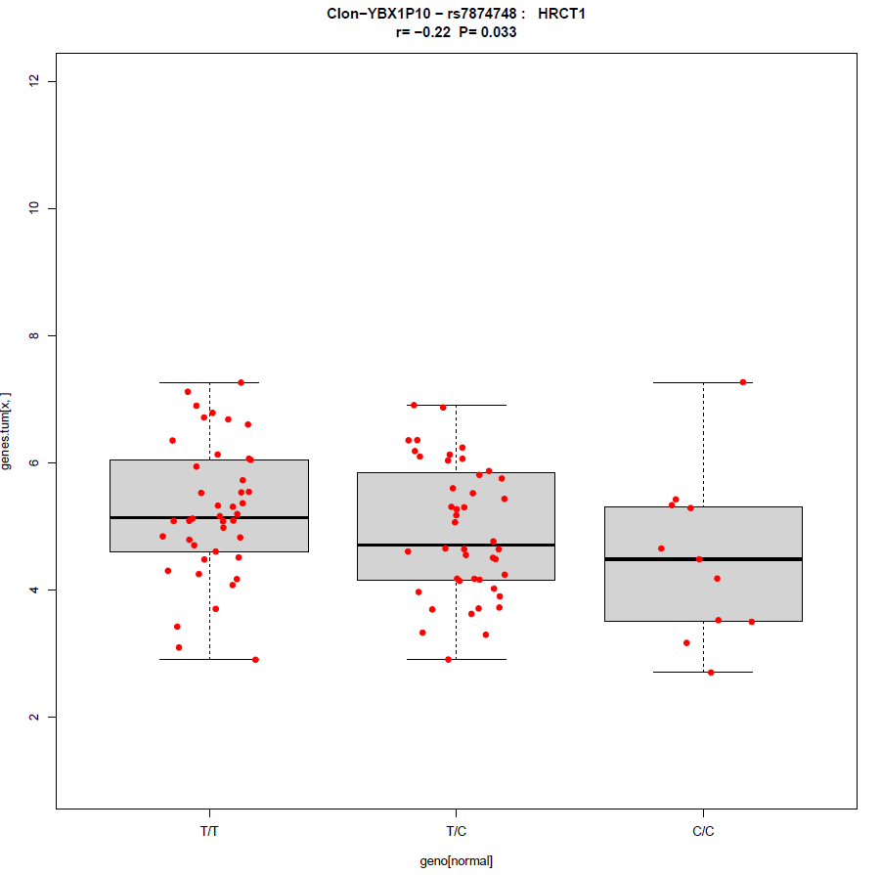

Figure S9. eQTL result for rs34245610 with ATP8B1 using Colonomics colon tumor tissue transcriptomic data.
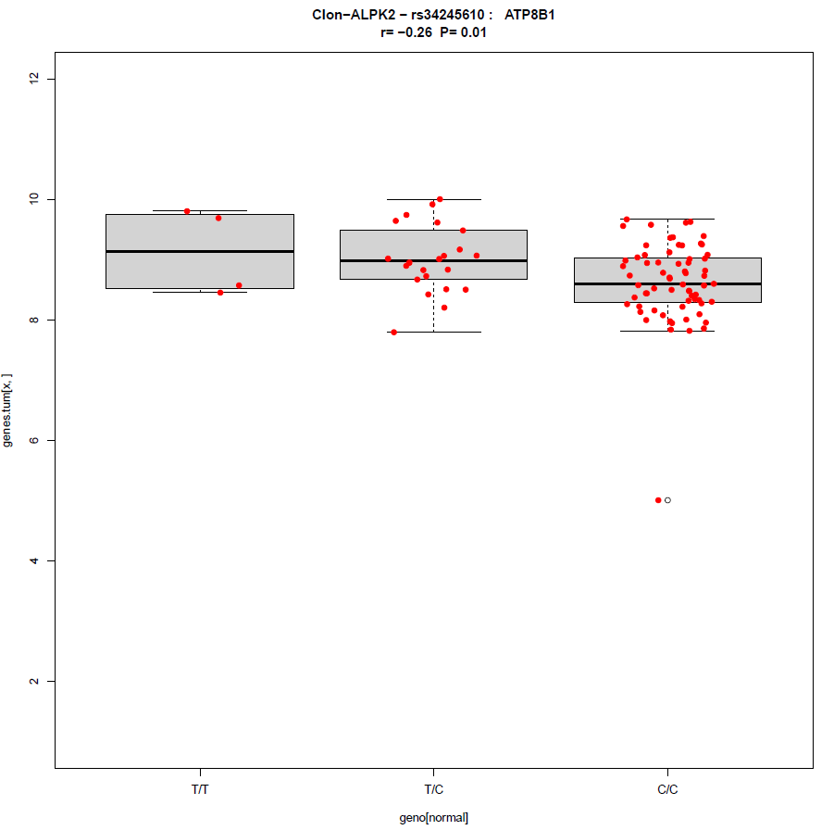

Figure S10. Q-Q plot for abundance from Discovery GWAS (N_{snp}=9,636,751).
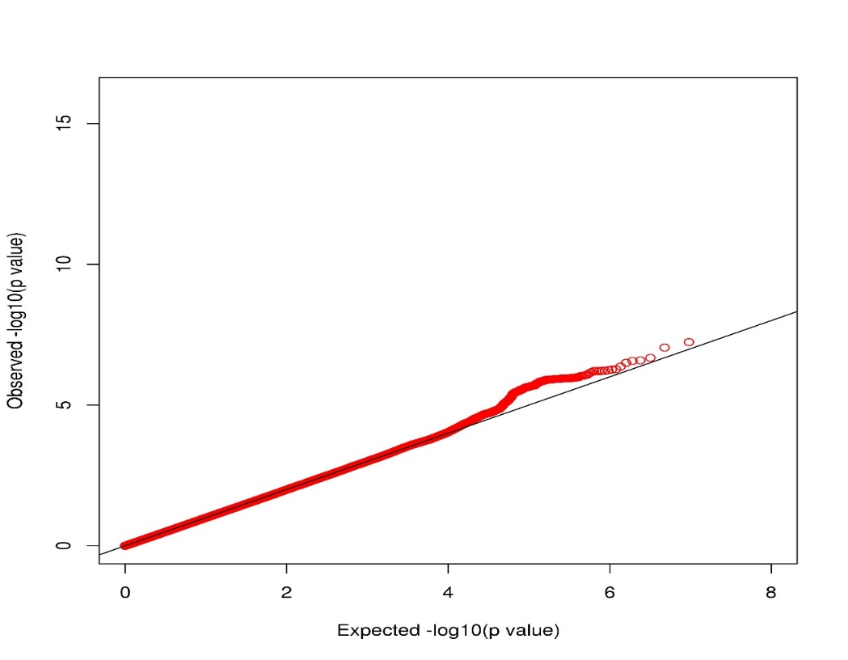

Figure S11. Manhattan plot for abundance from Discovery GWAS (N_{snp}=9,636,751).
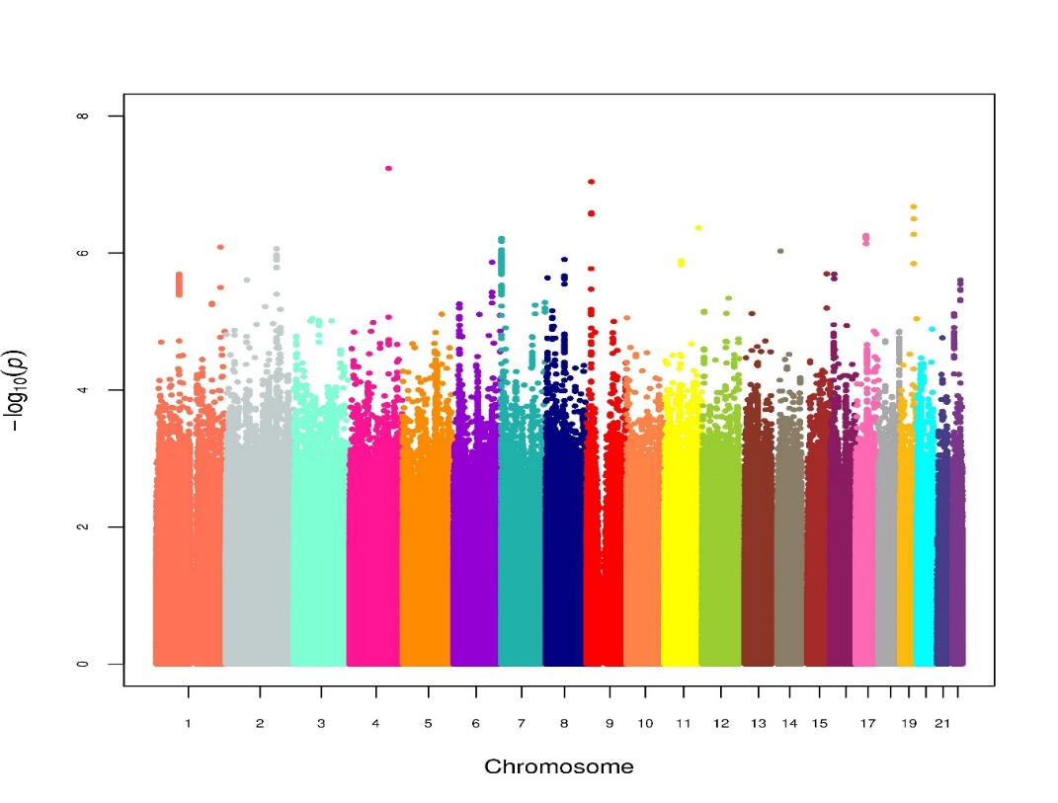

Figure S12. eQTL result for rs56148061 with SYT7 using Colonomics colon tumor tissue transcriptomic data.
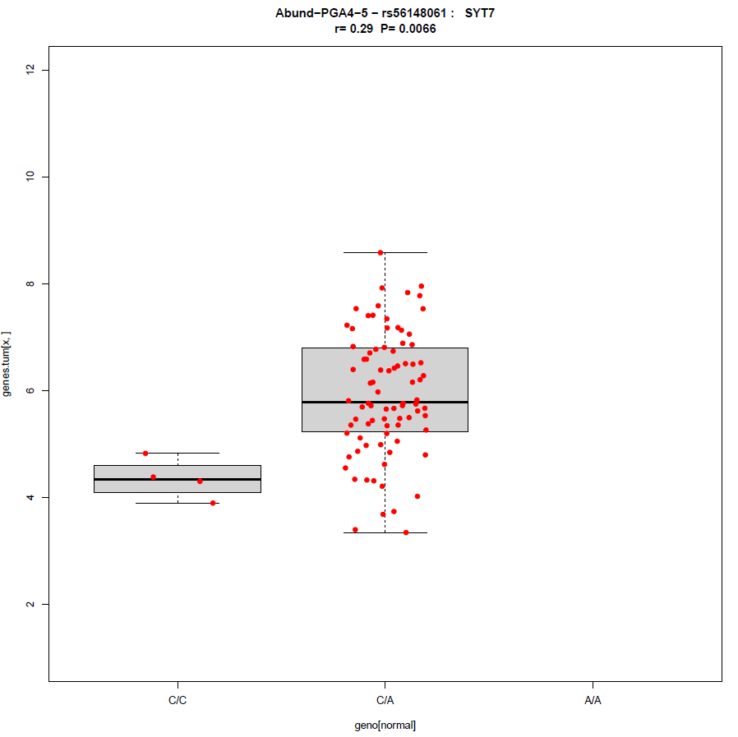

Figure S13. Q-Q plot for TILs/hpf from Discovery GWAS (N_{snp}=9,529,506).
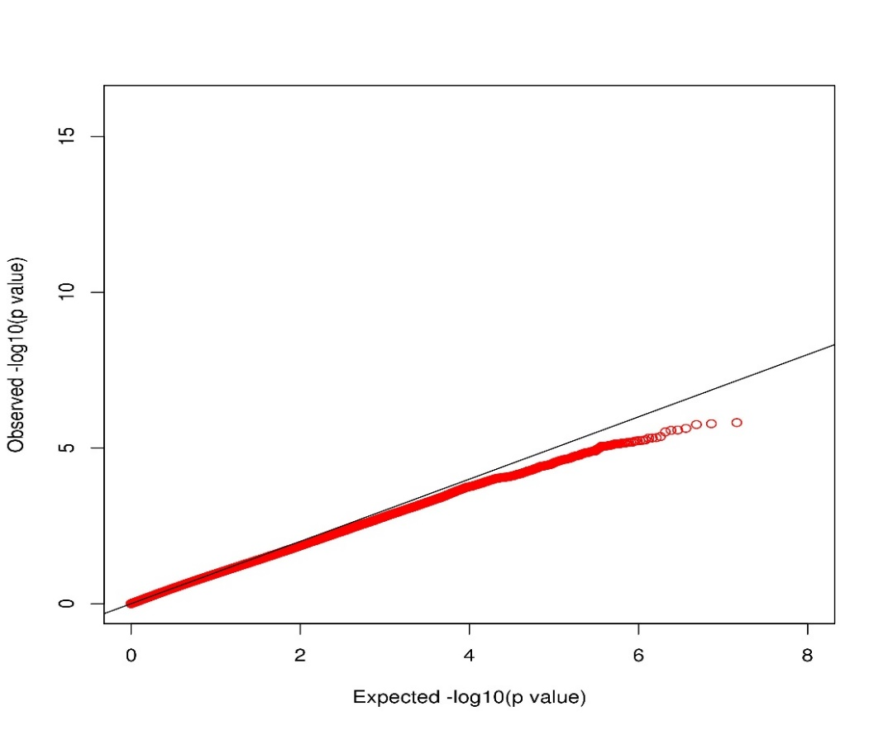

Figure S14. Manhattan plot for TILs/hpf from Discovery GWAS (N_{snp}=9,529,506).
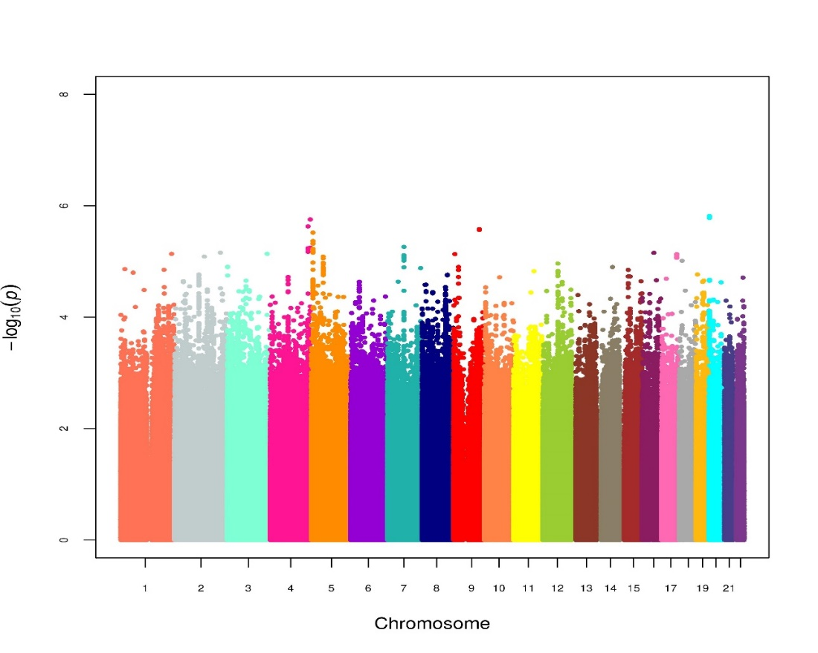

Figure S15. eQTL results for rs10982853 with TNFSF8 using BarcUVa-Seq healthy colonic mucosa transcriptomic data.
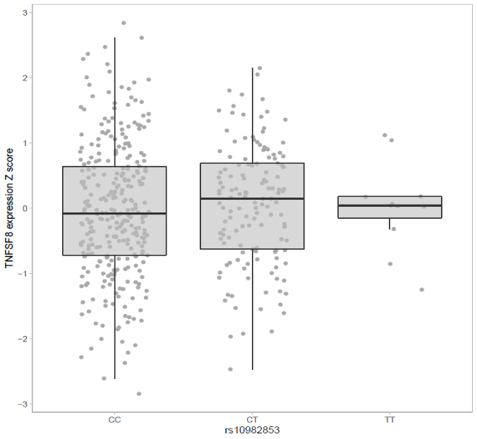
P=0.0139

Figure S16. eQTL result for rs10982853 with PAPPA using Colonomics colon tumor tissue transcriptomic data.
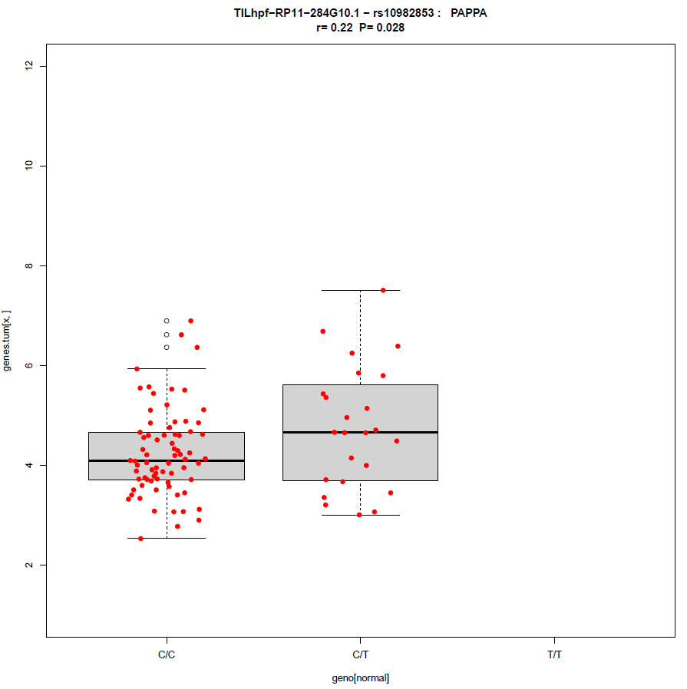

Figure S17. eQTL results for rs215529 with FASTKD5 and CPXM1 using BarcUVa-Seq healthy colonic mucosa transcriptomic data.
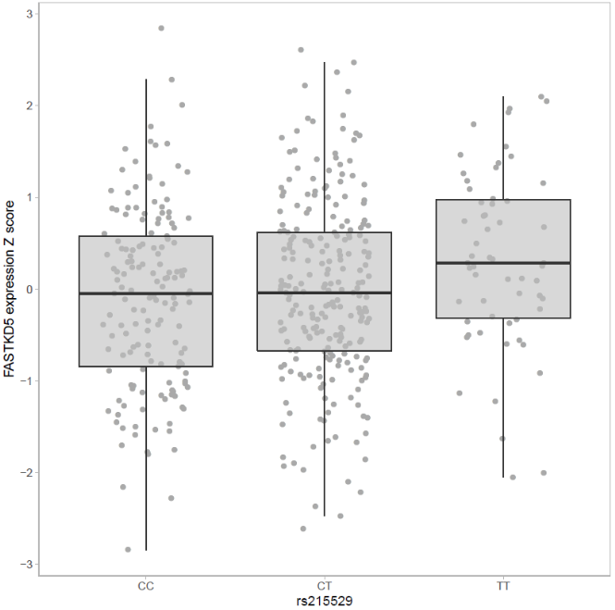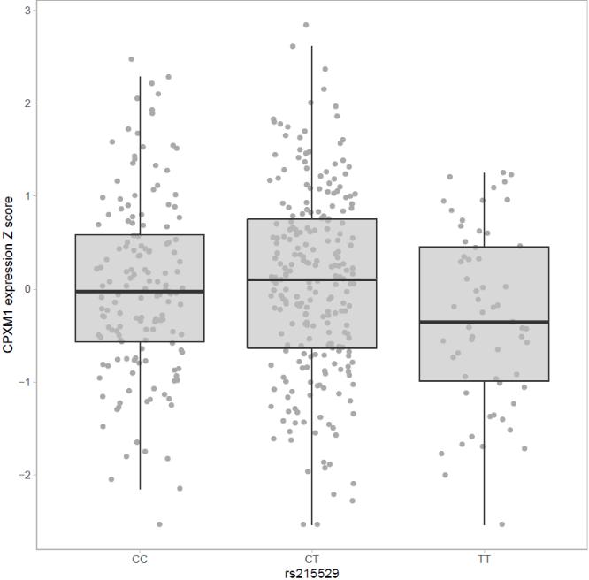
P=0.0369
P=0.0277

Figure S18. eQTL result for rs215529 with PDYN using Colonomics colon tumor tissue transcriptomic data.
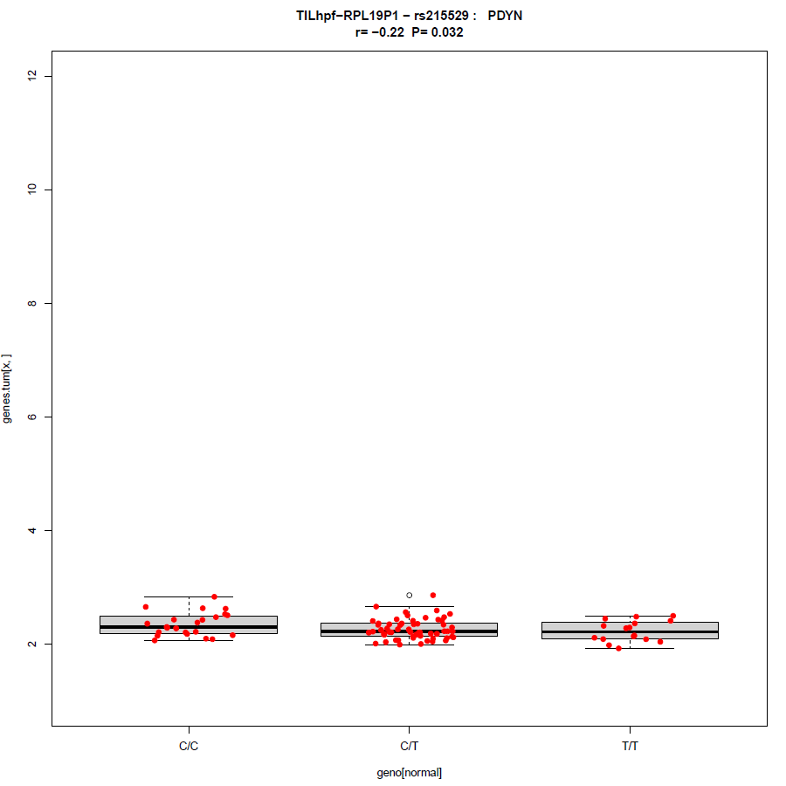

Figure S19. Violin plots for the top SNPs associated with clonality and abundance.
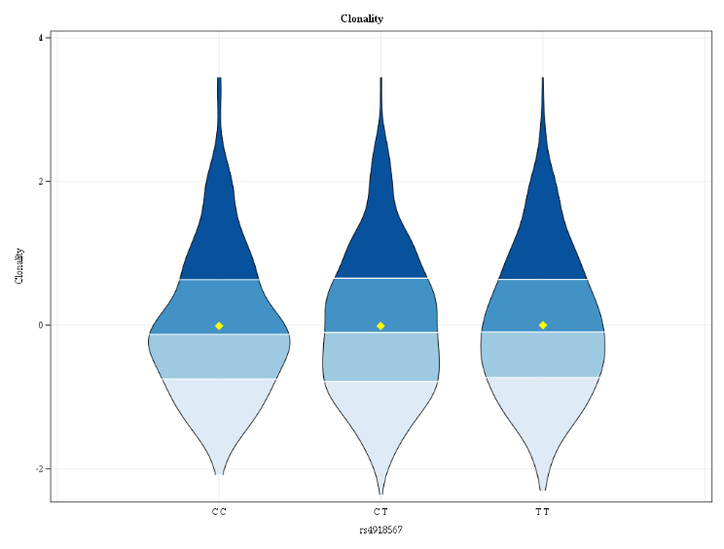 | 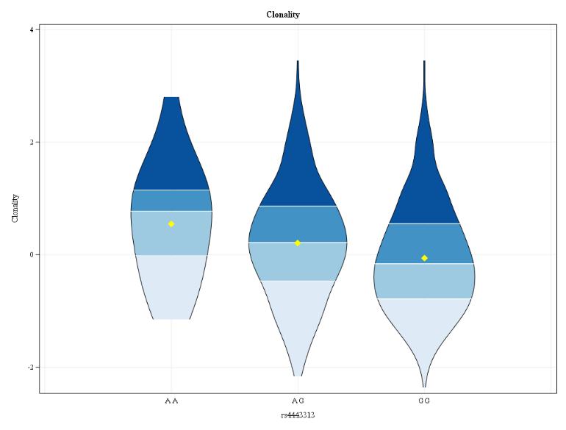
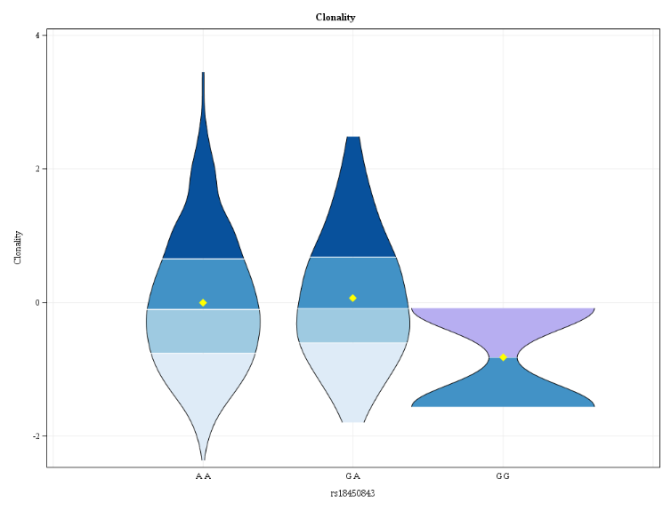 | 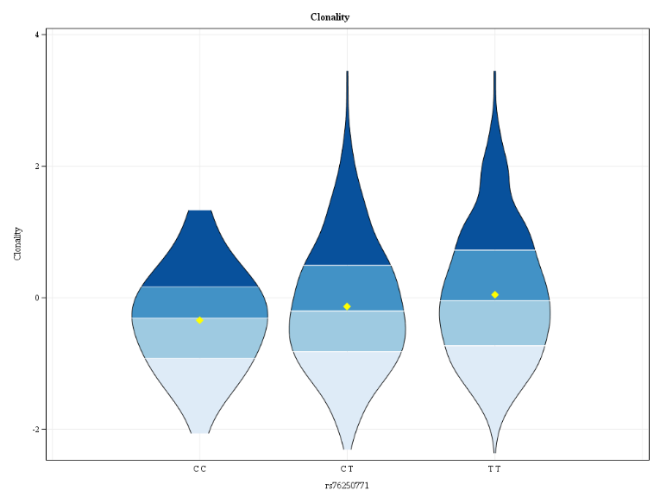
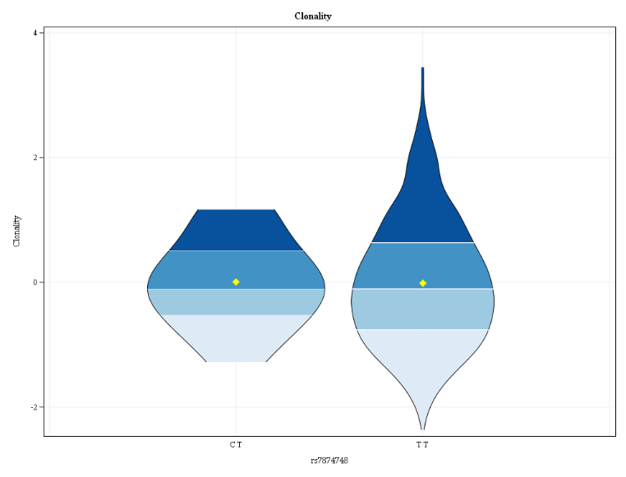 | 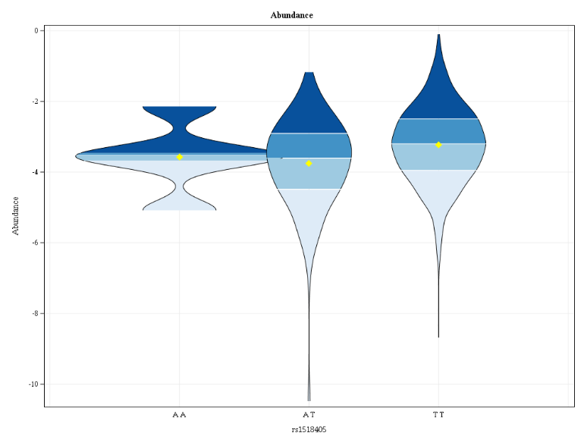
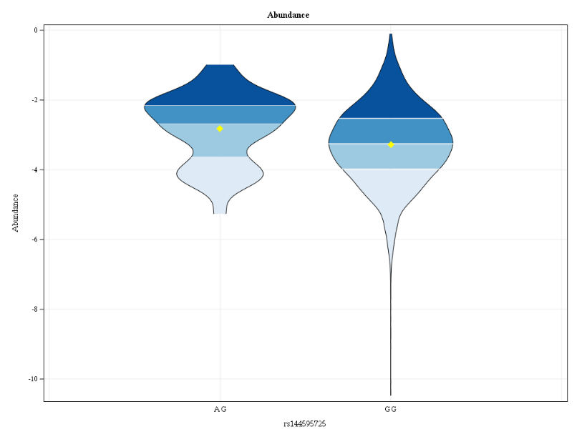 | 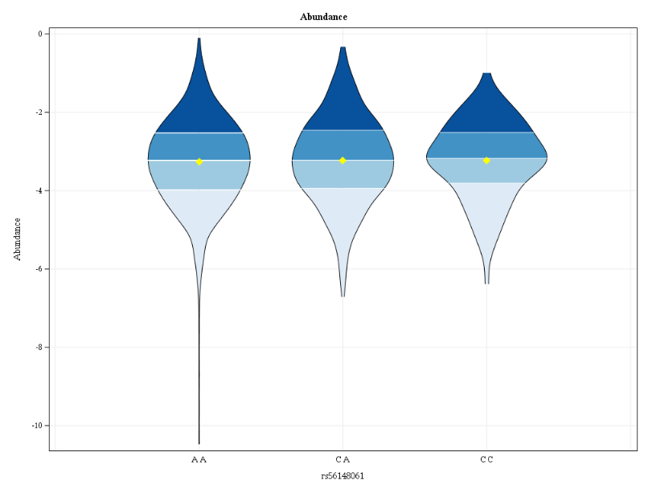
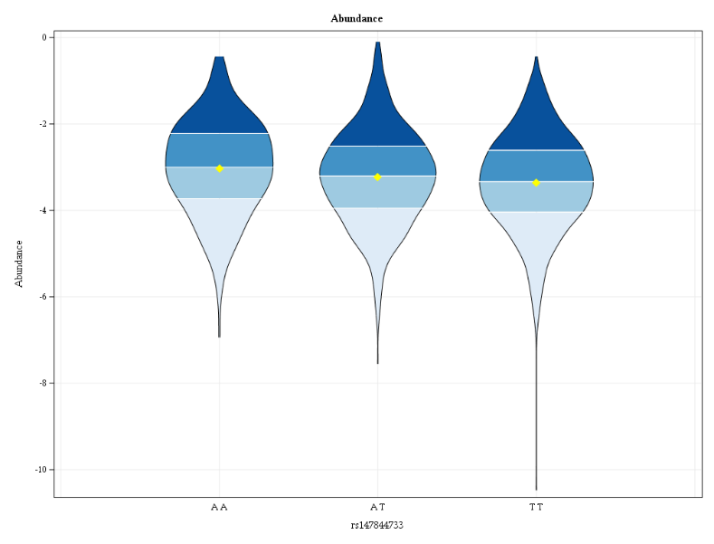 | 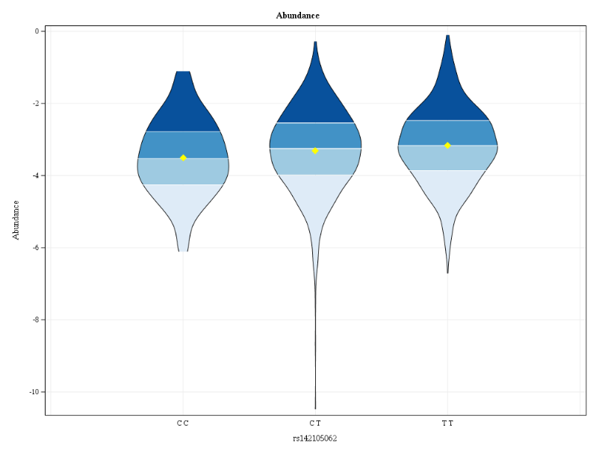
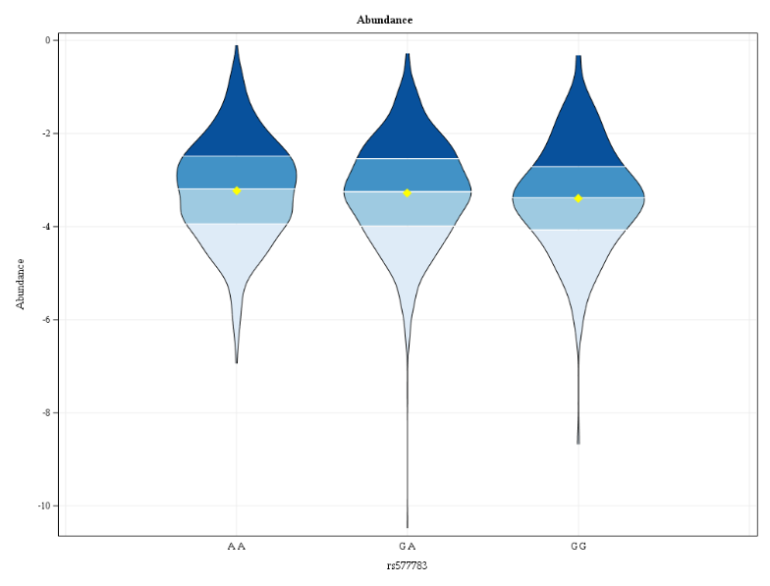 | 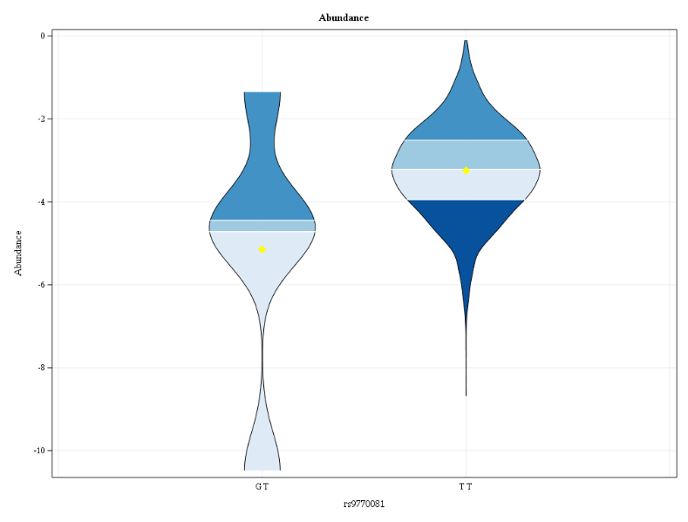
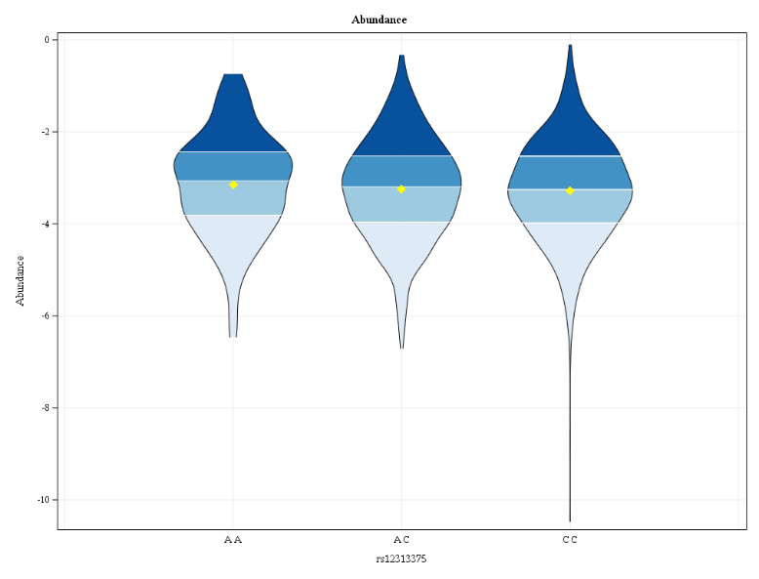 | 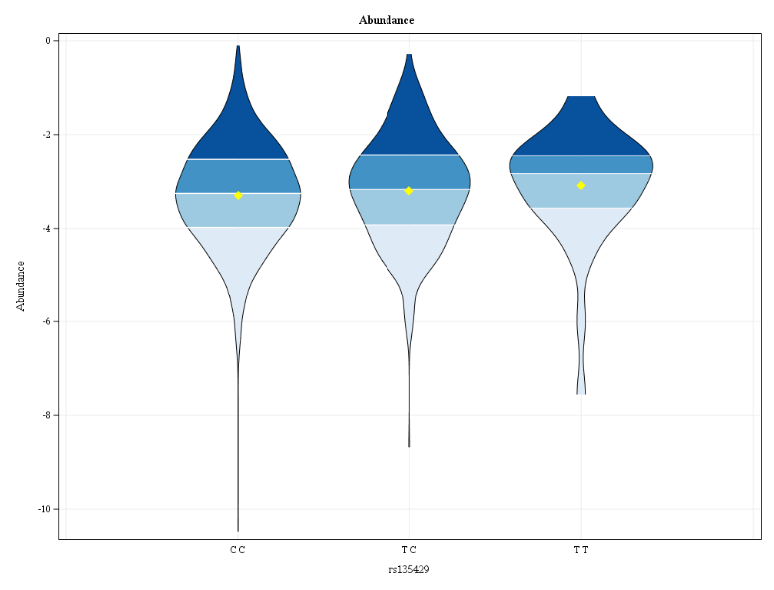
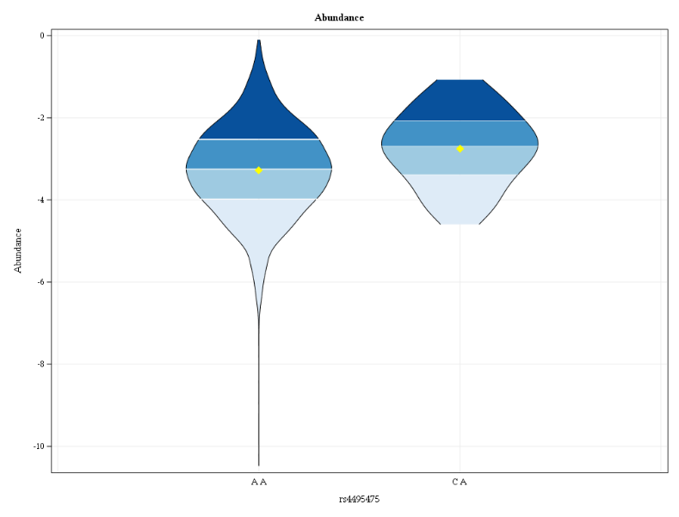 | 