Supplementary Material
Genome-wide detections for runs of homozygosity and selective signatures reveal novel candidate genes under domestication in chickens
Xiaodong Tan ^{a,1}, Lu Liu ^{b,c,1}, Jie Dong ª, Minjie Huang ª, Jiawen Zhang ª, Qinghai Li ^{d}, Huanhuan Wang ^{d}, Lijuan Bai ^{e}, Ming Cui ^{e}, Zhenzhen Zhou ª, De Wu ^{f}, Yun Xiang ^{c,}*, Weifen Li ^{b,}*, Deqian Wang ^{a,}*
ª Institute of Animal Husbandry and Veterinary Science, Zhejiang Academy of Agricultural Sciences, Hangzhou 310021, China.
^{b} College of Animal Sciences, Zhejiang University, Hangzhou, Zhejiang, 310058, China.
^{c} Jinhua Jinfan Feed Co., Ltd, Jinhua, Zhejiang, 321000, China.
^{d} Animal Husbandry Institute, Hangzhou Academy of Agricultural Sciences, Hangzhou 310024, China
^{e} Zhejiang Animal Husbandry Technology Extension and Breeding Livestock and Poultry Monitoring Station, Hangzhou 310020, China
^{f} Postdoctoral Research Station, Jinhua Development Zone, Jinhua, Zhejiang 321000, China
¹ These authors contributed equally to this work.
* Corresponding author: Yun Xiang, Jinhua Jinfan Feed Co., Ltd, Jinhua, Zhejiang, 321000, China, xyjhzj@aliyun.com; Weifen Li, College of Animal Sciences, Zhejiang University, Hangzhou, Zhejiang, 310058, China, wfli@zju.edu.cn; Deqian Wang, Institute of Animal Husbandry and Veterinary Science, Zhejiang Academy of Agricultural Sciences, Hangzhou 310021, China, wangdq@zaas.ac.cn.

Fig. S1 Correlations among 4 genomic inbreeding in each population.

Fig. S2 Correlation between ROH length and number in each population.

Fig. S3 Detection of whole-genome ROH islands in each population

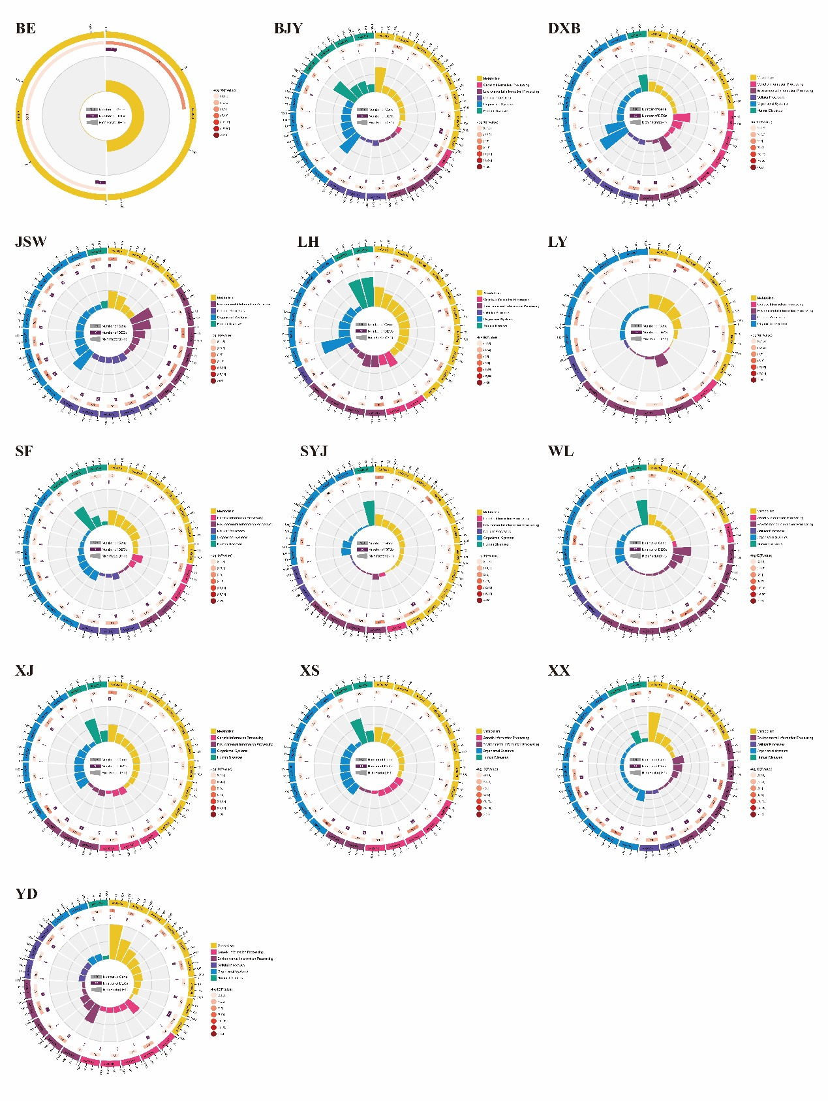Fig. S4 KEGG enrichment based on the genes covered by ROH islands.
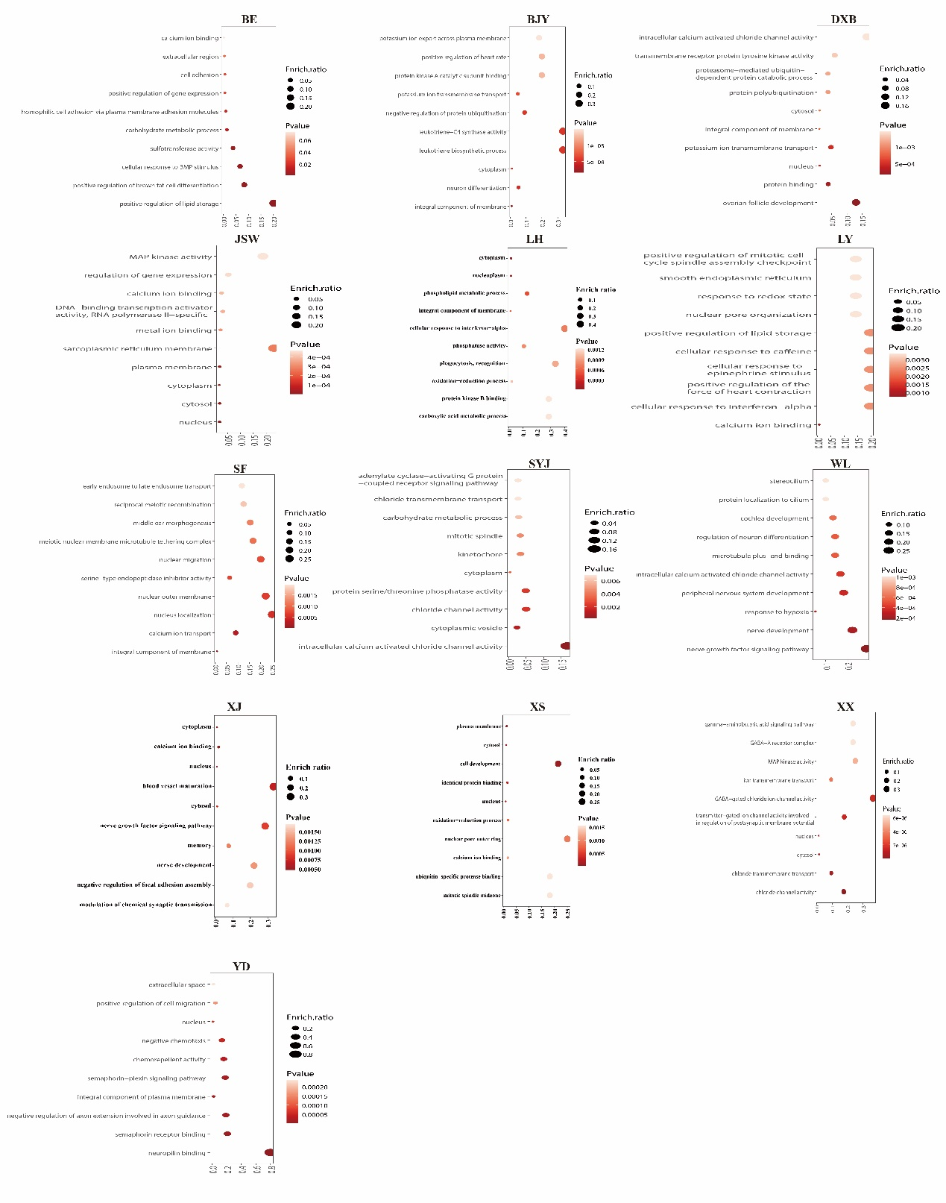Fig. S5 GO enrichment based on the genes covered by ROH islands.
Fig. S6 Number of known QTLs mapped by ROH islands in each population.
Fig. S7 SNP frequency within VSTM2A gene.
Fig. S8 SNP frequency within NELL1 gene.
Fig. S9 SNP frequency within NALF1 gene.
Fig. S10 Tajima’s D value in NALF1 gene in indigenous chickens and RJFs.

