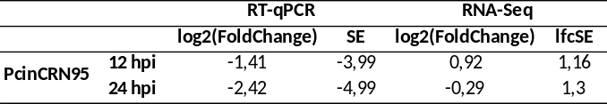
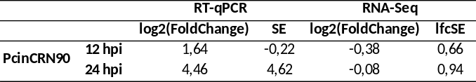
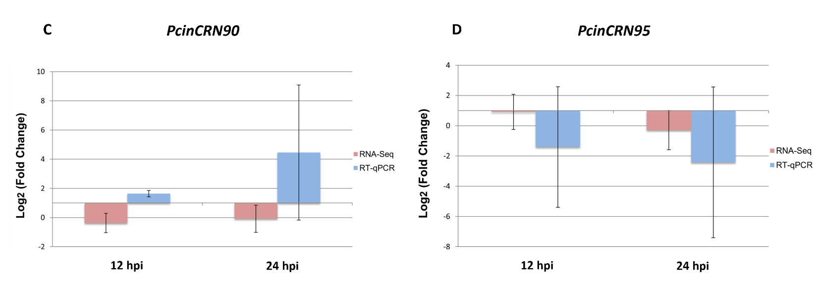
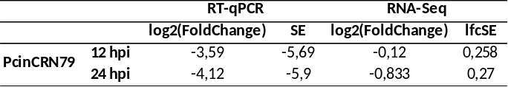
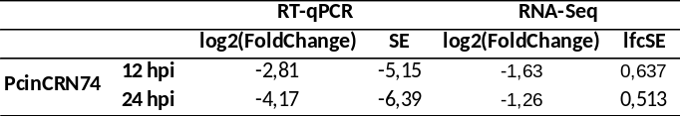
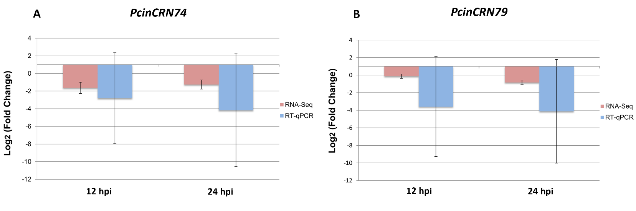
Supplementary Figure 2. Expression validation of selected Phytophthora cinnamomi crinkling and necrosis (PcinCRN) effector genes at 12 and 24 hpi compared to mycelial control. Normalized Log2 (Fold Change) for (A) PcinCRN74, (B) PcinCRN79, (C) PcinCRN90, and (D) PcinCRN95 were calculated using the method described by Pfaﬄ (2001) (58). The expression of PcinCRNs during infection of R012 avocado rootstock is indicated by vertical bars across two time points using RNA-seq data (red) and RT-qPCR (blue). The samples were compared to P. cinnamomi mycelia. SE for each bar is shown.

