Supplementary Information
Figures
Fig. S1. The original, uncropped DNA Electrophoretic in the paper.
Fig. S2. Genome distribution of Pseudomonas syringae pv. actinidiae (Psa) strains. (A) Genome distribution of Psa strain JZY2 (B) Genome distribution of Psa strain YXH1.
Fig. S1
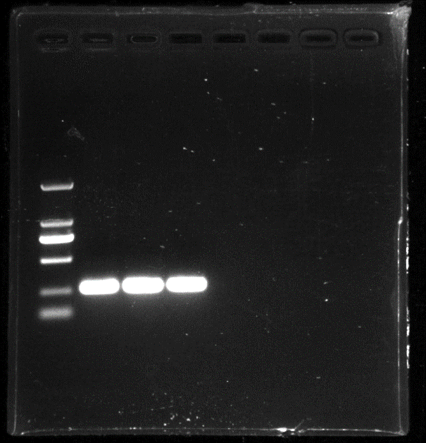
A

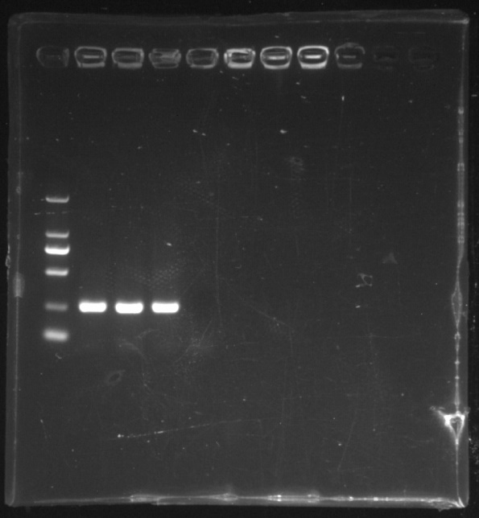
B

Fig. S1. A The original, uncropped DNA Electrophoretic in the paper Fig.1C. B Repeated experiment, the original, uncropped DNA Electrophoretic. The lanes from left to right are Marker, QSY6, JZY2, YXH1, and negative control.

Fig. S2
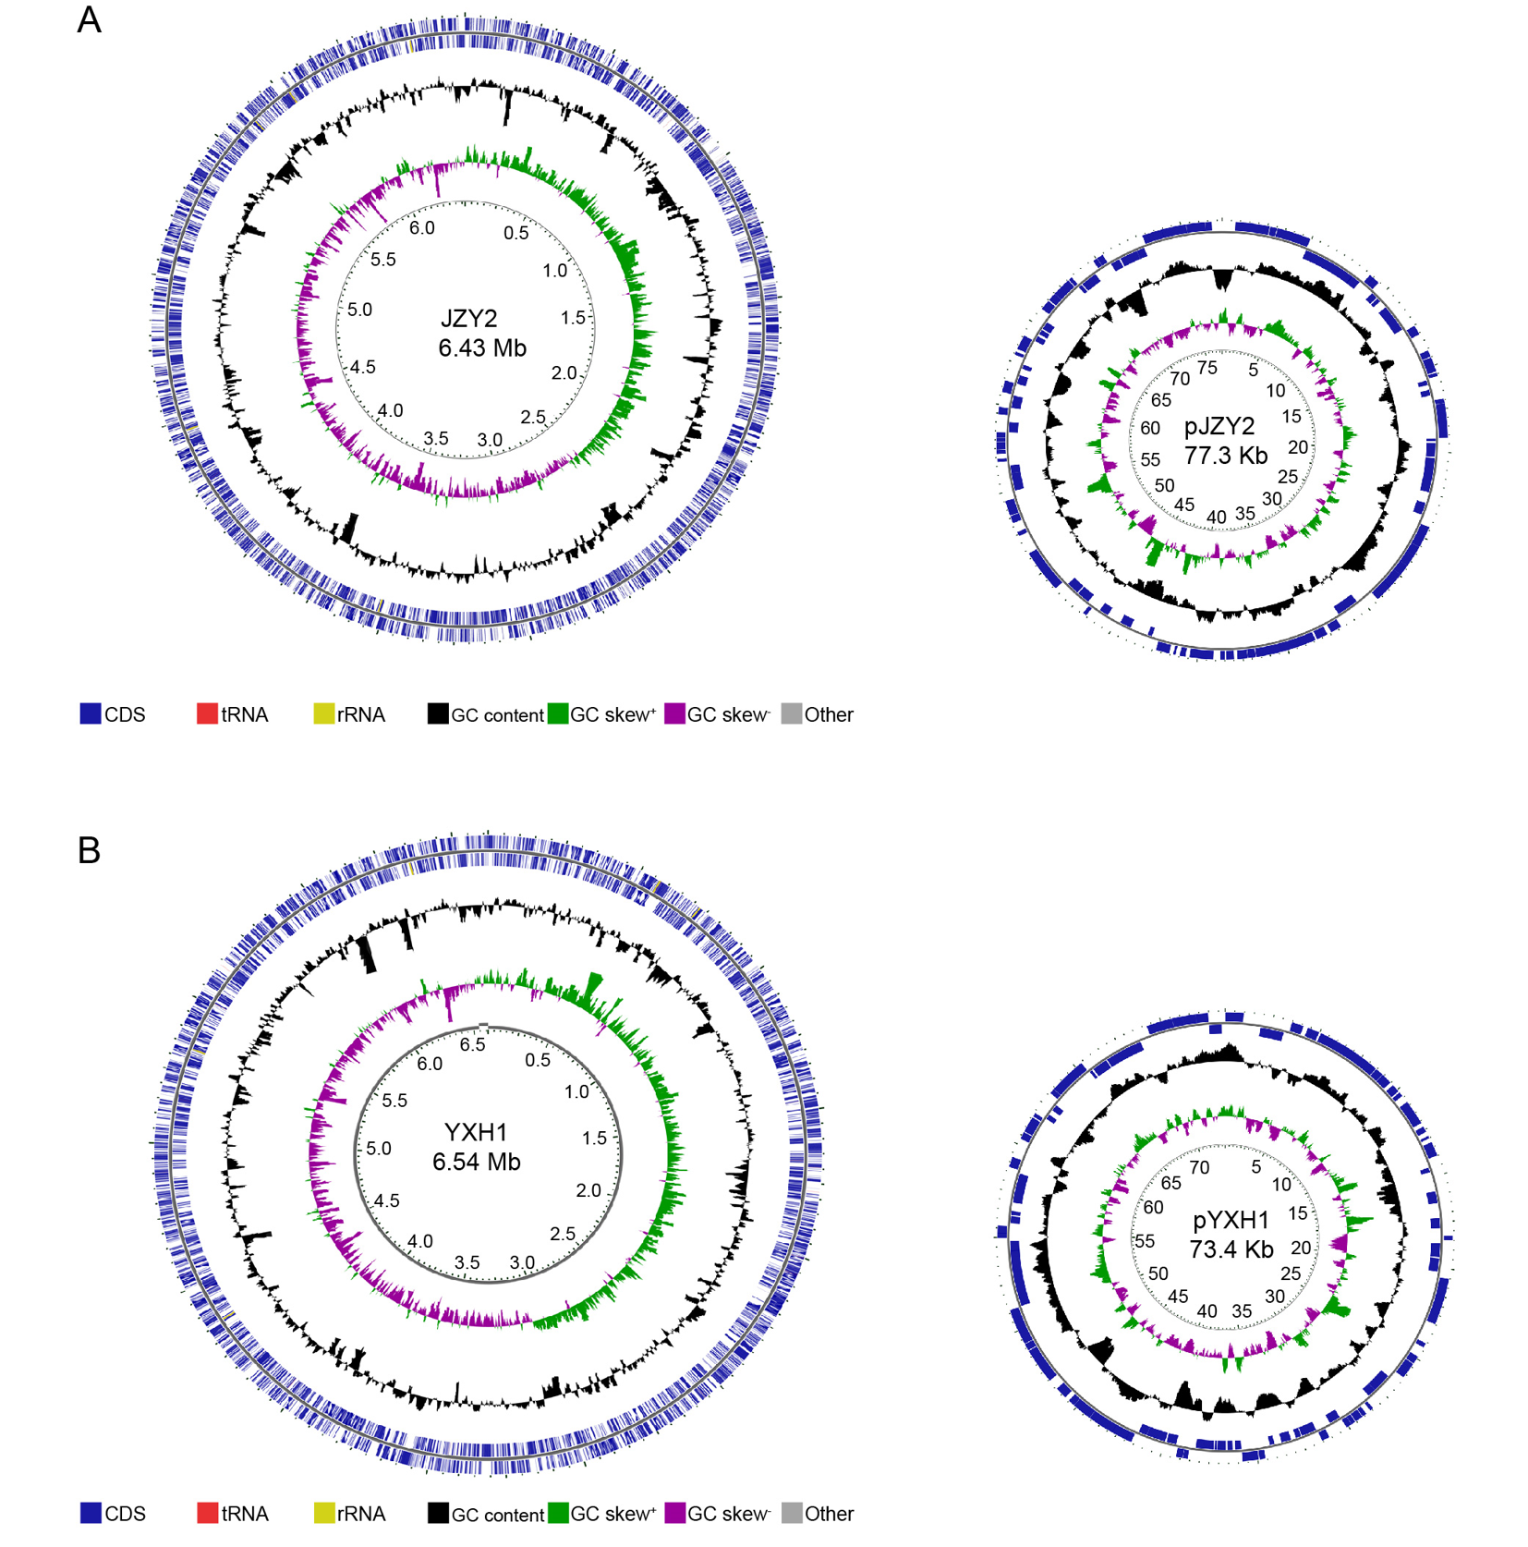
Fig. S2. Genome distribution of Pseudomonas syringae pv. actinidiae (Psa) strains. (A) Genome distribution of Psa strain JZY2 (B) Genome distribution of Psa strain YXH1. From the outer to the inner circle: CDS, tRNA, and rRNA on the forward strand; CDS, tRNA, and rRNA on the reverse strand; CDS on the reverse strand colored according to COG category; GC content; GC skew; and genome position in Mbp.

