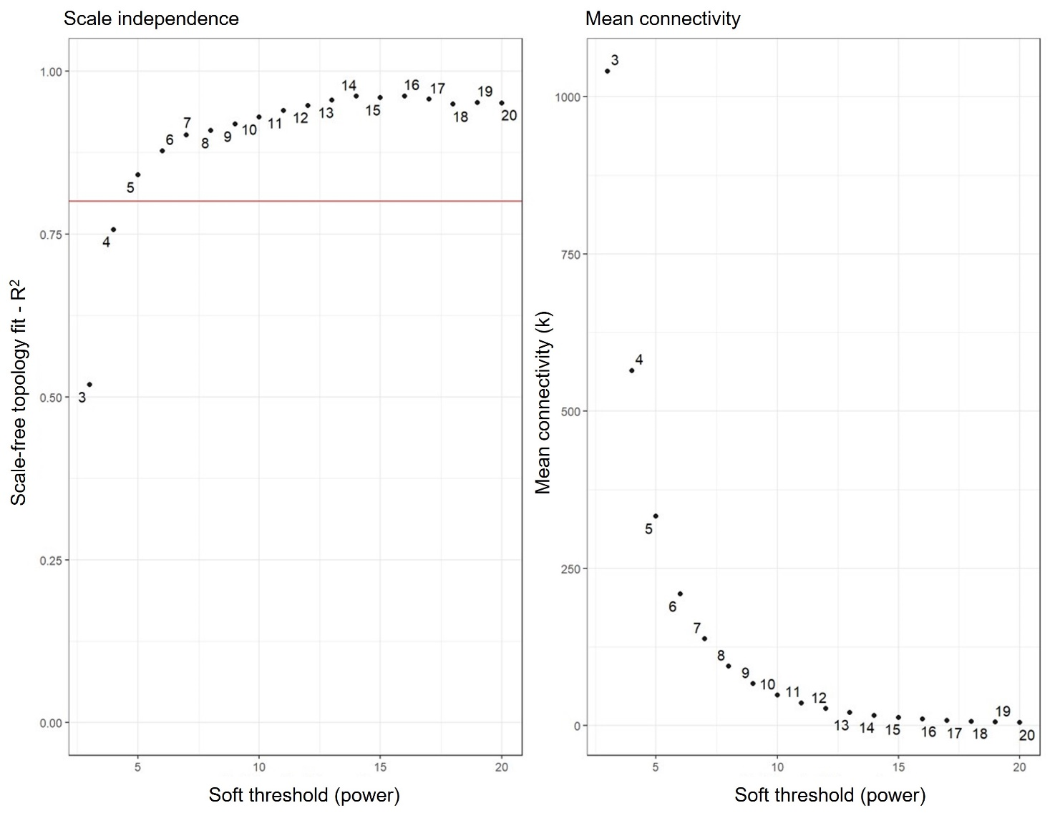
Additional file 8 - Graphic representation of the selection of the proper soft-threshold power β for WGCNA. The scale-free fit index of network topology was determined by soft-thresholding power analysis. The figure was generated by using the BioNero package of R.

