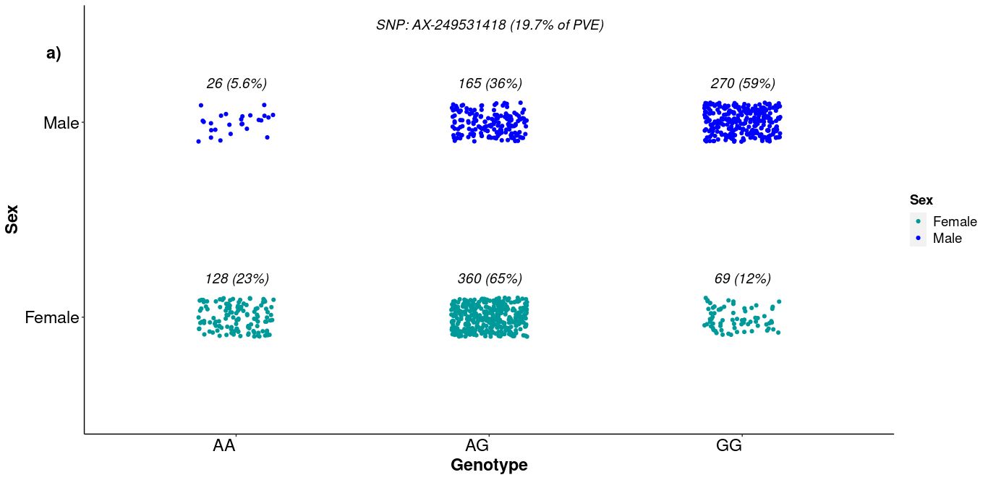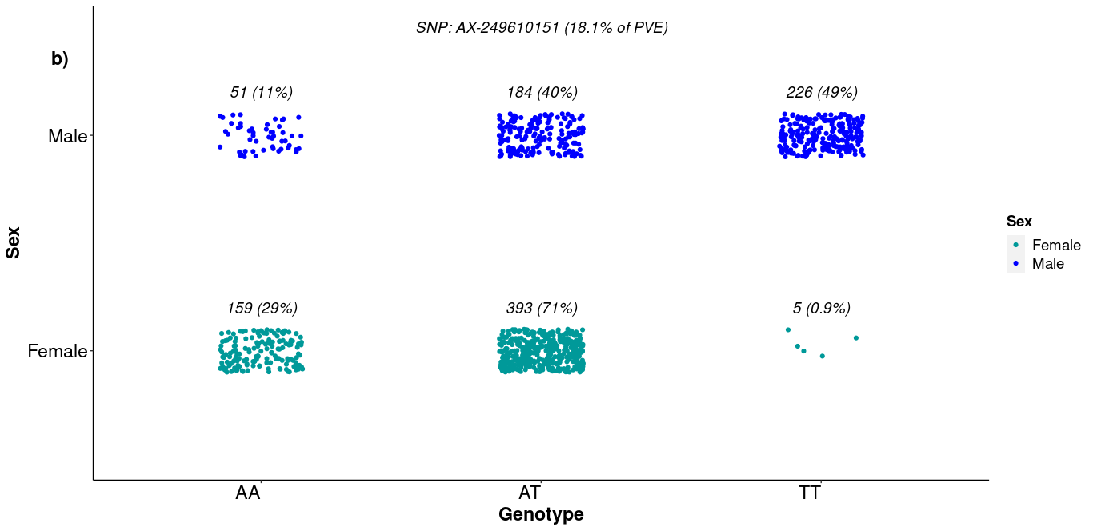
Figure S1. Distribution of L. vannamei males and females according to the three possible genotypes for the two SNPs with highest phenotypic variance explained (PVE) (percentages were calculated according to the number of males/females).

