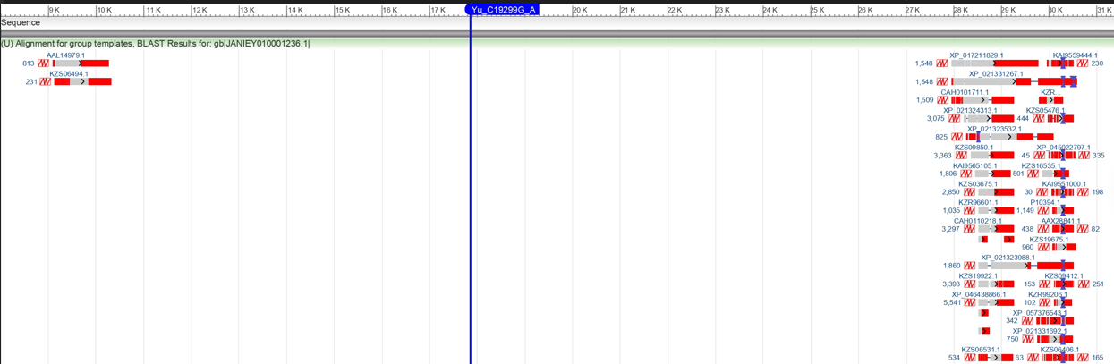
Figure S2. Position of the Yu_C19299G_B SNP and close conserved domains found in the JANIEY010001236.1 scaffold of L. vannamei.

