Phylogenetic tree consistency under different models of evolution

Taylorella equigenitalis phylogenetic tree (from Figure 2) generated under different models of evolution.

JC69
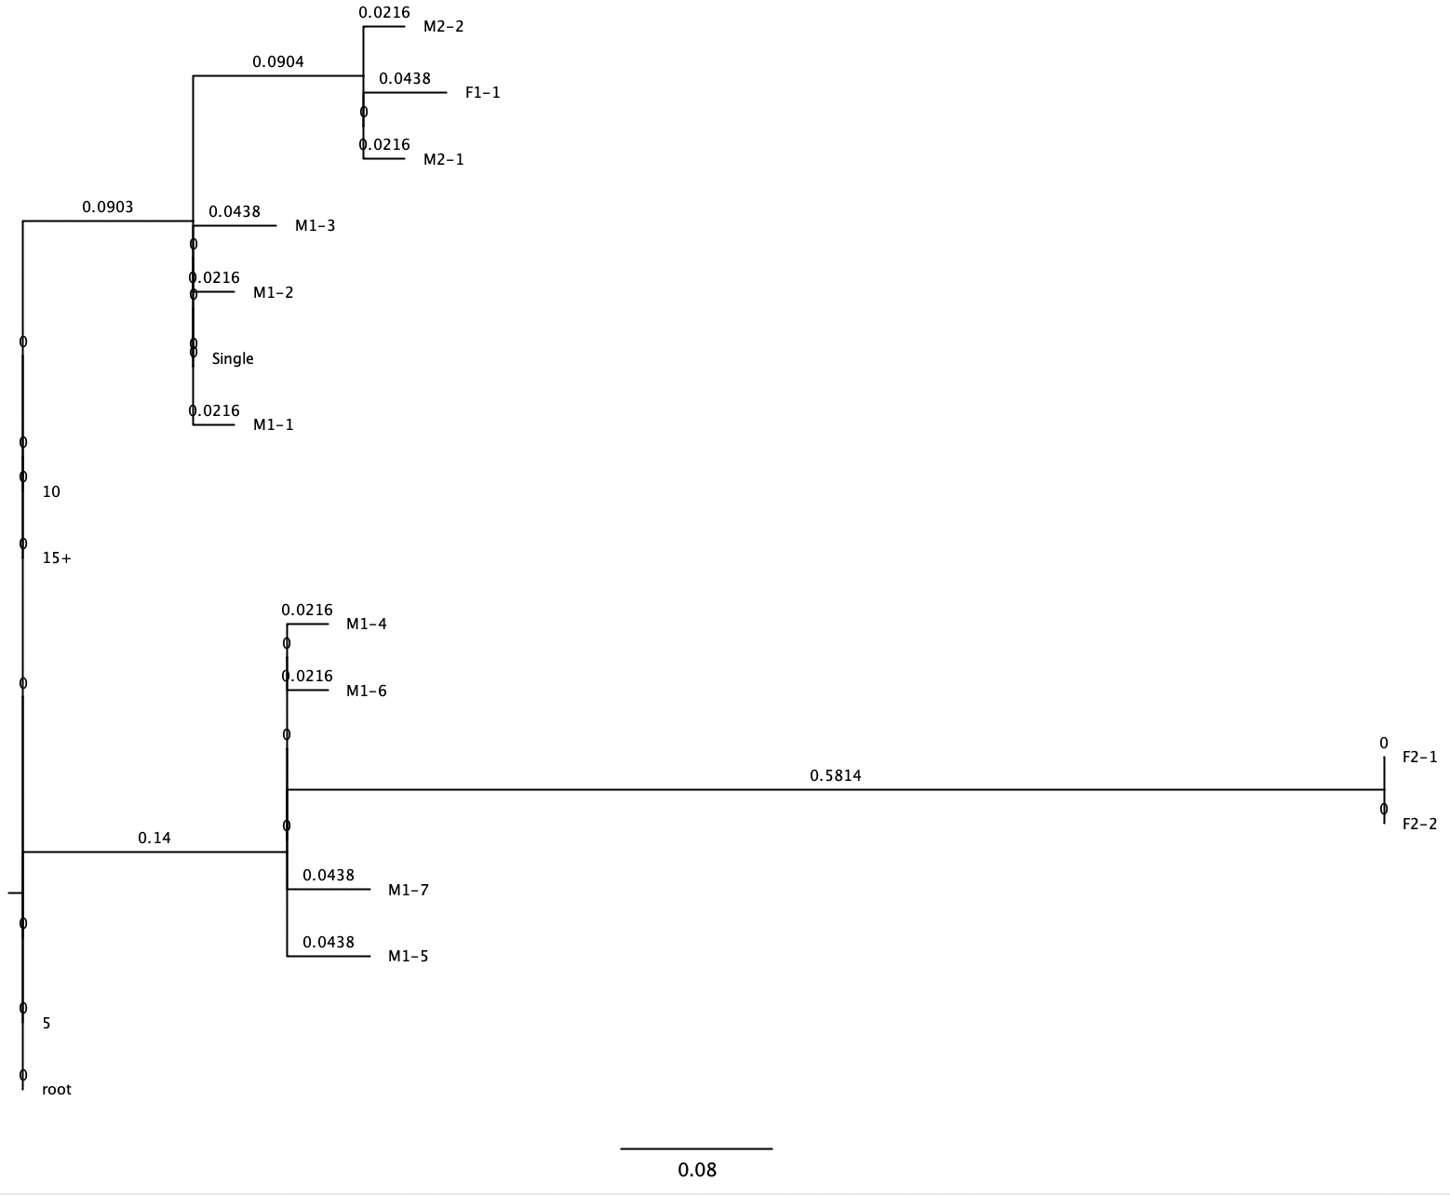
GTR-GAMMA
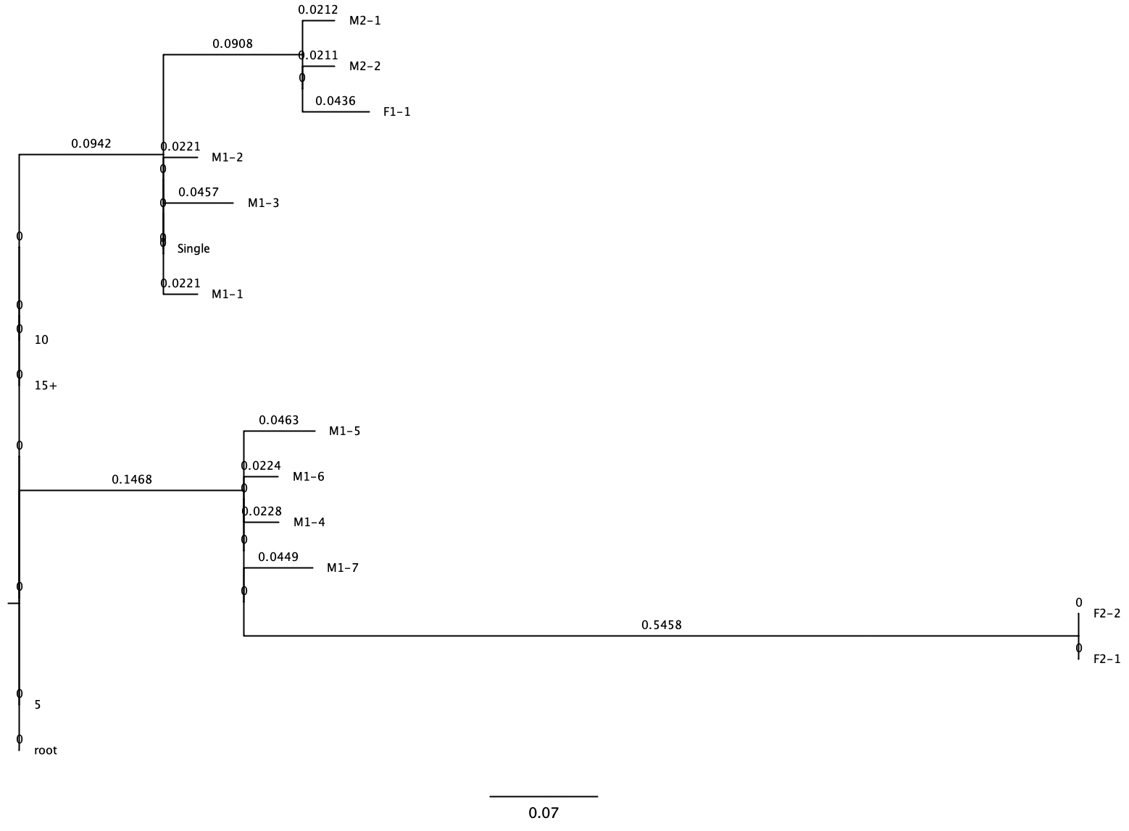
GTR-CATI
