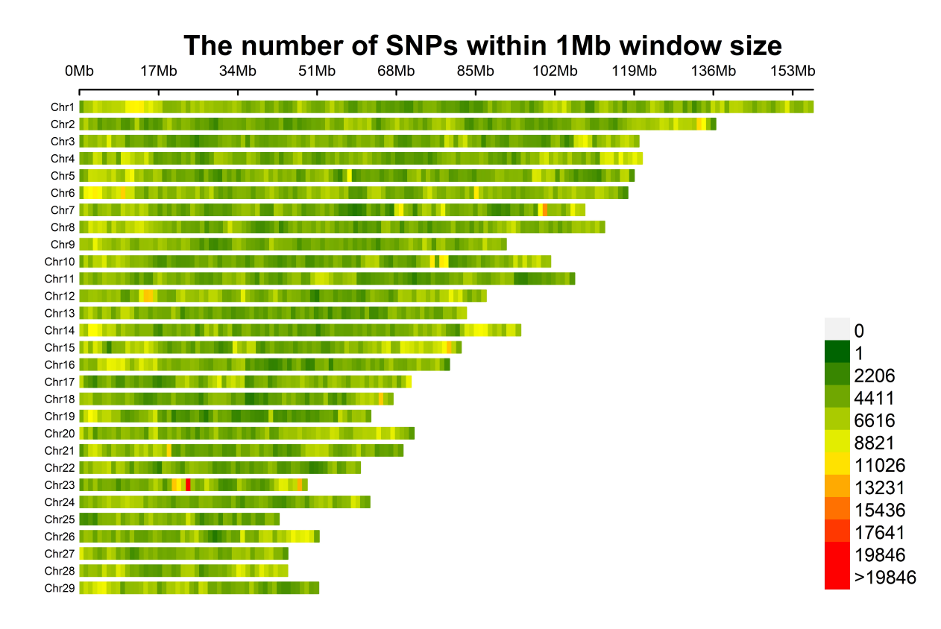
Fig. S1 The number of SNPs on each chromosome in the genome.

Fig. S2 The number of SNPs within 1 Mb window size. The figure shows the difference of SNP distribution in different regions of each chromosome. The color of the right legend of the figure indicates that the green area represents one SNP per 1 MB interval, while the red area denotes the presence of more than 19846 SNPs in that particular region.

