//Supporting Infomation
Figue S1 Phylogenetic tree obtained using the maximum likelihood (ML) methods for the Lycium species based on 55 PCGs.
Figue S2 Phylogenetic tree obtained using the Bayesian inference (BI) methods for the Lycium species based on 55 PCGs.
Figue S3 Phylogenetic tree obtained using the maximum likelihood (ML) methods for the Lycium species based on complete CPGs.
Figue S4 Phylogenetic tree obtained using the Bayesian inference (BI) methods for the Lycium species based on complete CPGs.

Figue S1
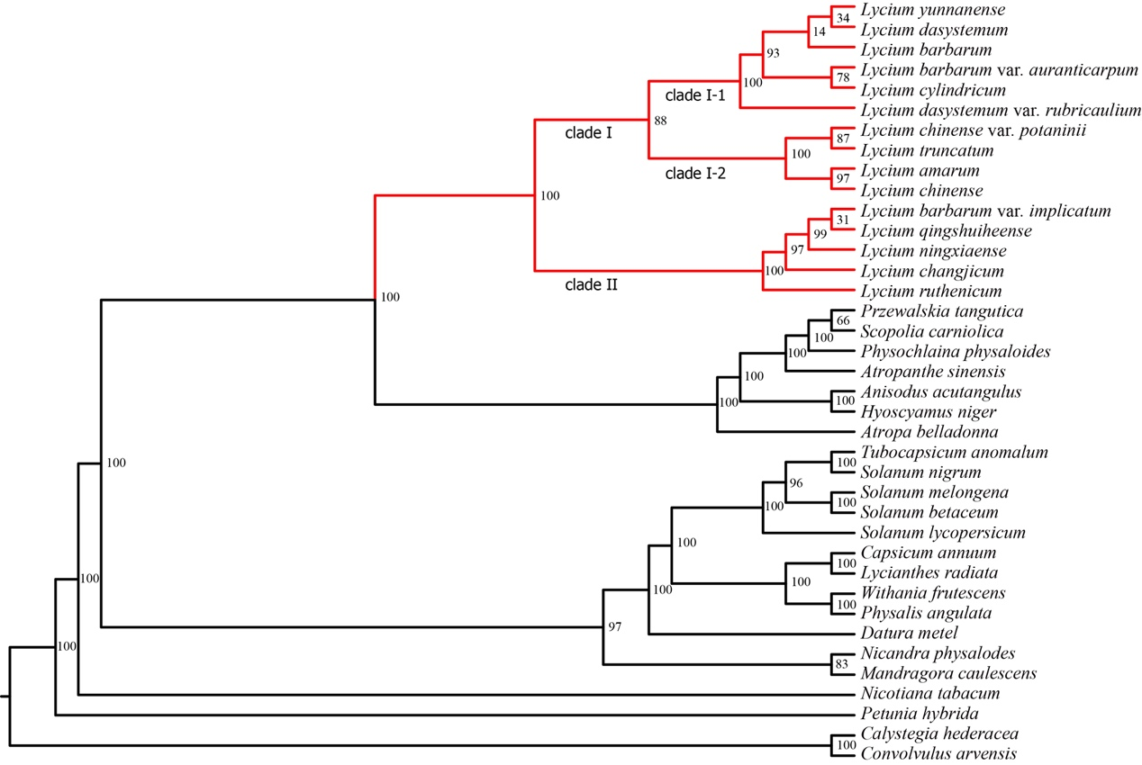

Figue S2
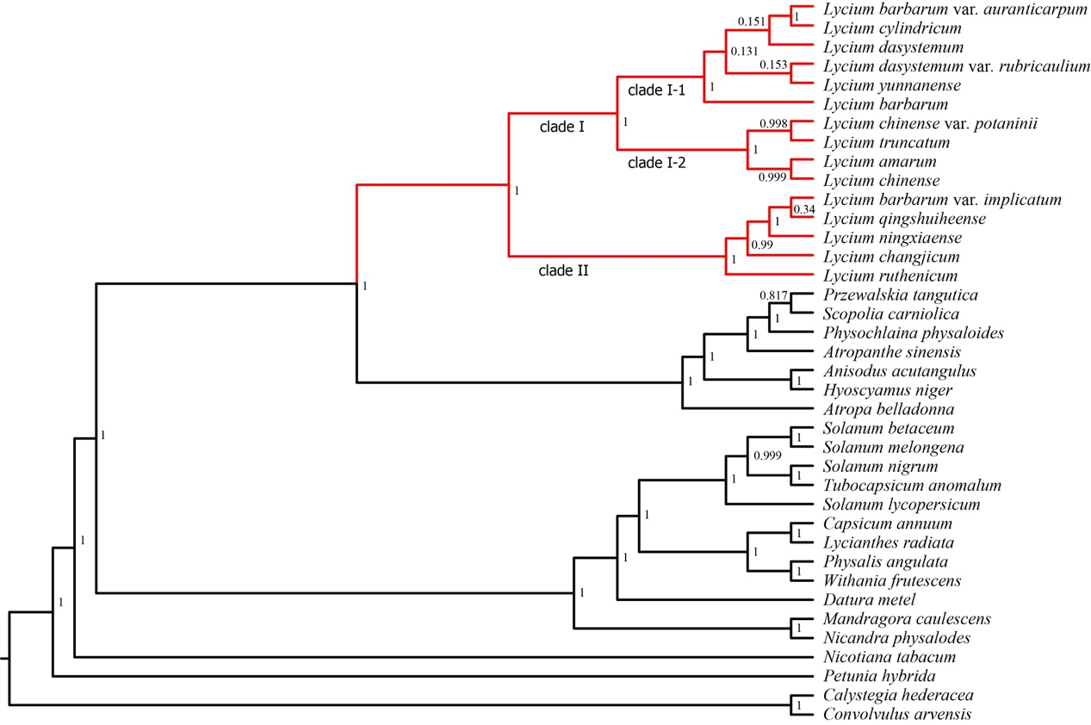

Figue S3
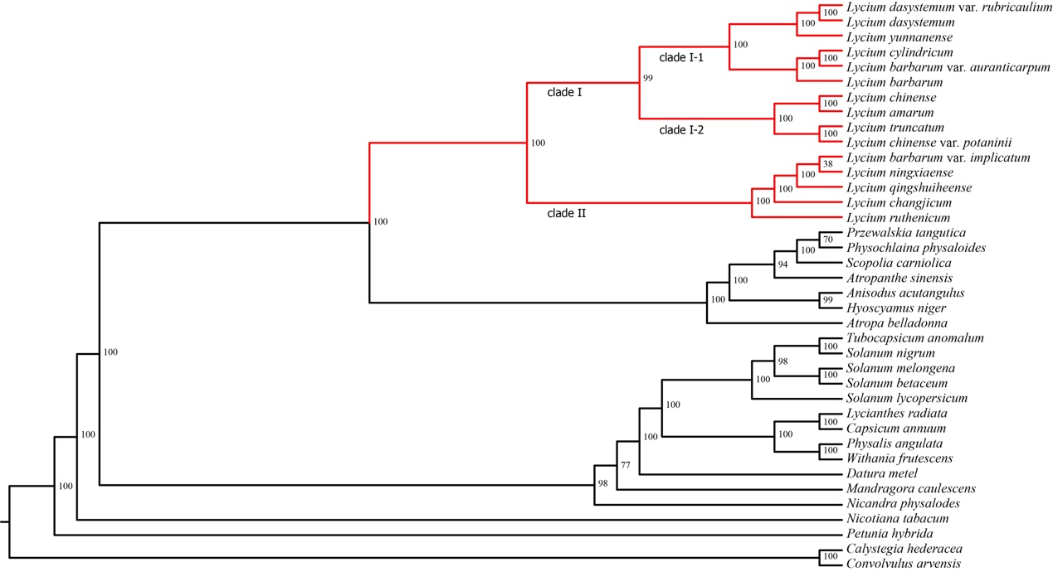

Figue S4
