Supporting information for

Unique features of conventional and nonconventional introns in Euglena gracilis
Pingwei Gao, Yali Zhao, Guangjie Xu, Yujie Zhong and Chengfu Sun

This file includes:
Supplementary Figure S1
Supplementary Figure S2
Supplementary Figure S3
Supplementary Figure S4
Supplementary Table S1

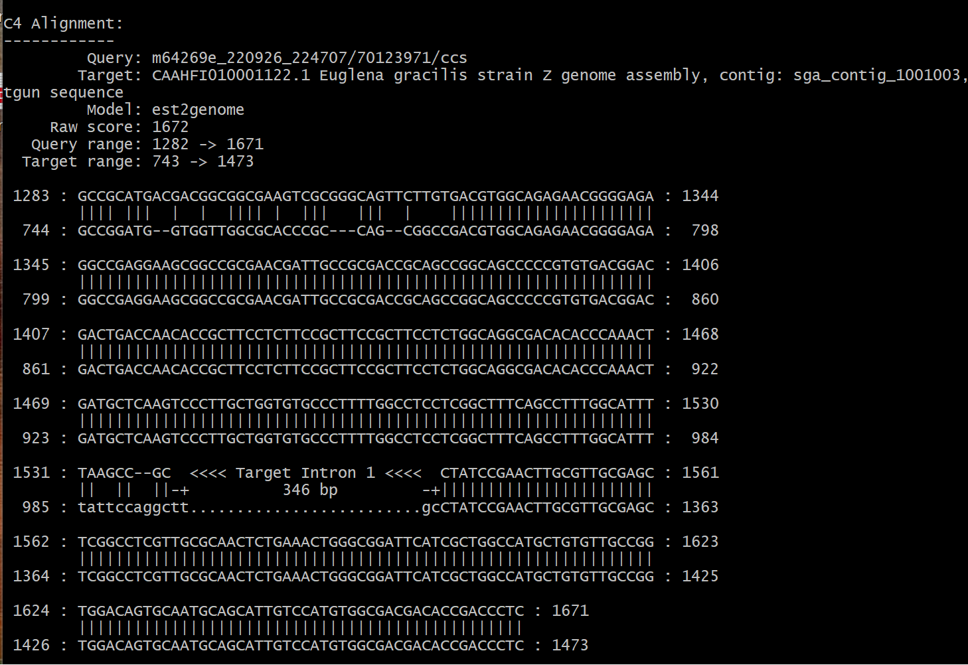

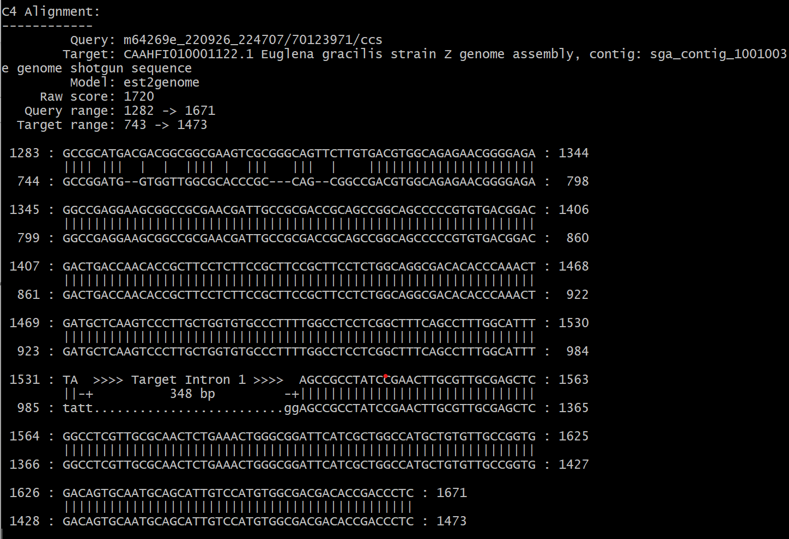

Supplementary Figure S1. Example of annotation of a nonconventional intron by the exonerate program with default (upper panel) and a custom PSSM (low panel).

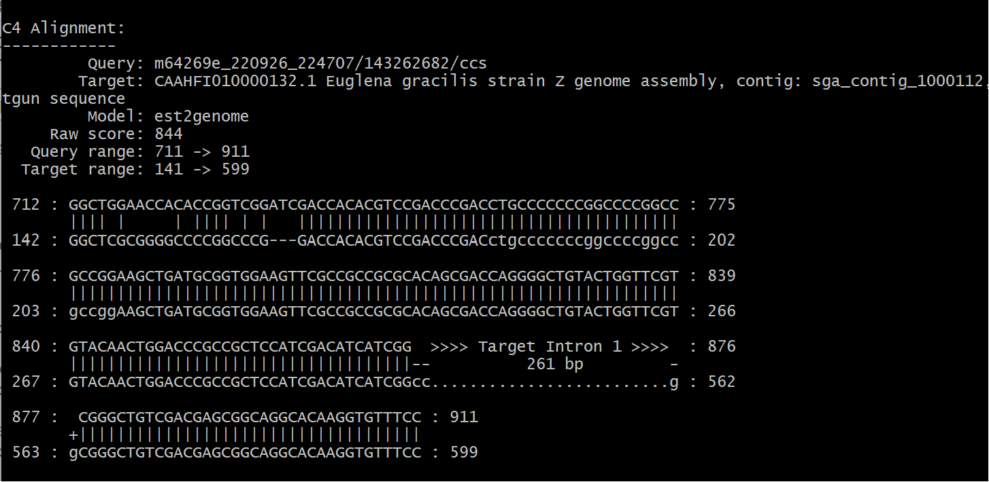

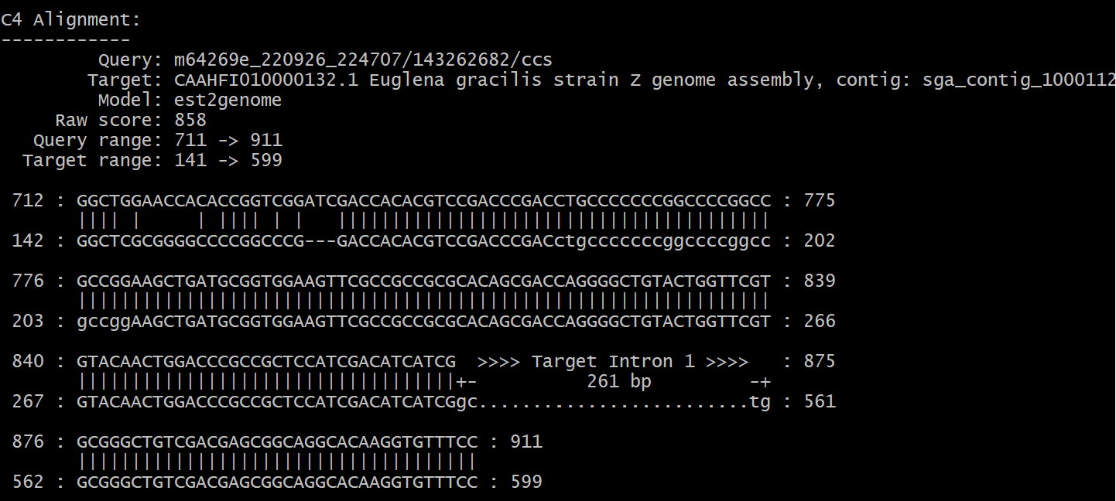

Supplementary Figure S2. Example of a ss-variant intron. Terminal nucleotides annotated by the exonerate program can be cc-gg (upper panel) or gc-tg (lower panel).

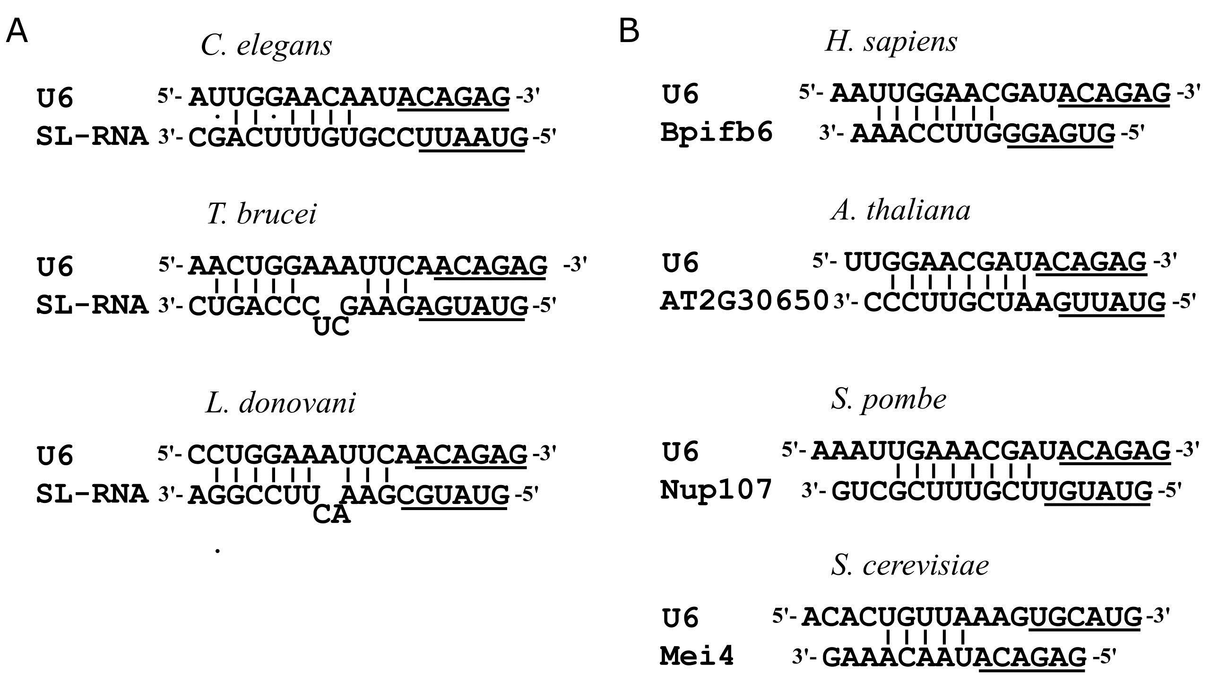

Supplementary Figure S3. The extended U6/5' ss helix in different species. (A) The extended U6/5' ss helix of SL-RNA in C. elegans, T. brucei, and L. donovani. (B) Examples of the extended U6/5' ss helix between the respective U6 and the 5' ss region of genes from H. sapiens, A. thaliana, S. pombe, and S. cerevisiae. The ACAGA box of U6 and the 5' ss of SL-RNA/intron are underlined.

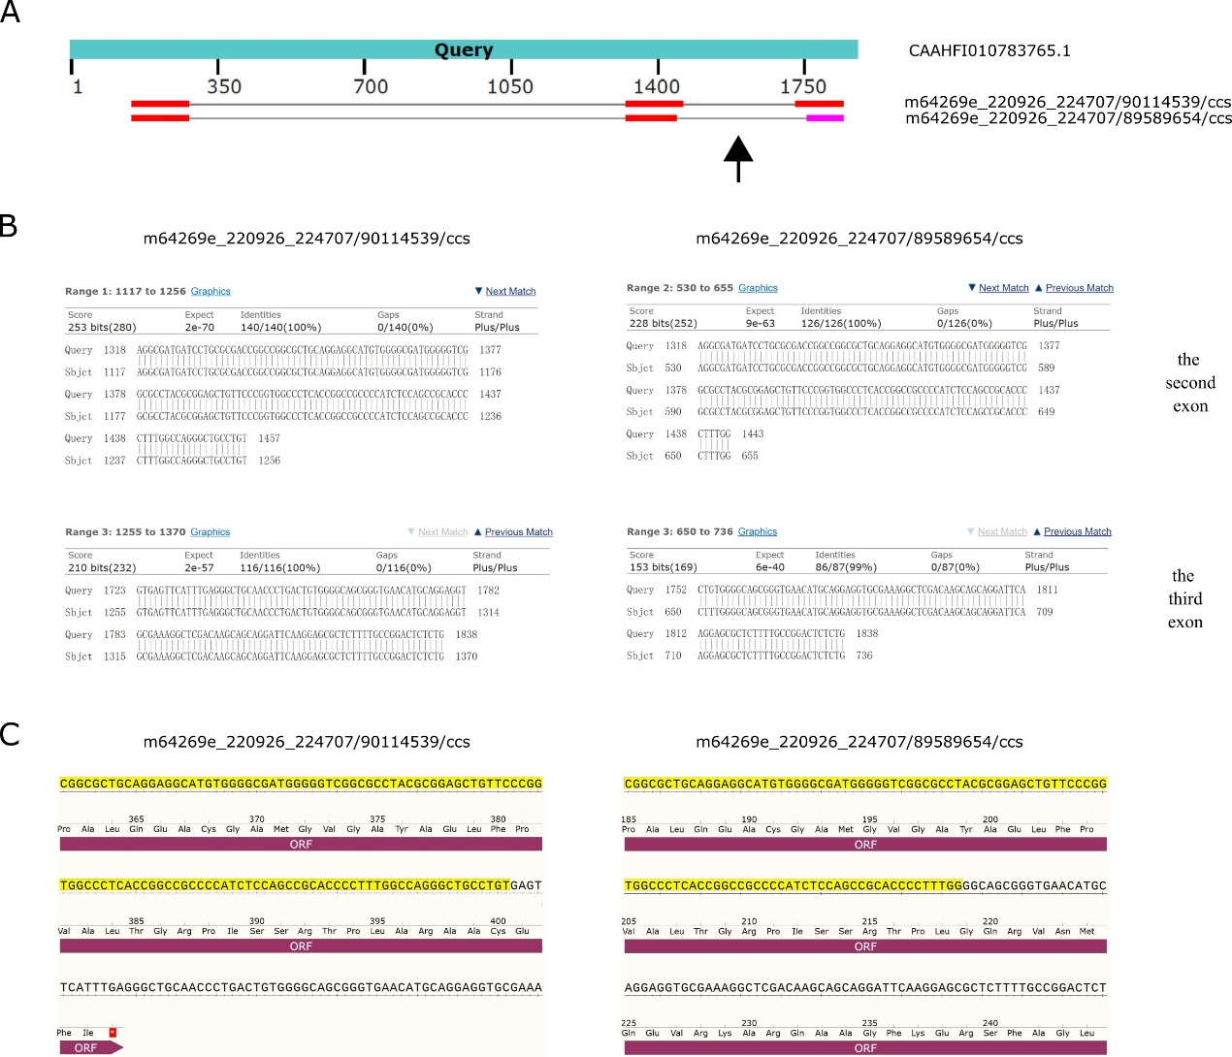
Supplementary Figure S4. An example of the AS pattern overlapping that affects the frameshift during translation. (A) Snapshot of the graphic summary of the sequence alignment generated by NCBI-BLAST program between the genomic DNA (used as query) and two RNA transcripts (used as subject) of a homolog of aarF domain-containing protein kinase 1 in E. gracilis. For the two transcripts, the second intron (indicated with a black arrow) between the second and the third exons is subject to overlapping. The length of this intron of the upper transcript (m64269e_220926_224707/90114539/ccs) is 267 bp and that of the lower transcript (m64269e_220926_224707/89589654/ccs) is 314 bp. (B) sequence alignment between the genomic DNA sequence and the second (upper panel) or third (lower panel) exons of the respective transcripts. (C) Translational frameshift of transcript m64269e_220926_224707/90114539/ccs in comparison to transcript m64269e_220926_224707/89589654/ccs. The second exons of both transcripts are colored in the yellow background. After intron removal, a stop codon occurs 9 nts downstream of this exon in m64269e_220926_224707/90114539/ccs.
Supplementary Table S1 AS events identified in this work
AS type | Genomic accession | Transcriptomic accession | intron size (bp)
Overlapping | CAAHFI010095568.1 | m64269e_220926_224707/43059924/ccs  m64269e_220926_224707/47121973/ccs | 507  422
Overlapping | CAAHFI010245853.1 | m64269e_220926_224707/39389135/ccs  m64269e_220926_224707/105775799/ccs | 244  181
Overlapping | CAAHFI010365539.1 | m64269e_220926_224707/130025364/ccs  m64269e_220926_224707/24773118/ccs | 1275  1214
Overlapping | CAAHFI010548366.1 | m64269e_220926_224707/38732698/ccs  m64269e_220926_224707/146606680/ccs | 1056  1001
Overlapping | CAAHFI011060464.1 | m64269e_220926_224707/106299553/ccs  m64269e_220926_224707/77400317/ccs | 455  428
Overlapping | CAAHFI011991134.1 | m64269e_220926_224707/59966605/ccs  m64269e_220926_224707/49941311/ccs | 632  586
Overlapping | CAAHFI010356404.1 | m64269e_220926_224707/132121167/ccs  m64269e_220926_224707/98501514/ccs | 425  382
Overlapping | CAAHFI010783765.1 | m64269e_220926_224707/89589654/ccs  m64269e_220926_224707/90114539/ccs | 314  267
Overlapping | CAAHFI011214082.1 | m64269e_220926_224707/79364138/ccs  m64269e_220926_224707/151063201/ccs | 606  538
Overlapping | CAAHFI011234586.1 | m64269e_220926_224707/5636690/ccs  m64269e_220926_224707/19858408/ccs | 626  509
Overlapping | CAAHFI011313882.1 | m64269e_220926_224707/90245730/ccs  m64269e_220926_224707/45351257/ccs | 75  53
Overlapping | CAAHFI011433261.1 | m64269e_220926_224707/55182940/ccs  m64269e_220926_224707/138610068/ccs | 361  325
Overlapping | CAAHFI011569944.1 | m64269e_220926_224707/70126275/ccs  m64269e_220926_224707/86245980/ccs | 609  443
Overlapping | CAAHFI011781967.1 | m64269e_220926_224707/127208210/ccs  m64269e_220926_224707/147130438/ccs | 257  252
Overlapping | CAAHFI011989906.1 | m64269e_220926_224707/11797629/ccs  m64269e_220926_224707/156763211/ccs | 351  322
Overlapping | CAAHFI012022742.1 | m64269e_220926_224707/56822410/ccs  m64269e_220926_224707/132317800/ccs | 569  547
Overlapping | CAAHFI012050753.1 | m64269e_220926_224707/143066356/ccs  m64269e_220926_224707/139527452/ccs | 416  313
Overlapping | CAAHFI011464222.1 | m64269e_220926_224707/79627380/ccs  m64269e_220926_224707/35258559/ccs | 625  505
Overlapping | CAAHFI010081492.1 | m64269e_220926_224707/47974732/ccs  m64269e_220926_224707/124387789/ccs | 1189  1173
Overlapping | CAAHFI010081492.1 | m64269e_220926_224707/124387789/ccs  m64269e_220926_224707/2752992/ccs | 376  181
Overlapping | CAAHFI010081492.1 | m64269e_220926_224707/2752992/ccs  m64269e_220926_224707/124387789/ccs | 203  197
Overlapping | CAAHFI010081492.1 | m64269e_220926_224707/124387789/ccs  m64269e_220926_224707/2752992/ccs | 1173  927
Overlapping | CAAHFI011326790.1 | m64269e_220926_224707/156304278/ccs  m64269e_220926_224707/119079977/ccs | 539  490
Overlapping | CAAHFI011718962.1 | m64269e_220926_224707/100993234/ccs  m64269e_220926_224707/1705157/ccs | 2481  616
Overlapping | CAAHFI010851876.1 | m64269e_220926_224707/67504620/ccs  m64269e_220926_224707/31393641/ccs | 464  428
Overlapping | CAAHFI010851876.1 | m64269e_220926_224707/67504620/ccs  m64269e_220926_224707/31393641/ccs | 698  691
Overlapping | CAAHFI010347071.1 | m64269e_220926_224707/48498241/ccs  m64269e_220926_224707/170526546/ccs | 643  631
Overlapping | CAAHFI010347071.1 | m64269e_220926_224707/76612282/ccs  m64269e_220926_224707/170526546/ccs | 620  631
Overlapping | CAAHFI010521295.1 | m64269e_220926_224707/163187180/ccs  m64269e_220926_224707/49414239/ccs | 890  853
Overlapping | CAAHFI010536519.1 | m64269e_220926_224707/165676250/ccs  m64269e_220926_224707/30869908/ccs | 731  708
Overlapping | CAAHFI010572383.1 | m64269e_220926_224707/72223500/ccs  m64269e_220926_224707/170198887/ccs | 384  366
Overlapping | CAAHFI010909693.1 | m64269e_220926_224707/155649477/ccs  m64269e_220926_224707/65864500/ccs | 820  764
Overlapping | CAAHFI010959876.1 | m64269e_220926_224707/96536236/ccs  m64269e_220926_224707/146342703/ccs | 282  181
Overlapping | CAAHFI011183243.1 | m64269e_220926_224707/52626203/ccs  m64269e_220926_224707/85983447/ccs | 226  182
Overlapping | CAAHFI011276374.1 | m64269e_220926_224707/176882287/ccs  m64269e_220926_224707/114819535/ccs | 537  476
Overlapping | CAAHFI011317307.1 | m64269e_220926_224707/55249255/ccs  m64269e_220926_224707/2883957/ccs | 431  405
Overlapping | CAAHFI011342166.1 | m64269e_220926_224707/50397362/ccs  m64269e_220926_224707/177537392/ccs | 661  592
Overlapping | CAAHFI011552157.1 | m64269e_220926_224707/11666435/ccs  m64269e_220926_224707/136907271/ccs | 643  633
Overlapping | CAAHFI011557255.1 | m64269e_220926_224707/92473232/ccs  m64269e_220926_224707/14024974/ccs | 1125  976
Overlapping | CAAHFI011902270.1 | m64269e_220926_224707/133366989/ccs  m64269e_220926_224707/170853083/ccs | 453  332
Overlapping | CAAHFI011958562.1 | m64269e_220926_224707/122815136/ccs  m64269e_220926_224707/151192962/ccs | 186  155
Overlapping | CAAHFI011972143.1 | m64269e_220926_224707/54003200/ccs  m64269e_220926_224707/110166862/ccs | 424  176
Overlapping | CAAHFI011991608.1 | m64269e_220926_224707/92405916/ccs  m64269e_220926_224707/163184746/ccs | 197  174
Overlapping | CAAHFI010295473.1 | m64269e_220926_224707/92602803/ccs  m64269e_220926_224707/152897144/ccs | 1534  1528
Overlapping | CAAHFI010546828.1 | m64269e_220926_224707/28575217/ccs  m64269e_220926_224707/123995553/ccs | 797  650
Overlapping | CAAHFI010580339.1 | m64269e_220926_224707/44630174/ccs  m64269e_220926_224707/21233997/ccs | 401  354
Overlapping | CAAHFI010667019.1 | m64269e_220926_224707/128647318/ccs  m64269e_220926_224707/170590327/ccs | 383  244
Overlapping | CAAHFI010874038.1 | m64269e_220926_224707/25561424/ccs  m64269e_220926_224707/25495777/ccs | 650  571
Overlapping | CAAHFI011119898.1 | m64269e_220926_224707/61344480/ccs  m64269e_220926_224707/108266360/ccs | 529  490
Overlapping | CAAHFI011660197.1 | m64269e_220926_224707/119932389/ccs  m64269e_220926_224707/118947893/ccs | 587  578
Overlapping | CAAHFI012023185.1 | m64269e_220926_224707/15991524/ccs  m64269e_220926_224707/6817316/ccs | 891  855
Overlapping | CAAHFI012051415.1 | m64269e_220926_224707/113770944/ccs  m64269e_220926_224707/123668601/ccs | 317  296
Overlapping | CAAHFI010042953.1 | m64269e_220926_224707/25822647/ccs  m64269e_220926_224707/84149969/ccs | 168  107
Overlapping | CAAHFI010272689.1 | m64269e_220926_224707/152371829/ccs  m64269e_220926_224707/87755449/ccs | 983  976
Overlapping | CAAHFI010699269.1 | m64269e_220926_224707/168626511/ccs  m64269e_220926_224707/41158690/ccs | 1489  1416
Overlapping | CAAHFI011451322.1 | m64269e_220926_224707/152764890/ccs  m64269e_220926_224707/117245561/ccs | 1338  1302
Overlapping | CAAHFI011883343.1 | m64269e_220926_224707/85131491/ccs  m64269e_220926_224707/172753631/ccs | 611  580
Overlapping | CAAHFI011008416.1 | m64269e_220926_224707/116327091  m64269e_220926_224707/138085842 | 607  595
Overlapping | CAAHFI011655251.1 | m64269e_220926_224707/64029565/ccs  m64269e_220926_224707/60490157/ccs | 723  696
A5SS | CAAHFI011091074.1 | m64269e_220926_224707/127140882/ccs  m64269e_220926_224707/57018893/ccs | 473  422
A5SS | CAAHFI010422330.1 | m64269e_220926_224707/134284305/ccs  m64269e_220926_224707/5046787/ccs | 308  263
A5SS | CAAHFI010306310.1 | m64269e_220926_224707/102236931/ccs  m64269e_220926_224707/88605166/ccs | 213  189
A5SS | CAAHFI011051963.1 | m64269e_220926_224707/155910693/ccs  m64269e_220926_224707/85721392/ccs | 1898  1860
A5SS | CAAHFI011442426.1 | m64269e_220926_224707/114558393/ccs  m64269e_220926_224707/85002576/ccs | 657  586
A5SS | CAAHFI010347071.1 | m64269e_220926_224707/48498241/ccs  m64269e_220926_224707/76612282/ccs | 643  620
A5SS | CAAHFI010354116.1 | m64269e_220926_224707/29820316/ccs  m64269e_220926_224707/93782689/ccs | 417  409
A5SS | CAAHFI010388402.1 | m64269e_220926_224707/7013374/ccs  m64269e_220926_224707/117573555/ccs | 265  228
A5SS | CAAHFI011223848.1 | m64269e_220926_224707/170460429/ccs  m64269e_220926_224707/28117570/ccs | 1010  1005
A3SS | CAAHFI011004980.1 | m64269e_220926_224707/149948060/ccs  m64269e_220926_224707/34604746/ccs | 1468  1406
A3SS | CAAHFI011779575.1 | m64269e_220926_224707/156239323/ccs  m64269e_220926_224707/92865199/ccs | 814  745
A3SS | CAAHFI011133615.1 | m64269e_220926_224707/56297830/ccs  m64269e_220926_224707/2032067/ccs | 3515  3454
A3SS | CAAHFI010851876.1 | m64269e_220926_224707/67504620/ccs  m64269e_220926_224707/31393641/ccs | 400  376
A3SS | CAAHFI010708712.1 | m64269e_220926_224707/23726551/ccs  m64269e_220926_224707/24316759/ccs | 1421  1368
A3SS | CAAHFI010727729.1 | m64269e_220926_224707/14092929/ccs  m64269e_220926_224707/149554050/ccs | 594  591
A3SS | CAAHFI010793419.1 | m64269e_220926_224707/167641783/ccs  m64269e_220926_224707/134743117/ccs | 962  950
A3SS | CAAHFI011631804.1 | m64269e_220926_224707/46202977/ccs  m64269e_220926_224707/171377062/ccs | 259  181
A3SS | CAAHFI011819729.1 | m64269e_220926_224707/72745495/ccs  m64269e_220926_224707/111609248/ccs | 544  499
SE | CAAHFI010928795.1 | m64269e_220926_224707/6947845/ccs  m64269e_220926_224707/73729733/ccs | 313  157/90
atypical SE | CAAHFI010816564.1 | m64269e_220926_224707/124977878/ccs  m64269e_220926_224707/91359879/ccs | 740  149/568
atypical SE | CAAHFI010746424.1 | m64269e_220926_224707/92539151/ccs  m64269e_220926_224707/107611860/ccs | 1591  172/52/400/395/128
atypical SE | CAAHFI010851876.1 | m64269e_220926_224707/31393641/ccs  m64269e_220926_224707/67504620/ccs | 901  337/310
atypical SE | CAAHFI010002354.1 | m64269e_220926_224707/103154417/ccs  m64269e_220926_224707/6032004/ccs | 601  389/111
atypical SE | CAAHFI010884710.1* | m64269e_220926_224707/157615496/ccs  m64269e_220926_224707/72157398/ccs | 2546  1184/1293
atypical SE | CAAHFI010971903.1* | m64269e_220926_224707/131924688/ccs  m64269e_220926_224707/67635903/ccs | 943  225/563
atypical SE | CAAHFI011136820.1 | m64269e_220926_224707/3145862/ccs  m64269e_220926_224707/71631551/ccs | 784  47/422
atypical SE | CAAHFI011903693.1 | m64269e_220926_224707/69338870/ccs  m64269e_220926_224707/176293414/ccs | 2498  1818/510
atypical SE | CAAHFI010206979.1 | m64269e_220926_224707/165675916/ccs  m64269e_220926_224707/58392993/ccs | 2066  1216/864
atypical SE | CAAHFI010129350.1* | m64269e_220926_224707/120063365/ccs  m64269e_220926_224707/53609876/ccs | 850  89/728
RI | CAAHFI010251568.1 | m64269e_220926_224707/124453184/ccs  m64269e_220926_224707/52560265/ccs | 301
RI | CAAHFI010251568.1 | m64269e_220926_224707/124453184/ccs  m64269e_220926_224707/52560265/ccs | 569
RI | CAAHFI010183057.1 | m64269e_220926_224707/131599195/ccs  m64269e_220926_224707/46204556/ccs | 206
RI | CAAHFI010117114.1 | m64269e_220926_224707/178652730/ccs  m64269e_220926_224707/25756321/ccs | 301
RI | CAAHFI010252207.1 | m64269e_220926_224707/9240933/ccs  m64269e_220926_224707/127861445/ccs | 107
RI | CAAHFI010424696.1 | m64269e_220926_224707/119799873/ccs  m64269e_220926_224707/21301410/ccs | 427
RI | CAAHFI010424696.1 | m64269e_220926_224707/119799873/ccs  m64269e_220926_224707/21301410/ccs | 64
RI | CAAHFI010458001.1 | m64269e_220926_224707/170657313/ccs  64269e_220926_224707/83427732/ccs | 46
RI | CAAHFI011181616.1 | m64269e_220926_224707/176423776/ccs  m64269e_220926_224707/163447644/ccs | 43
RI | CAAHFI011268395.1 | m64269e_220926_224707/44763529/ccs  m64269e_220926_224707/162267615/ccs | 38
RI | CAAHFI011313882.1 | m64269e_220926_224707/45351257/ccs  m64269e_220926_224707/76546619/ccs | 53/75
RI | CAAHFI011342166.1 | m64269e_220926_224707/177537392/ccs  m64269e_220926_224707/50397362/ccs | 75
RI | CAAHFI011441990.1/CAAHFI010008997.1 | m64269e_220926_224707/75499924/ccs  m64269e_220926_224707/173146546/ccs | 459
RI | CAAHFI011445760.1/CAAHFI011768082.1 | m64269e_220926_224707/86181388/ccs  m64269e_220926_224707/17498667/ccs | 323
RI | CAAHFI010834601.1 | m64269e_220926_224707/9240633/ccs  m64269e_220926_224707/81331924/ccs  m64269e_220926_224707/49939395/ccs | 137/202/256/639/186
RI | CAAHFI010840030.1/CAAHFI010871724.1 | m64269e_220926_224707/105908210/ccs  m64269e_220926_224707/47710286/ccs | 257
RI | CAAHFI010910719.1 | m64269e_220926_224707/33095776/ccs  m64269e_220926_224707/99616075/ccs | 943
RI | CAAHFI010938757.1 | m64269e_220926_224707/69143116/ccs  m64269e_220926_224707/8323678/ccs | 106
RI | CAAHFI011136523.1 | m64269e_220926_224707/57149828/ccs  m64269e_220926_224707/28379574/ccs | 268
RI | CAAHFI011136523.1 | m64269e_220926_224707/57149828/ccs  m64269e_220926_224707/28379574/ccs | 301
RI | CAAHFI011136523.1 | m64269e_220926_224707/57149828/ccs  m64269e_220926_224707/28379574/ccs | 317
RI | CAAHFI011212125.1 | m64269e_220926_224707/95552345/ccs  m64269e_220926_224707/3672563/ccs | 527
RI | CAAHFI011212125.1 | m64269e_220926_224707/95552345/ccs  m64269e_220926_224707/3672563/ccs | 533
RI | CAAHFI011248382.1 | m64269e_220926_224707/36504281/ccs  m64269e_220926_224707/105253532/ccs | 276
RI | CAAHFI011381915.1 | m64269e_220926_224707/6096316/ccs  64269e_220926_224707/59116066/ccs | 245
RI | CAAHFI011894065.1 | m64269e_220926_224707/107874445/ccs  m64269e_220926_224707/48563120/ccs | 47
RI | CAAHFI011894065.1 | m64269e_220926_224707/107874445/ccs  m64269e_220926_224707/48563120/ccs | 45
RI | CAAHFI011956605.1/CAAHFI0111787/87.1 | m64269e_220926_224707/32704569/ccs  64269e_220926_224707/129500553/ccs | 443
RI | CAAHFI011958562.1 | m64269e_220926_224707/151192962/ccs  m64269e_220926_224707/122815136/ccs  m64269e_220926_224707/97780953/ccs | 299/186/155
RI | CAAHFI010089739.1 | m64269e_220926_224707/18088509/ccs m64269e_220926_224707/23986587/ccs | 52
RI | CAAHFI010287594.1 | m64269e_220926_224707/19007685/ccs m64269e_220926_224707/123472344/ccs | 146
RI | CAAHFI010289419.1 | m64269e_220926_224707/64553644/ccs  m64269e_220926_224707/132317639/ccs | 86
RI | CAAHFI010545152.1 | m64269e_220926_224707/22675755/ccs  m64269e_220926_224707/99485865/ccs | 657
RI | CAAHFI010553483.1/CAAHFI011315372.1 | m64269e_220926_224707/47580562/ccs  m64269e_220926_224707/53871888/ccs | 774
RI | CAAHFI010556605.1 | m64269e_220926_224707/88935172/ccs  m64269e_220926_224707/72288817/ccs | 366
RI | CAAHFI010621152.1 | m64269e_220926_224707/61802380/ccs  m64269e_220926_224707/99879018/ccs | 206/53
RI | CAAHFI010642553.1 | m64269e_220926_224707/29690618/ccs  m64269e_220926_224707/55246883/ccs | 423
RI | CAAHFI010739965.1 | m64269e_220926_224707/2361516/ccs  64269e_220926_224707/97518047/ccs | 384
RI | CAAHFI010777982.1 | m64269e_220926_224707/74711382/ccs  m64269e_220926_224707/34015495/ccs | 492
RI | CAAHFI010798983.1 | m64269e_220926_224707/140641993/ccs  m64269e_220926_224707/77923112/ccs | 344/60
RI | CAAHFI010808994.1 | m64269e_220926_224707/94109738/ccs  m64269e_220926_224707/142936872/ccs | 86
RI | CAAHFI010867420.1 | m64269e_220926_224707/112984650/ccs  m64269e_220926_224707/90767712/ccs | 44
RI | CAAHFI010876927.1 | m64269e_220926_224707/56494121/ccs  m64269e_220926_224707/24447304/ccs | 161
RI | CAAHFI010997633.1 | m64269e_220926_224707/140904706/ccs  m64269e_220926_224707/53674879/ccs | 46
RI | CAAHFI011003871.1 | m64269e_220926_224707/86902153/ccs  m64269e_220926_224707/37486700/ccs | 46
RI | CAAHFI011055188.1 | m64269e_220926_224707/166724564/ccs  m64269e_220926_224707/131205235/ccs | 187
RI | CAAHFI011058993.1 | m64269e_220926_224707/109512973/ccs  m64269e_220926_224707/108857003/ccs | 371
RI | CAAHFI011205260.1 | m64269e_220926_224707/72352247/ccs  m64269e_220926_224707/176424398/ccs | 79
RI | CAAHFI011336853.1 | m64269e_220926_224707/131402195/ccs  m64269e_220926_224707/82182908/ccs | 802
RI | CAAHFI011375181.1 | m64269e_220926_224707/104333554/ccs  m64269e_220926_224707/125239935/ccs | 698
RI | CAAHFI011461811.1 | m64269e_220926_224707/87820527/ccs  m64269e_220926_224707/157878403/ccs | 109
RI | CAAHFI011519620.1 | m64269e_220926_224707/68225104/ccs  m64269e_220926_224707/20056487/ccs | 119
RI | CAAHFI011533207.1 | m64269e_220926_224707/7537261/ccs  m64269e_220926_224707/45353457/ccs | 488
RI | CAAHFI011582030.1/CAAHFI011356103.1 | m64269e_220926_224707/77007101/ccs  m64269e_220926_224707/166724855/ccs | 88
RI | CAAHFI011588633.1 | m64269e_220926_224707/138412971/ccs  m64269e_220926_224707/17041535/ccs | 99
RI | CAAHFI011591745.1 | m64269e_220926_224707/64028913/ccs  m64269e_220926_224707/177997138/ccs | 367
RI | CAAHFI011648406.1 | m64269e_220926_224707/78119856/ccs  m64269e_220926_224707/60752672/ccs | 146
RI | CAAHFI011660600.1 | m64269e_220926_224707/37358141/ccs  m64269e_220926_224707/154928478/ccs | 320
RI | CAAHFI011662811.1 | m64269e_220926_224707/34408416/ccs  m64269e_220926_224707/154141428/ccs | 42
RI | CAAHFI011864412.1/CAAHFI011960032.1 | m64269e_220926_224707/98371702/ccs  m64269e_220926_224707/1705605/ccs | 272
RI | CAAHFI011974773.1 | m64269e_220926_224707/122686065/ccs  m64269e_220926_224707/144376982/ccs | 53/53
RI | CAAHFI012040318.1 | m64269e_220926_224707/163382336/ccs  m64269e_220926_224707/22022386/ccs | 92
RI | CAAHFI010015404.1 | m64269e_220926_224707/16975318/ccs  m64269e_220926_224707/34866553/ccs | 42
RI | CAAHFI010024059.1 | m64269e_220926_224707/94308925/ccs  m64269e_220926_224707/7800110/ccs | 256
RI | CAAHFI010042953.1 | m64269e_220926_224707/84149969/ccs  m64269e_220926_224707/88015560/ccs | 40
RI | CAAHFI010056306.1 | m64269e_220926_224707/94307933/ccs m64269e_220926_224707/151587211/ccs | 179
RI | CAAHFI010096060.1 | m64269e_220926_224707/175049399/ccs  m64269e_220926_224707/92997727/ccs | 49
RI | CAAHFI010103312.1 | m64269e_220926_224707/137953866/ccs  m64269e_220926_224707/57344423/ccs | 1080223/342
RI | CAAHFI010165720.1 | m64269e_220926_224707/8391098/ccs  m64269e_220926_224707/138479954/ccs | 50
RI | CAAHFI010175873.1 | m64269e_220926_224707/154599433/ccs  m64269e_220926_224707/7078780/ccs | 538/646
RI | CAAHFI010212341.1 | m64269e_220926_224707/140248245/ccs  m64269e_220926_224707/113903349/ccs | 273
RI | CAAHFI010221356.1/CAAHFI010806849.1 | m64269e_220926_224707/91817066/ccs  m64269e_220926_224707/87295368/ccs | 475
RI | CAAHFI010280974.1/CAAHFI010243923.1 | m64269e_220926_224707/79300653/ccs  m64269e_220926_224707/105581071/ccs | 138
RI | CAAHFI010305033.1 | m64269e_220926_224707/21102887/ccs  m64269e_220926_224707/116393009/ccs | 253/625
RI | CAAHFI010313717.1 | m64269e_220926_224707/151585502/ccs  m64269e_220926_224707/90966277/ccs | 120
RI | CAAHFI010365237.1 | m64269e_220926_224707/34537980/ccs  m64269e_220926_224707/99813463/ccs | 307
RI | CAAHFI010436661.1/CAAHFI010076854.1 | m64269e_220926_224707/16451610/ccs  m64269e_220926_224707/4129539/ccs | 267
RI | CAAHFI010477291.1 | m64269e_220926_224707/161744514/ccs  m64269e_220926_224707/124650129/ccs | 48
RI | CAAHFI010490763.1 | m64269e_220926_224707/81068160/ccs  m64269e_220926_224707/126484816/ccs | 85
RI | CAAHFI010561259.1 | m64269e_220926_224707/119802601/ccs  m64269e_220926_224707/14876856/ccs | 222
RI | CAAHFI010563531.1 | m64269e_220926_224707/98371573/ccs  m64269e_220926_224707/78907504/ccs | 325
RI | CAAHFI010580500.1 | m64269e_220926_224707/14551322/ccs  m64269e_220926_224707/158991364/ccs | 207/275
RI | CAAHFI010671002.1/CAAHFI011978759.1 | m64269e_220926_224707/38142104/ccs  m64269e_220926_224707/35782971/ccs | 127
RI | CAAHFI010740163.1 | m64269e_220926_224707/59639769/ccs m64269e_220926_224707/87950588/ccs | 69
RI | CAAHFI010790380.1 | m64269e_220926_224707/36373643/ccs m64269e_220926_224707/10683252/ccs | 43
RI | CAAHFI010808415.1 | m64269e_220926_224707/6947578/ccs  m64269e_220926_224707/23399160/ccs | 220
RI | CAAHFI010867865.1/CAAHFI011387466.1 | m64269e_220926_224707/29231513/ccs  m64269e_220926_224707/55118649/ccs | 104
RI | CAAHFI010979715.1 | m64269e_220926_224707/72615592/ccs  m64269e_220926_224707/120391163/ccs | 260/435
RI | CAAHFI011184642.1/CAAHFI011223267.1 | m64269e_220926_224707/106235146/ccs  m64269e_220926_224707/90704295/ccs | 49
RI | CAAHFI011251957.1 | m64269e_220926_224707/16976172/ccs  m64269e_220926_224707/80022139/ccs | 242/710
RI | CAAHFI011252142.1 | m64269e_220926_224707/72091012/ccs  m64269e_220926_224707/61669907/ccs | 45
RI | CAAHFI011339149.1 | m64269e_220926_224707/51317014/ccs  m64269e_220926_224707/167249750/ccs | 355
RI | CAAHFI011494914.1 | m64269e_220926_224707/1902432/ccs  m64269e_220926_224707/147652615/ccs | 347
RI | CAAHFI011514322.1 | m64269e_220926_224707/53740971/ccs  m64269e_220926_224707/167708422/ccs | 489
RI | CAAHFI011518668.1/CAAHFI011367957.1 | m64269e_220926_224707/12715887/ccs  m64269e_220926_224707/141363650/ccs | 736
RI | CAAHFI011548752.1/CAAHFI011985068.1 | m64269e_220926_224707/115279155/ccs  m64269e_220926_224707/93849977/ccs | 301
RI | CAAHFI011602900.1 | m64269e_220926_224707/165347735/ccs  m64269e_220926_224707/63309526/ccs | 126
RI | CAAHFI011658843.1 | m64269e_220926_224707/106824634/ccs  m64269e_220926_224707/37291225/ccs | 41
RI | CAAHFI011667060.1 | m64269e_220926_224707/50005958/ccs  m64269e_220926_224707/84084082/ccs | 609
RI | CAAHFI011682341.1/CAAHFI010052243.1 | m64269e_220926_224707/153946897/ccs  m64269e_220926_224707/105253299/ccs | 310
RI | CAAHFI011821328.1/CAAHFI010484113.1 | m64269e_220926_224707/23724442/ccs  m64269e_220926_224707/19989337/ccs | 666
RI | CAAHFI011857585.1 | m64269e_220926_224707/133498173/ccs  m64269e_220926_224707/127535178/ccs | 477
RI | CAAHFI011912623.1 | m64269e_220926_224707/29492184/ccs  m64269e_220926_224707/75302521/ccs | 237
RI | CAAHFI011917852.1/CAAHFI011586153.1 | m64269e_220926_224707/70912396/ccs  m64269e_220926_224707/45812438/ccs | 516
RI | CAAHFI011992067.1 | m64269e_220926_224707/117836412/ccs  m64269e_220926_224707/114885302/ccs | 46/48
RI | CAAHFI012034269.1/CAAHFI010098996.1 | m64269e_220926_224707/109774664/ccs  m64269e_220926_224707/18614675/ccs | 252
RI | CAAHFI010087310.1 | m64269e_220926_224707/33292576/ccs  m64269e_220926_224707/85984803/ccs | 44/51/51
RI | CAAHFI010798983.1 | m64269e_220926_224707/140641993/ccs  m64269e_220926_224707/77923112/ccs | 344/60
RI | CAAHFI010218620.1 | m64269e_220926_224707/27133920/ccs  m64269e_220926_224707/123929473/ccs | 102/237/75
RI | CAAHFI010746424.1 | m64269e_220926_224707/107611860/ccs  m64269e_220926_224707/124520885/ccs | 52
RI | CAAHFI011645292.1 | m64269e_220926_224707/42140649/ccs  m64269e_220926_224707/158467092/ccs | 174/318/598/95
RI | CAAHFI011439774.1 | m64269e_220926_224707/99812553/ccs  m64269e_220926_224707/102498909/ccs | 113/291/413/662
RI | CAAHFI010081492.1 | m64269e_220926_224707/2752992/ccs  m64269e_220926_224707/47974732/ccs | 927/181
RI | CAAHFI011947138.1 | m64269e_220926_224707/49939399/ccs  m64269e_220926_224707/97321100/ccs | 240/298
RI | CAAHFI010235868.1 | m64269e_220926_224707/158271152/ccs  m64269e_220926_224707/123471428/ccs | 493
RI | CAAHFI010248748.1 | m64269e_220926_224707/138807764/ccs m64269e_220926_224707/39977266/ccs | 191
RI | CAAHFI010546773.1/CAAHFI011462264.1 | m64269e_220926_224707/21433056/ccs m64269e_220926_224707/141101184/ccs | 47
RI | CAAHFI010552633.1 | m64269e_220926_224707/64883021/ccs  m64269e_220926_224707/175899233/ccs | 220
RI | CAAHFI010600833.1 | m64269e_220926_224707/89459215/ccs  m64269e_220926_224707/109971974/ccs | 977
RI | CAAHFI010617149.1 | m64269e_220926_224707/131138402/ccs  m64269e_220926_224707/175901328/ccs | 59/613
RI | CAAHFI010634071.1 | m64269e_220926_224707/9635362/ccs  m64269e_220926_224707/12453269/ccs | 440/64
RI | CAAHFI010694525.1/CAAHFI010443843.1 | m64269e_220926_224707/31260827/ccs  m64269e_220926_224707/13434903/ccs | 82
RI | CAAHFI010804878.1 | m64269e_220926_224707/132187969/ccs  m64269e_220926_224707/139855726/ccs | 143
RI | CAAHFI010959876.1 | m64269e_220926_224707/96536236/ccs  m64269e_220926_224707/51642752/ccs | 282/290/303
RI | CAAHFI010967293.1 | m64269e_220926_224707/32704569/ccs  m64269e_220926_224707/129500553/ccs | 443
RI | CAAHFI011055609.1 | m64269e_220926_224707/89721314/ccs m64269e_220926_224707/149292565/ccs | 132/66/909
RI | CAAHFI011367070.1 | m64269e_220926_224707/39519676/ccs m64269e_220926_224707/51905047/ccs | 512/626
RI | CAAHFI011408146.1 | m64269e_220926_224707/92078858/ccs  m64269e_220926_224707/133890605/ccs | 415
RI | CAAHFI011479801.1 | m64269e_220926_224707/78578814/ccs  m64269e_220926_224707/153946956/ccs | 55
RI | CAAHFI011510581.1 | m64269e_220926_224707/57018669/ccs  m64269e_220926_224707/95093244/ccs | 418
RI | CAAHFI011522833.1 | m64269e_220926_224707/177998240/ccs  m64269e_220926_224707/159581740/ccs | 660
RI | CAAHFI011635244.1 | m64269e_220926_224707/179899056/ccs  m64269e_220926_224707/129959467/ccs | 193
RI | CAAHFI011643931.1 | m64269e_220926_224707/127076143/ccs  m64269e_220926_224707/79563418/ccs | 187/632/669
RI | CAAHFI011734280.1 | m64269e_220926_224707/122619124/ccs  m64269e_220926_224707/168429499/ccs | 251/378/442
RI | CAAHFI011735749.1 | m64269e_220926_224707/129042828/ccs  m64269e_220926_224707/18088090/ccs | 80
RI | CAAHFI011806276.1 | m64269e_220926_224707/158335562/ccs  m64269e_220926_224707/100665998/ccs | 1326/98
RI | CAAHFI011923938.1/CAAHFI011097670.1 | m64269e_220926_224707/64226920/ccs  m64269e_220926_224707/165743134/ccs | 514
RI | CAAHFI011948404.1 | m64269e_220926_224707/133562940/ccs  m64269e_220926_224707/96731853/ccs | 115/143
RI | CAAHFI010072932.1 | m64269e_220926_224707/119081761/ccs  m64269e_220926_224707/67701420/ccs | 367
RI | CAAHFI010244548.1 | m64269e_220926_224707/116591088/ccs  m64269e_220926_224707/142477275/ccs | 107
RI | CAAHFI010645279.1 | m64269e_220926_224707/157158187/ccs  m64269e_220926_224707/45417719/ccs | 197
RI | CAAHFI010761963.1 | m64269e_220926_224707/167315204/ccs  m64269e_220926_224707/7145781/ccs | 46/47/47/48/53
RI | CAAHFI011156458.1 | m64269e_220926_224707/163055438/ccs  m64269e_220926_224707/67436738/ccs | 213/440/484/86
RI | CAAHFI011430762.1 | m64269e_220926_224707/179243393/ccs  m64269e_220926_224707/164955899/ccs | 228
RI | CAAHFI011584046.1 | m64269e_220926_224707/30737336/ccs  m64269e_220926_224707/22217391/ccs | 134/204
RI | CAAHFI011703139.1 | m64269e_220926_224707/133958119/ccs  m64269e_220926_224707/74843461/ccs | 111/197/803
RI | CAAHFI010054903.1 | m64269e_220926_224707/122489486/ccs  m64269e_220926_224707/88605595/ccs | 1196/185/47/75/82
RI | CAAHFI010078595.1 | m64269e_220926_224707/60688656/ccs  m64269e_220926_224707/170852933/ccs | 234
RI | CAAHFI010272689.1 | m64269e_220926_224707/87755449/ccs  m64269e_220926_224707/152371829/ccs | 121
RI | CAAHFI010359876.1 | m64269e_220926_224707/174721391/ccs  m64269e_220926_224707/31524226/ccs | 120/205/257/495
RI | CAAHFI010928795.1 | m64269e_220926_224707/73729733/ccs  m64269e_220926_224707/6947845/ccs  m64269e_220926_224707/70583704/ccs | 157/311/313/90
RI | CAAHFI011004469.1 | m64269e_220926_224707/116263023/ccs  m64269e_220926_224707/79431872/ccs | 254/313
RI | CAAHFI011124639.1 | m64269e_220926_224707/22544738/ccs  m64269e_220926_224707/22544738/ccs | 86
RI | CAAHFI011451106.1 | m64269e_220926_224707/148635675/ccs  m64269e_220926_224707/9243427/ccs | 263/303/825
RI | CAAHFI011495331.1 | m64269e_220926_224707/90899949/ccs  m64269e_220926_224707/68684069/ccs | 212/308
RI | CAAHFI011721723.1 | m64269e_220926_224707/7932098/ccs  m64269e_220926_224707/78250482/ccs | 109/341
RI | CAAHFI011918215.1/CAAHFI011876870.1 | m64269e_220926_224707/92210343/ccs  m64269e_220926_224707/40764103/ccs | 165
RI | CAAHFI011961491.1 | m64269e_220926_224707/10422564/ccs  m64269e_220926_224707/51315372/ccs | 185/502/580
RI | CAAHFI010086765.1 | m64269e_220926_224707/48038957/ccs  m64269e_220926_224707/138347703/ccs | 240
RI | CAAHFI010463498.1 | m64269e_220926_224707/107873713/ccs  m64269e_220926_224707/18940608/ccs | 1013/380/59/67
RI | CAAHFI011860170.1 | m64269e_220926_224707/57999749/ccs  m64269e_220926_224707/93651673/ccs | 546
*same 5' ss

