Supplementary File S9A: Comparison of BLAST-predicted and InterPro-predefined module lengths and presence of QX[F;W;Y] motifs.
Genbank ID | Module coordinates (BLAST) |  | Module coordinates (InterPro) |  | Length (BLAST) | Length (InterPro) | Length difference | QX[F;W;Y] motifs outside of predicted module | Type of QX[FWY] motif | BLAST score
Genbank ID | Start | End | Start | End
AAA32625 | 274 | 401 | 272 | 399 | 128 | 128 | 0 | 0 | - | 675
ACU38183 | 38 | 165 | 33 | 162 | 128 | 130 | 2 | 0 | - | 675
BAA36393 | 129 | 260 | 131 | 258 | 132 | 128 | -4 | 0 | - | 695
BAZ32339 | 9 | 138 | 3 | 136 | 130 | 134 | 4 | 0 | - | 242
CAG2249197 | 557 | 680 | 559 | 679 | 124 | 121 | -3 | 0 | - | 196
EAQ67128 | 586 | 684 | 561 | 694 | 99 | 109 | 35 | 1 | QKF | 156
GEK00516 | 383 | 513 | 382 | 512 | 131 | 131 | 0 | 0 | - | 542
HCZ74701 | 427 | 557 | 428 | 554 | 131 | 127 | -4 | 0 | - | 656
JAV29930 | 373 | 491 | 376 | 484 | 119 | 109 | -10 | 0 | - | 233
KOX40828 | 535 | 677 | 537 | 672 | 143 | 136 | -7 | 0 | - | 649
LAB60325 | 215 | 345 | 222 | 340 | 131 | 119 | -12 | 0 | - | 683
MUN35854 | 53 | 167 | 40 | 168 | 115 | 129 | 14 | 0 | - | 639
NII05187 | 362 | 463 | 358 | 445 | 102 | 88 | -14 | 0 | - | 105
OAM16885 | 74 | 184 | 65 | 185 | 111 | 121 | 10 | 0 | - | 163
PKF81495 | 265 | 405 | 267 | 410 | 141 | 144 | 3 | 0 | - | 108
QES47169 | 121 | 244 | 118 | 246 | 124 | 129 | 5 | 0 | - | 284
RQX12202 | 115 | 204 | 121 | 208 | 90 | 88 | -2 | 0 | - | 103
SBV24963 | 768 | 896 | 755 | 895 | 129 | 141 | 12 | 0 | - | 589
TCJ39650 | 292 | 414 | 278 | 414 | 123 | 137 | 14 | 0 | - | 535
VDB90017 | 66 | 171 | 38 | 172 | 106 | 135 | 29 | 0 | - | 104

Supplementary File S9B: Screenshot of the InterPro webpage of genbank ID EAQ67128. The red rectangle indicates the predefined module. Module coordinates are extracted by hovering over the highlighted module (indicated with the red box).
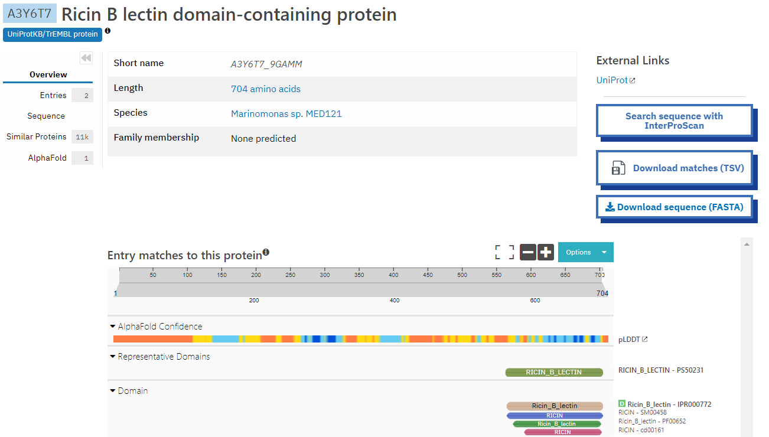

Supplementary File S9C: Multiple sequence alignment of the CBM13-predicted ricin-B lectin module and its full length amino acid sequence. The CBM13-predicted ricin-B lectin module is denoted with “mod”, while the full-length amino acid sequence is denoted with “full”. Yellow: predefined module length, given by InterPro. Cyan: predicted module length. Bold and red: QX[F;W;Y] motif found adjacent to the predicted module but part of the module as defined by InterPro.

EAQ67128.1_586-684mod ------------------------------------------------------------ 0
EAQ67128.1full MKKTLLYLSMLASASSVYADTGDQCSAYIDRVESNGGVTYNIESAAILSANTAITTGVEV 60

EAQ67128.1_586-684mod ------------------------------------------------------------ 0
EAQ67128.1full LGQSTLSAVFPYASIILRQITPGETTAAADPDLVACLESFDSRLTTLETYLLAEEASIAL 120

EAQ67128.1_586-684mod ------------------------------------------------------------ 0
EAQ67128.1full NAVRSKIQKDIIEQHDAVANFDVYESYDVIAAKLAGTLSYFLHEDQIENADADIYETIKN 180

EAQ67128.1_586-684mod ------------------------------------------------------------ 0
EAQ67128.1full DTLLYLLSAQNSAFLHNLEFNAYCAKEKNYQWTSTATSYIEHNDSKNHALMDYDLLKSLS 240

EAQ67128.1_586-684mod ------------------------------------------------------------ 0
EAQ67128.1full DFGYSTEDLQESNFDITDCELGRDSHSRYKALLSENTSYSPIAQIYDDLGFDITLDSGNS 300

EAQ67128.1_586-684mod ------------------------------------------------------------ 0
EAQ67128.1full NYLDVAIDIDSSKLADYRKGLIGSCSHSVDWGIAGHSGRDPWGTLILGGAKITTTSKDYG 360

EAQ67128.1_586-684mod ------------------------------------------------------------ 0
EAQ67128.1full GTATFSKSVIAGRNKIDSAKRYNEGYCDTWVGNLEDDLDDEVITLLNAIKVSLKNLSMYQ 420

EAQ67128.1_586-684mod ------------------------------------------------------------ 0
EAQ67128.1full LVRPAYELAGRAPQFLTYETGVIDNDLLESYMLVPQFDVNDEGDISDNYNHYQLFNAANG 480

EAQ67128.1_586-684mod ------------------------------------------------------------ 0
EAQ67128.1full DRYLKHRFDVGIVARNNGSGIDSHWQLSQRWPGEKTRMMNVYTNECVVISDAGELHMRSC 540

EAQ67128.1_586-684mod ---------------------------------------------SNSNKIAATDCDITN 15
EAQ67128.1full DEYPIAYVWDIHANTSGAVDASLKLSSNSHKNQCVLVSDETMPEYSNSNKIAATDCDITN 600
***************

EAQ67128.1_586-684mod ANQTFVLGDNNDIRVNGICLDVPRSEAFAGQSVIVYSCHYGDNQSWDLNPDGTIQSALNA 75
EAQ67128.1full ANQTFVLGDNNDIRVNGICLDVPRSEAFAGQSVIVYSCHYGDNQSWDLNPDGTIQSALNA 660
************************************************************

EAQ67128.1_586-684mod VDGTNLCLEANDATSDIAITLQAC-------------------- 99
EAQ67128.1full VDGTNLCLEANDATSDIAITLQACDSSNPAQKFIPNEIVEEEEV 704
************************

