SUPPLEMENTARY TABLES
Supplementary Table 1. Summary statistics about the annotated reference assemblies.
Sample | Number of contigs | Total assembly length (bp) | Number of genes | Chromosome length (bp) | Number of chromosomal genes | Number of plasmids | Number of plasmid genes | Total plasmid length (bp) | Total length of homopolymers (bp) | Total length of short repeats (bp) | Bases of genome where short reads do not map uniquely
CFSAN110825 | 2 | 4844012 | 4524 | 4770496 | 4449 | 1 | 75 | 73516 | 771448 | 1022780 | 169541
CFSAN110826 | 10 | 5104881 | 4846 | 4813027 | 4506 | 9 | 340 | 291854 | 814486 | 1061229 | 287013
CFSAN110827 | 2 | 4844037 | 4527 | 4770505 | 4451 | 1 | 76 | 73532 | 771191 | 1022938 | 165138
CFSAN110828 | 2 | 4885243 | 4581 | 4811731 | 4504 | 1 | 77 | 73512 | 777945 | 1030921 | 239910
CFSAN110829 | 6 | 5008212 | 4726 | 4769576 | 4453 | 5 | 273 | 238636 | 797579 | 1046546 | 191544
CFSAN110832 | 3 | 4898252 | 4602 | 4769863 | 4450 | 2 | 152 | 128389 | 780753 | 1030157 | 180941
CFSAN110833 | 3 | 4875473 | 4569 | 4770503 | 4448 | 2 | 121 | 104970 | 777481 | 1027480 | 216639
CFSAN110834 | 3 | 4932061 | 4620 | 4770516 | 4448 | 2 | 172 | 161545 | 785174 | 1036677 | 166489
CFSAN110835 | 2 | 4843421 | 4532 | 4769911 | 4455 | 1 | 77 | 73510 | 771365 | 1022570 | 166833
CFSAN110836 | 2 | 4843721 | 4535 | 4770214 | 4460 | 1 | 75 | 73507 | 771221 | 1022726 | 160010
CFSAN110837 | 3 | 4877683 | 4573 | 4770511 | 4447 | 2 | 126 | 107172 | 777407 | 1027859 | 162894
CFSAN110838 | 2 | 4842936 | 4528 | 4769422 | 4452 | 1 | 76 | 73514 | 771130 | 1022565 | 172495
CFSAN110902 | 2 | 4844148 | 4522 | 4770571 | 4446 | 1 | 76 | 73577 | 771452 | 1022845 | 170143
CFSAN112116 | 3 | 4848102 | 4521 | 4770525 | 4443 | 2 | 78 | 77577 | 771953 | 1023365 | 170219
CFSAN112117 | 2 | 4843998 | 4518 | 4770486 | 4443 | 1 | 75 | 73512 | 771248 | 1022674 | 149259

Supplementary Table 2. List of virulence-associated genomic features that occurred in regions that did not assemble in the short read assemblies.
Virulence gene/feature | Function
Heme ABC exporter | Aids in scavenging heme from the human host [37]
Phage-associated recT recombinase | Increases the efficiency of incorporating DNA sequences into bacterial chromosomes and plasmids [38, 39]
IS3 elements
Cell wall-associated hydrolase | Aids in biofilm formation and cell wall modifications to evade the host immune response [40]
Sodium ion-translocating decarboxylase | Involved with energy generation and the maintenance of pH homeostasis under conditions of low pH or high concentrations of organic acids such as in the gastrointestinal tract [41]

Supplementary Table 3. Summary of regions that were masked in the reference assemblies.
Isolate | Regions (>5 nt) with low depth of coverage  (< 40X) | Regions (>5 nt) with low median MapQ read alignment score  (< 40) | Polymorphic loci (nt) | Whole genome alignment error (nt) | Chromosome-associated loci (nt) | Plasmid-associated loci (nt) | Total nucleotides excluded | Main biological features associated with excluded regions
CFSAN110825 | 42 | 966 | 100 | 0 | 1,107 | 1 | 1,108 | Polymorphic loci, hin-recombinase-associated inversion
CFSAN110826 | 22,545 | 69,718 | 58 | 0 | 71,297 | 21,024 | 92,375 | Polymorphic loci, hin-recombinase-associated inversion, low abundance plasmids, duplicated phage
CFSAN110827 | 15 | 966 | 34 | 0 | 997 | 18 | 1,015 | Polymorphic loci, hin-recombinase-associated inversion
CFSAN110828 | 26,937 | 36,626 | 32 | 0 | 63,591 | 4 | 63,595 | Polymorphic loci, hin-recombinase-associated inversion, duplicated phage
CFSAN110829 | 2,044 | 966 | 61 | 0 | 1,016 | 2,055 | 3,071 | Polymorphic loci, hin-recombinase-associated inversion
CFSAN110832 | 10 | 966 | 32 | 0 | 992 | 16 | 1,008 | Polymorphic loci, hin-recombinase-associated inversion
CFSAN110833 | 77 | 0 | 32 | 0 | 37 | 72 | 109 | Polymorphic loci
CFSAN110834 | 0 | 0 | 23 | 0 | 21 | 2 | 23 | Polymorphic loci
CFSAN110835 | 0 | 966 | 42 | 0 | 1,007 | 1 | 1,008 | Polymorphic loci, hin-recombinase-associated inversion
CFSAN110836 | 11 | 0 | 50 | 75 | 130 | 2 | 132 | Polymorphic loci
CFSAN110837 | 100 | 0 | 32 | 0 | 26 | 106 | 132 | Polymorphic loci
CFSAN110838 | 0 | 717 | 1,001 | 0 | 1,024 | 226 | 1,250 | Polymorphic loci, hin-recombinase-associated inversion
CFSAN110902 | 106 | 966 | 139 | 0 | 1,087 | 123 | 1,210 | Polymorphic loci, hin-recombinase-associated inversion
CFSAN112116 | 9 | 0 | 286 | 0 | 76 | 219 | 295 | Polymorphic loci
CFSAN112117 | 104 | 966 | 21 | 0 | 1,090 | 1 | 1,091 | Polymorphic loci, hin-recombinase-associated inversion

Supplementary Table 4. Comparison of the total assembly lengths and number of assembled plasmids for the Flye, Unicycler, and reference assemblies.
Isolate | Total assembly length |  |  | Plasmids (length of unassembled plasmid)
 | Reference | Flye | Unicycler | Reference | Flye | Unicycler
CFSAN110825 | 4844012 | 4828957 | 4843730 | 1 | 1 | 1
CFSAN110826 | 5104881 | 5107349 | 5032289 | 9 (2,403 nt) | 10 | 9 (73,221 nt)
CFSAN110827 | 4844037 | 4862009 | 4877748 | 1 (33,548 nt) | 2 | 2
CFSAN110828 | 4885243 | 4829831 | 4844051 | 1 | 1 | 1
CFSAN110829 | 5008212 | 4995218 | 5008821 | 5 | 4 (4,087 nt) | 5
CFSAN110832 | 4898252 | 4886408 | 4898911 | 2 | 2 | 2
CFSAN110833 | 4875473 | 4858963 | 4875370 | 2 | 2 | 2
CFSAN110834 | 4932061 | 4992071 | 4932079 | 2 | 2 | 2
CFSAN110835 | 4843421 | 4826591 | 4843779 | 1 | 1 | 1
CFSAN110836 | 4843721 | 4830660 | 4844038 | 1 | 1 | 1
CFSAN110837 | 4877683 | 4898323 | 4877608 | 2 | 2 | 2
CFSAN110838 | 4842936 | 4916500 | 4948521 | 1 (85,985 nt) | 2 | 2
CFSAN110902 | 4844148 | 4830775 | 4843794 | 1 | 1 | 1
CFSAN112116 | 4848102 | 4917085 | 4934503 | 2 (86,149 nt) | 2 (4,064 nt) | 3
CFSAN112117 | 4843998 | 4918181 | 4931668 | 1 (87,759 nt) | 2 | 2

Supplementary Table 5. Percentage of homopolymer-associated errors by homopolymer type for the last assembly or polishing tool used in a pipeline.
Homopolymer type | Pilon | POLCA | Polypolish | NextPolish | ntEdit | Flye | Unicycler | Reference genomes
A | 34% | 42% | 39% | 41% | 31% | 33% | 38% | 33%
C | 16% | 9% | 12% | 9% | 19% | 17% | 12% | 17%
G | 16% | 7% | 10% | 6% | 19% | 17% | 13% | 17%
T | 34% | 42% | 39% | 43% | 31% | 33% | 38% | 33%

Supplementary Table 6. Runtimes for the tools and the best performing pipelines used in this study. All jobs were run with 8 cores on a high-performance computing cluster (3.0GHz AMD® EPYC® 7313 Processor) with a memory ceiling of 36 GB RAM.
Tool Type | Pipeline (number of iterations of polishing) | Minimum  (minute:second) | Median  (minute:second) | Maximum  (minute:second)
Assembler | Flye | 4:20 | 26:52 | 105:49
Assembler | Unicycler | 114:42 | 210:04 | 487:13
Long-read polisher | Racon_1x | 3:13 | 11:18 | 39:42
Long-read polisher | Racon_4x | 12:48 | 44:50 | 155:50
Long-read polisher | medaka_1x | 3:43 | 5:14 | 10:52
Long-read polisher | medaka_1x_Racon_4x | 17:05 | 49:00 | 160:54
Long-read polisher | Racon_4x_medaka_1x | 17:06 | 48:31 | 161:26
Short-read polisher | NextPolish_1x | 1:41 | 4:10 | 9:12
Short-read polisher | NextPolish_4x | 6:35 | 16:27 | 36:36
Short-read polisher | ntEdit_1x | 0:05 | 0:07 | 0:17
Short-read polisher | ntEdit_4x | 0:22 | 0:31 | 1:09
Short-read polisher | Pilon_1x | 2:26 | 7:06 | 19:42
Short-read polisher | Pilon_4x | 8:56 | 25:16 | 63:36
Short-read polisher | POLCA_1x | 1:18 | 4:15 | 14:51
Short-read polisher | POLCA_4x | 4:37 | 16:02 | 46:57
Short-read polisher | Polypolish_1x | 1:05 | 3:20 | 10:04
Short-read polisher | Polypolish_4x | 4:05 | 12:20 | 39:54
Top 5 performing pipelines | Unicycler_Racon_4x_medaka_NextPolish_4x | 159:19 | 277:04 | 668:47
Top 5 performing pipelines | Flye_Racon_4x_medaka_NextPolish_4x | 44:15 | 92:46 | 287:59
Top 5 performing pipelines | Unicycler_medaka_NextPolish_4x | 132:33 | 232:28 | 515:26
Top 5 performing pipelines | Flye_medaka_NextPolish_4x | 30:30 | 49:25 | 133:45
Top 5 performing pipelines | Unicycler_medaka_POLCA_4x | 129:33 | 232:46 | 511:43

SUPPLEMENTARY FIGURES

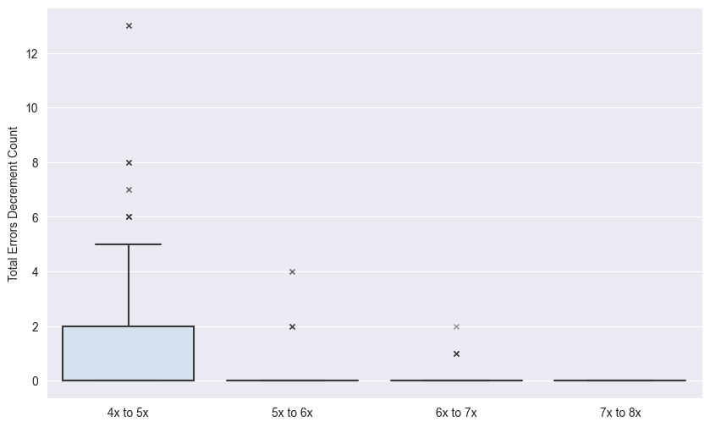
Supplementary Figure 1. The effect of additional iterations of polishing on the accuracy of Pilon. Pilon was the only short read polisher where increasing the iterations of polishing from one to four substantially decreased the number of errors. The boxplot shows the change in total errors when running Pilon with 5 to 8 iterations of polishing.

