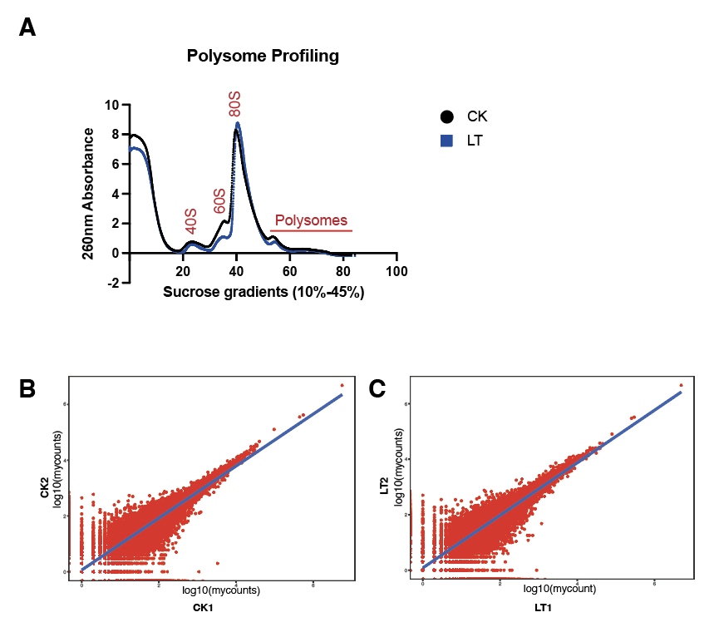
Fig.S1 Polysome profiling of lychee leaves under cold stress (LT) or normal condition (CK) (A). Correlation analysis for two replicates for CK (B) and LT treatments (C).

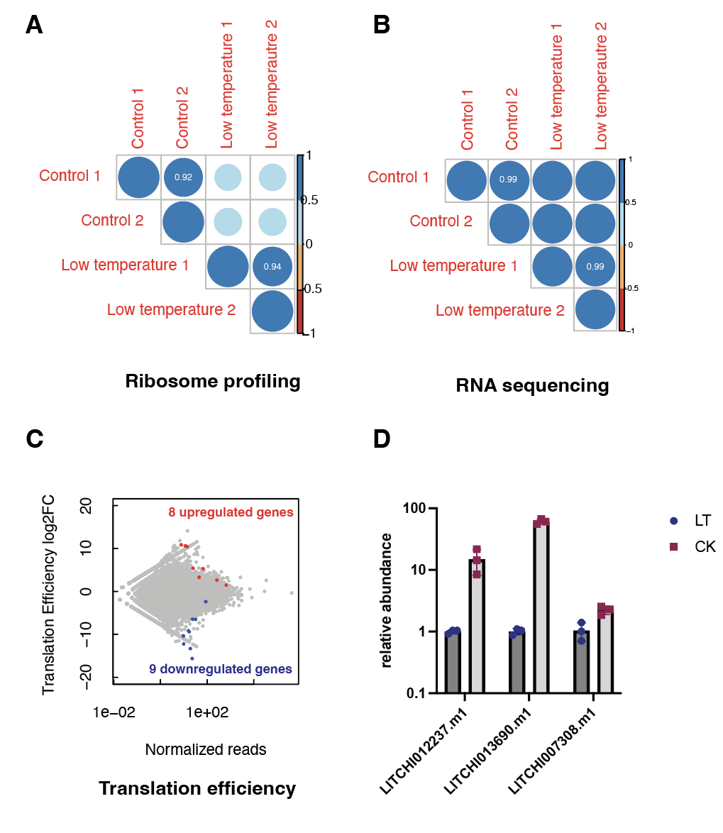
Fig.S2 Correlation between replicates under CK and cold stress conditions (A and B), scatter plot of transcripts defined by translation efficiency (C), and RT-qPCR of the most downregulated genes under cold stress (D).

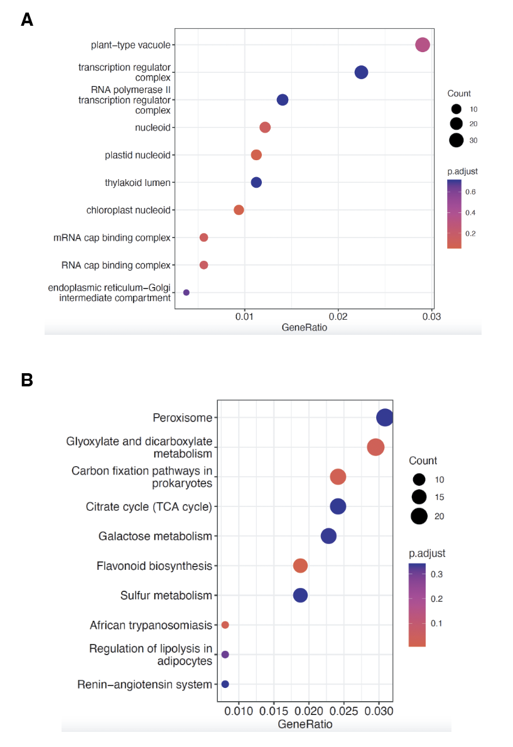
Fig. S3 Pathway enrichments analysis. (A) GO analysis for transcriptionally affected genes under cold stress. (B) KEGG analysis for transcriptionally affected genes under cold stress.

