Supplemental figures
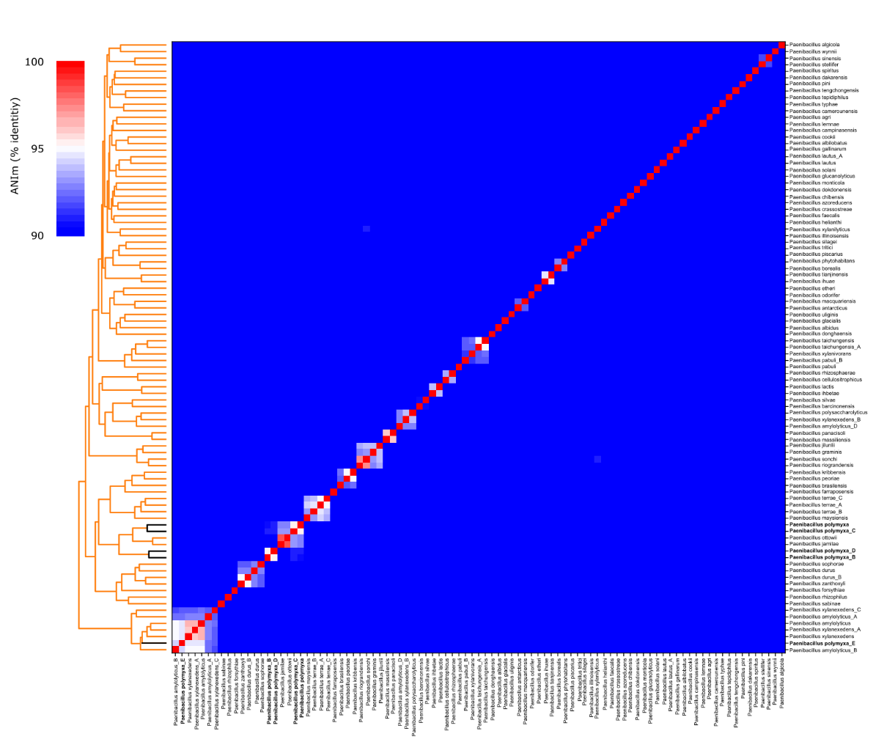
Figure S1 Average nucleotide identity results for 93 Paenibacillus species representative strains based on mummer comparisons. The representative strains of GTDB-validated Paenibacillus species were selected for this analysis. Strains of the different P. polymyxa groups are indicated in bold and black bars on the dendrogram.

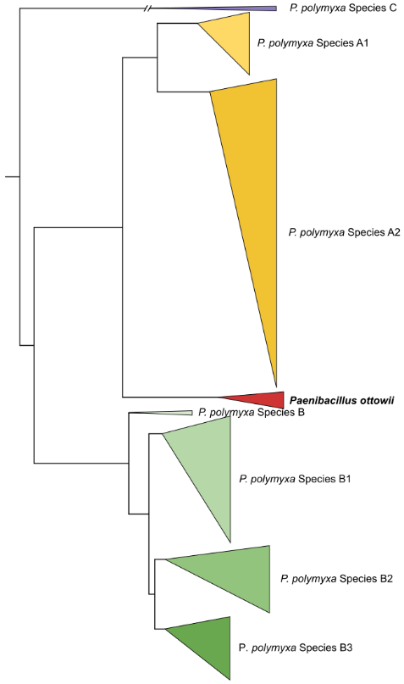
Figure S2 Phylogenetic reconstruction P. polymyxa species groups and P. ottowii. Single copy orthologous protein sequences were detected and aligned for 157 P. polymyxa genomes and 5 P. ottowii genomes using Orthofinder resulting in an alignment of 1388 sequences for a total of 403,770 amino acids. The tree was build using FastTree with default parameters.

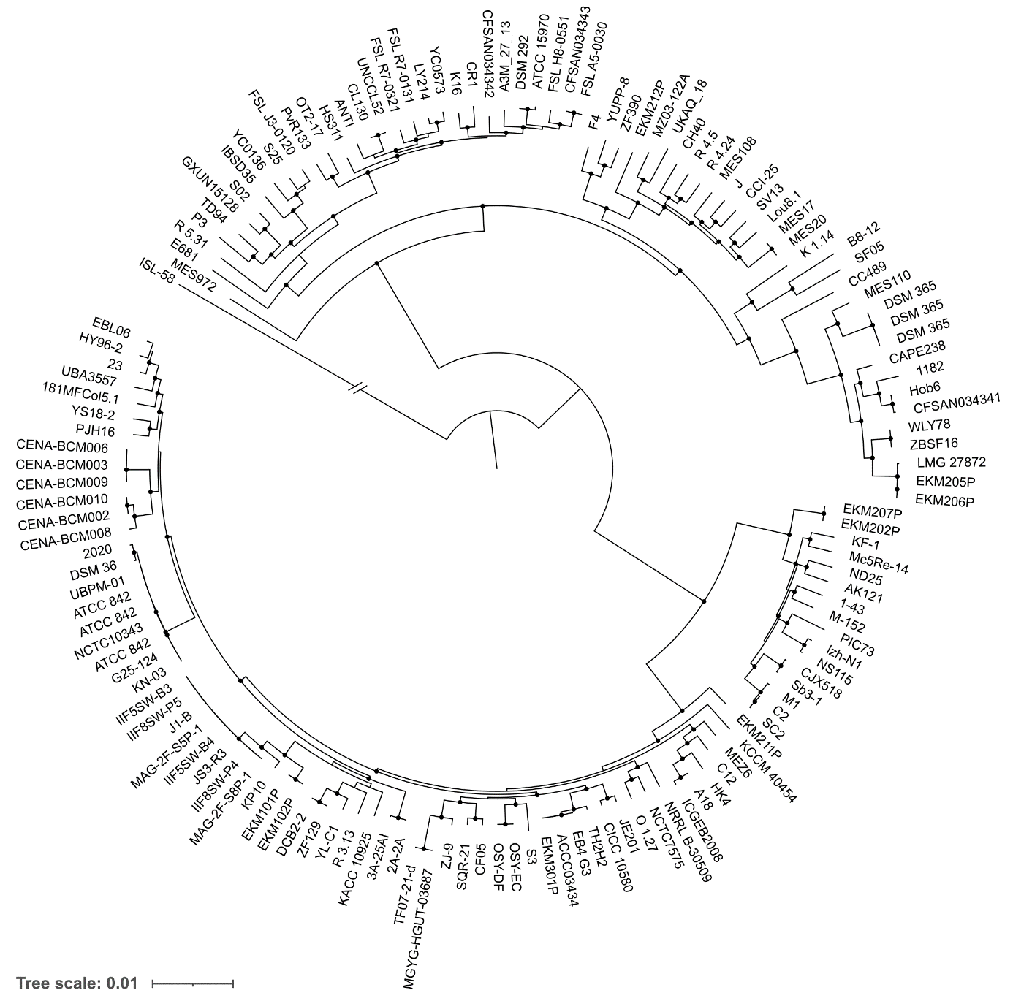
Figure S3 Phylogenetic reconstruction of P. polymyxa affiliated strains. Single copy orthologous protein sequences were detected and aligned using Orthofinder resulting in an alignment of 1,397 sequences for a total of 406,116 amino acids. Black dots represent local support values >95% obtained through the Shimodaira-Hasegawa test. Branch length for ISL-58 is 0.43

