Supplemental information

S1. Ablation study based on a dataset of artificial mixture samples
We performed the ablation study using the GSE182379 test set, which consists of 12 artificial mixture samples from adult blood. This dataset was chosen because it is the only test set that includes all 12 cell types present in our reference dataset. The results of the ablation study are presented in Supplemental Figure 2. First, we fixed the number of PCs at 20 and varied the number of top probes per cell type. Panel A shows the relationship between the mean R² across cell types and the number of top probes, while Panel B displays the corresponding mean RMSE. The results indicate that selecting an appropriate number of cell type-specific probes is important for the performance, and the performance is optimal for this dataset when the number of top probes is between 150 and 300. We chose 150 as our default value, as it is also the number used in the IDOL-Ext method. Next, we fixed the number of top probes at 150 and varied the number of PCs used for deconvolution. Panel C presents the relationship between the mean R² across cell types and the number of PCs, while Panel D shows the corresponding mean RMSE. The results demonstrate that including the first 12 PCs is crucial to achieve optimal performance for this dataset. Furthermore, the performance remains largely unchanged when more PCs are included beyond the first 12. We arbitrarily chose 20 as our default value for the number of PCs.

S2. Additional EPIC and 450K results
All datasets used in this study are listed in Supplemental Table 1. In addition to the results presented in Figure 2 and Table 1, we evaluated our method with two additional datasets of artificial mixture samples from EPIC arrays (shown in Supplemental Figure 3 A and B and Supplemental Table 2). We further evaluated the performance of the 450K-specific projection with three datasets from 450K arrays, and compared the results with those of 450K IDOL-Ext. The results (Supplemental Figure 3 C-E and Supplemental Table 3) demonstrate our method’s robust performance, similar to that of 450K IDOL-Ext in most cases.

S3. BloodCellDecon R package
The "BloodCellDecon" R package is publicly accessible at GitHub Repository. Prior to installing "BloodCellDecon," the Bioconductor package "genefilter" must be installed.
It’s straightforward to use the main function “estimateCellComposition” to calculate cell composition in test samples. This function requires the beta-value matrix of the test samples (with probes in rows and samples in columns). In addition, a projection matrix and reference mean beta-value matrix are also required, both of which are provided in the package. Users can specify the number of top PCs to include for deconvolution (20 by default), and whether proportions of Bcell, CD4T, CD8T and Gran should be included in the results, which correspond to Bmem + Bnv, CD4mem + CD4nv + Treg, CD8mem + CD8nv, and Bas + Eos + Neu respectively. Correct probe IDs must be used as row names for the test sample beta-value matrix to ensure correct projection. The function transforms the probe-level beta-value matrix to PCA space, followed by CP/QP optimization using the “solve.QP” function from the “quadprog” package. The output is a cell type-composition matrix with samples in rows and cell types in columns.
The “plot_celltype” function creates scatter plots of predicted versus actual cell fractions. It requires the output from “estimateCellComposition”, the actual cell fraction data, and the cell type name for plotting. The output includes the data used in the plot and the ggplot object itself.
To facilitate creating projection and mean beta-value matrices from reference samples, we also included the “createReferenceProjection” function. This function takes the entire beta-value matrix of reference samples and a vector of cell types as inputs. It performs t-test-based probe selection (default to the top and bottom 75 probes for each cell type based on t-statistics) using “rowttests” function from “genefilter” package, and a PCA on the selected probes to project them into PCA space. The output is a list containing the projection matrix, the mean beta-value matrix of reference cell types, and the PCA result. We have included results for the 56 reference samples from GSE167998 for EPIC and 450K arrays as ref.projection.EPIC and ref.projection.450k in the package. Users should select the appropriate projection and mean beta-value matrix based on the array type of their test samples.

List of figures and tables:
Supplemental Figure 1. PCA plots of the reference samples.
Supplemental Figure 2. Plots of independent purified cell samples in the PCA space of the reference samples.
Supplemental Figure 3. Results of ablation study based on GSE182379 dataset.
Supplemental Figure 4. Scatter plots showing the predicted cell proportions by BloodCellDecon versus the actual cell proportions for each cell type in additional EPIC and 450K datasets.
Supplemental Table 1. List of datasets used in this study.
Supplemental Table 2. Comparison of deconvolution results between BloodCellDecon and IDOL-Ext for 2 additional EPIC datasets.
Supplemental Table 3. Comparison of deconvolution results between BloodCellDecon and 450K IDOL-Ext for 450K datasets.

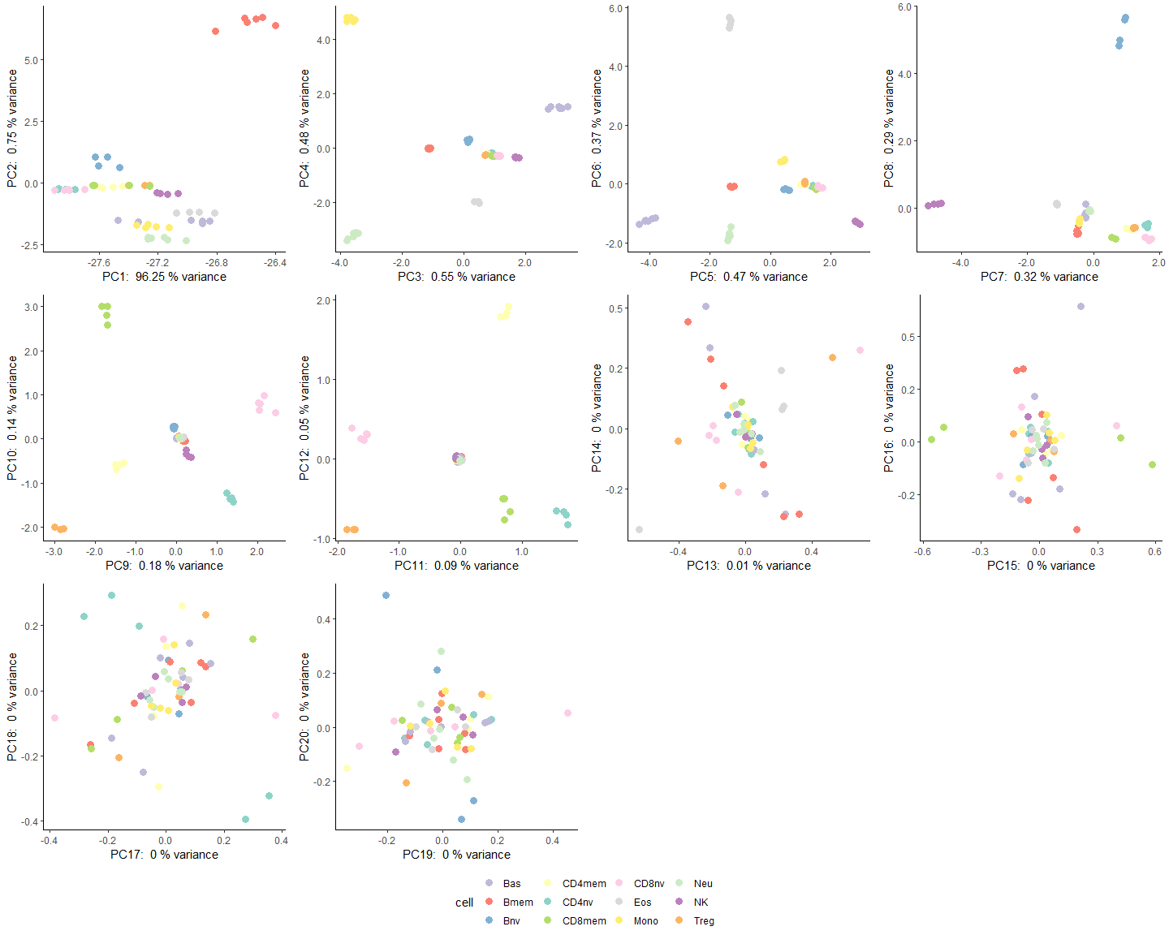
Supp Figure 1. PCA plots of the reference samples based on 1800 EPIC probes. As shown in the plots, the top 12 PCs of the selected probes are highly correlated with cell types.

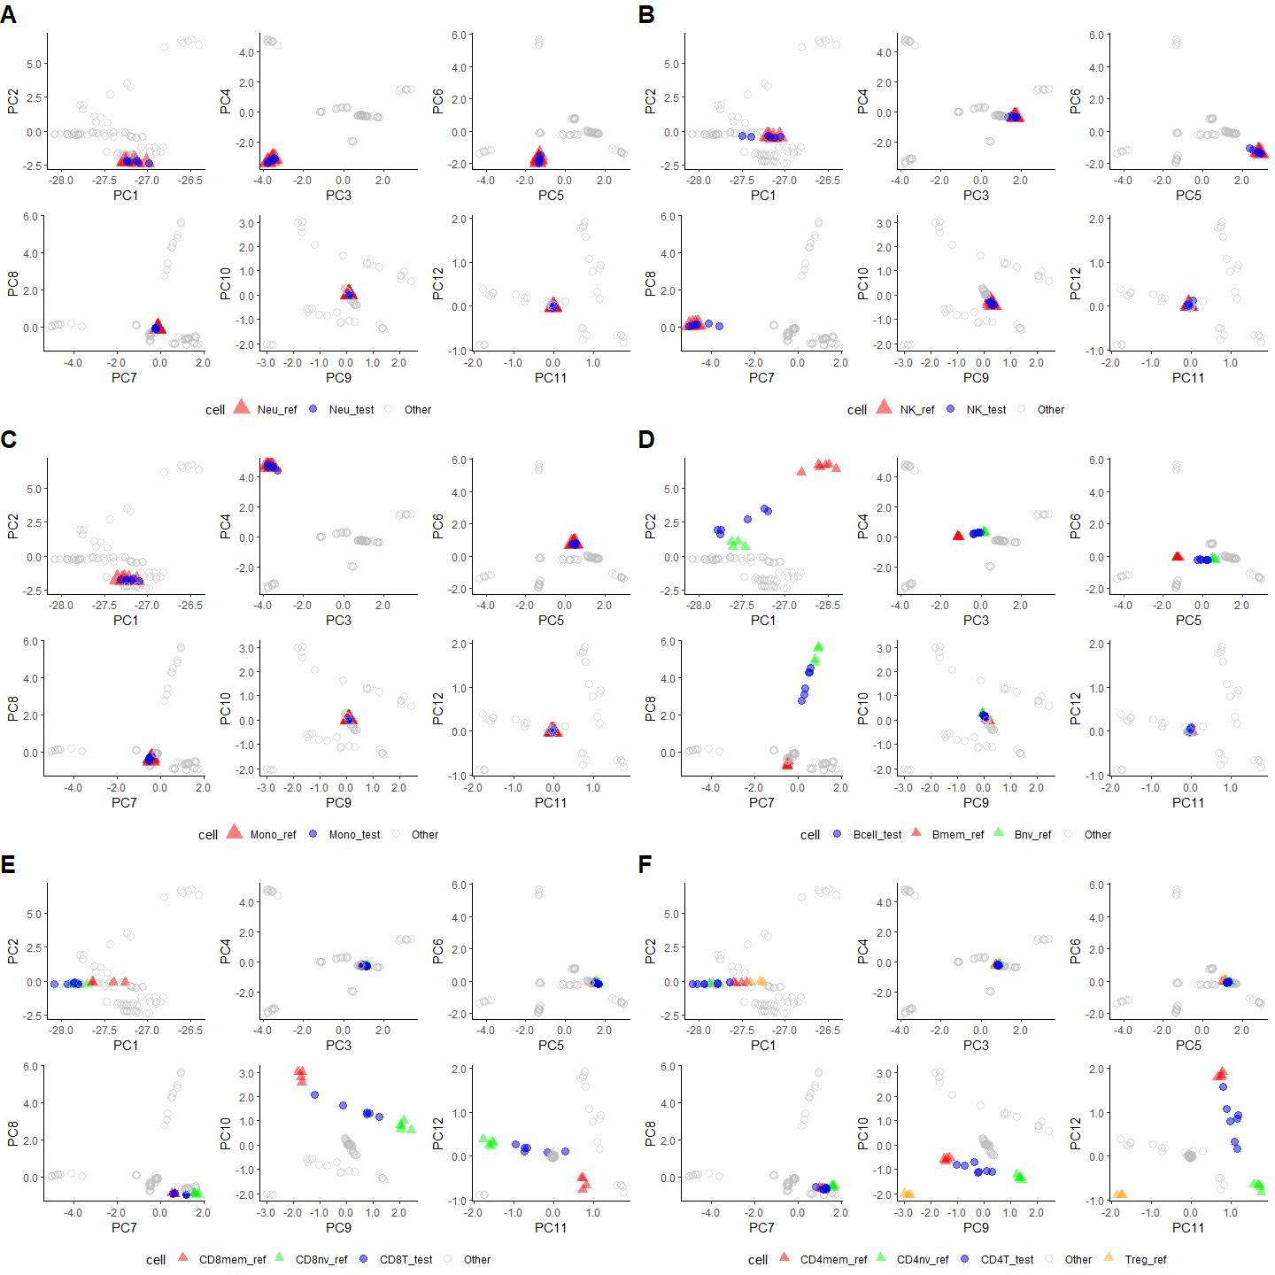
Supp Figure 2. Plots of independent purified cell samples in the PCA space of the reference data. The test samples in GSE110554 contain purified cells from 6 cell types. (A) Neu, (B) NK, (C) Mono, (D) Bcell, (E) CD8T, and (F) CD4T. The test samples largely overlap with the corresponding reference samples for Neu, NK and Mono cells in PCA space. For Bcell, CD8T and CD4T, the test samples are mostly between Bmem and Bnv, CD8mem and CD8nv, CD4mem and CD4nv, respectively, indicating mixture of those cells in the test samples. These plots suggest high reliability of representing different cell types in PCA space, and no shrinkage bias correction is necessary when projecting new samples.

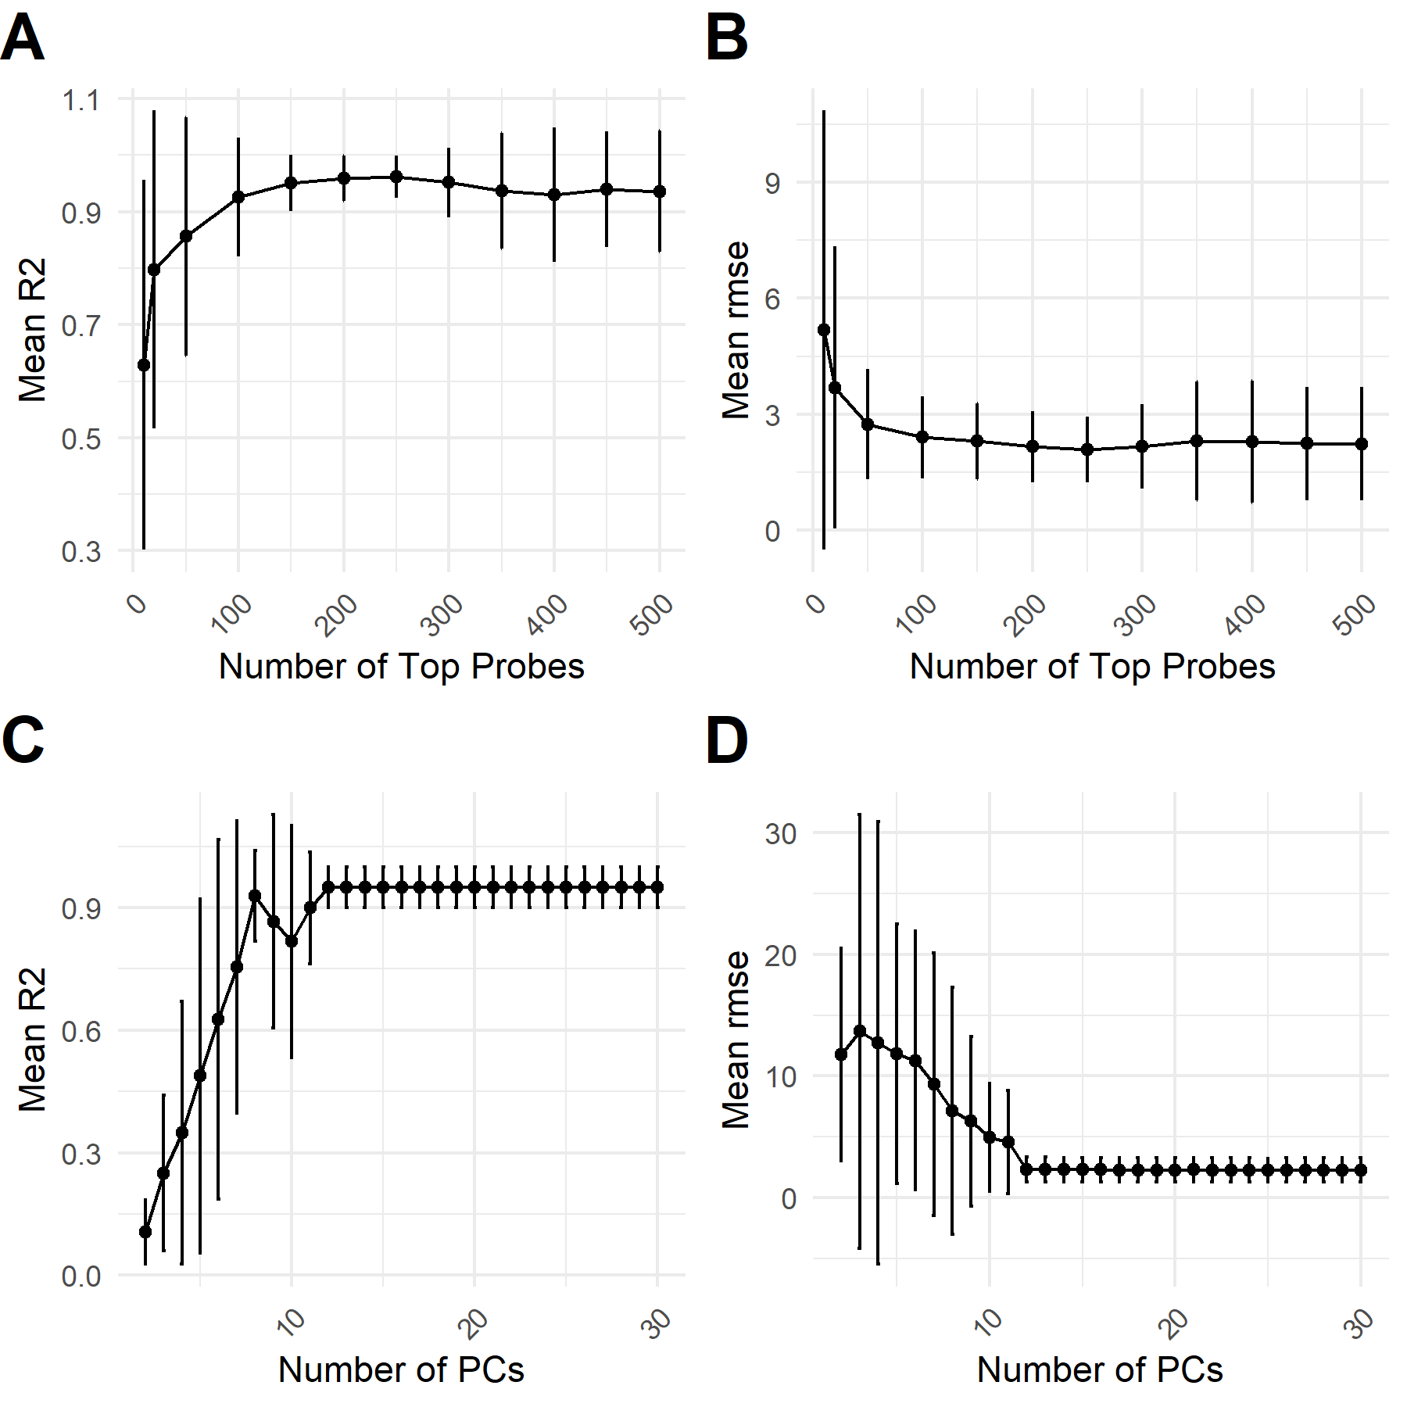
Supp Figure 3. Results of ablation study based on GSE182379 dataset. Panels A and B show the relationship between R² and RMSE against the number of top probes. As the results suggest, the number of top probes is important for the result. The performance is optimal for this dataset when the number of top probes is 150, 200 or 250. Panels C and D show the relationship between R² and RMSE against the number of PCs. The results demonstrate that including the first 12 PCs is essential to achieve optimal performance for this dataset, and the performance remains largely unchanged when more PCs are included beyond the first 12.

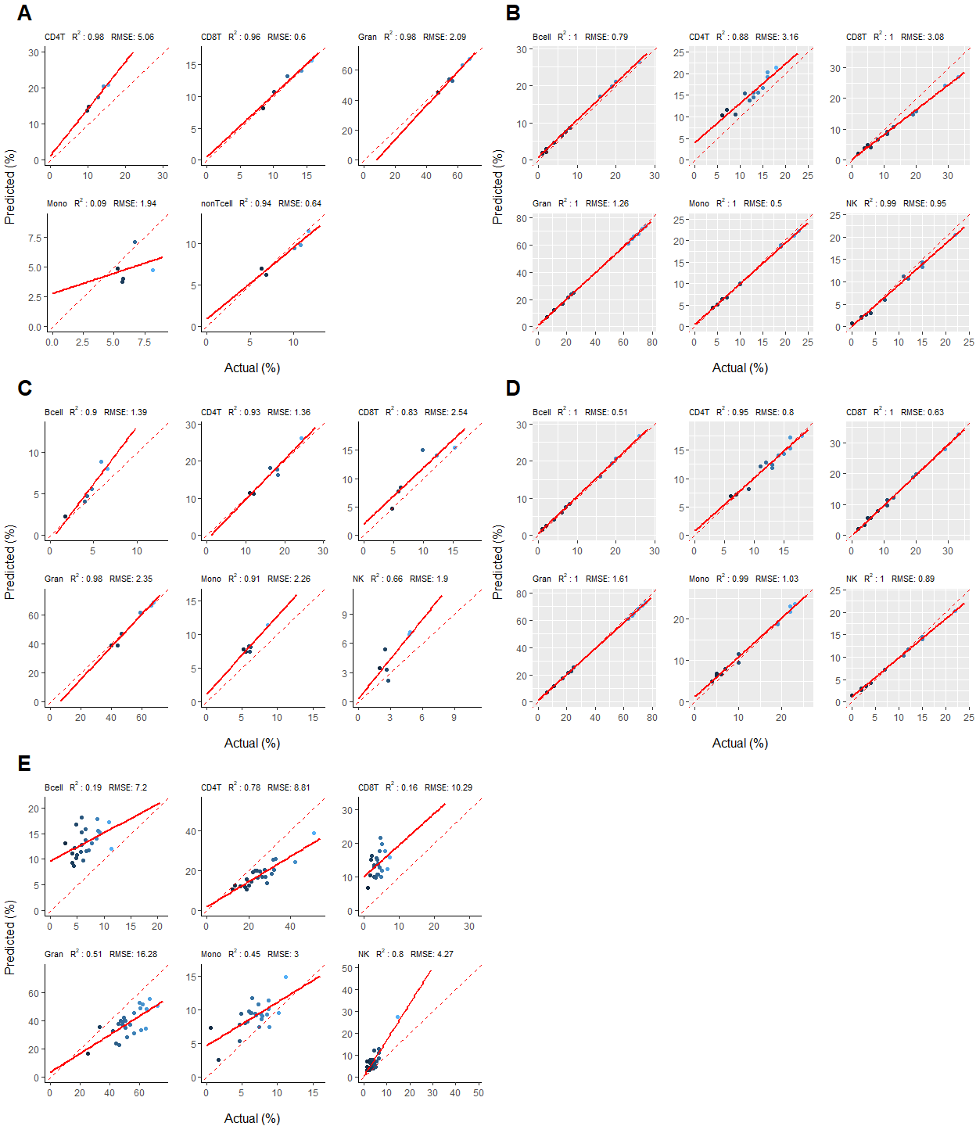
Supp Figure 4. Scatter plots showing the predicted cell proportions by BloodCellDecon versus the actual cell proportions for each cell type in additional EPIC and 450K datasets. (A) GSE110530 contains 5 EPIC adult blood samples with FCM information. (B) GSE110554 contains 12 EPIC artificial mixture samples of 6 cell types from adult blood. (C) GSE77797-1 contains 6 450K adult blood samples with FCM information. (D) GSE77797-2 contains 12 450K artificial mixture samples. (E) GSE127824 contains 24 450K cord blood samples with FCM information. Each blue dot represents a sample in the test sets. The solid red line indicates the linear regression line fitted by regressing predicted against the actual proportions for all samples in the test set. The dashed line indicates identical result between predicted and actual values. CD4T corresponds to the sum of CD4mem, CD4nv and Treg. CD8T to the sum of CD8mem and CD8nv. Gran as sum of Bas, Eos, and Neu. NonTcell in (A) corresponds to sum of Bmem, Bnv and NK.
Supplemental Table 1. List of datasets used in this study.
Platform | Data | Samples | N
EPIC | GSE167998 | Purified cells (reference) | 56
EPIC | GSE167998 | Blood artificial mixtures | 12
EPIC | GSE182379 | Blood artificial mixtures | 12
EPIC | GSE180970 | Cord blood artificial mixtures | 12
EPIC | GSE180683 | Glioma blood with FCM* information | 76
EPIC | GSE110530 | Adult blood with FCM information | 5
EPIC | GSE110554 | Blood artificial mixtures | 12
EPIC | GSE110554 | Purified cells | 37
450K | GSE77797 | Adult blood with FCM information | 6
450K | GSE77797 | Blood artificial mixtures | 12
450K | GSE127824 | Cord blood with FCM information | 24
FCM: Flow Cytometry, a technique used to measure the proportion of different cell types in a sample based on their physical and fluorescent characteristics.

Supplemental Table 2. Comparison of deconvolution results between BloodCellDecon and IDOL-Ext for 2 additional EPIC datasets.
 |  | BloodCellDecon |  | IDOL-Ext
Data | Cell | R² | RMSE | R² | RMSE
GSE110530 | CD4T | 0.98 | 5.06 | 0.91 | 2.15
GSE110530 | CD8T | 0.96 | 0.60 | 1.00 | 1.19
GSE110530 | Gran | 0.98 | 2.09 | 0.99 | 1.13
GSE110530 | Mono | 0.09 | 1.94 | 0.19 | 2.04
GSE110530 | nonTcell | 0.94 | 0.64 | 0.97 | 1.26
GSE110554 | Bcell | 1.00 | 0.79 | 1.00 | 1.45
GSE110554 | CD4T | 0.88 | 3.16 | 0.99 | 1.21
GSE110554 | CD8T | 1.00 | 3.08 | 1.00 | 3.39
GSE110554 | Gran | 1.00 | 1.26 | 1.00 | 1.25
GSE110554 | Mono | 1.00 | 0.50 | 1.00 | 0.75
GSE110554 | NK | 0.99 | 0.95 | 1.00 | 1.26
R²: Coefficient of determination, the proportion of variance in cell proportion that can be explained by the predicted value. RMSE: Root Mean Square Error, a measure of the average deviation between the predicted and actual cell proportions. CD4T corresponds to the sum of CD4mem, CD4nv and Treg. CD8T corresponds to the sum of CD8mem and CD8nv. Gran: Granulocytes, which include basophils (Bas), eosinophils (Eos), and neutrophils (Neu). nonTcell: Non-T cells, which include B cells (Bmem and Bnv) and natural killer cells (NK).

Supplemental Table 3. Comparison of deconvolution results between BloodCellDecon and 450K IDOL-Ext for 450K datasets.
 |  | BloodCellDecon |  | 450K IDOL-Ext
Data | Cell | R2 | RMSE | R2 | RMSE
GSE77797-1 | Bcell | 0.90 | 1.39 | 0.97 | 0.85
GSE77797-1 | CD4T | 0.93 | 1.36 | 0.96 | 1.98
GSE77797-1 | CD8T | 0.83 | 2.54 | 0.81 | 2.86
GSE77797-1 | Gran | 0.98 | 2.35 | 0.98 | 1.83
GSE77797-1 | Mono | 0.91 | 2.26 | 0.89 | 1.59
GSE77797-1 | NK | 0.66 | 1.90 | 0.66 | 2.48
GSE77797-2 | Bcell | 1.00 | 0.51 | 1.00 | 1.30
GSE77797-2 | CD4T | 0.95 | 0.80 | 0.95 | 0.90
GSE77797-2 | CD8T | 1.00 | 0.63 | 0.99 | 0.89
GSE77797-2 | Gran | 1.00 | 1.61 | 1.00 | 2.52
GSE77797-2 | Mono | 0.99 | 1.03 | 0.99 | 1.01
GSE77797-2 | NK | 1.00 | 0.89 | 0.99 | 0.95
GSE127824 | Bcell | 0.19 | 7.20 | 0.31 | 6.16
GSE127824 | CD4T | 0.78 | 8.81 | 0.75 | 4.39
GSE127824 | CD8T | 0.16 | 10.29 | 0.17 | 4.01
GSE127824 | Gran | 0.51 | 16.28 | 0.53 | 16.02
GSE127824 | Mono | 0.45 | 3.00 | 0.46 | 1.91
GSE127824 | NK | 0.80 | 4.27 | 0.81 | 4.85
R²: Coefficient of determination, the proportion of variance in cell proportion that can be explained by the predicted value. RMSE: Root Mean Square Error, a measure of the average deviation between the predicted and actual cell proportions. CD4T corresponds to the sum of CD4mem, CD4nv and Treg. CD8T corresponds to the sum of CD8mem and CD8nv. Gran: Granulocytes, which include basophils (Bas), eosinophils (Eos), and neutrophils (Neu).

