Supporting Information for

Genomic insights of immune adaptation and hypoxia tolerance in the invasive crayfish Cherax quadricarinatus
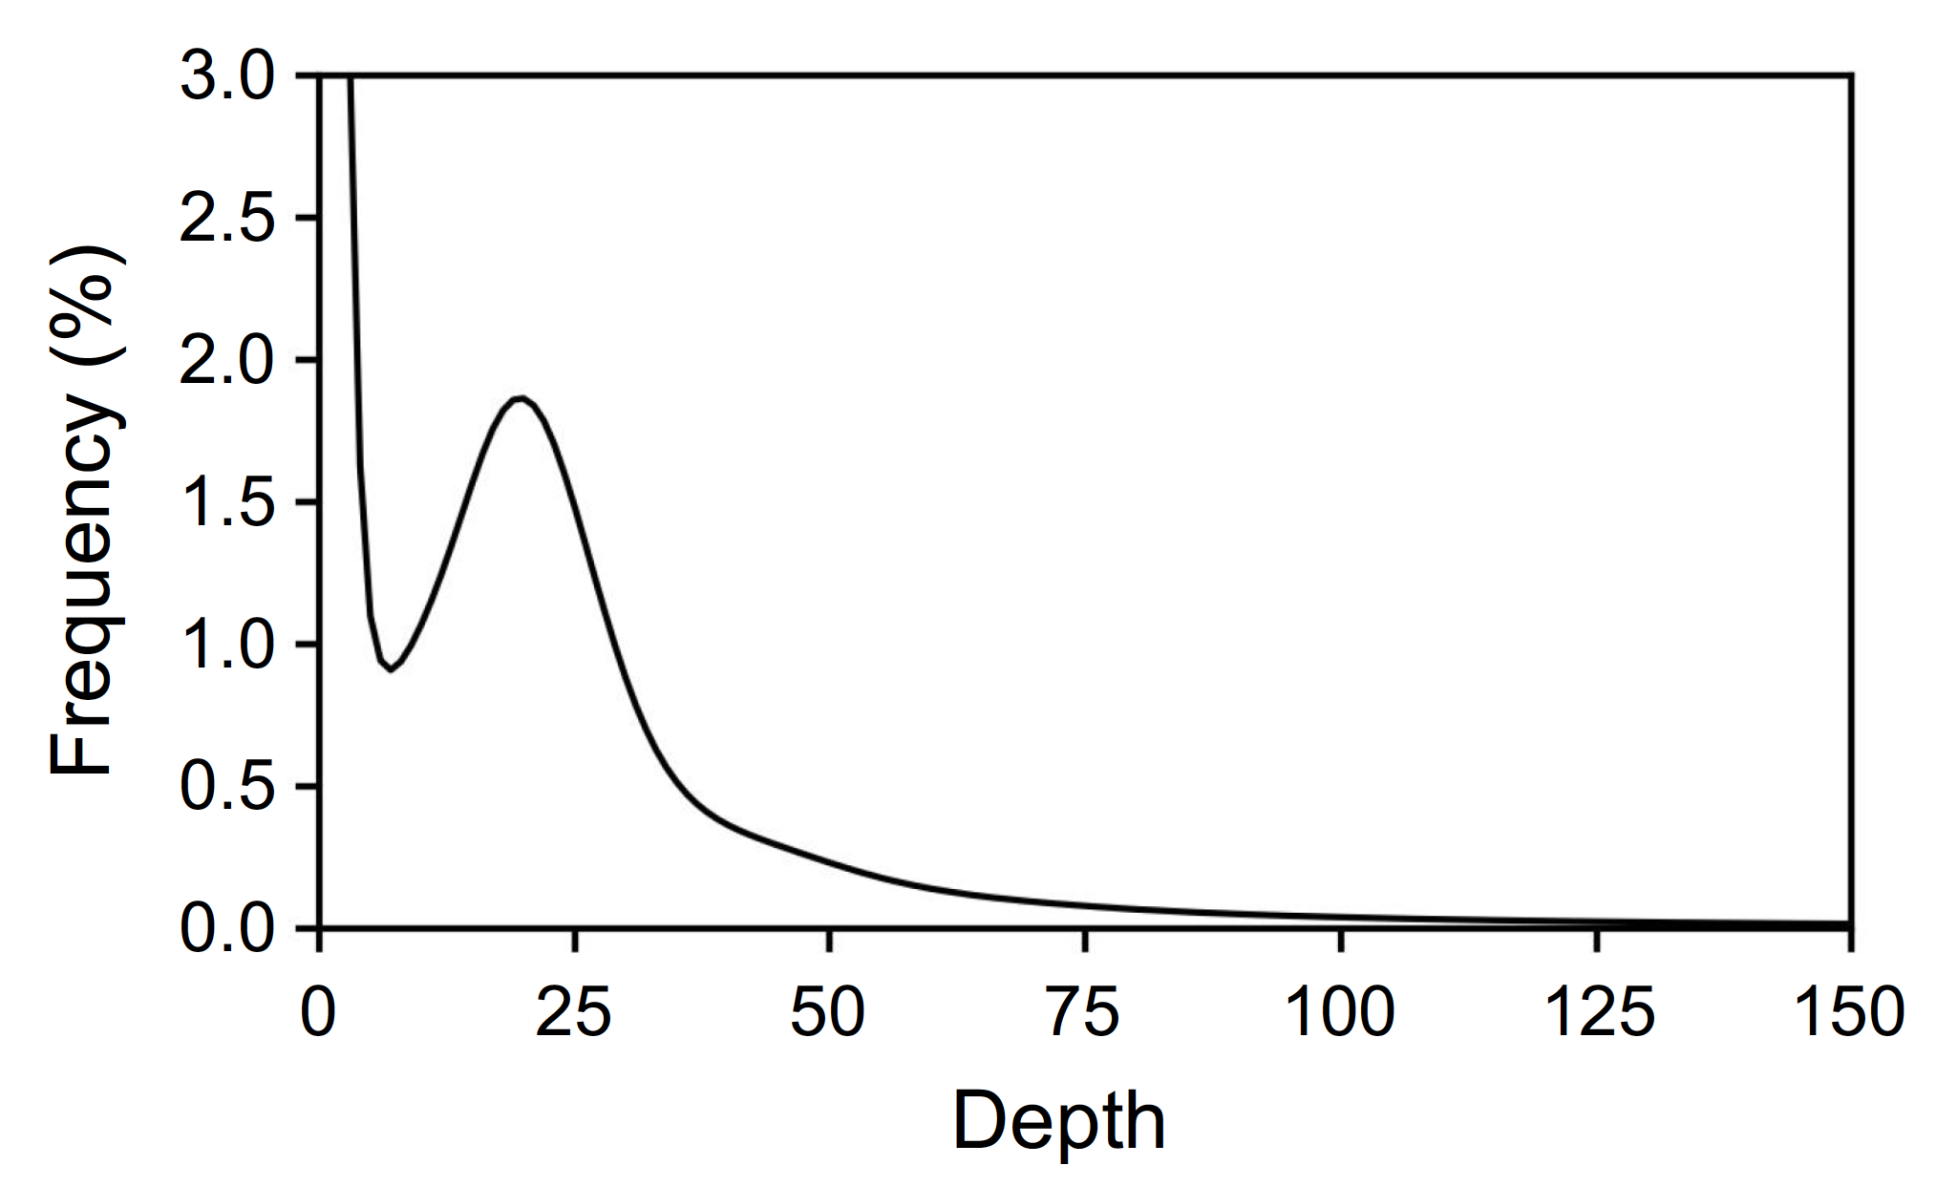

Supplementary Figure 1. Distribution of 17-mer frequency in C. quadricarinatus genome. The genome size was determined based on the k-mer distribution. Size of C. quadricarinatus was estimated at 6.02 Gb.

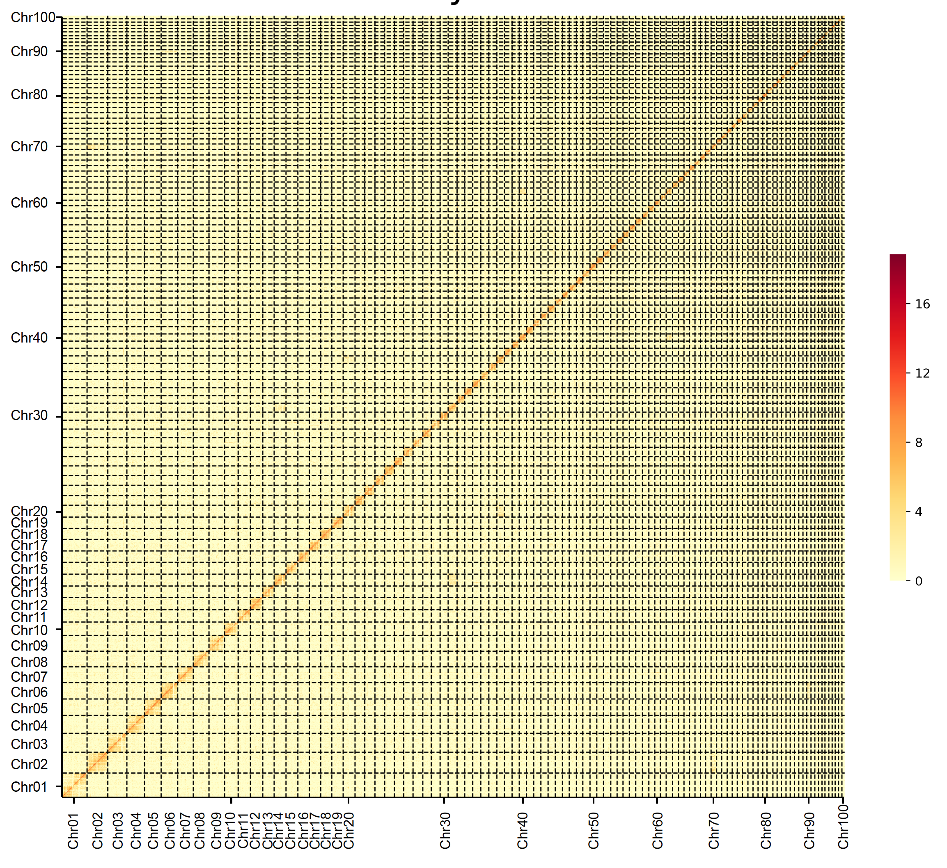
Supplementary Figure 2 Hi-C interaction matrix for assembled C. quadricarinatus scaffolds. Darker colors indicate higher frequency of chromatin interactions. Plot shows clear separation of chromosomal boundaries (dark yellow rectangles) and limited off-diagonal interactions, supporting global structure of chromosome-scale scaffolds.

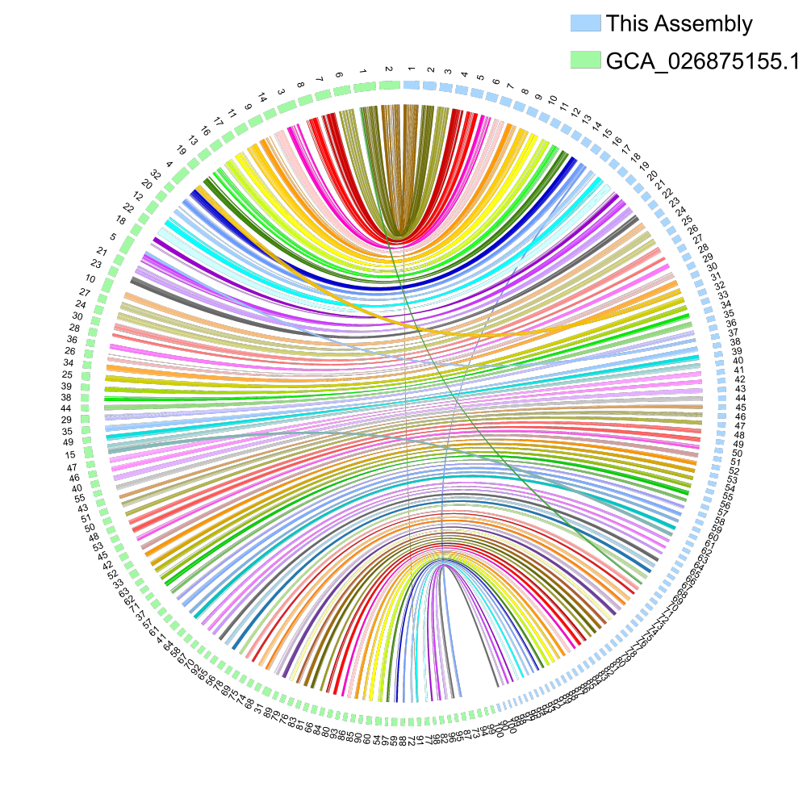
Supplementary Figure 3 Syntenic analysis between chromosomes of the previously published assembly (GCF_026875155.1) and our assembly.

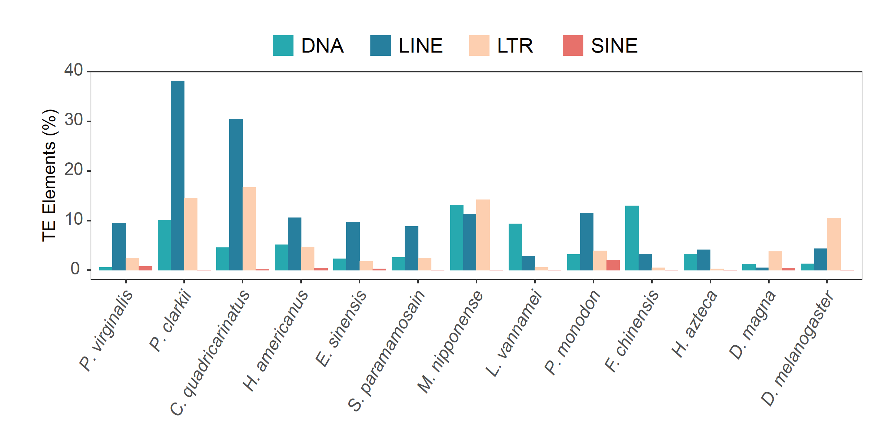
Supplementary Figure 4 Comparison of DNA transposons, LTR retrotransposons, LINEs, and SINEs in the genomes of 13 arthropod species.

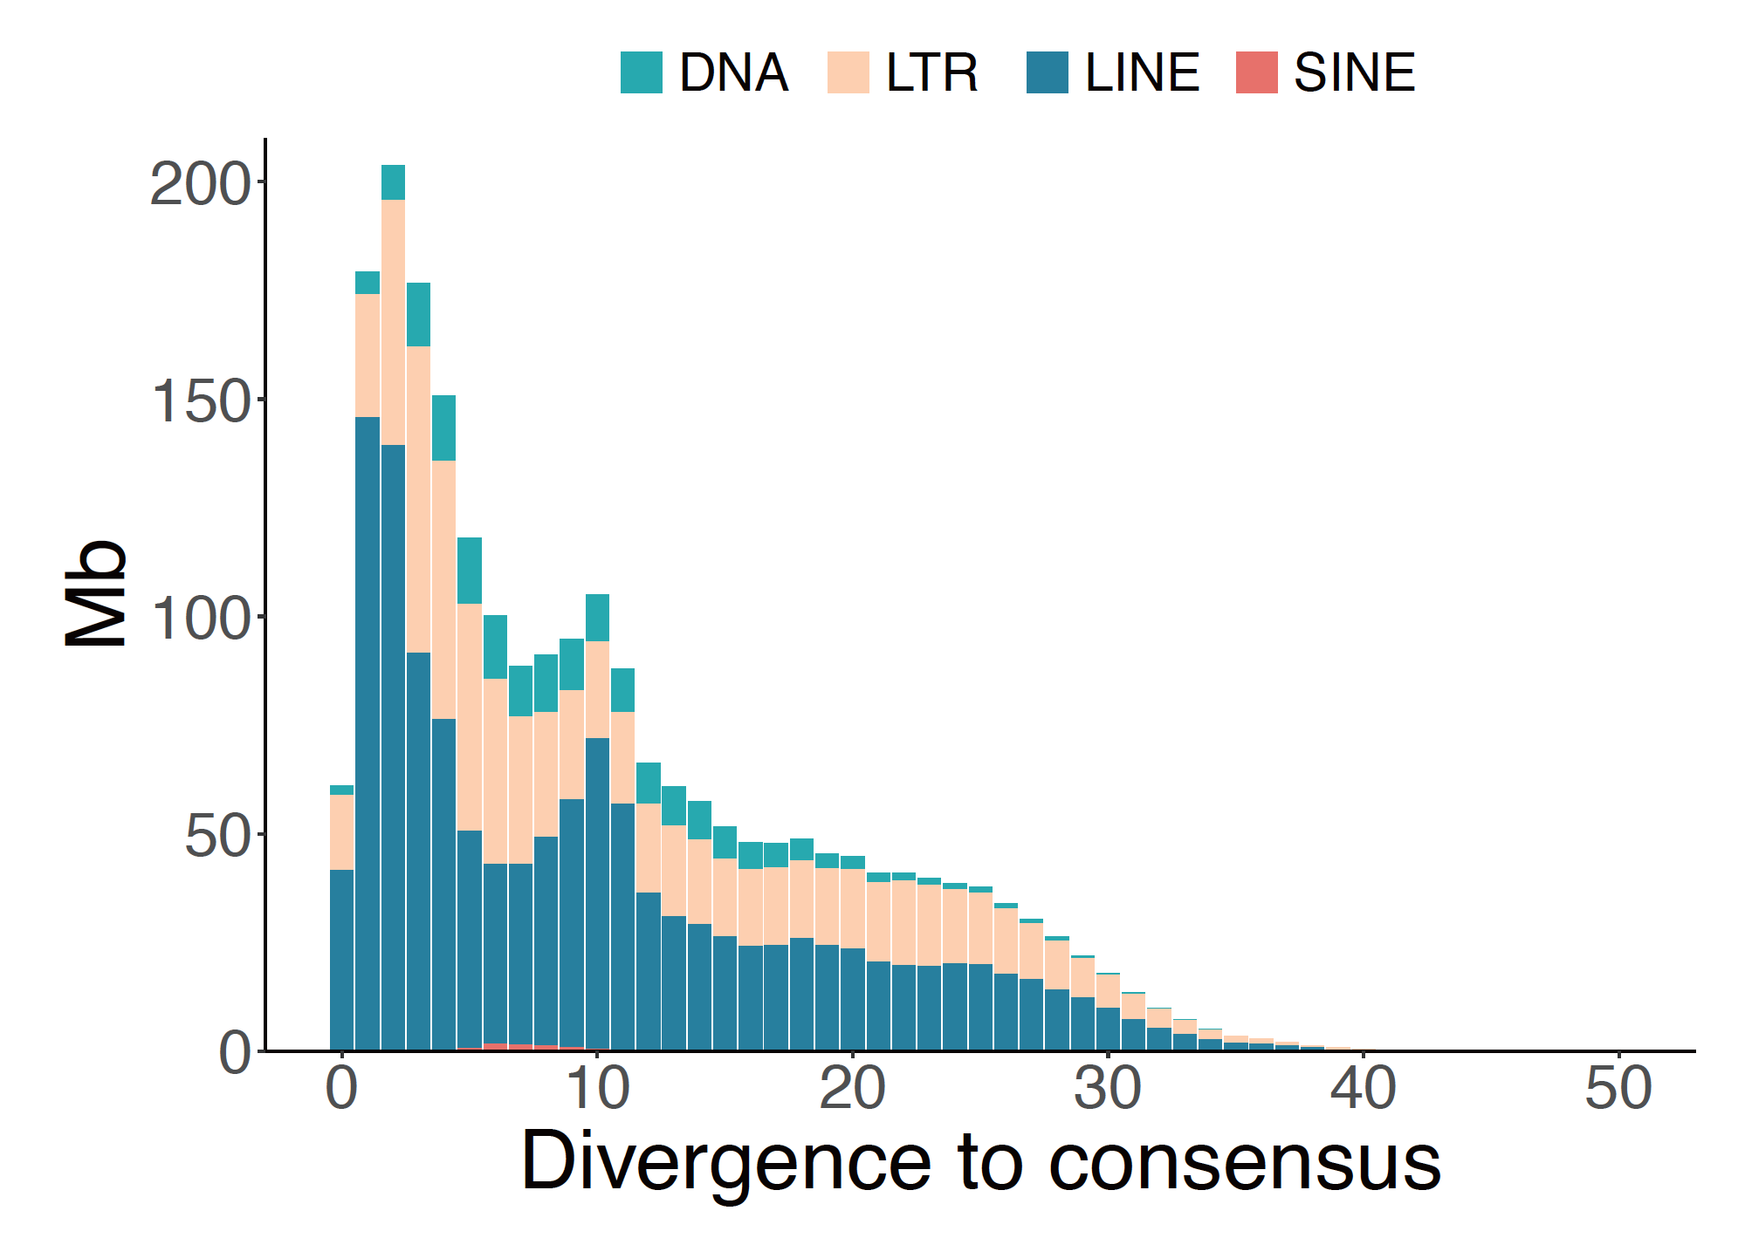
Supplementary Figure 5 Transposable element-accumulation profile in C. quadricarinatus genome. Recent bursts of LINEs and LTR retrotransposons were observed in C. quadricarinatus.

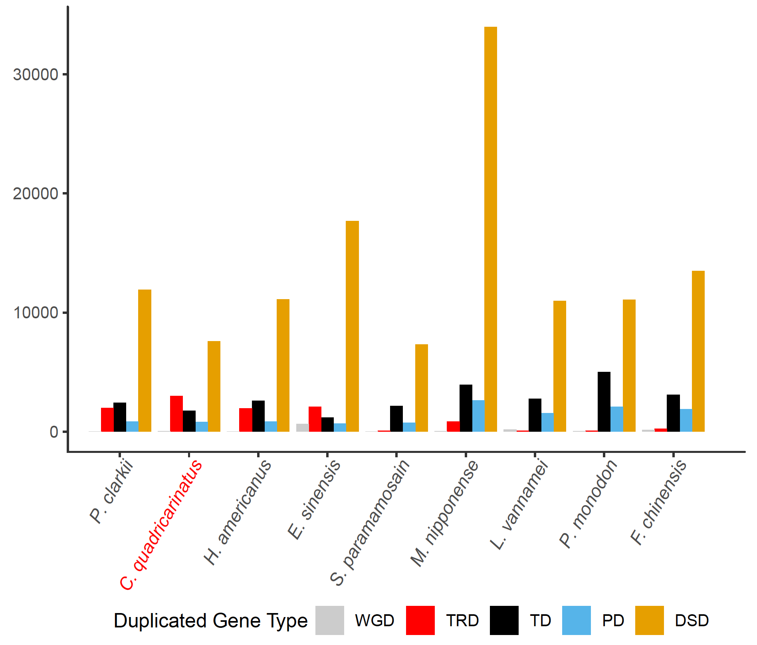
Supplementary Figure 6 Summary of different duplicated gene types in the genomes of 9 decapod crustaceans. WGD whole-genome duplication, TD tandem duplication, PD proximal duplication, TRD transposed duplication, DSD dispersed duplication.

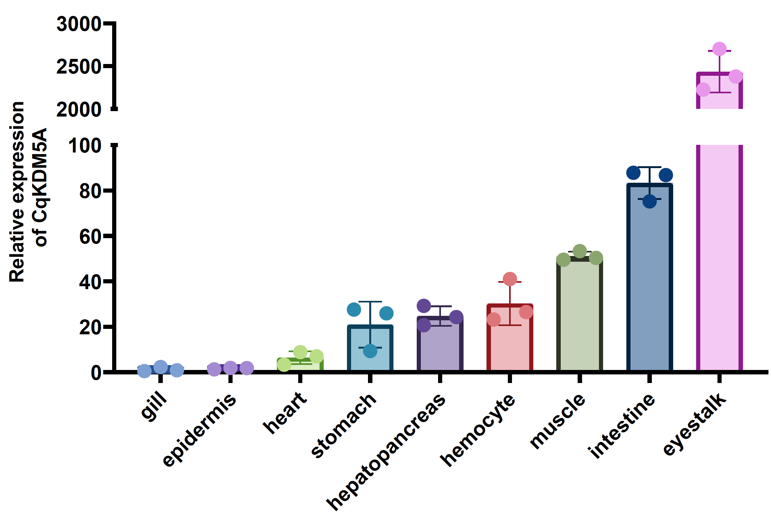

Supplementary Figure 7 Tissue distribution of CqKDM5A expression in C. quadricarinatus.

Supplementary Table 1 Basic statistics of Nanopore reads

Total number of reads | Total number of bases (Gb) | Maximum length of reads (bp) | Minimum length of reads (bp) | Average length of reads (bp) | Depth of coverage
11,348,855 | 224.26 | 247,603 | 2 | 19,760.8 | 56.72

Supplementary Table 2 Basic statistics of Illumina reads

Total number of reads | Total number of base pairs | Percentage of Q20 base pairs (%) | Percentage of Q30 base pairs (%) | GC (%)
1,058,272,386 | 158,740,857,900 | 96.95 | 92.39 | 42.18

Supplementary Table 3 Basic statistics of PacBio HiFi reads

Number of reads | Total bases (bp) | Maximum length of reads (bp) | Minimum length of reads (bp) | Average length of reads (bp)
2,149,923 | 27,224,125,841 | 31,261 | 45 | 12,662.8

Supplementary Table 4 Basic statistics of Hi-C reads

Total bases (bp) | Depth of coverage ($×$) | Unique mapped paired-end reads | cis-chromosomal interaction (%)
635,996,436,942 | 105.4 | 715,911,154 | 19.96%

Supplementary Table 5 BUSCO evaluation of C. quadricarinatus genome assemblies

 | C. quadricarinatus  (This study) | C. quadricarinatus  (GCA_026875155)
Complete BUSCOs | 896 (88.5%) | 822 (81.2%)
Complete and single-copy BUSCOs | 878 (86.7%) | 812 (80.2%)
Complete and duplicated BUSCOs | 18 (1.8%) | 10 (1.0%)
Fragmented BUSCOs | 45 (4.4%) | 105 (10.4%)
Missing BUSCOs | 72 (7.1%) | 86 (8.4%)
Total BUSCO groups searched | 1013 | 1013

Supplementary Table 6 Statistics of assembly quality and completeness evaluation using Mercury

 | QV | Error rate | Completeness (%)
This assembly | 32.8092 | 0.0005237 | 81.5079
Previous assembly (GCA_026875155) | 18.7453 | 0.0133495 | 80.0641

Supplementary Table 7 Summary of annotated repeats in C. quadricarinatus genome

 | Number | Length (bp) | Percentage (%)
Retroelements:
SINEs | 39,582 | 7,084,196 | 0.18
LINEs | 2,320,875 | 1,202,683,291 | 30.42
LINE1 | 134,635 | 44,244,583 | 1.12
LINE2 | 111,600 | 75,493,905 | 1.91
L3/CR1 | 1,198,314 | 638,959,927 | 16.16
LTR elements | 2,258,029 | 659,406,522 | 16.68
ERVL | 2,239 | 2,165,077 | 0.05
ERV_classI | 2,178 | 305,255 | 0.01
ERV_classII | 21,627 | 1,735,095 | 0.04
DNA transposons: | 865,267 | 180,082,583 | 4.55
hAT-Charlie | 22,540 | 3,915,275 | 0.10
TcMar-Tigger | 151,198 | 68,941,078 | 1.74
Unclassified: | 2,714,369 | 601,231,657 | 15.21
Total interspersed repeats: |  | 2,650,488,249 | 67.03
Satellites: |  | 15,953,575 | 0.40
Minisatellites: |  | 813,019,949 | 20.58
Microsatellite: |  | 198,786,513 | 5.03
Total tandem repeats: |  | 1,027,760,037 | 26.01
Small RNA: | 53,610 | 12,231,587 | 0.31
Total |  | 3,690,479,873 | 93.36

Supplementary Table 8 Summary of annotated repeats in genomes of C. quadricarinatus and 12 arthropod species

 | DNA elements | LINEs | SINEs | LTR | Unclassified | Low complexity repeats
P. virginalis | 22.33 (0.62%) | 342.81 (9.52%) | 28.81 (0.8%) | 90.02 (2.5%) | 444 (12.33%) | 11.88 (0.33%)
P. clarkii | 274 (10.06%) | 1038.96 (38.13%) | 0.77 (0.03%) | 396.5 (14.55%) | 209.67 (7.7%) | 0 (0)
C. quadricarinatus | 180.08 (4.55%) | 1202.68 (30.42%) | 7.08 (0.18%) | 659.41 (16.68%) | 601.23 (15.21%) | 0 (0)
H. americanus | 113.36 (5.15%) | 234.14 (10.63%) | 9.82 (0.45%) | 103.79 (4.71%) | 597.16 (27.12%) | 0 (0)
E. sinensis | 35.15 (2.3%) | 148.54 (9.72%) | 4.43 (0.29%) | 27.35 (1.79%) | 158.78 (10.39%) | 31.17 (2.04%)
S. paramamosain | 40.15 (2.6%) | 137.13 (8.87%) | 1.29 (0.08%) | 37.67 (2.44%) | 97.39 (6.3%) | 19.6 (1.27%)
M. nipponense | 557.61 (13.11%) | 480.05 (11.29%) | 2.81 (0.07%) | 604.72 (14.22%) | 582.9 (13.7%) | 0 (0)
L. vannamei | 155.21 (9.33%) | 46.91 (2.82%) | 1 (0.06%) | 10.31 (0.62%) | 56.89 (3.42%) | 157.87 (9.49%)
P. monodon | 75.96 (3.17%) | 276.64 (11.56%) | 49.49 (2.07%) | 93.21 (3.9%) | 368.13 (15.39%) | 59.09 (2.47%)
F. chinensis | 205.53 (13%) | 51.7 (3.27%) | 1.74 (0.11%) | 8.38 (0.53%) | 55.65 (3.52%) | 134.22 (8.49%)
H. azteca | 17.88 (3.29%) | 22.31 (4.11%) | 0.01 (0%) | 1.75 (0.32%) | 92.14 (16.97%) | 0 (0)
D. magna | 1.96 (1.22%) | 0.82 (0.51%) | 0.69 (0.43%) | 6.1 (3.79%) | 0 (0%) | 0 (0)
D. melanogaster | 1.86 (1.31%) | 6.2 (4.37%) | 0 (0%) | 14.98 (10.55%) | 4.41 (3.11%) | 0 (0)

Supplementary Table 9 BUSCO evaluation of predicted gene models of C. quadricarinatus

 | C. quadricarinatus  (This study) | C. quadricarinatus  (GCA_026875155)
Complete BUSCOs | 894 (88.3%) | 893 (88.2%)
Complete and single-copy BUSCOs | 874 (86.3%) | 875 (86.4%)
Complete and duplicated BUSCOs | 20 (2.0%) | 18 (1.8%)
Fragmented BUSCOs | 37 (3.7%) | 54 (5.3%)
Missing BUSCOs | 82 (8.0%) | 66 (6.5%)
Total BUSCO groups searched | 1013 | 1013

Supplementary Table 10. Summary of gene functional annotations

 |  | C. quadricarinatus
Total |  | 17,698
Annotated | NCBI NR | 14,847 (83.39%)
Annotated | InterPro | 15,803 (85.22%)
Annotated | KEGG | 6,160 (34.81%)
Annotated | eggNOG | 9,429 (53.28%)
Annotated | Total | 16,509 (93.28%)
Unannotated |  | 1,189 (6.72%)

Supplementary Table 11 Summary of duplicated genes in genomes of C. quadricarinatus and 9 decapod species

 | WGD | TRD | TD | PD | DSD
P. virginalis | 0 | 34 | 579 | 156 | 16,537
P. clarkii | 12 | 1,987 | 2,423 | 844 | 11,911
C. quadricarinatus | 46 | 3,001 | 1,740 | 832 | 7,578
H. americanus | 12 | 1,971 | 2,598 | 856 | 11,106
E. sinensis | 146 | 2,103 | 1,188 | 677 | 17,667
S. paramamosain | 0 | 67 | 2,172 | 757 | 7,319
M. nipponense | 44 | 862 | 3,948 | 2,613 | 33,971
L. vannamei | 174 | 87 | 2,751 | 1,548 | 10,979
P. monodon | 50 | 83 | 5,001 | 2,088 | 11,069
F. chinensis | 159 | 237 | 3,080 | 1,899 | 13,495

Supplementary Table 12 Positively selected genes (PSGs) in C. quadricarinatus

No. | Gene ID | Gene Name | Abbreviation | Omega
1 | chqu.30702.1 | methionine synthase reductase | MTRR | 12.47126
2 | chqu.40186.1 | peptidyl-prolyl cis-trans isomerase-like 4 | PPIL4 | 998.9968
3 | chqu.3264.1 | phosphoinositide-3-kinase, regulatory subunit 4 | PIK3R4 | 154.53869
4 | chqu.9895.1 | nucleolar GTP-binding protein 1 | NOG1 | 495.19255
5 | chqu.36798.1 | T-complex protein 1 subunit zeta | CCT6A | 153.12891
6 | chqu.22185.1 | heme oxygenase 2 | HMOX2 | 124.43248
7 | chqu.17292.2 | lysine demethylase 5A | KDM5A | 201.491
8 | chqu.7824.1 | EEF1A lysine methyltransferase 2 | EEF1AKMT2 | 998.93738
9 | chqu.17769.1 | polypeptide N-acetylgalactosaminyltransferase 1 | GALNT1 | 196.45187
10 | chqu.1217.3 | Ras-associated and pleckstrin homology domains-containing protein 1 | RAPH1 | 308.25805
11 | chqu.1248.1 | sushi, von Willebrand factor type A, EGF and pentraxin domain-containing protein 1 | SVEP1 | 4.66657
12 | chqu.11188.1 | autophagy-related protein 16 like 1 | ATG16L1 | 998.99945
13 | chqu.28441.1 | adenylate kinase 6 | AK6 | 30.09105
14 | chqu.22892.3 | family with sequence similarity 173, member B | FAM173B | 75.70096
15 | chqu.31162.1 | Pre-mRNA-splicing factor CWC25 | CWC25 | 27.3422
16 | chqu.6669.1 | F-type H+-transporting ATPase subunit delta | ATPD | 998.95374
17 | chqu.35267.1 | TRPL translocation defect protein 14 | TTD14 | 371.56508
18 | chqu.21511.1 | U3 small nucleolar RNA-associated protein 15 | UTP15 | 3.83345
19 | chqu.16382.2 | DNA topoisomerase I | TOP1 | 36.73339
20 | chqu.27392.7 | lysine demethylase 5A | KDM3A | 119.66651
21 | chqu.36740.1 | GPI-anchor transamidase subunit K | PIGK | 98.57514
22 | chqu.24618.1 | aminomethyltransferase | AMT | 7.963
23 | chqu.26998.1 | cytosolic Fe-S cluster assembly factor NARFL | NARFL | 17.57492
24 | chqu.16327.1 | programmed cell death 6-interacting protein | PDCD6IP | 8.9026
25 | chqu.19391.2 | catenin beta 1 | CTNNB1 | 23.09987
26 | chqu.41340.1 | alpha-soluble NSF attachment protein | NAPA | 243.78212
27 | chqu.22699.1 | StAR-related lipid transfer protein 7 | STARD7 | 998.99883

Supplementary Table 13 Primer sequences used in this study

 |  | Sequences (5’–3’)
Quantitative PCR (qPCR)
CqKDM5a-F | ACAACTTGCCAGTATTGGAGGGGTCT
CqKDM5a-R | TGATAGAGTAACTCCAGTGATCTTCATTATGCC
Cqβ-actin-F | ATCACTGCTCTGGCTCCTGCTACC
Cqβ-actin-R | CGGACTCGTCGTACTCCTCCTTGG
LvKDM5a-F | TGTGAGGGCTGGTTCCACTACATTT
LvKDM5a-R | GGTAGGCTCGTGGCAAGGCTGA
LvEF-1α-F | TATGCTCCTTTTGGACGTTTTGC
LvEF-1α-R | CCTTTTCTGCGGCCTTGGTAG
dsRNA templates amplification
CqKDM5A-F | CTGGTATGAAAGTCCCCTGGATGTATGT
CqKDM5A-R | CCAGCCAGTCAGGTGGAGCAAAG
CqKDM5A-T7F | TAATACGACTCACTATAGGCTGGTATGAAAGTCCCCTGGATGTATGT
CqKDM5A-T7R | TAATACGACTCACTATAGGCCAGCCAGTCAGGTGGAGCAAAG
LvKDM5A-F | GCCAGTCAGATTGCCAGAAGGAGAAG
LvKDM5A-R | GAGATCGGGTAGCAGAGGTAAGAGTAATAAGG
LvKDM5A-T7F | TAATACGACTCACTATAGGGCCAGTCAGATTGCCAGAAGGAGAAG
LvKDM5A-T7R | TAATACGACTCACTATAGGGAGATCGGGTAGCAGAGGTAAGAGTAATAAGG
GFP-F | CGACGTAAACGGCCACAAGTT
GFP-R | ATGGGGGTGTTCTGCTGGTAG
GFP-T7-F | GGATCCTAATACGACTCACTATAGGCGACGTAAACGGCCACAAGTT
GFP-T7-R | GGATCCTAATACGACTCACTATAGGATGGGGGTGTTCTGCTGGTAG

