Supplementary material

Supplementary Parameters Analysis

1.1 Supplementary Parameters Analysis for SPLHRNMTF
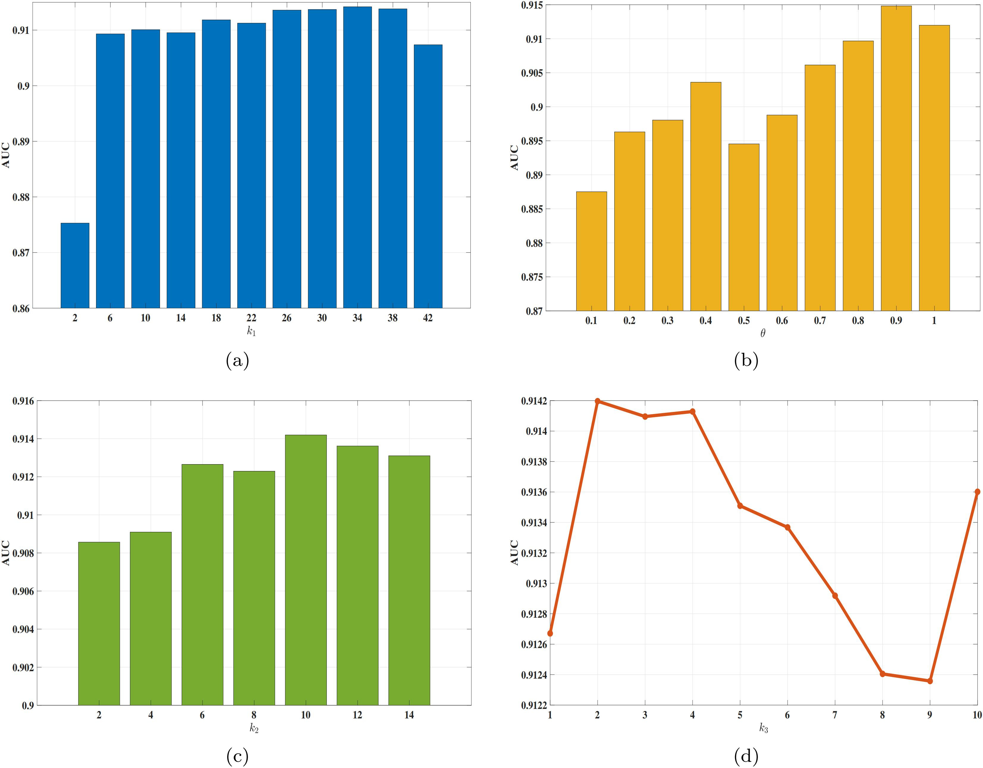
Supplementary Figure S1. The influence of different hyperparameters on SPLHRNMTF based on the MDAv2.0_data dataset. (a) The impact of hyperparameter $k_{1}$ on SPLHRNMTF. (b) The impact of hyperparameter $θ$ on SPLHRNMTF. (c) The impact of hyperparameter $k_{2}$ on SPLHRNMTF. (d) The impact of hyperparameter $k_{3}$ on SPLHRNMTF.
For the MDAv2.0_data dataset, we adjust another four hyperparameters as shown in Supplementary Figure S1. From Supplementary Figure S1 (a), we can see that the $k_{1}$ value in KNN method used by constructing hypergraphs is set to 34, the prediction performance of the model is optimal. Similarly, as can be seen from Supplementary Figure S1 (b), Figure S1 (c) and Figure S1 (d), the optimal performance of the model can be achieved, when decay term $θ=0.9$, $k_{2}$ in WKNN method is set to 10 and $k_{3}$ in KNN method used by sparse similarity matrix is set to 2.
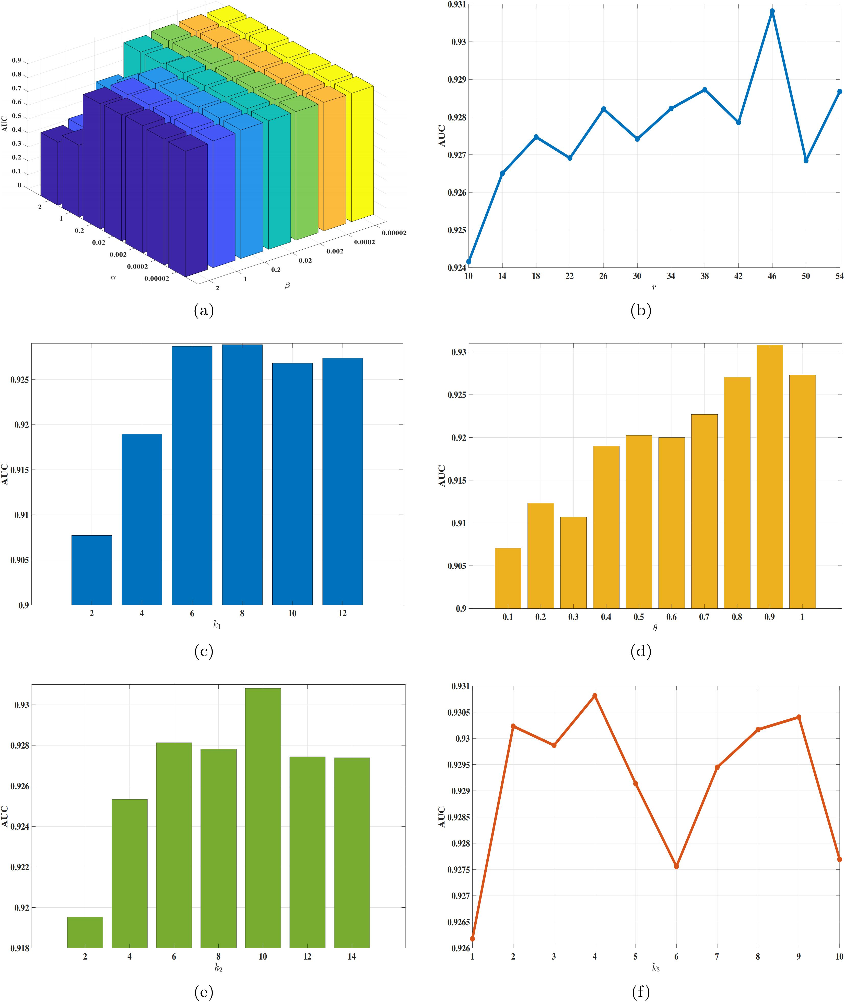
Supplementary Figure S2. The influence of different hyperparameters on SPLHRNMTF based on the MDAv3.2_data1 dataset. (a) The impact of hyperparameters $α$ and $β$ on SPLHRNMTF. (b) The impact of hyperparameter $r$ on SPLHRNMTF. (c) The impact of hyperparameter $k_{1}$ on SPLHRNMTF. (d) The impact of hyperparameter $θ$ on SPLHRNMTF. (e) The impact of hyperparameter $k_{2}$ on SPLHRNMTF. (f) The impact of hyperparameter $k_{3}$ on SPLHRNMTF.
For the MDAv3.2_data1 dataset, we adjust six hyperparameters as shown in Supplementary Figure S2. From Supplementary Figure S2 (a), we can see that $α=0.2$ and $β=0.002$, the prediction performance of the model is optimal. Similarly, as can be seen from Supplementary Figure S2 (b), Figure S2 (c), Figure S2 (d), Figure S2 (e) and Figure S2 (f), the optimal performance of the model can be achieved, when matrix rank $r=46$, $k_{1}$ value in KNN method used by constructing hypergraphs is set to 8, decay term $θ=0.9$, $k_{2}$ in WKNN method is set to 10 and $k_{3}$ in KNN method used by sparse similarity matrix is set to 4.
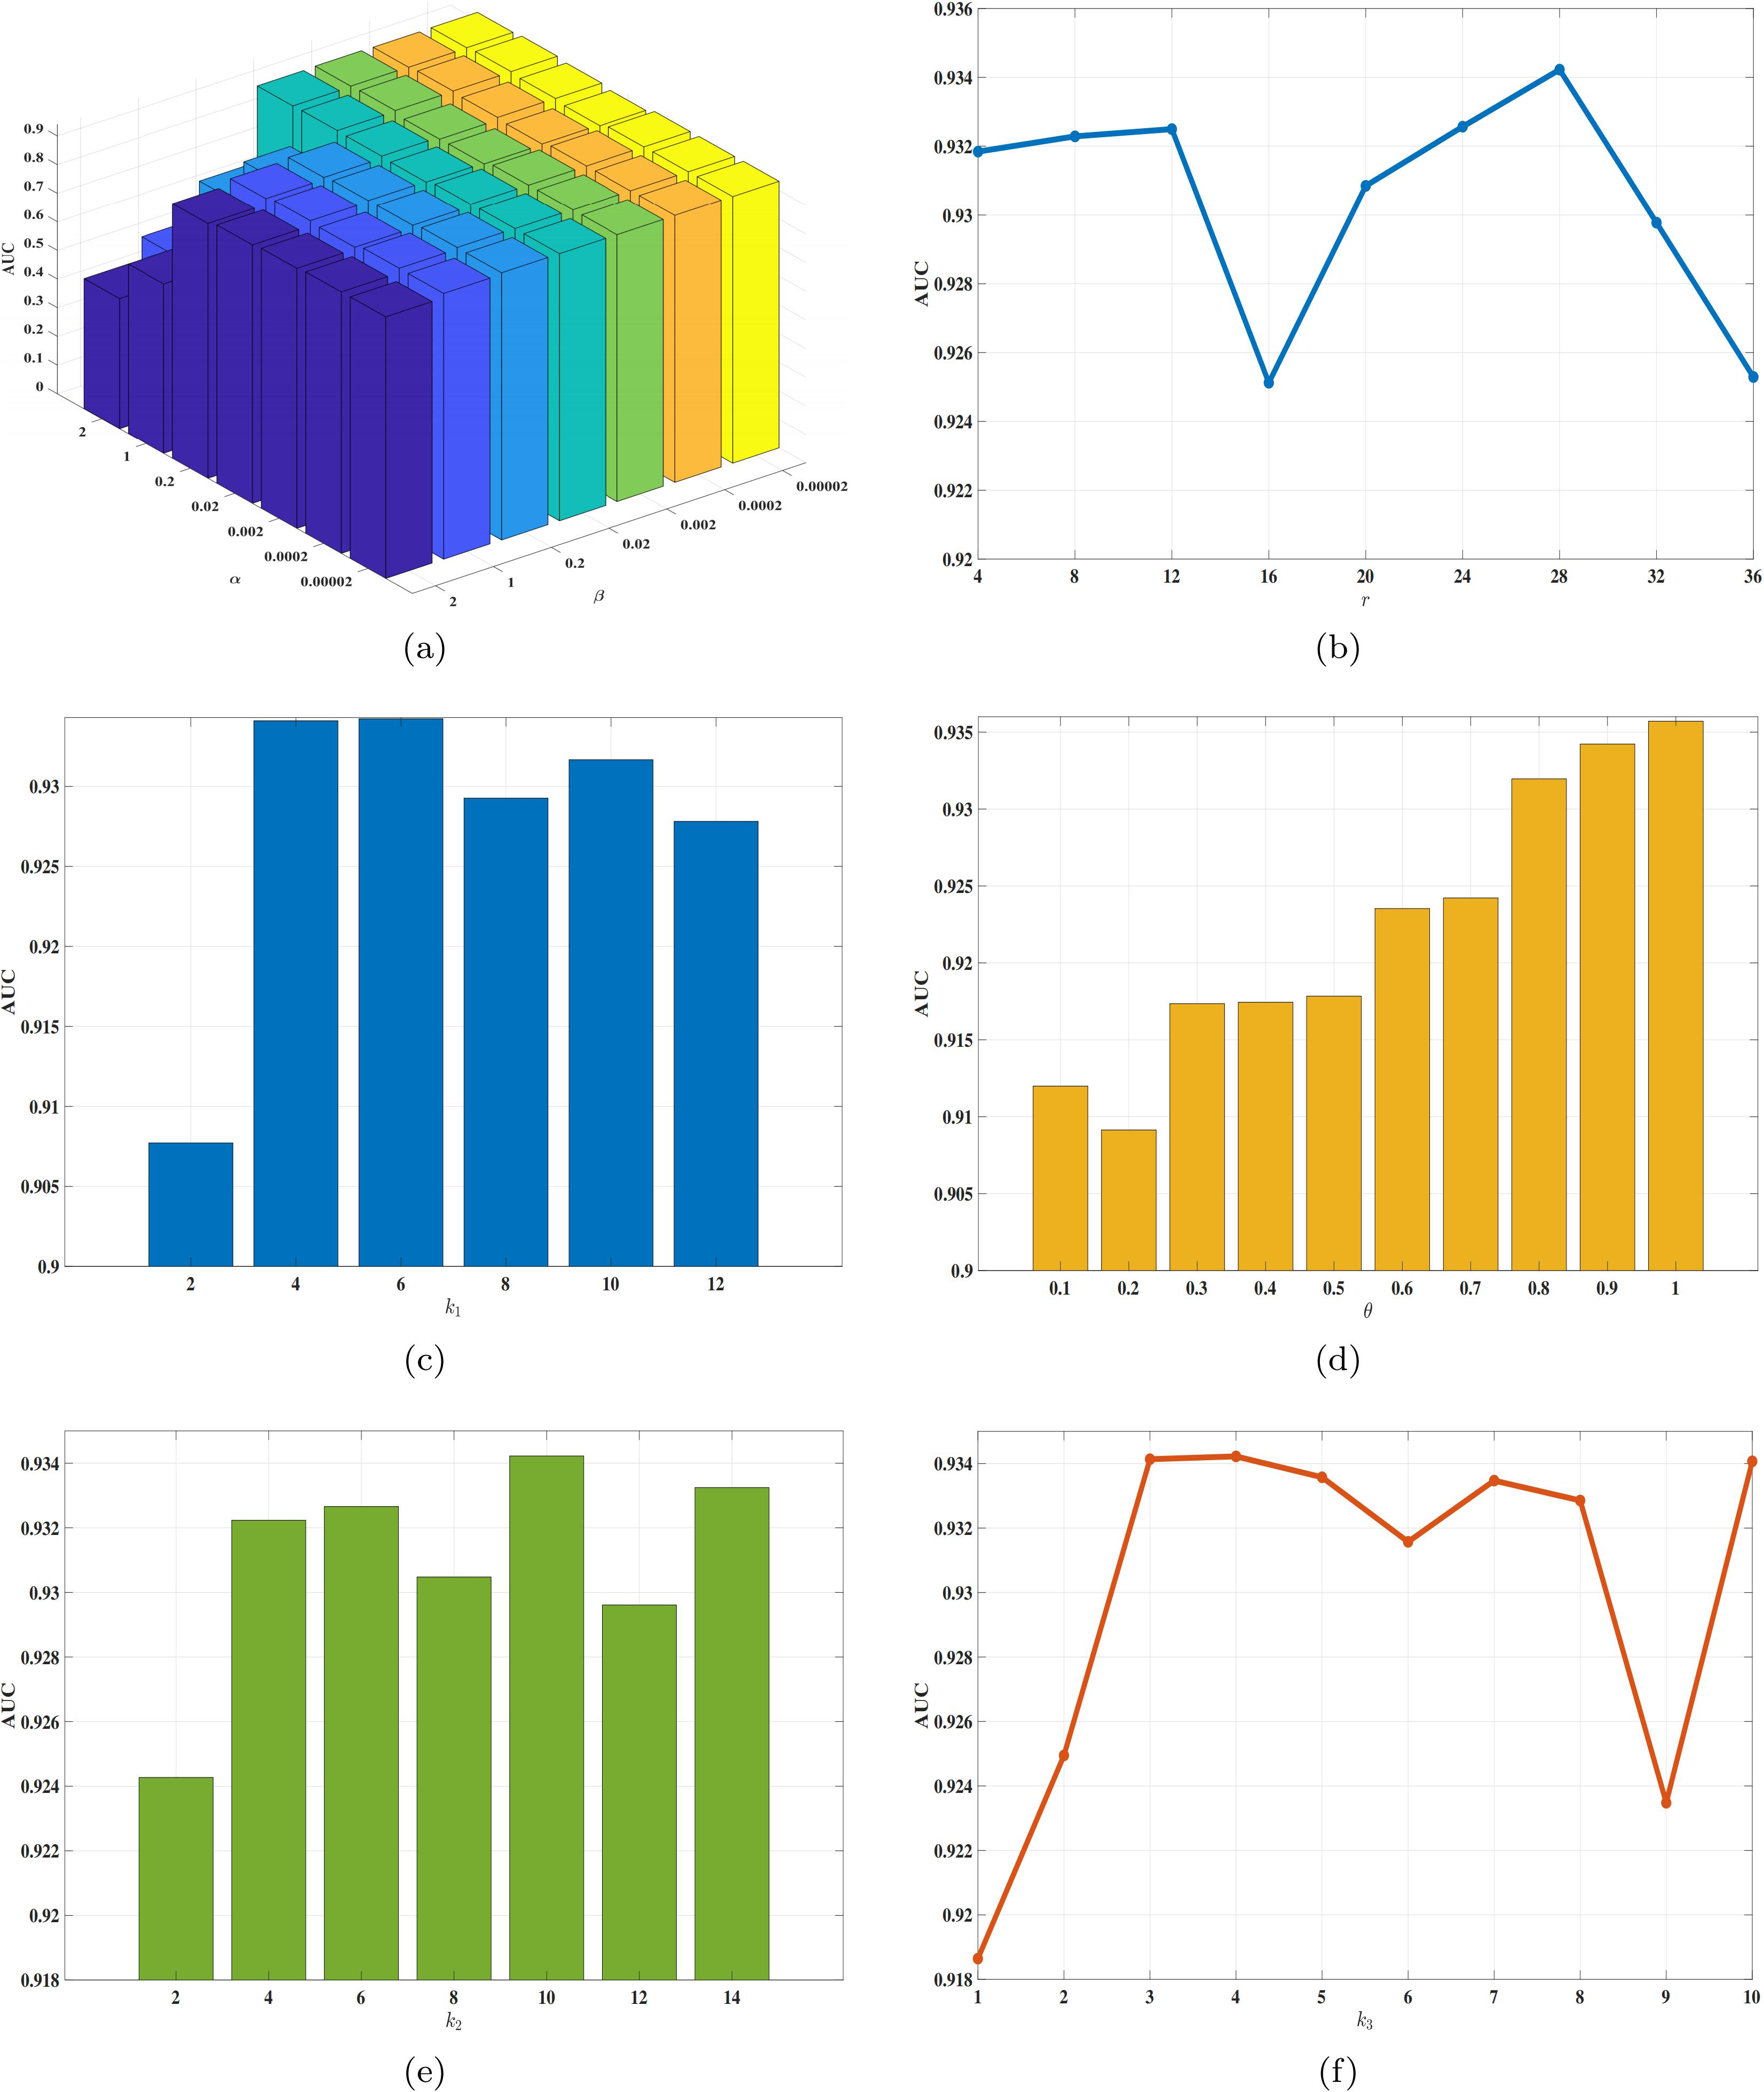
Supplementary Figure S3. The influence of different hyperparameters on SPLHRNMTF based on the MDAv3.2_data2 dataset. (a) The impact of hyperparameters $α$ and $β$ on SPLHRNMTF. (b) The impact of hyperparameter $r$ on SPLHRNMTF. (c) The impact of hyperparameter $k_{1}$ on SPLHRNMTF. (d) The impact of hyperparameter $θ$ on SPLHRNMTF. (e) The impact of hyperparameter $k_{2}$ on SPLHRNMTF. (f) The impact of hyperparameter $k_{3}$ on SPLHRNMTF.
For the MDAv3.2_data2 dataset, we adjust six hyperparameters as shown in Supplementary Figure S3. From Supplementary Figure S3 (a), we can see that $α=0.0002$ and $β=0.2$, the prediction performance of the model is optimal. Similarly, as can be seen from Supplementary Figure S3 (b), Figure S3 (c), Figure S3 (d), Figure S3 (e) and Figure S3 (f), the optimal performance of the model can be achieved, when matrix rank $r=28$, $k_{1}$ value in KNN method used by constructing hypergraphs is set to 6, decay term $θ=1.0$, $k_{2}$ in WKNN method is set to 10 and $k_{3}$ in KNN method used by sparse similarity matrix is set to 4.

1.2 Supplementary Experimental Results for All Models
Supplementary Table S1. The prediction performance of all models evaluated
by 5-fold cross-validation five times on the MDAv2.0_data dataset.
 | AUC | AUPR | F1
NMTF | 0.7855±0.0024 | 0.8011±0.0028 | 0.7296±0.0014
$L_{2,1}$-NMTF | 0.8325±0.0037 | 0.8499±0.0032 | 0.7550±0.0021
IMCMDA | 0.8065±0.0003 | 0.8206±0.0002 | 0.7548±0.0002
GRNMF | 0.8962±0.0014 | 0.9058±0.0009 | 0.8260±0.0020
MDHGI | 0.8875±0.0011 | 0.9085±0.0007 | 0.8396±0.0014
SPLGRNMF | 0.7854±0.0044 | 0.7823±0.0047 | 0.7636±0.0021
NMTFDR | 0.8857±0.0027 | 0.8936±0.0018 | 0.8197±0.0024
NMTF-DTI | 0.9021±0.0019 | 0.9111±0.0012 | 0.8322±0.0021
SPLNMTF | 0.9059±0.0006 | 0.9123±0.0004 | 0.8368±0.0010
NMFMC | 0.8617±0.0008 | 0.8404±0.0006 | 0.8048±0.0014
NIMCGCN | 0.8883±0.0004 | 0.8865±0.0007 | 0.8205±0.0009
MMGCN | 0.8854±0.0011 | 0.9093±0.0007 | 0.8405±0.0015
SPLHRNMTF | 0.9138±0.0002 | 0.9199±0.0004 | 0.8417±0.0008
From Supplementary Table S1, we observe that the proposed SPLHRNMTF model outperforms other baseline models on the MDAv2.0_data dataset, even including graph convolutional network-based models, in terms of average value for AUC, AUPR and F1. Additionally, the calculated standard deviation is also relatively small. These results indicate that SPLHRNMTF not only has superior prediction performance but also exhibits better robustness and stability.

1.3 Supplementary Parameters Analysis for GRNMF
In terms of GRNMF, $λ_{m}$ and $λ_{d}$ are coefficients controlling the graph Laplacian regularization term. Supplementary Figure S4 shows the selection of optimal $λ_{m}$ and $λ_{d}$ values through grid search and evaluation using AUC value.
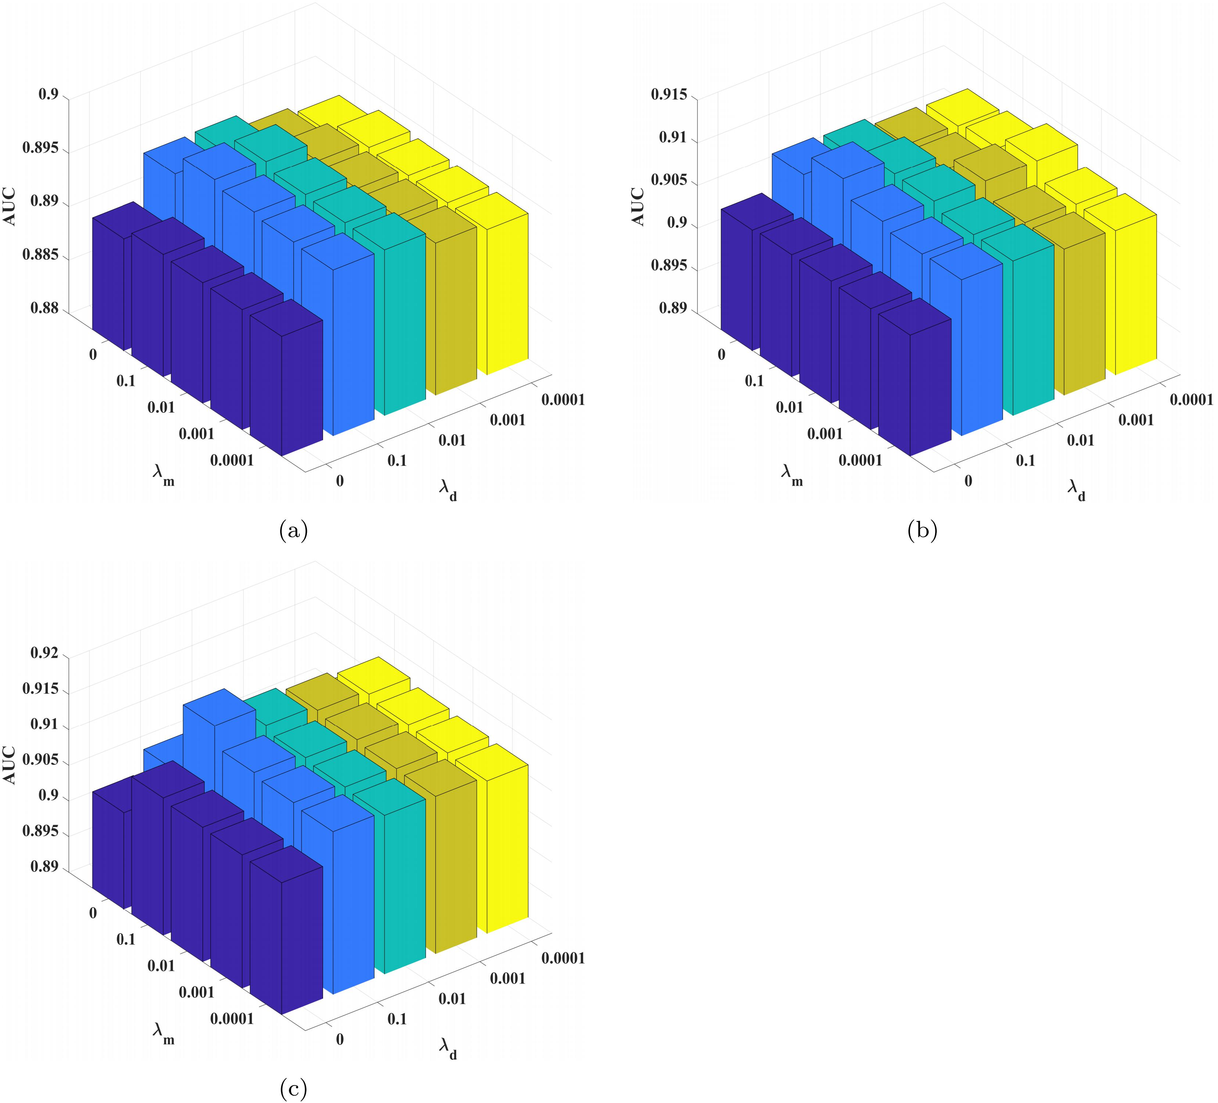
Supplementary Figure S4. The influence of hyperparameters $λ_{m}$ and $λ_{d}$ on GRNMF. (a) The hyperparameter analysis results are based on the MDAv2.0_data dataset. (b) The hyperparameter analysis results are based on the MDAv3.2_data1 dataset. (c) The hyperparameter analysis results are based on the MDAv3.2_data2 dataset.
From Supplementary Figure S4 (a), we can see that $λ_{m}=0.1$ and $λ_{d}=0.1$, the prediction performance of the GRNMF model is optimal on the MDAv2.0_data dataset. Similarly, as can be seen from Supplementary Figure S4 (b), the optimal performance of the model can be achieved on the MDAv3.2_data1 dataset when $λ_{m}=0.1$ and $λ_{d}=0.1$. In Supplementary Figure S4 (c), the optimal performance of the model can be achieved on the MDAv3.2_data2 dataset when $λ_{m}=0.1$ and $λ_{d}=0.1$.

1.4 Supplementary Parameters Analysis for SPLGRNMF
In terms of SPLGRNMF, $α$ and $β$ are coefficients controlling the graph Laplacian regularization term we added. Supplementary Figure S5 shows the selection of optimal $α$ and $β$ values through grid search and evaluation using AUC value.
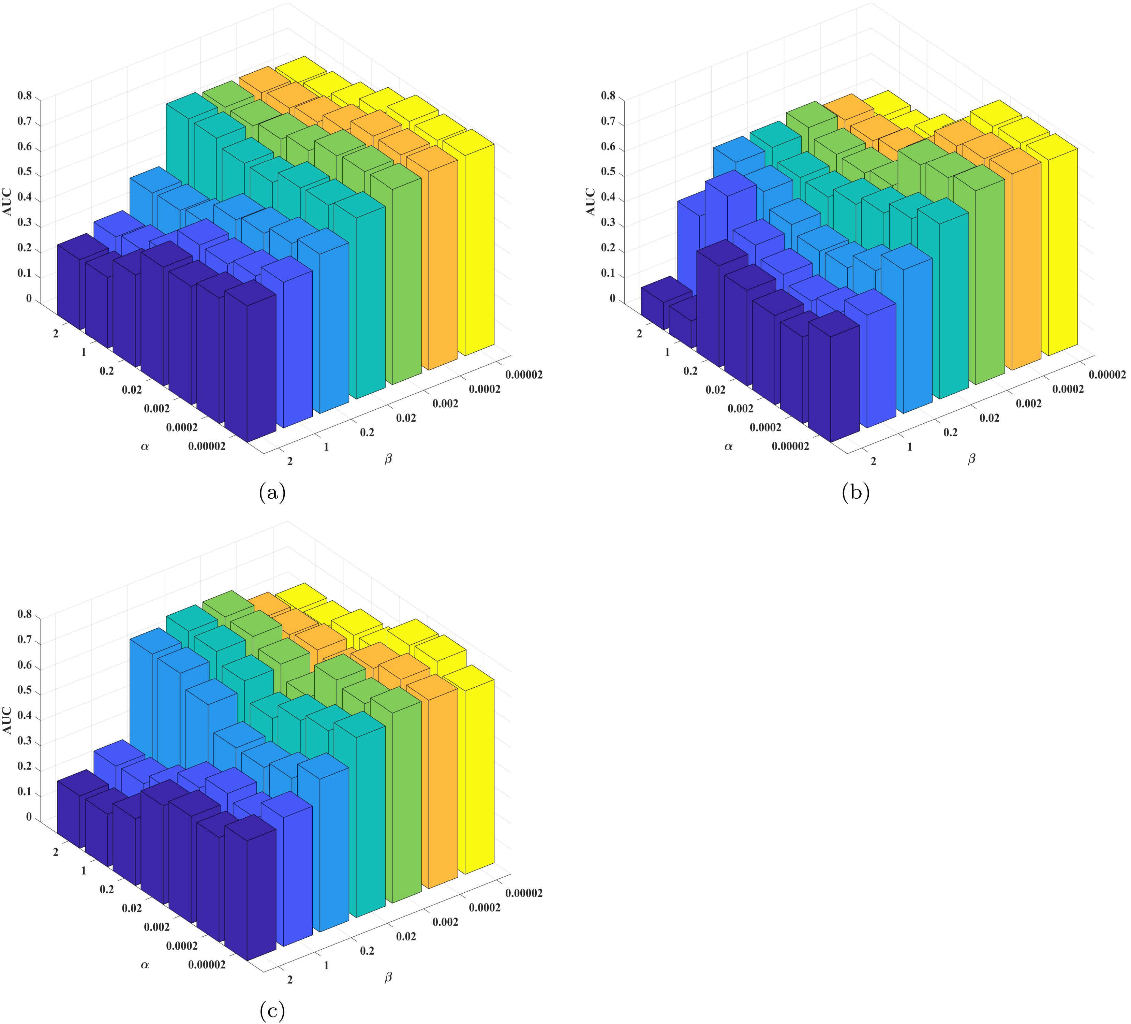
Supplementary Figure S5. The influence of hyperparameters $α$ and $β$ on SPLGR-NMF. (a) The hyperparameter analysis results are based on the MDAv2.0_data dataset. (b) The hyperparameter analysis results are based on the MDAv3.2_data1 dataset. (c) The hyperparameter analysis results are based on the MDAv3.2_data2 dataset
From Supplementary Figure S5 (a), we can see that $α=0.00002$ and $β=0.00002$, the prediction performance of the SPLGRNMF model is optimal on the MDAv2.0_data dataset. Similarly, as can be seen from Supplementary Figure S5 (b), the optimal performance of the model can be achieved on the MDAv3.2_data1 dataset when $α=0.00002$ and $β=0.0002$. In Supplementary Figure S5 (c), the optimal performance of the model can be achieved on the MDAv3.2_data2 dataset when $α=0.0002$ and $β=0.00002$.

1.5 Supplementary Parameters Analysis for NMTF-DTI
In terms of NMTF-DTI, $λ_{t}$ and $λ_{d}$ are coefficients controlling the graph Laplacian regularization term. Supplementary Figure S6 shows the selection of optimal $λ_{t}$ and $λ_{d}$ values through grid search and evaluation using AUC value.

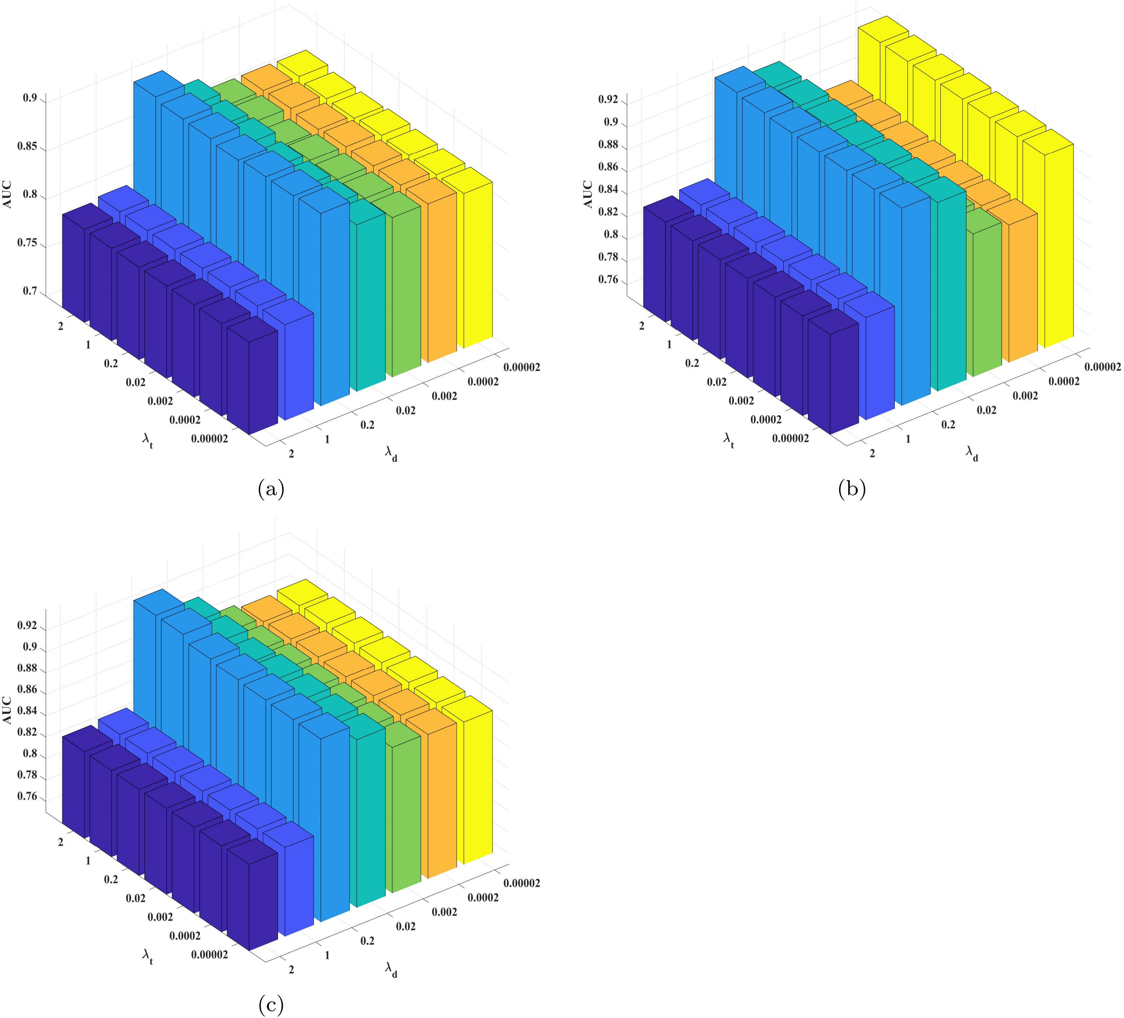
Supplementary Figure S6. The influence of hyperparameters $λ_{t}$ and $λ_{d}$ on NMTF-DTI. (a) The hyperparameter analysis results are based on the MDAv2.0_data dataset. (b) The hyperparameter analysis results are based on the MDAv3.2_data1 dataset. (c) The hyperparameter analysis results are based on the MDAv3.2_data2 dataset.
From Supplementary Figure S6 (a), we can see that $λ_{t}=2$ and $λ_{d}=0.2$, the prediction performance of the NMTF-DTI model is optimal on the MDAv2.0_data dataset. Similarly, as can be seen from Supplementary Figure S6 (b), the optimal performance of the model can be achieved on the MDAv3.2_data1 dataset when $λ_{t}=2$ and $λ_{d}=0.2$. In Supplementary Figure S6 (c), the optimal performance of the model can be achieved on the MDAv3.2_data2 dataset when $λ_{t}=2$ and $λ_{d}=0.2$.

1.6 Supplementary Parameters Analysis for NMFMC
In terms of NMFMC, $λ_{m}$ and $λ_{d}$ are coefficients controlling the graph Laplacian regularization term. Supplementary Figure S7 shows the selection of optimal $λ_{m}$ and $λ_{d}$ values through grid search and evaluation using AUC value.
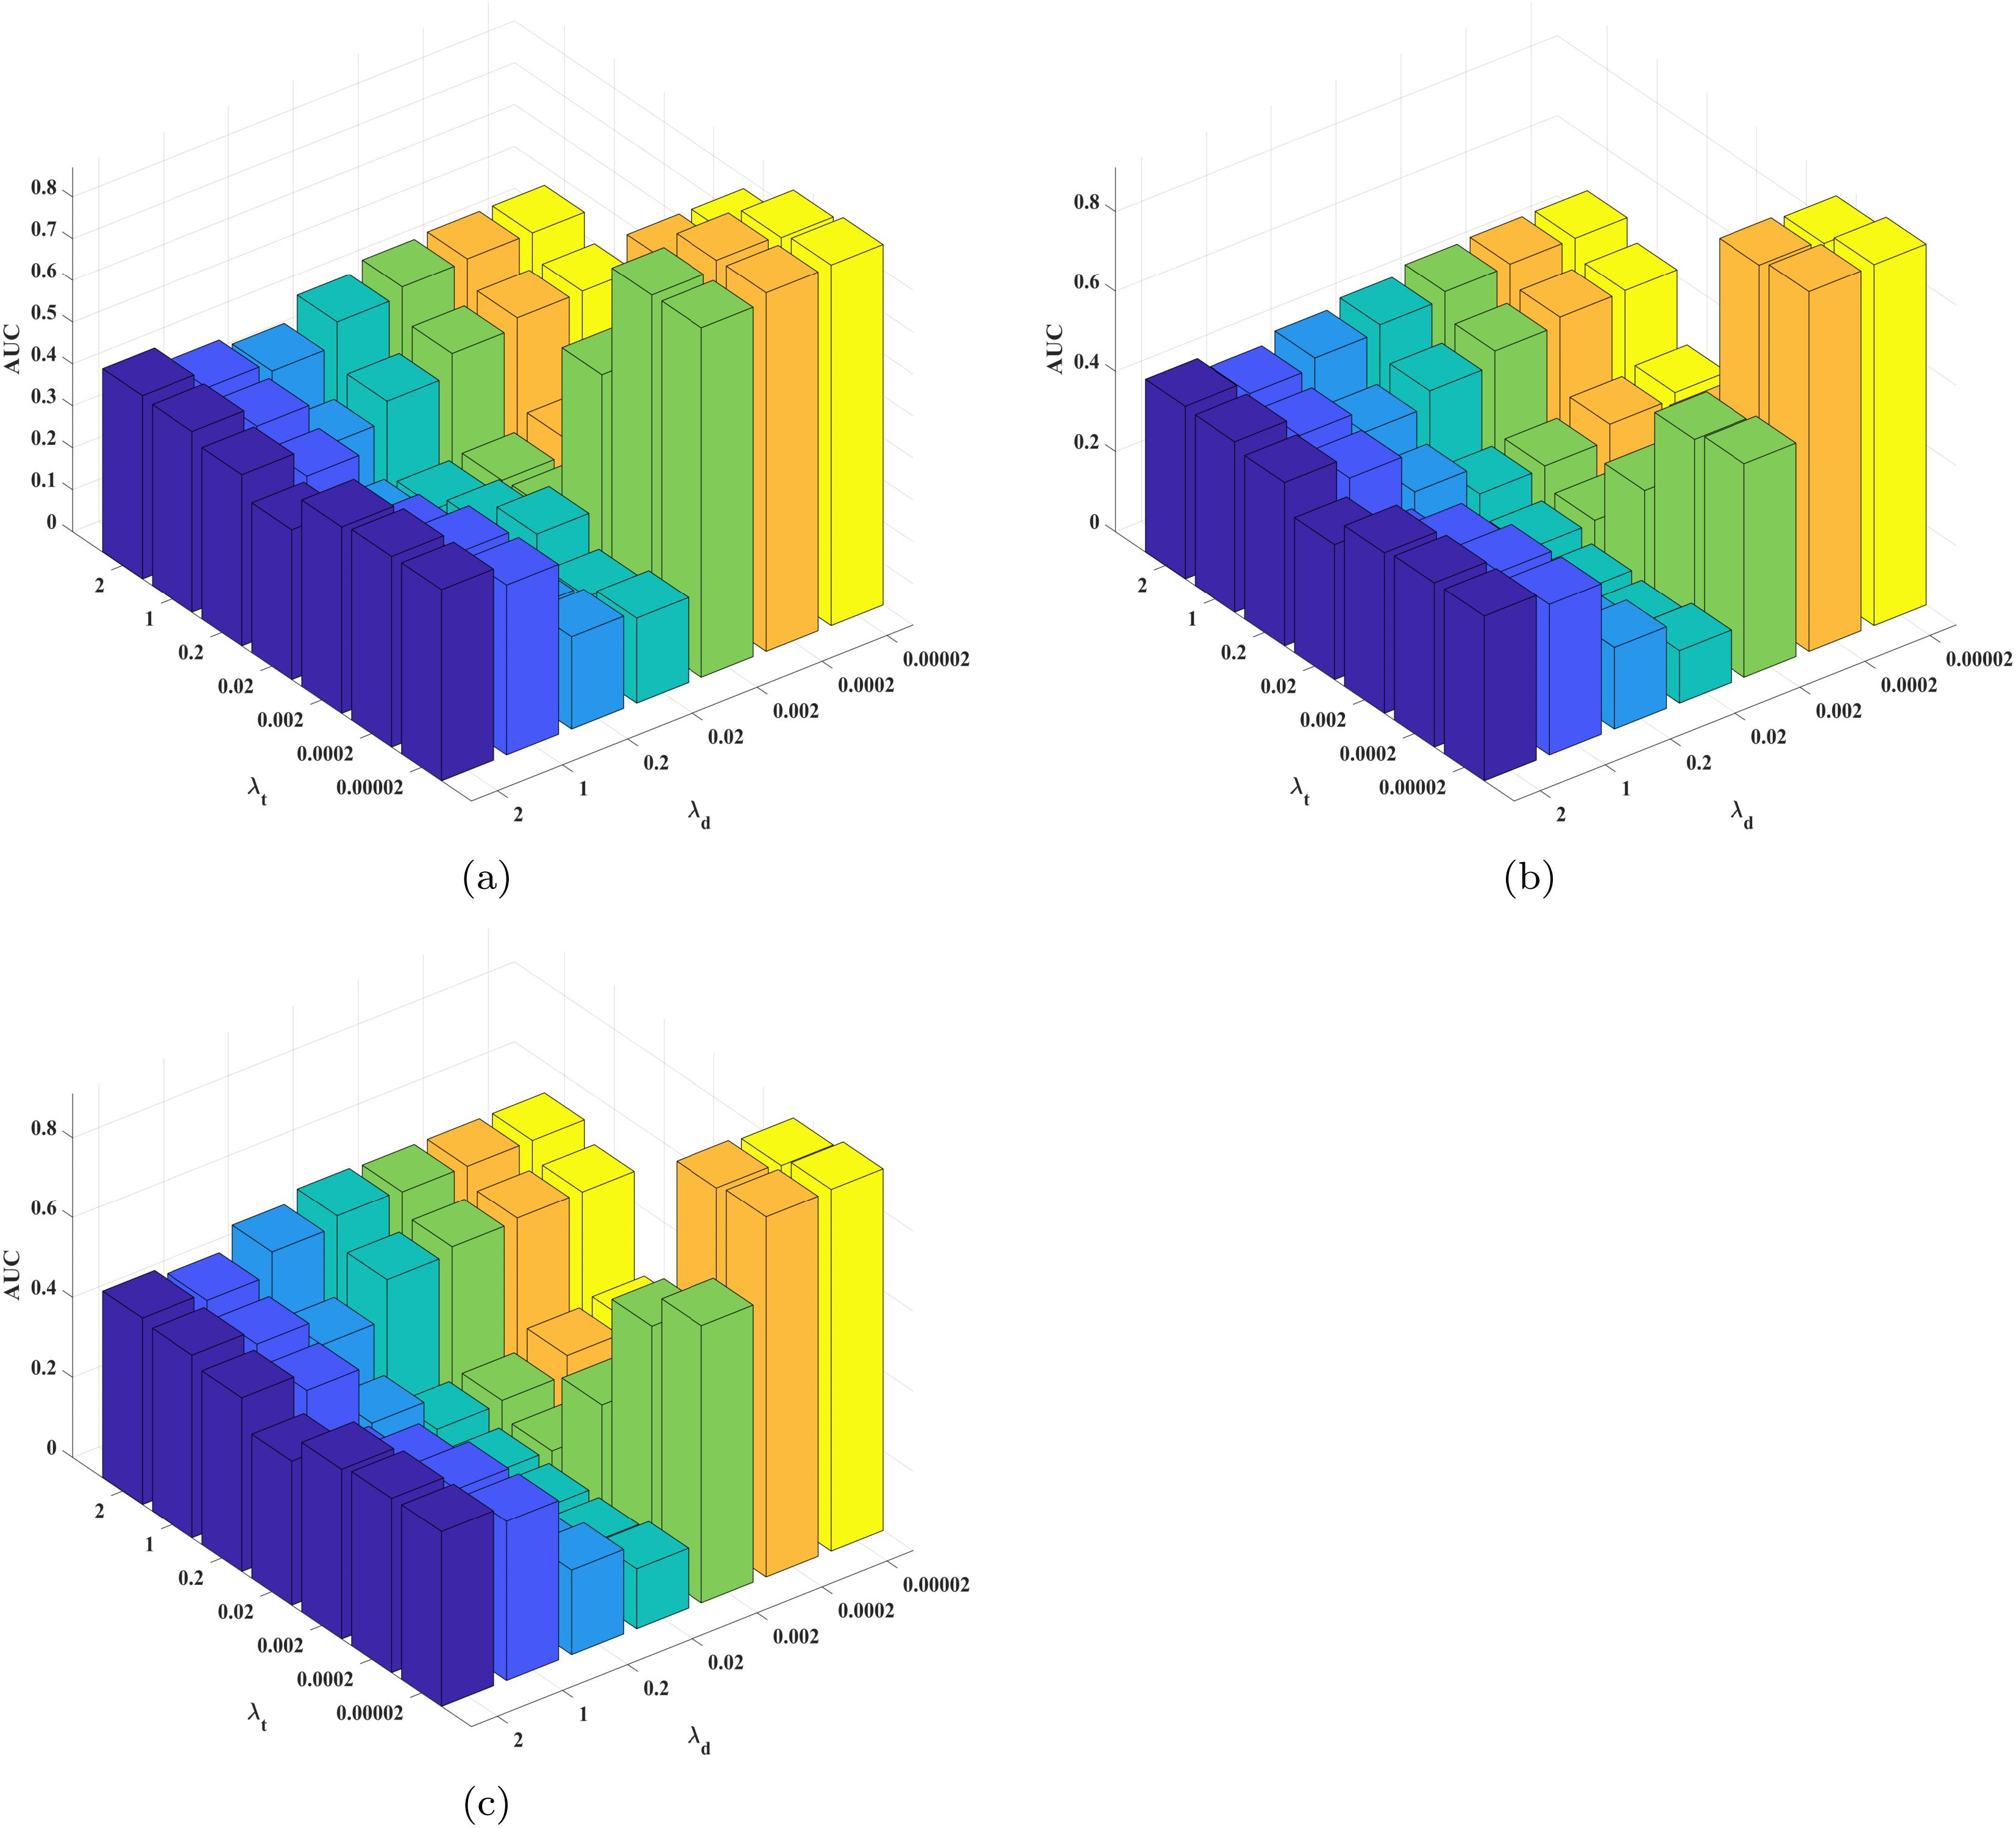
Supplementary Figure S7. The influence of hyperparameters $λ_{m}$ and $λ_{d}$ on NMFMC. (a) The hyperparameter analysis results are based on the MDAv2.0_data dataset. (b) The hyperparameter analysis results are based on the MDAv3.2_data1 dataset. (b) The hyperparameter analysis results are based on the MDAv3.2_data2 dataset.
From Supplementary Figure S7 (a), we can see that $λ_{m}=0.00002$ and $λ_{d}=0.00002$, the prediction performance of the NMFMC model is optimal on the MDAv2.0_data dataset. Similarly, as can be seen from Supplementary Figure S7 (b), the optimal performance of the model can be achieved on the MDAv3.2_data1 dataset when $λ_{m}=0.00002$ and $λ_{d}=0.00002$. In Supplementary Figure S7 (c), the optimal performance of the model can be achieved on the MDAv3.2_data2 dataset when $λ_{m}=0.00002$ and $λ_{d}=0.00002$.

Supplementary for Case Studies

2.1 Supplementary Figure for Case Studies
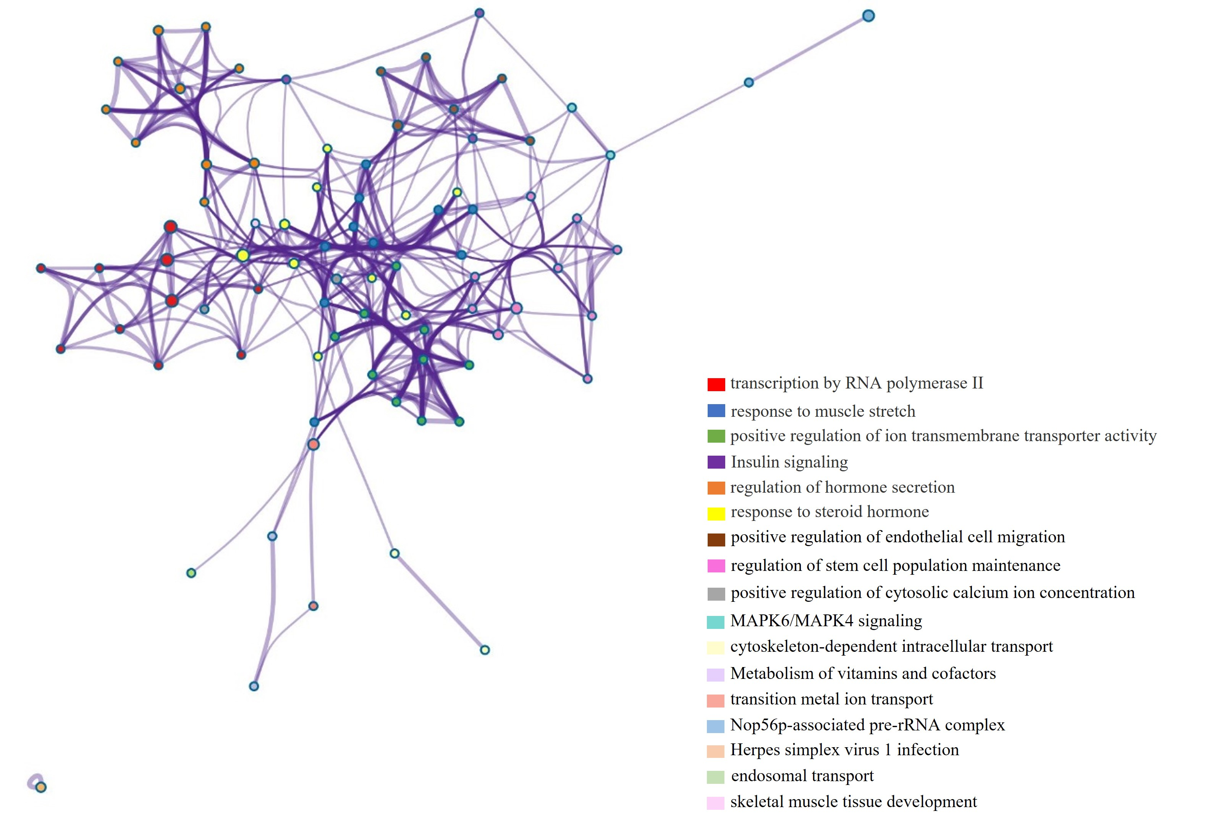
Supplementary Figure S8. Network of enriched terms, where each node represents an enriched term and is colored first by its cluster ID.

2.2 Supplementary Table for Case Studies
Supplementary Table S2. Top 50 lung neoplasms-related miRNAs predicted by SPLHRNMTF based on the MDAv2.0_data dataset. Note that the number in evidence means PubMed Unique Identifier (PMID).
Rank | miRNA | Evidence
1 | hsa-mir-125b-2 | dbDEMC
2 | hsa-mir-16-1 | dbDEMC
3 | hsa-mir-16-2 | dbDEMC
4 | hsa-mir-218-1 | dbDEMC
5 | hsa-mir-15a | 32808032
6 | hsa-mir-195 | 33332541
7 | hsa-mir-199a-2 | unconfirmed
8 | hsa-mir-141 | 30645846
9 | hsa-mir-133a-2 | unconfirmed
10 | hsa-mir-92a-2 | dbDEMC
11 | hsa-mir-106b | 34071592
12 | hsa-mir-429 | 31884798
13 | hsa-mir-24-1 | dbDEMC
14 | hsa-mir-130a | 31526129
15 | hsa-mir-99a | 36289596
16 | hsa-mir-19b-2 | unconfirmed
17 | hsa-mir-151a | 32633369
18 | hsa-mir-296 | 33972506
19 | hsa-mir-204 | 31287095
20 | hsa-mir-302b | dbDEMC
21 | hsa-mir-10a | 31829310
22 | hsa-mir-15b | dbDEMC
23 | hsa-mir-193b | 31262974
24 | hsa-mir-152 | 36229645
25 | hsa-mir-23b | 32281274
26 | hsa-mir-194-1 | unconfirmed
27 | hsa-mir-302c | dbDEMC
28 | hsa-mir-625 | 35988100
29 | hsa-mir-196b | dbDEMC
30 | hsa-mir-149 | 31789388
31 | hsa-mir-302a | dbDEMC
32 | hsa-mir-20b | 36289596
33 | hsa-mir-708 | 34754623
34 | hsa-mir-139 | 32913469
35 | hsa-mir-194-2 | dbDEMC
36 | hsa-mir-451a | 32106373
37 | hsa-mir-373 | 32426273
38 | hsa-mir-215 | dbDEMC
39 | hsa-mir-342 | 30645846
40 | hsa-mir-367 | 36221890
41 | hsa-mir-378a | dbDEMC
42 | hsa-mir-449a | 31686849
43 | hsa-mir-452 | dbDEMC
44 | hsa-mir-302d | dbDEMC
45 | hsa-mir-122 | 36045598
46 | hsa-mir-130b | 31524549
47 | hsa-mir-99b | dbDEMC
48 | hsa-mir-320a | dbDEMC
49 | hsa-mir-129-2 | dbDEMC
50 | hsa-mir-211 | 30402848

Supplementary for Parameter Information of Each Model
To facilitate readers to re-implement the proposed model and other baseline models, we provide detailed parameter information of each model on three datasets. To be more specific, we uniformly set the same rank as SPLHRNMTF for all baseline models on different datasets for fairness. Since the GRNMF, SPLGRNMF, NMTF-DTI, and NMFMC models with hyperparameters controlling the graph Laplace regularization, we perform grid search to find the optimal hyperparameters. In addition, in order to ensure a fair comparison, some parameters in the compared models are set to their default values, as recommended by the authors.
In term of MDAv2.0_data dataset, the detailed parameter information of each model is as follows:
1) For NMTF, we set the matrix rank to 23.
2) For $L_{2,1}$-NMTF, we set the matrix rank to 23.
3) For IMCMDA, we set the matrix rank to 23, $λ_{1}=λ_{2}=1$.
4) For GRNMF, we set the matrix rank to 23, $λ_{m}=0.1$, $λ_{d}=0.1$, $λ_{l}=0.0001$.
5) For MDHGI, we set $α=0.1$, $μ={10}^{-4}$, $\max_{μ}={10}^{10}$, $ε={10}^{-6}$.
6) For SPLGRNMF, we set the matrix rank to 23, $α=0.00002$, $β=0.00002$, where $α$ and $β$ are coefficients controlling the graph Laplacian regularization term we added.
7) For NMTFDR, we set the matrix rank to 23.
8) For NMTF-DTI, we set the matrix rank to 23, $λ_{t}=2$, $λ_{d}=0.2$, $λ_{l}=0.0001$.
9) For SPLNMTF, we set the matrix rank to 23, $γ=1.2$, $λ_{12end}=λ_{23end}=0.008$, $λ_{12}=λ_{23}=1.1$.
10) For NMFMC, we set the matrix rank to 23, $λ_{m}=0.00002$, $λ_{d}=0.00002$, $λ_{c}=0.0001$.
11) For NIMCGCN, we use the PyTorch deep learning framework, set the learning rate to 0.0001, $α=0.4$, the number of GCN layers to 2, and the optimizer to Adam. In addition, the number of hidden layers in GCN is 256 for miRNAs and diseases.
12) For MMGCN, we use the PyTorch deep learning framework, set the learning rate to 0.0001, the number of GCN layers for each similarity to 2, and the optimizer to Adam. In addition, the number of hidden layers in GCN is 256 for miRNAs and diseases.
13) For SPLHRNMTF, we set the matrix rank to 23, $α=0.00002$, $β=0.02$, $k_{1}=34$, $θ=0.9$, $k_{2}=10$, $k_{3}=2$.

In term of MDAv3.2_data1 dataset, the detailed parameter information of each model is as follows:
1) For NMTF, we set the matrix rank to 46.
2) For $L_{2,1}$-NMTF, we set the matrix rank to 46.
3) For IMCMDA, we set the matrix rank to 46, $λ_{1}=λ_{2}=1$.
4) For GRNMF, we set the matrix rank to 46, $λ_{m}=0.1$, $λ_{d}=0.1$, $λ_{l}=0.0001$.
5) For MDHGI, we set $α=0.1$, $μ={10}^{-4}$, $\max_{μ}={10}^{10}$, $ε={10}^{-6}$.
6) For SPLGRNMF, we set the matrix rank to 46, $α=0.00002$, $β=0.0002$, where $α$ and $β$ are coefficients controlling the graph Laplacian regularization term we added.
7) For NMTFDR, we set the matrix rank to 46.
8) For NMTF-DTI, we set the matrix rank to 46, $λ_{t}=2$, $λ_{d}=0.2$, $λ_{l}=0.0001$.
9) For SPLNMTF, we set the matrix rank to 46, $γ=1.2$, $λ_{12end}=λ_{23end}=0.008$, $λ_{12}=λ_{23}=1.1$.
10) For NMFMC, we set the matrix rank to 46, $λ_{m}=0.00002$, $λ_{d}=0.00002$, $λ_{c}=0.0001$.
11) For NIMCGCN, we use the PyTorch deep learning framework, set the learning rate to 0.0001, $α=0.4$, the number of GCN layers to 2, and the optimizer to Adam. In addition, the number of hidden layers in GCN is 256 for miRNAs and diseases.
12) For MMGCN, we use the PyTorch deep learning framework, set the learning rate to 0.0001, the number of GCN layers for each similarity to 2, and the optimizer to Adam. In addition, the number of hidden layers in GCN is 256 for miRNAs and diseases.
13) For MHCLMDA, we use the PyTorch deep learning framework, set the learning rate to 0.002, temperature hyperparameter $τ$ for contrastive loss of 0.7, the number of hypergraph convolutional network (HGCN) layers to 2, the number of neighbors selected when constructing the hypergraph $K=10$, and the optimizer to Adam.
14) For SPLHRNMTF, we set the matrix rank to 46, $α=0.2$, $β=0.002$, $k_{1}=8$, $θ=0.9$, $k_{2}=10$, $k_{3}=4$.

In term of MDAv3.2_data2 dataset, the detailed parameter information of each model is as follows:
1) For NMTF, we set the matrix rank to 28.
2) For $L_{2,1}$-NMTF, we set the matrix rank to 28.
3) For IMCMDA, we set the matrix rank to 28, $λ_{1}=λ_{2}=1$.
4) For GRNMF, we set the matrix rank to 28, $λ_{m}=0.1$, $λ_{d}=0.1$, $λ_{l}=0.0001$.
5) For MDHGI, we set $α=0.1$, $μ={10}^{-4}$, $\max_{μ}={10}^{10}$, $ε={10}^{-6}$.
6) For SPLGRNMF, we set the matrix rank to 28, $α=0.0002$, $β=0.00002$, where $α$ and $β$ are coefficients controlling the graph Laplacian regularization term we added.
7) For NMTFDR, we set the matrix rank to 28.
8) For NMTF-DTI, we set the matrix rank to 28, $λ_{t}=2$, $λ_{d}=0.2$, $λ_{l}=0.0001$.
9) For SPLNMTF, we set the matrix rank to 28, $γ=1.2$, $λ_{12end}=λ_{23end}=0.008$, $λ_{12}=λ_{23}=1.1$.
10) For NMFMC, we set the matrix rank to 28, $λ_{m}=0.00002$, $λ_{d}=0.00002$, $λ_{c}=0.0001$.
11) For NIMCGCN, we use the PyTorch deep learning framework, set the learning rate to 0.0001, $α=0.4$, the number of GCN layers to 2, and the optimizer to Adam. In addition, the number of hidden layers in GCN is 256 for miRNAs and diseases.
12) For MMGCN, we use the PyTorch deep learning framework, set the learning rate to 0.0001, the number of GCN layers for each similarity to 2, and the optimizer to Adam. In addition, the number of hidden layers in GCN is 256 for miRNAs and diseases.
13) For MHCLMDA, we use the PyTorch deep learning framework, set the learning rate to 0.002, temperature hyperparameter $τ$ for contrastive loss of 0.7, the number of hypergraph convolutional network (HGCN) layers to 2, the number of neighbors selected when constructing the hypergraph $K=10$, and the optimizer to Adam.
14) For SPLHRNMTF, we set the matrix rank to 28, $α=0.0002$, $β=0.2$, $k_{1}=6$, $θ=1.0$, $k_{2}=10$, $k_{3}=4$.

