Additional File 1
Figure S1 - Pedigree completeness indicating the percentage of known ancestors per parental generation.

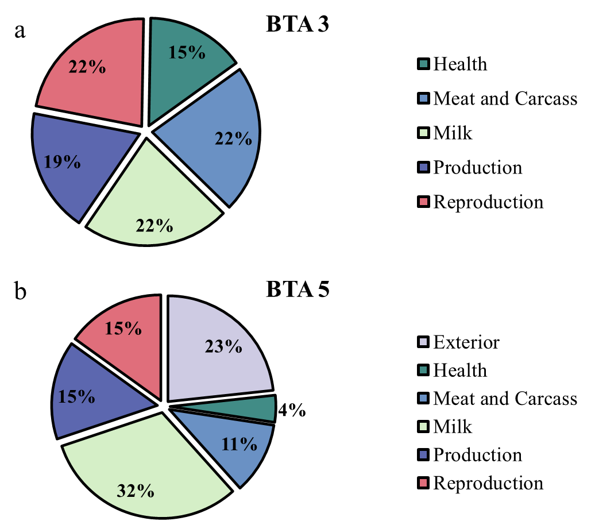
Figure S2 – Quantitative trait loci mapping the two longest runs of homozygosity segments in Nelore cattle.

Figure S3 – Pearson's correlation of inbreeding coefficients based on pedigree information (F_{Ped}), runs of homozygosity (F_{ROH}) considering segments length higher than 1 Mb (F_{ROH1 > 1}), 2 Mb (F_{ROH1 > 2}), 4 Mb (F_{ROH1 > 4}) and higher than 8 Mb (F_{ROH >8}). Asterisk (***) represents statistical significance (p-value < 0.005).

