The Amphibian Genomics Consortium: advancing genomic and genetic resources for amphibian research and conservation

Authors
Tiffany A. Kosch^{1§}*, María Torres-Sánchez^{2§}*, H. Christoph Liedtke³, Kyle Summers⁴, Maximina H. Yun^{5,6}, Andrew J. Crawford^{7,8}, Simon T. Maddock^{9,10}, Md. Sabbir Ahammed¹¹, Victor L. N. Araújo⁷, Lorenzo V. Bertola¹², Gary Bucciarelli¹³, Albert Carné¹⁴, Céline M. Carneiro¹⁵, Kin O. Chan¹⁶, Ying Chen¹⁷, Angelica Crottini^{18,19,20}, Jessica M. da Silva^{21,22}, Robert D. Denton²³, Carolin Dittrich²⁴, Gonçalo Espregueira Themudo²⁵, Katherine A. Farquharson^{26,27}, Natalie J. Forsdick²⁸, Edward Gilbert^{29,30}, Che Jing^{31,32}, Barbara A. Katzenback³³, Ramachandran Kotharambath³⁴, Nicholas A. Levis³⁵, Roberto Márquez³⁶, Glib Mazepa^{37,38}, Kevin P. Mulder³⁹, Hendrik Müller⁴⁰, Mary J. O'Connell⁴¹, Pablo Orozco-terWengel⁴², Gemma Palomar^{43,44}, Alice Petzold⁴⁵, David W. Pfennig⁴⁶, Karin S. Pfennig⁴⁶, Michael S. Reichert⁴⁷, Jacques Robert⁴⁸, Mark D. Scherz⁴⁹, Karen Siu-Ting^{50,51,52}, Anthony A Snead⁵³, Matthias Stöck⁵⁴, Adam M. M. Stuckert⁵⁵, Jennifer L. Stynoski⁵⁶, Rebecca D. Tarvin⁵⁷, Katherina C. Wollenberg Valero⁵⁸, and The Amphibian Genomics Consortium (AGC).

§contributed equally to the manuscript
*correspondence:
Tiffany A. Kosch (tiffany.kosch@gmail.com)
María Torres-Sánchez (torressanchez.maria@gmail.com)

Affiliations
¹One Health Research Group, Melbourne Veterinary School, Faculty of Science, University of Melbourne, Werribee, Victoria, Australia
²Department of Biodiversity, Ecology, and Evolution, Complutense University of Madrid, 28040 Madrid, Spain
³Eco-Evo-Devo Group, Estación Biológica de Doñana CSIC, Seville, Spain
⁴Biology Department, East Carolina University, Greenville, NC, USA 27858
⁵Technische Universität Dresden, CRTD/Center for Regenerative Therapies Dresden, Dresden, Germany
⁶Max Planck Institute for Molecular Cell Biology and Genetics, Dresden, Germany
⁷Department of Biological Sciences, Universidad de los Andes, Bogotá, 111711, Colombia
⁸Museo de Historia Natural C.J. Marinkelle, Universidad de los Andes, Bogotá, 111711, Colombia.
⁹School of Natural and Environmental Sciences, Newcastle University, UK
¹⁰Island Biodiversity and Conservation Centre, University of Seychelles, Seychelles
¹¹Department of Zoology, Jagannath University, Dhaka 1100, Bangladesh
¹²Centre for Tropical Bioinformatics and Molecular Biology, James Cook University, QLD 4810, Australia
¹³Department of Wildlife, Fish, and Conservation Biology, University of California, Davis, USA
¹⁴Museo Nacional de Ciencias Naturales-CSIC, Madrid, Spain
¹⁵Department of Integrative Biology, The University of Texas at Austin, Austin, TX, USA
¹⁶University of Kansas Biodiversity Institute and Natural History Museum, Lawrence, Kansas 66045, USA
¹⁷Biology Department, Queen's University, Ontario, Canada
¹⁸CIBIO, Centro de Investigação em Biodiversidade e Recursos Genéticos, InBIO Laboratório Associado, Campus de Vairão, Universidade do Porto, 4485-661 Vairão, Portugal
¹⁹Departamento de Biologia, Faculdade de Ciências, Universidade do Porto, rua do Campo Alegre s/n, 4169– 007 Porto, Portugal
²⁰BIOPOLIS Program in Genomics, Biodiversity and Land Planning, CIBIO, Campus de Vairão, 4485-661 Vairão, Portugal
²¹Evolutionary Genomics and Wildlife Management, Foundatonal Biodiversity Science, Kirstenbosch Research Centre, South African National Biodiversity Institute, Newlands 7735, Cape Town, South Africa
²²Centre for Evolutionary Genomics and Wildlife Conservation, Department of Zoology, University of Johannesburg, Auckland Park 2006, Johannesburg, South Africa
²³Department of Biology, Marian University, Indianapolis, IN 46222, USA
²⁴Rojas Lab, Konrad-Lorenz-Institute of Ethology, Department of Life Science, University of Veterinary Medicine, Vienna, Austria
²⁵CIIMAR Interdisciplinary Centre of Marine and Environmental Research, University of Porto, Terminal de Cruzeiros do Porto de Leixões, Avenida General Norton de Matos, S/N, Matosinhos, Portugal
²⁶School of Life and Environmental Sciences, The University of Sydney, Sydney, NSW 2006, Australia
²⁷Australian Research Council Centre of Excellence for Innovations in Peptide and Protein Science, The University of Sydney, Sydney, New South Wales, Australia
²⁸Manaaki Whenua – Landcare Research, Auckland, New Zealand
²⁹School of Natural Sciences, The University of Hull, Hull, HU6 7RX, United Kingdom
³⁰Energy and Environment Institute, The University of Hull, Hull, HU6 7RX, United Kingdom
³¹ Key Laboratory of Genetic Evolution and Animal Models, and Yunnan Key Laboratory of Biodiversity and Ecological Conservation of Gaoligong Mountain, Kunming Institute of Zoology, Chinese Academy of Sciences, Kunming 650223, China
³² Southeast Asia Biodiversity Research Institute, Chinese Academy of Sciences, Yezin, Nay Pyi Taw 05282, Myanmar
³³Department of Biology, University of Waterloo, Waterloo, Ontario, Canada N2L 3G1
³⁴Herpetology Lab, Dept. of Zoology, Central University of Kerala, Tejaswini Hills, Kasaragod, Kerala, 671320, India
³⁵Department of Biology, Indiana University, Bloomington, IN 47405, USA
³⁶Department of Biological Sciences, Virginia Tech. Blacksburg, VA 24060, USA
³⁷Department of Ecology and Evolution, University of Lausanne, Biophore, 1015, Switzerland
³⁸Department of Ecology and Genetics, Evolutionary Biology, Norbyvägen 18D, 75236 Uppsala, Sweden
³⁹Wildlife Health Ghent, Faculty of Veterinary Medicine, Ghent University, Merelbeke, Belgium
⁴⁰Central Natural Science Collections, Martin Luther University Halle-Wittenberg, D-06108 Halle (Saale), Germany
⁴¹School of Life Sciences, Faculty of Medicine and Health Sciences, University of Nottingham, UK
⁴²School of Biosciences, Cardiff University, Museum Avenue, CF10 3AX Cardiff, United Kingdom
⁴³Department of Genetics, Physiology, and Microbiology; Faculty of Biological Sciences; Complutense University of Madrid, Madrid, Spain
⁴⁴Institute of Environmental Sciences, Faculty of Biology, Jagiellonian University, Kraków, Poland
⁴⁵Institute of Biochemistry and Biology, University of Potsdam, Karl-Liebknecht Str.24-25, 14476 Potsdam, Germany
⁴⁶Department of Biology, University of North Carolina, Chapel Hill, NC 27599, USA
⁴⁷Department of Integrative Biology, Oklahoma State University, Stillwater OK, USA
⁴⁸Department of Microbiology and Immunology, University of Rochester Medical Center, Rochester, NY, 14642, USA
⁴⁹Natural History Museum of Denmark, University of Copenhagen, Universitetsparken 15, 2100, Copenhagen Ø, Denmark
⁵⁰School of Biological Sciences, Queen's University Belfast, Belfast, BT7 1NN, Northern Ireland, United Kingdom
⁵¹Instituto Peruano de Herpetología, Ca. Augusto Salazar Bondy 136, Surco, Lima, Peru
⁵²Herpetology Lab, The Natural History Museum, London, United Kingdom
⁵³Department of Biology, New York University, New York, NY, USA
⁵⁴Leibniz Institute of Freshwater Ecology and Inland Fisheries (IGB), Müggelseedamm 301, D-12587 Berlin, Germany
⁵⁵Department of Biology and Biochemistry, University of Houston, Houston, Texas, 77204, USA
⁵⁶Instituto Clodomiro Picado, Universidad de Costa Rica, San José, Costa Rica
⁵⁷Museum of Vertebrate Zoology and Department of Integrative Biology, University of California, Berkeley, CA 94720, USA
⁵⁸School of Biology and Environmental Science, University College Dublin, Belfield Campus, Dublin 4, Ireland

This PDF includes:
1. Supplementary Methods
2. Table S1
3. Figures S1 – S3
4. References

Supplementary Methods
We downloaded records from the NCBI Genome browser to compare the number of sequenced genomes and genome size across tetrapod classes (all NCBI records were accessed on 1 March 2024). Current number of species per class was obtained from different databases (amphibians: https://amphibiaweb.org/, reptiles: http://www.reptile-database.org/, birds: https://datazone.birdlife.org/, mammals: https://www.mammaldiversity.org/; records accessed on 1 March 2024). We built a contingency table with the numbers of total species and the number of species with sequenced genomes for each tetrapod class, compared these values through a Chi-squared test with the chisq.test function of R, and visualized data percentages using a mosaic plot by the mosaicplot function of R. To assess genome size bias between species with and without sequenced genomes across tetrapods, we also downloaded genome size records from the Animal Genome Size Database ([https://www.genomesize.com/ 1]). We averaged genome size C-values for species with more than one estimate and calculated genome size in Gb considering 1 pg equivalent to 0.978 Gb. Due to the low number of amphibian records for caecilians, we obtained additional amphibian genome size values from HC Liedtke, DJ Gower, M Wilkinson and I Gomez-Mestre [2]. The raincloud plots visualized data from NCBI genome assembly sizes and estimated genome size records of unsequenced species. The plots used combined box and density plots with raw values as points (https://github.com/PsyTeachR/introdataviz). We used this graphical representation for exploring genome differences across tetrapod classes and amphibian orders, respectively. We formally tested differences in genome size by tetrapod class for species with and without reference genomes using analysis of the variance and post-hoc tests with the aov and TukeyHSD functions of R. We further explored the distribution of genome sizes regarding genome references at family level in the amphibian phylogeny from W Jetz and RA Pyron [3] including genome size inferences from GoaT [4] using phytools package of R [5]. We also summarized amphibian information from NCBI Sequence Read Archive (SRA) by sorting amphibian SRA data by BioProject ID and quantifying the number of times different sequencing techniques have been applied to the study of amphibians. We represented this information by grouping BioProjects yearly.

To analyze the information from the results of the AGC survey (see Table S2 for detailed information about AGC survey questions), we first quantified the number of sequencing techniques that AGC members have used in their research and the amphibian order that these researchers have worked with (AGC survey questions 11 and 9). We visualized both datasets using bar plots with barplot function of R. Answers from questions 8, 12, and 13 treated as quantitative variables were combined using principal components analysis with the prcomp function of R. We visualized the results of this dimensionality reduction analysis using several plots with the functions of factorextra package of R [6]. We created two new variables with the scores of the first and second dimensions, which grouped answers defining genomics expertise and identified challenges of the AGC members. To explain the variation of these two new variables, we used as explanatory variables the scientific expertise of AGC members (AGC survey question 5), the funding success (AGC survey question 16), and two other variables based on the information provided about the country of main affiliation of the member (AGC survey question 4). These two variables were the number of described amphibian species (data from AmphibiaWeb: https://amphibiaweb.org/) and gross domestic expenditure on R&D (GERD) per capita (data from UNESCO: http://data.uis.unesco.org, World Bank: https://data.worldbank.org/, and World population data: https://worldpopulationreview.com/). We explored the correlation between the dependent (scores from dimension 1 and 2) and independent variables and collinearity among independent variables and, subsequently, modelled dimension 1 and dimension 2 independently using generalized linear models with glm function of R.

Table S1. Amphibian Genomics Consortium (AGC) Survey Questions. Each row contains one of the 23 questions.
1 Contact details (answering this question is optional; all data will be treated anonymously and details will only be used to contact respondents if clarifications on answers are required)
Name (1) __________________________________________________
E-mail (2) __________________________________________________
2 Are you member of the Amphibian Genomics Consortium (https://mvs.unimelb.edu.au/amphibian-genomics-consortium)?
Yes (1)
No (2)
3 Organization(s) you are affiliated to (write the name of your organization in the corresponding category)
University (1) _____________________________________________
Research center / Museum (2) _____________________________________________
Private company (3) _____________________________________________
NGO (4) _____________________________________________
4 Country(ies) of affiliation
__________________________________________________
5 Number of years since PhD dissertation, as a measure of research experience. Indicate “0” if you are a student (i.e., Master’s, PhD student/candidate, or similar)
__________________________________________________
6 Research topic. Rate each topic, being 0 = you haven’t worked in the field yet, 1 = rarely worked, 2 = occasionally, 3 = often, and 4 = main research topicç
Ecology and Evolution (1) _________________________________
Conservation and Management (2) _________________________________
Development and Regeneration (3) _________________________________
Biomedical research and drug discovery (4) _________________________________
7 How often have you applied sequencing technologies in your research? Indicate a number, being 0 = never, 1 = rarely, 2 = occasionally, 3 = often, and 4 = mainly
__________________________________________________
8 Type of work you mainly undertake. Rate each of the following items, being 0 = you haven’t performed the task yet, 1 = rarely performed, 2 = occasionally, 3 = often, and 4 = main activity
Field surveys (1) _________________________________
Laboratory work (2) _________________________________
Computational work (3) _________________________________
Writing (articles, reports, and grants) (4) _________________________________
9 Amphibian order you mainly work with. Rate each of the amphibian orders, being 0 = you haven’t worked with the group yet, 1 = rarely worked with it, 2 = occasionally, 3 = often, and 4 = mainly
Anura (1) __________________________________________________
Caudata (2) __________________________________________________
Gymnophiona (3) __________________________________________________
10 Select sequencing technologies that you have implemented in your research (multiple choice)
Sanger sequencing (1)
Short read sequencing (2)
Long read sequencing (3)
11 Select the sequencing focus of your research (multiple choice)
Whole genome sequencing (1)
Whole exome sequencing (2)
Whole methylome sequencing (3)
Chromatin Immunoprecipitation followed by sequencing (4)
Transcriptome sequencing (5)
Restriction site-associated DNA sequencing (6)
Targeted sequencing (7)
Other (8)
12 Bioinformatic analyses that you have performed. Rate each of the following analyses by your level of expertise, being 0 = you haven’t performed the analysis yet, 1 = novice at the analysis, 2 = advanced beginner, 3 = competent, 4 = proficient, and 5 = expert
Sequences quality control (1) _____________________________________________
Filtering and trimming (2) _____________________________________________
De novo assembly (3) _____________________________________________
Mapping to reference (4) _____________________________________________
Genomics annotation (5) _____________________________________________
Downstream analyses (6) _____________________________________________
13 Evaluate the challenges for the amphibian genomics advancement. Rate each of the following items, being 0 = not issue at all, 1 = somehow problematic, 2 = average, 3 = complicated, and 4 = extremely challenging
Sample acquisition (1) _____________________________________________
Protocol transferability (2) _____________________________________________
Data quantity and quality (3) _____________________________________________
Data integration (4) _____________________________________________
Computational resources (5) _____________________________________________
Data storage (6) _____________________________________________
Funding sources (7) _____________________________________________
14 Identify other challenges and score them according to the scale in the previous question
__________________________________________________
15 Have you applied for any funding for high-throughput sequencing in amphibians?
Yes (1)
No (2)
16 If yes in question 15, have you been successful?
Yes (1)
No (2)
17 Type of body fund/funds that you have applied (multiple choice)
Governmental (1)
Scientific association (2)
Private company (3)
NGO (4)
Other (5)
18 Name the body fund/funds
__________________________________________________
19 How much money have you roughly obtained specifically for sequencing (for large projects please consider only the subtotal amount related to sample preparation and sequencing)
0 (1)
0 – 5,000 (2)
5,000 – 10,000 (3)
10,000 – 50,000 (4)
>50,000 (5)
20 Money currency of the sequencing project(s)
__________________________________________________
21 Type of body fund(s) that could support amphibian genomics initiatives, such as AGC actions (multiple choice)
Governmental (1)
Scientific association (2)
Private company (3)
NGO (4)
Other (5)
22 Name the body fund(s)s that could support amphibian genomics initiatives, such as AGC actions
__________________________________________________
23 State in a sentence or two your opinion about the current gap of knowledge in amphibian genomics
__________________________________________________

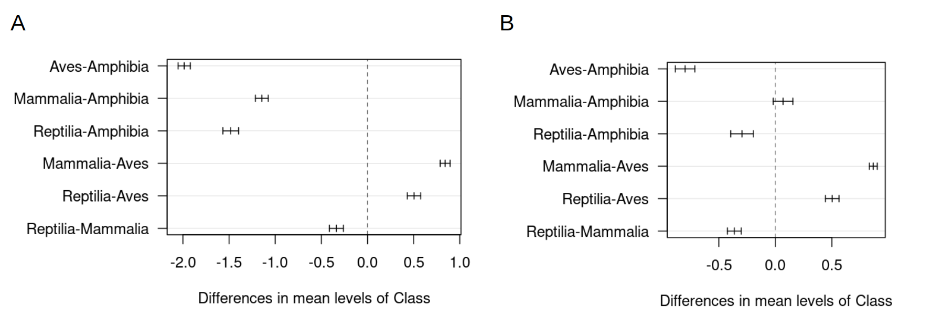

Figure S1. Mean differences of genome size across tetrapods. Comparisons of all possible pairs of tetrapod classes resulted from the post-hoc analyses using Tukey tests. Charts represent the mean differences for each pair of class (e.g. Aves-Amphibia) using all the species explored in our study (A) and only the species sequenced genomes (B).

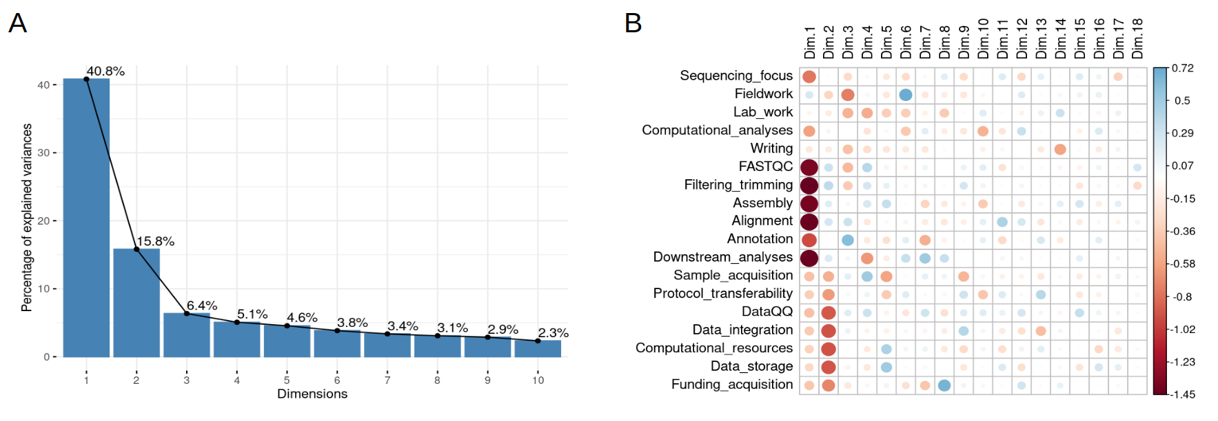

Figure S2. Principal component analysis (PCA) results of the responses of the Amphibian Genomics Consortium (AGC) survey. (A) Bar plot representing the percentage of explained variance per each dimension. (B) Correlation of each variable (from the quantitative questions of the Amphibian Genomics Consortium [AGC] survey) with each PCA dimension. Direction of the relation and effect is color and size coded.

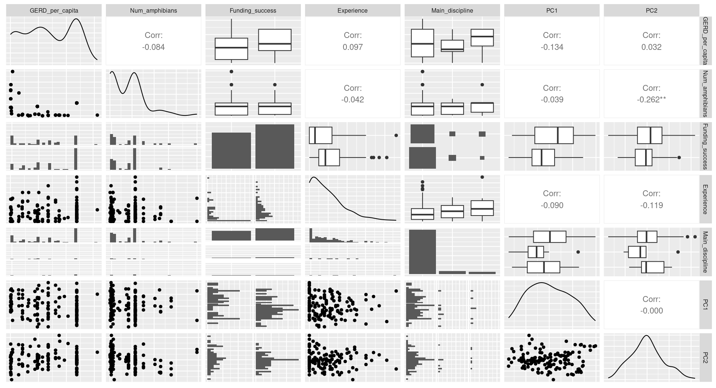

Figure S3. Relations and distributions of the variables to model responses of the Amphibian Genomics Consortium (AGC) survey. Orthogonal dimensions or principal components (PC) as independent variables are compared to the explanatory variables. Information about the number of amphibians per country was obtained from the AmphibiaWeb. The research and development expenditure of the gross domestic product (GERD) per capita was calculated using the information from the UNESCO and World bank websites provided about the most recent year for each country.
References
1. Gregory TR: Animal genome size database. 2024.
2. Liedtke HC, Gower DJ, Wilkinson M, Gomez-Mestre I: Macroevolutionary shift in the size of amphibian genomes and the role of life history and climate. Nature Ecology & Evolution 2018, 2(11):1792-1799.
3. Jetz W, Pyron RA: The interplay of past diversification and evolutionary isolation with present imperilment across the amphibian tree of life. Nature Ecology & Evolution 2018, 2(5):850-858.
4. Challis R, Kumar S, Sotero-Caio C, Brown M, Blaxter M: Genomes on a Tree (GoaT): A versatile, scalable search engine for genomic and sequencing project metadata across the eukaryotic tree of life [version 1; peer review: 2 approved]. Wellcome Open Research 2023, 8(24).
5. Revell LJ: phytools 2.0: an updated R ecosystem for phylogenetic comparative methods (and other things). PeerJ 2024, 12:e16505.
6. Kassambara A: Factoextra: extract and visualize the results of multivariate data analyses. R package version 2016, 1.

