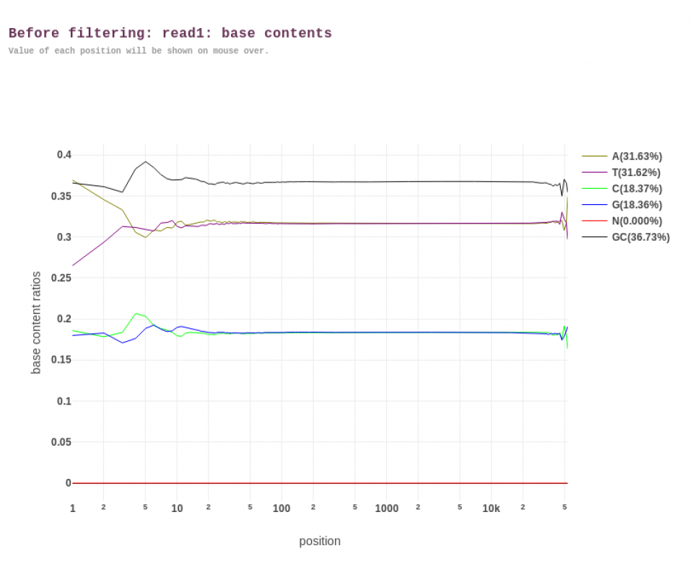
Supplementary Figure 6 Base composition report of the HiFi reads using fastp (before trimming).
The x-axis represents the position in the read ranging from positions 1 to 50,000, and y-axis shows the base content ratios for each nucleotide (A, T, C, and G, represented by pastel yellow, purple, light green, and blue, respectively). The N (red) and GC (black) percentages are shown. The relatively horizontal lines across the read positions after the 20th base for A, T, C, and G bases indicate the absence of significant base composition bias. In contrast, at the beginning of the read up to 20th base may be biased due to artificial sequences.

