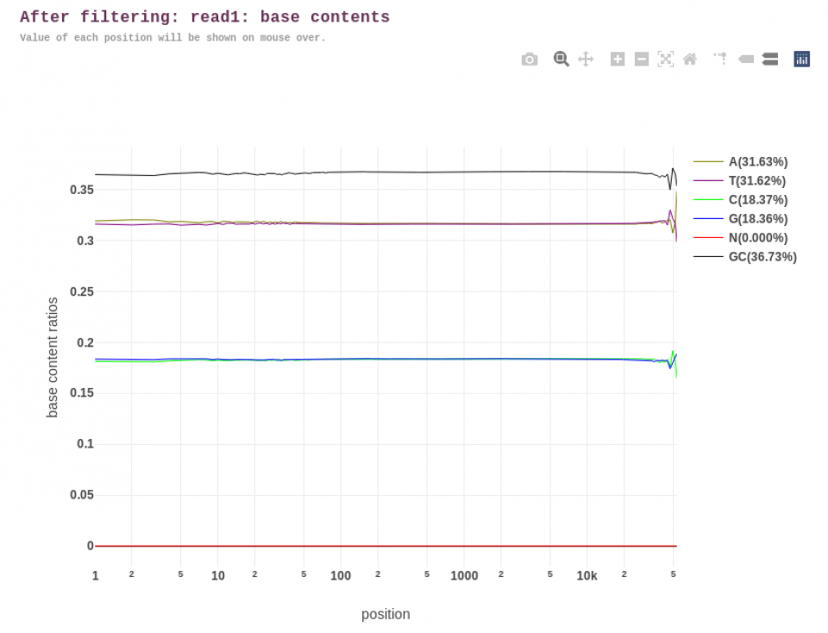
Supplementary Figure 7 Base composition report of the HiFi reads using fastp (after trimming).
The x-axis represents the position in the read ranging from 1 to 50,000, and the y-axis shows the base content ratios for each nucleotide (A, T, C, and G, represented by pastel yellow, purple, light green, and blue, respectively). The N (red) and GC (black) percentages are shown. The relatively horizontal lines across the overall read positions suggest that no significant bias in base composition after trimming.

