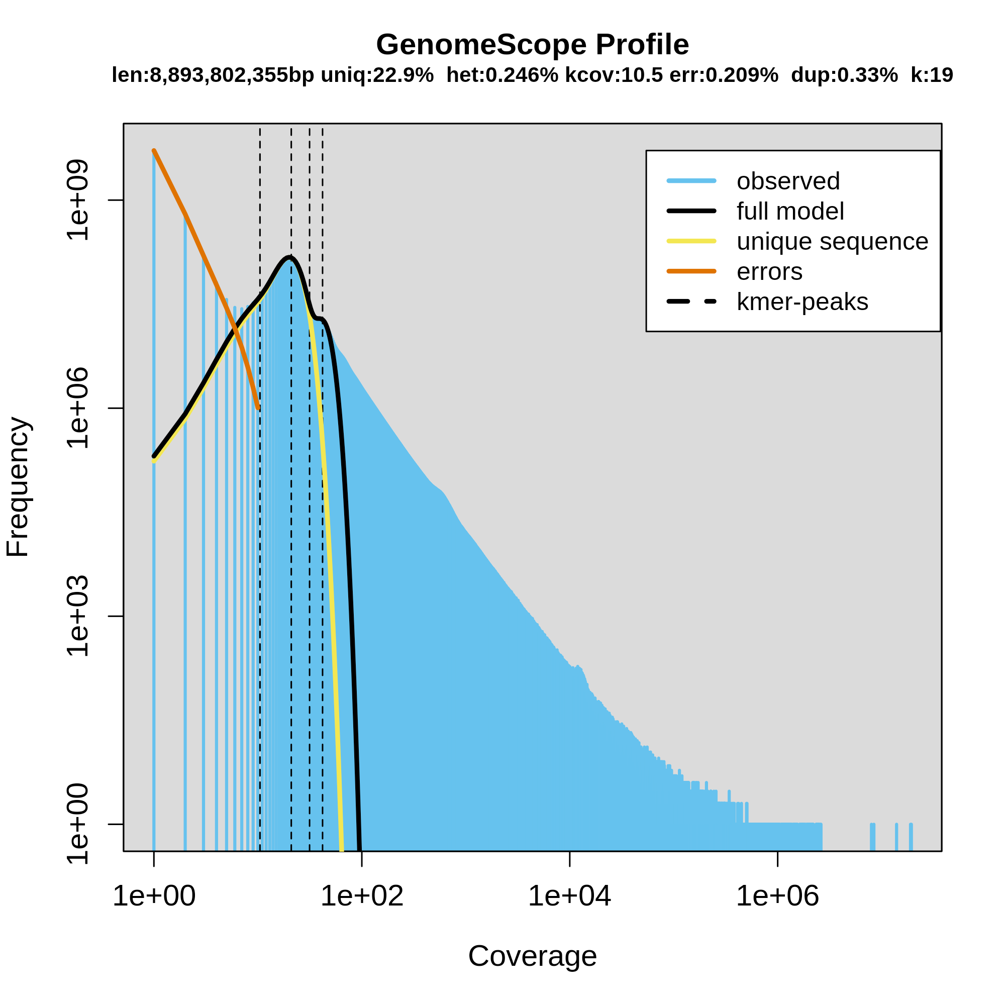

Supplementary Figure 1 Histogram of k-mer frequency at each coverage (k = 19) and model fitting using GenomeScope.

Key parameters estimated from the profile are annotated at the top, indicating the genome length (len: 8,893,802,355 bp), unique sequence percentage (uniq: 22.9%), heterozygosity (het: 0.246%), k-mer coverage (kcov: 10.5), error rate (err: 0.209%), and duplication rate (dup: 0.33%).

