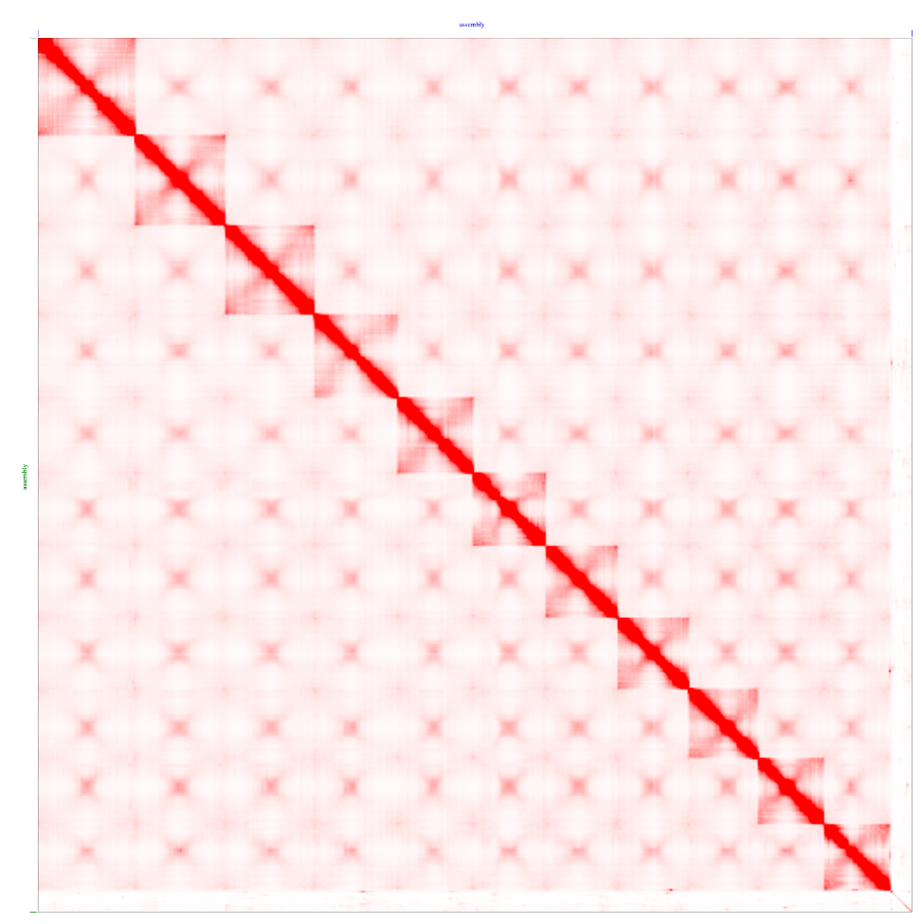
Supplementary Figure 2 Final contact map of the Hi-C analysis after the manual correction.
The chromosomal interactions within a genome are shown, as determined using Hi-C analysis. The matrix displays eleven distinct squares along the diagonal, corresponding to the eleven chromosomes of C. japonica. Each chromosome appears as a square along the diagonal, because Hi-C contacts were the most frequent within the same chromosome.

