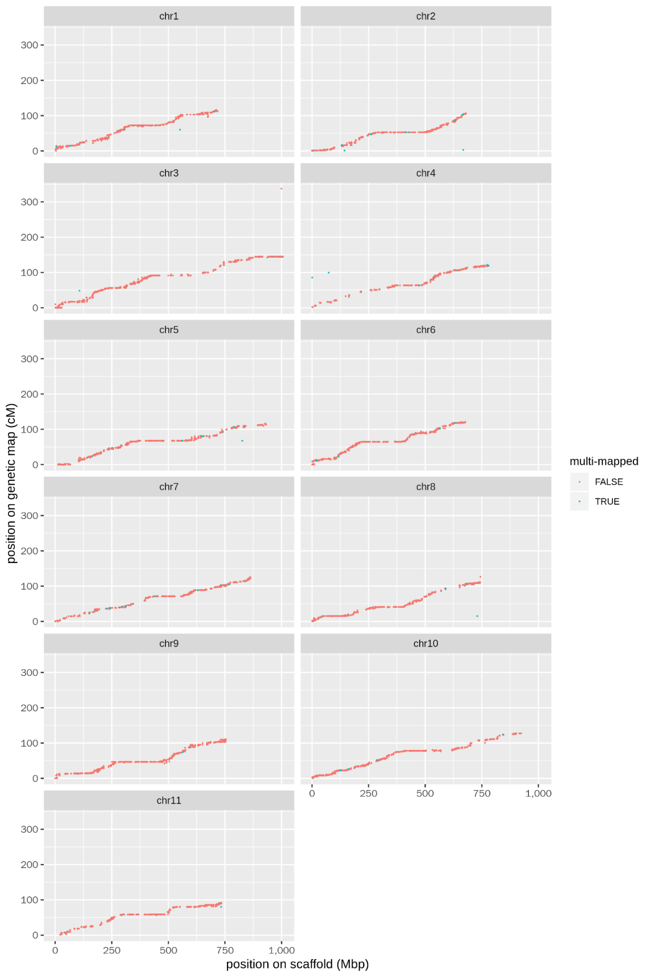
Supplementary Figure 3 Relationship between the marker positions (cM) and the physical position (Mbp) of the markers.
The genetic map and the scaffolds are highly consistent, except for the multi-mapped markers (blue dots) where the sequence aligns to multiple locations on the genome.

