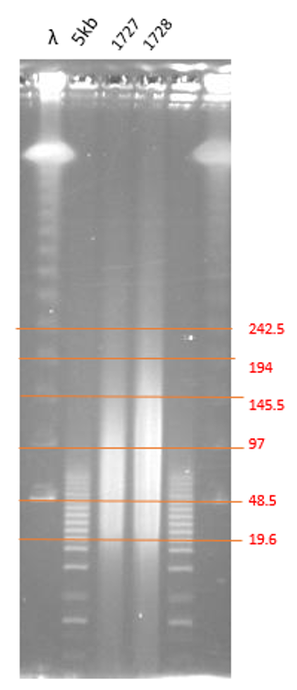
Supplementary Figure 5 Pulsed-field gel electrophoresis (PFGE) of high molecular weight DNA from Cryptomeria japonica flushing buds.
Size distribution of high molecular weight (HMW) DNA from Cryptomeria japonica samples (labeled 1727 and 1728) was assessed using PFGE. HMW DNA samples ranging from 20–200 ng of were electrophoresed through a 1% agarose gel over a 15 hour period using the Bio-Rad CHEF Mapper system. A lambda ladder and a 5-kbp ladder (labeled as λ and 5kb, respectively) were employed as molecular size standards that flanked the lanes containing the HMW DNA samples. Orange lines corresponding to the bands of the size standards (in kbp).

